2014 State Damage Prevention Program Grant Mid-Term Progress Report
CFDA Number: 20.720

Award Number: DTPH5614GPPS15
Project Title: New Jersey Board of Public Utilities State Damage Prevention Grant
Date Submitted: April 30, 2015
Submitted by: Michael Stonack

Specific Objective(s) of the Agreement

Under this grant agreement, the NJBPU will enforce:
▪ Laws and regulations of the damage prevention process

Workscope

Under the terms of this grant agreement, the Recipient will address the following elements listed in the approved application as stated in 49 U.S.C. §60134 (b).
▪ Element 7 (Enforcement): Enforcement of State damage prevention laws and regulations
for all aspects of the damage prevention process, including public education, and the use of
civil penalties for violations assessable by the appropriate State authority.

Accomplishments for this period (Item 1 under Article IX, Section 9.01 Progress Report: “A comparison of actual accomplishments to the objectives established for the period.”)

The New Jersey Board of Public Utilities ("NJBPU") is using the 2014 SDP Grant funds to offset salary and expenses for a damage prevention compliance and complaint investigator for its damage prevention program. The NJBPU implemented a new Damage Prevention / One Call database in 2014 to track underground facility damages, damage and non-compliance investigations, enforcement actions, and settlements of the enforcement actions. This Grant project is concentrated on natural gas facility damages, although other utility damages are also being reviewed. Natural gas facility damage locations and related enforcement actions are in the process of being GIS mapped and reviewed on a statewide basis. The damage prevention compliance enforcement and complaint investigator funded by this SDP Grant has conducted inspections of probable non-compliance and complaints relative to the New Jersey Underground Facility Protection Act ("Act"), issued probable non-compliance enforcement actions, addressed responses to non-compliance enforcement actions, determined proposed enforcement penalties with other damage prevention staff for probable non-compliance with the Act, and tracked probable non-compliance and complaint inspections and actions through the NJBPU database. Utilizing the Grant funding, non-compliance investigations were increased, additional non-compliance enforcement actions were processed, and the NJBPU damage prevention program was strengthened. This project directly affects Element 7 (Enforcement) of the NJBPU Damage Prevention Program.

Table 1 on page 2 provides a multiyear review of total gas facility damages and damages that occurred as a result of locates not being requested (no calls). In addition, Chart 1 on page 2 shows gas facility damages per 1,000 incoming ticket locate requests. This chart shows an overall declining trend over the years.

Table 1 - Gas Facility Damages in New Jersey
Year | Total Damages | Locate-Not-Requested Damages
2009 | 1,654 | 604
2010 | 1,724 | 497
2011 | 1,637 | 566
2012 | 1,555 | 579
2013 | 1,836 | 643
2014 | 1,772 | 522

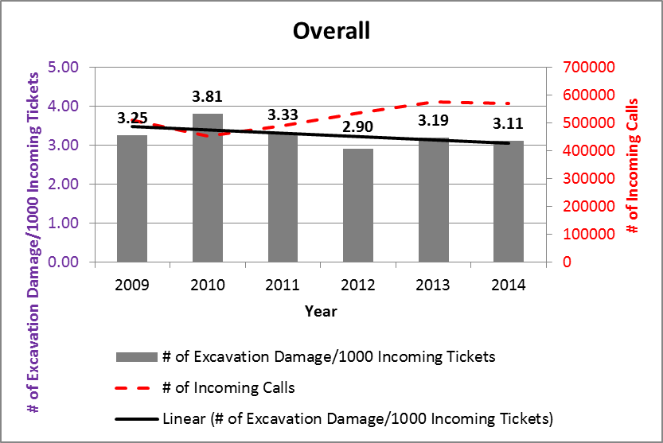
Chart 1 Gas Facility Damages and Damages/1000 Tickets in New Jersey (2009-2014)

The following table illustrates total gas facility damage cases entered into the database for review and those cases that have been opened for investigation (entitled Handled by Staff). The total cases entered for review also include locate not requested cases (no calls) that did not result in damages. These cases are ones where staff investigation found excavators digging without calling NJ One Call for a locate request or where a complaint was submitted against an excavator who was digging without underground facilities being marked.

Case Investigations by Month

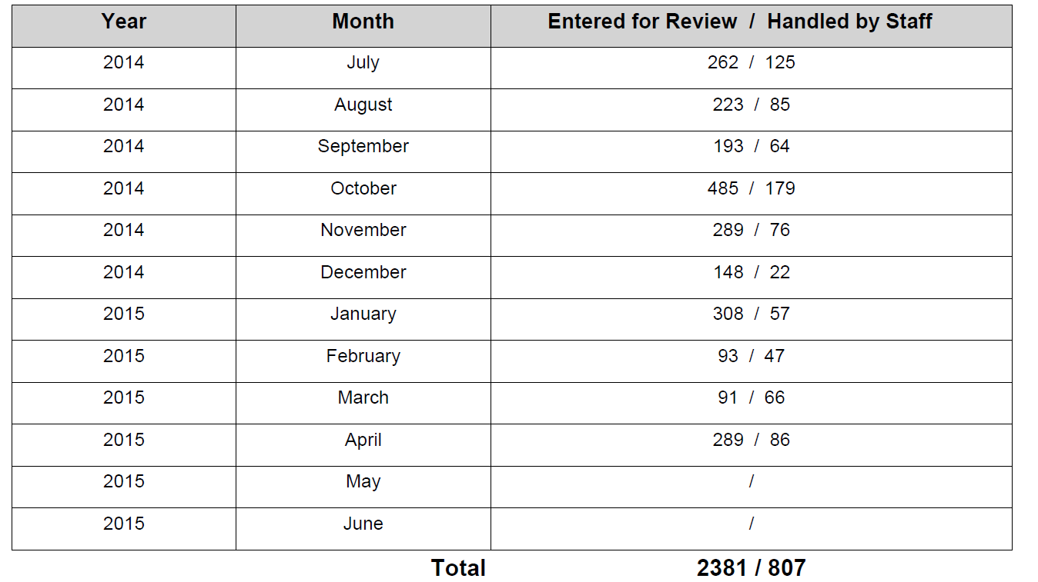

The Non-Compliance Enforcement Status Report on page 4 is an example page of a report from the NJBPU database showing the status and tracking of damaged gas facility cases being investigated for possible enforcement actions.

Non-Compliance Enforcement Status Report

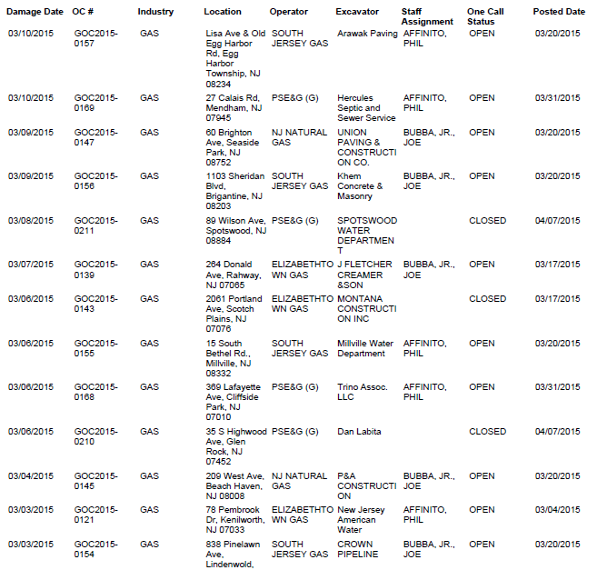

Quantifiable Metrics/Measures of Effectiveness (Item 2 under Article IX, Section 9.01 Progress Report: “Where the output of the project can be quantified, a computation of the cost per unit of output.”)

As of this 2014 SDP Grant Mid-Term Progress Report, the work being performed by the investigator has been very effective in accomplishing the Grant objectives of enhancing compliance and complaint investigations, and enforcement actions where appropriate. As indicated in the following 2014 and 2015 settlement reports (pages 5 and 6), enforcement settlements for the 1st quarter of 2015 totaled $243,000 in comparison with $65,000 for the 1st quarter of 2014. This represents an increase of 374%, which is directly attributable to the work being performed by the damage prevention compliance and complaint investigator.

The 2014 and 2015 settlement reports also show the number of letters of inquiry (LOI) and number of notices of violation (NOV) that were sent to excavators and operators by damage prevention staff.

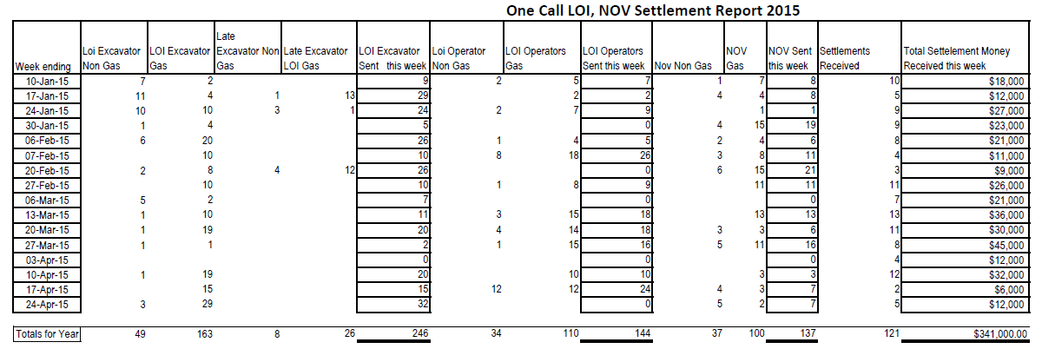
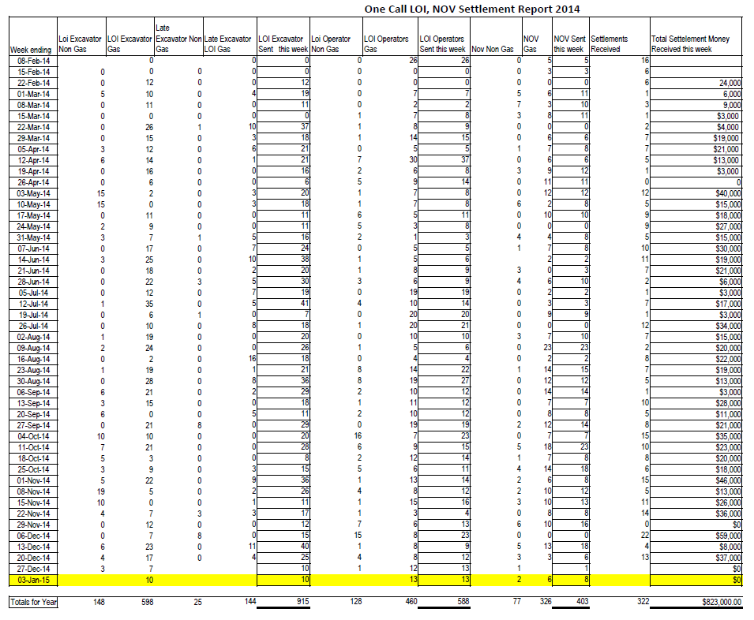

Issues, Problems or Challenges (Item 3 under Article IX, Section 9.01 Progress Report: “The reasons for slippage if established objectives were not met. “)

The established objectives for the Grant project were achieved. However, the project costs as of this report are lower than anticipated due to a delay in the NJBPU assigning the Damage Prevention Investigator to a permanent position. This issue is being addressed with the NJBPU Human Resources office and it is anticipated that it will be resolved within a short period of time.

Mid-term Financial Status Report

The final financial report has been sent as a separate attachment to the AA. See Form SF-425, Federal Financial Report, submitted by PI on April 30, 2015.

Project Costs

Personnel (Damage Prevention Investigator)……931.25 Hours @$26.73/Hour……...…24,892.31
Fringe Benefits…………………………………………………………………………………… 0.00
Travel……………………………………………………………………………………………… 0.00
Equipment…………………………………………………………………………………………. 0.00
Supplies……………………………………………………………………………………………. 0.00
Contractual……………………………………………………………………………………….. 0.00
Other……………………………………………………………………………………………….. 0.00
Indirect…………………………………………………………………………………………….. 0.00

Total Project Costs…………………………………………………………..…$24,892.31

Plans for Next Period (Remainder of Grant)

The NJBPU will continue to build on the mid-term progress achieved on this SDP Grant project relative to non-compliance investigations, processing non-compliance enforcement actions where appropriate, and strengthening the NJBPU damage prevention program.

Requests of the AOR and/or PHMSA

No actions requested at this time.

