CAAP Final Report
Date of Report: 9/30/2025
Recipient Organization: Rutgers University
Prepared for: U.S. DOT Pipeline and Hazardous Materials Safety Administration
Annual Period: From 10/1/2021 to 9/30/2025
Contract Number: 693JK32150001CAAP
Project Title: Pipeline Risk Management Using Artificial Intelligence-Enabled Modeling and Decision Making
Prepared by: Hao Wang, Bingyan Cui, Qindan Huang, Alireza Khatami, Xingsen Yang
Contact Information: Hao Wang, Rutgers University, hwang.cee@rutgers.edu
Table of Contents
List of Figures iii
List of Tables vii
List of Acronyms viii
1 Executive Summary 1
1.1 Project Deliverables 1
1.2 Education Accomplishments (student engagement, outreach activities) 2
1.3 Publications 3
1.4 Conclusions, Achievements, and Future Work 3
2 Background and Objectives 5
2.1 Background 5
2.2 Objectives and Scope 5
3 Literature Review 7
3.1 Overview of Prediction Models for Pipeline Corrosion 7
3.2 Probabilistic Prediction Models 8
3.3 Artificial Neural Network and Bayesian Neural Network 10
3.4 Variability Consideration in Corrosion Growth 14
3.5 Pipeline Maintenance and Risk Management 16
3.6 Application of AI for Decision Making 20
4 Data Collection from Industry 23
4.1 First Dataset from Pipeline Operator 23
4.2 Second Dataset from Pipeline Operator 25
5 Probabilistic Modeling of Pipeline Corrosion Growth 29
5.1 Data Analytics of Pipeline Corrosion Defects 29
5.1.1 Analysis methodology 29
5.1.2 Interaction of adjacent defects 31
5.1.3 Findings 47
5.2 Defect Growth Modeling with Bayesian Neural Network 48
5.2.1 Development of Bayesian Neural Network 48
5.2.2 Defect growth prediction using BNN 50
5.2.3 Findings 57
5.3 Defect Growth Modeling with Probabilistic Power Models 58
5.3.1 Modeling methodology 58
5.3.2 Growth model development 63
5.3.3 Findings 76
5.4 Identification of Corrosive Soil Environment 77
5.4.1 Anomaly Detection with Machine Learning 77
5.4.2 Augmented Datasets and Analysis Results 78
5.4.3 Findings 81
6 Quantification of Probability of Failure 82
6.1 Pipe Capacity before and after Composite Wrap Repair 82
6.2 Probability of Failure 86
6.3 Findings 94
7 Decision Making of Inspection and Repair Strategy 96
7.1 Optimized Inspection and Repair Strategy using Reinforcement Learning 96
7.1.1 Reinforcement learning framework 96
7.1.2 Case study 100
7.1.3 Findings 114
7.2 Analytical Framework for Time-Dependent Failure Modeling Under Repair 114
7.2.1 Theory background 115
7.2.2 Case study 118
7.2.3 Findings 120
7.3 LCC of Pipeline with Multiple Joints and Defects 120
7.3.1 Assumptions 121
7.3.2 Monte Carlo simulation results 122
7.3.3 Findings 127
8 Conclusions 128
9 Future Work 130
10 Lessons Learned 131
11 References 132
List of Figures
Figure 2.1 Proposed AI-enabled pipeline risk management 6
Figure 3.1 Architecture of ANN model with two hidden layers 12
Figure 3.2 Architecture of BNN model 13
Figure 3.3 Evolution of maintenance policies from 1940 to present 16
Figure 3.4 General process of risk assessment 19
Figure 3.5 The deep reinforcement learning framework using GCN 21
Figure 3.6 Deep Q-learning framework for pipeline maintenance 22
Figure 4.1 Number of external corrosion defects along the pipeline in different inspection years 24
Figure 4.2 Clustering plot of corrosion defects in different inspection years 24
Figure 4.3 Scatter plot of pipe damage along the length of the pipeline for the original dataset (a) corrosion depth, (b) corrosion length 26
Figure 4.4 Scatter plot of corrosion defects along pipeline length for the zone-based dataset (a) corrosion depth, (b) corrosion length 27
Figure 5.1 Number of defects from 2005 to 2016 in (a) scatter plot, (b) boxplot 32
Figure 5.2 Corrosion depth from 2005 to 2016 in (a) scatter plot, (b) boxplot 33
Figure 5.3 2D contour plot of peak corrosion depth from ILI in (a) 2005, (b) 2012, (c) 2016 35
Figure 5.4 Density plots of (a) longitudinal locations of corrosion defects; (b) circumferential locations of corrosion defects from ILI 35
Figure 5.5 Hierarchical clustering of corrosion defects based on peak depth and ERF 36
Figure 5.6 Geographical distribution of corrosion severity levels 37
Figure 5.7 Illustration of location parameters on a 2D plane for one pipe segment 38
Figure 5.8 Correlation plots between three input variables: (a) scatter pair plot, (b) heat map of correlation coefficients 39
Figure 5.9 Impacts of input variables (a) importance of input variables on three severity levels; (b) impact of input variables on low severity level; (c) impact of input variables on medium severity level; (d) impact of input variables on high severity level 41
Figure 5.10 Plot of maximum corrosion depth (a) density plot, (b) boxplot 42
Figure 5.11 Fitting of Gumbel Distribution in different inspection years: (a) histogram plot, (b) Q-Q plot 43
Figure 5.12 Fitted lines of Gumbel distribution parameters (a) location parameter; (b) scale parameter with respect to inspection years 44
Figure 5.13 Plot of corrosion number density (a) density plot, (b) boxplot 45
Figure 5.14 Fitting of Weibull Distribution in different inspection years: (a) histogram plot, 46
Figure 5.15 Fitted lines of Weibull distribution parameters (a) shape parameter; (b) scale parameter with respect to inspection years 47
Figure 5.16 Illustration of BNN model for probabilistic modeling of corrosion growth 49
Figure 5.17 BNN fitting results of original dataset (a) prediction of corrosion depth; (b) prediction of corrosion length at different locations; (c) predicted vs. measured corrosion depth; (d) predicted vs. measured corrosion length 52
Figure 5.18 BNN fitting results of zone-based dataset (a) prediction of corrosion depth; (b) prediction of corrosion length at different zones; (c) predicted vs. measured corrosion depth; (d) predicted vs. measured corrosion length 54
Figure 5.19 Importance ranking of influencing factors on (a) corrosion depth, (b) corrosion length 56
Figure 5.20 Prediction of corrosion growth over time (a)corrosion depth, (b) corrosion length 57
Figure 5.21 The relationship between initiation times of individual defects 60
Figure 5.22 Distribution of identified defects in the Mexico1 dataset along the pipeline: (a) depth, (b) length, and (c) scatter plot of defect depth vs. length 65
Figure 5.23 Histogram of identified defects dimension in the Mexico1 dataset: (a) depth and (b) length 66
Figure 5.24 Variations of soil properties along the pipeline: (a) moisture and (b) pH 67
Figure 5.25 Comparison between predicted vs. measured defect dimension: (a) depth and (b) length 70
Figure 5.26 Considered measurement error bias in measured (a) depth and (b) length 71
Figure 5.27 Predictive evolution of corrosion depth (top) and length (bottom) over time: (a) considering soil properties and no measurement error, (b) without considering soil properties and measurement error, and (c) considering soil properties and measurement error 72
Figure 5.28 Scatter plot of predicted vs. measured defect depth: (a) Prediction model considering soil properties and no measurement error; (b) Prediction model without considering soil properties and measurement error; (c) Prediction model considering soil properties and measurement error 73
Figure 5.29 Scatter plot of predicted vs. measured defect length: (a) Prediction model considering soil properties and no measurement error; (b) Prediction model without considering soil properties and measurement error; (c) Prediction model considering soil properties and measurement error 74
Figure 5.30 Effect of soil properties inclusion in the prediction model on the defect growth 76
Figure 5.31 Number of observations before and after data augmentation for the (a) original dataset, (b) zone-based dataset 79
Figure 5.32 Importance of parameters on corrosive soil environment based on SHAP plot. 80
Figure 6.1 Illustration of pipe-composite wrap system 85
Figure 6.2 Pipeline probability of failure in each zone section before repair 87
Figure 6.3 Pipeline probability of failure after repair in each zone (indicated by zone number) with different repair thickness (a) 2 mm, (b) 4 mm, (c) 7 mm, (d) 10 mm 90
Figure 6.4 Probability of failure versus repair thickness in zone #194 91
Figure 6.5 Pipeline probability of failure after repair in each zone section with different material modulus (a) 20GPa, (b) 40GPa, (c) 60GPa, (d) 80GPa 93
Figure 6.6 Probability of failure versus material modulus in zone #194 94
Figure 7.1 Overall framework of RL-based maintenance plan 96
Figure 7.2 Pseudocode of the Dueling DQN algorithm 99
Figure 7.3 (a) Maintenance matrix for multiple zones; (b) Cost distribution for multiple zones 103
Figure 7.4 Changes in failure probability over time 104
Figure 7.5 Impact of consequence costs of pipe burst on life-cycle costs (log-scale at x axis) 105
Figure 7.6 (a) Maintenance matrix using maximum failure cost; (b) density distribution of maintenance actions using different failure costs 106
Figure 7.7 Impact of failure probability threshold on life-cycle cost 107
Figure 7.8 (a) Maintenance matrix using 10⁻⁵ threshold; (b) density distribution of maintenance actions using different thresholds 108
Figure 7.9 Impact of unit inspection cost on life-cycle cost. 109
Figure 7.10 Impact of corrosion reduction factor on life-cycle costs 110
Figure 7.11 (a) maintenance matrix at a reduction factor of 0.5; (b) density distribution of maintenance actions using different reduction factors 111
Figure 7.12 Impact of operating pressure on life-cycle cost 112
Figure 7.13 (a) Maintenance matrix using 10.5 MPa operating pressure; (b) density distribution of maintenance actions at different pressure levels 113
Figure 7.14 Decision tree (F: failure, $F:$survival, Ri,j: repair conducted at t_{i} on branch j (j = 1, 2, …2^{i-1}) 115
Figure 7.15 CDF of T_{f} with two inspections 117
Figure 7.16 Comparison of CDF of corroded pipeline under repair for analytical approach and simulated defect growth 119
Figure 7.17 Number of defects per joint with at least one defect 120
Figure 7.18 Probability of failure of joints with defects under Δt = 5 years and α = 0.8: (a) first failure and (b) second failure 123
Figure 7.19 Time of failures with uncertainties under 5-year inspection interval: (a) first failure and (b) second failure 123
Figure 7.20 Time of repairs with uncertainties under Δt = 5 years and α = 0.8: (a) 1st repair, (b) 2nd repair, and (c) 3rd repair 124
Figure 7.21 Time of repairs with uncertainties under Δt = 5 years and α = 0.8: (a) first failure and (b) second failure 124
Figure 7.22 Mean probability of failure across all the joints with defects under different inspection intervals with α = 0.8: (a) first failure and (b) second failure 125
Figure 7.23 Expected LCC components under α = 0.8 and different inspection intervals: (a) 5-year, (b) 8-year, (c) 10-year and (d) 15-year 125
Figure 7.24 Expected LCC over investigated time under α = 0.8 and different inspection intervals 126
Figure 7.25 Expected LCC under α = 0.8 and different inspection intervals considering investigated time of 100 years 126
Figure 7.26 Expected LCC of pipeline network under Δt = 5 years and different repair factors (𝛼) values 127

List of Tables
Table 3.1 Comparison among different maintenance strategies of pipelines 19
Table 4.1 General information about the pipeline 23
Table 4.2 Number of external corrosion defects found in different inspection years 23
Table 4.3 Number of external corrosion defects in different clusters 25
Table 4.4 Summary of soil survey data 28
Table 5.1 Classification results of corrosion severity levels 37
Table 5.2 Performance of different machine learning methods 40
Table 5.3 Fitting parameters of Gumbel distributions 43
Table 5.4 Fitting parameters of Weibull distributions 47
Table 5.5 Summary of R² for corrosion depth and length 54
Table 5.6 Posterior distribution statistics of model parameters for the first half of the pipeline 69
Table 5.7 Summary of quantitative measures for prediction performance of three sets of models 71
Table 5.10 Model performance before and after data augmentation (original dataset) 79
Table 5.11 Model performance before and after data augmentation (zone-based dataset) 79
Table 6.1 Target probability of failure 88
Table 7.1 Statistics summary of consequence costs of burst failure in gas pipelines (from PHMSA database) 101
Table 7.2 Summary of different types of cost data 101
Table 7.3 Statistical parameters of random variables used in the case study 118
Table 7.4 Distribution parameters of random variables used in the case study 121
Table 7.5 Corrosion defect model parameters statistics used in the case study 121

List of Acronyms

AI | Artificial Intelligence
ALS | Accidental limit State
AM  AdaBoost | Adaptive Metropolis  adaptive boosting
ANN | Artificial Neural Network
BNN | Bayesian Neural Network
BR | Bayesian Regularization
B2B | Box to Box
CBM | Condition-Based Maintenance
CDF | Cumulative Distribution Function
CFRP  cGAN | Carbon Fiber-Reinforced Polymer  Conditional Generative Adversarial Network
CM | Corrective Maintenance
CMC | Crude Monte Carlo simulation
DLM | Dynamic Linear Model
DNV | Det Norske Veritas
DQN | Deep-Q Network
DR | Delayed Rejection
DRL | Deep Reinforcement Learning
EC | Eddy Current
ERF | Estimated Repair Factor
ESS | Error Sum of Squares
FE | Finite Element
FLS | Fatigue Limit State
FRP  GAN | fiber-reinforced polymer  Generative Adversarial Network
GCN | Graph Convolutional Network
GCR | Growth/Corrosion Rate
GD | Gradient Descent
GEV | Generalized Extreme Value
GFRP | Glass Fiber-Reinforced Polymer
IGP | Inverse Gaussian Process
ILI | In-Line Inspection
KL | Kullback-Leibler
KNN | K-Nearest Neighbor
LCC | Life-Cycle Cost
LightGBM | Light Gradient Boosting Machine
LM | Levenberg-Marquardt
MAOP | Maximum Allowable Operating Pressure
MAPE | Mean Absolute Percentage Error
MCMC | Markov Chain Monte Carlo
MFL | Magnetic Flux Leakage
MLP | Multi-Layer Perception
MSE  OD | Mean Squared Error  Relative distance from corrosion defect to girth weld
PDF | Probability Density Function
PHMSA | Pipeline and Hazardous Materials Safety Administration
PI | Practicality Index
PM | Preventive Maintenance
PoF | Probability of Failure
PSWP | Poisson Square Wave Process
RBF | Radial Basis Function
RBM | Risk-Based Maintenance
RF | Random Forest
RL | Reinforcement Learning
R² | Coefficient of Determination
SC | Scaled Conjugate
SHAP | SHapley Additive exPlanations
SLS  SMOTE | Serviceability Limit State  Synthetic Minority Over-sampling TEchnique
SVM | Support Vector Machine
ULS | Ultimate Limit State
UT | Ultrasonic Testing
VI | Variational Inferen
XGBoost | Extreme Gradient Boosting

Executive Summary
The research objective is to develop Artificial Intelligence (AI)-enabled tools to improve accuracy of probabilistic performance modeling and support decision making of inspection and repair actions in pipeline risk management. Risk-based management has been widely accepted in the pipeline industry for supporting cost-effective decisions while ensuring pipeline safety. However, there is a need for processing pipeline inspection data to minimize data errors and to extract essential information for risk assessment and decision making. This research develops Artificial Intelligence (AI) based solutions that can identify connections between pipeline corrosion characteristics through data analytics, predict corrosion growth using Bayesian Neural Network (BNN) and probabilistic power function, quantify probability of failure with uncertainties, and support decision making of pipeline inspection and repair using Reinforcement Learning (RL) and decision tree approaches. The research outcome provides efficient tools for pipeline operators to make reliable and autonomous decision making as well as saving pipeline inspection and repair costs.

Project Deliverables
- Task 1: Literature Review
An extensive literature review is performed on the following topics related to the proposed research: 1) current practice on prediction of pipeline performance degradation 2) probabilistic prediction models based on statistics and machine learning; 3) Pipeline maintenance and integrity management; and 4) potential of AI for decision making of pipeline risk management.

- Task 2: Data Collection from Industry
In-line inspection (ILI) data was obtained from two pipeline operators, mainly focused on external corrosion. The first dataset includes only corrosion depth, length and locations, while the second dataset has detailed soil characteristics along the pipeline in addition to corrosion data.

- Task 3: Probabilistic Modeling of Pipeline Corrosion Growth
Pipeline ILI data was analyzed using different statistical and machine learning methods for various purposes. These include 1) analyzing the relationship between the location and severity level of corrosion defects using unsupervised machine learning; 2) developing statistical growth model of maximum corrosion depth and number density; 3) developing probabilistic growth model of corrosion depth/length using Bayesian Neural Network considering the effects of soil properties; and 4) developing probabilistic growth model of corrosion depth/length using power law considering the effects of soil properties and random corrosion generation.

- Task 4: Quantification of Probability of Failure
The probability of failure (PoF) of steel pipes due to external corrosion was calculated considering uncertainty in the developed predictive models. Two distinct failure modes are considered: small leak and burst. The pipe capacity before and after composite wrap repair is derived and used to calculate the PoF at different composite modulus and thickness values.

- Task 5: Decision Making of Inspection and Repair Strategy
An Artificial Intelligence (AI)-enabled decision-making method is developed to minimize the life-cycle cost of pipeline system using reinforcement learning (RL) for pipeline inspection and repair planning while ensuring the required level of reliability in pipeline risk management. On the other hand, an analytical framework for evaluating the time-dependent reliability of corroded pipelines under periodic inspections and repairs is developed for analysis of life-cycle cost.

- Task 6 Final Report and Presentation
The final report is submitted after addressing the review comments from the technical panel. The mid-term presentation and project closeout presentation are delivered.

Education Accomplishments (student engagement, outreach activities)
- Student engagement
  - Bingyan Cui, PhD student in Civil and Environmental Engineering at Rutgers University, 2020-2025, currently Postdoc at Rutgers University.
  - Xingsen Yang, PhD student in Civil and Environmental Engineering at Rutgers, 2024-now.
  - Alireza Khatami, PhD student in Civil, Construction, and Environmental Engineering at Marquette University, 2022-now.
  - Emad Farahani, PhD student in Civil, Construction, and Environmental Engineering at Marquette University, 2022-now.

- Development of curriculums for university students
  - The PI (Dr. Wang) introduced the concept of pipeline integrity management and in-line-inspection of pipeline in the graduate course – Infrastructure Management System at Rutgers University.
  - The Co-PI (Dr. Huang) presented the probabilistic model of corrosion defect and reliability concept in the graduate course – Engineering Reliability Analysis at Marquette University.

Publications
- Journal/conference publications
  - Cui, B.Y. and H. Wang*, Analysis and Prediction of Pipeline Corrosion Defects Based on Data Analytics of In-Line Inspection, Journal of Infrastructure Preservation and Resilience, 2023, Vol. 4, Article No.14
  - Cui, B.Y. and H. Wang*, Pipeline Corrosion Prediction and Analysis with an Ensemble Bayesian Neural Network Approach, Process Safety and Environmental Protection, 2024, Vol. 187, pp. 483-494.
  - Farahani, E.M., Q.D. Huang*, and H. Wang, A Probabilistic Framework for External Pitting Corrosion Growth Modelling for Buried Steel Pipelines Considering Soil Properties, International Journal of Pressure Vessels and Piping, 2024, Vol. 210, 105234.
  - Cui, B.Y. and H. Wang*, Optimization of Risk-Based and Cost-Minimized Maintenance Strategy for Corroded Pipeline Using Reinforcement Learning, Reliability Engineering & System Safety (under review)

- Conference presentations/posters/invited talks, etc.
  - Khatami, A. and Q.D. Huang*, Maintenance Strategy Optimization of Corroded Steel Pipelines with Multiple Defects, AMPP (Association for Materials Protection and Performance) Annual Conference & Expo., Apr. 6-10, 2025, Nashville, TN.
  - Cui, B.Y. and H. Wang*, X.S. Yang, Artificial Intelligence-Enabled Pipeline Integrity Management for Detection and Prediction of Corrosion Defects, Proceeding of ASCE UESI Pipeline Conference, Aug. 9-13, 2025, Tampa, FL.

Conclusions, Achievements, and Future Work
The following conclusions and achievements can be drawn:
- Data analytics of ILI records are conducted to classify corrosion severity and analyze how defect location influences severity, especially when defects are close together. The defects close to welds, or the neighboring defects are more likely to be severe and need closer monitoring.
- Machine learning-based classification with data augmentation was employed to identify corrosive soil environment based on the existence of corrosion in ILI data. Pipeline corrosion is more likely to occur in soil environments with high moisture content, low pH, and high redox potential.
- BNN can effectively predict corrosion growth with uncertainty quantification. Key influencing factors include pipeline age, soil moisture, pH, and chemical properties.
- A novel time-dependent power function for modeling pipeline corrosion growth using ILI data was proposed. The approach incorporates a Poisson process for defect initiation, directly models defect dimensions without requiring matched data, and accounts for soil property variability.
- A robust method to quantify pipeline failure probability before and after composite wrap repair was proposed incorporating composite wrap properties such as thickness and modulus into the analysis.
- A RL-based approach for optimizing long-term maintenance strategies in multi-zone pipeline systems was developed. The model adaptively adjusts maintenance actions based on influencing factors such as corrosion severity, failure cost, repair effectiveness, and operating pressure.
- A decision tree-based model is developed to capture all possible repair paths and calculate cumulative failure probability through recursive probability calculations. This failure time distribution supports life-cycle cost analysis and can accommodate additional uncertainties such as detection probability and measurement errors.
Based on the study outputs, it is recommended to develop refined data processing techniques for selecting representative defects in each soil zone considering both corrosion depth and length and as well as corrosion at pipe body and girth weld. It is also recommended to improve the statistical and machine learning models for prediction of pipeline defects and the reinforcement learning models for optimization of pipeline inspection and repair strategies to ensure pipeline operation safety.

Background and Objectives

Background
The pipeline is a critical infrastructure to transport and distribute gas, oil, water, chemical, and petroleum products that support economic and social development. During the service life, the integrity of pipeline is under various threats by harsh environment, material degradation, extreme hazards, and stress due to loading. The failure of pipeline could result in economic, environmental, and social catastrophes, and even impose the risk of human injury. To reduce the likelihood of sudden pipeline failure and its catastrophic consequences, it is essential for operators to inspect, maintain, and repair pipeline systems to ensure the pipeline integrity.
Pipeline inspection is conducted to detect and identify threats affecting pipeline integrity by deploying various methods, including direct assessment, in-line inspection (ILI) tools, hydrostatic tests, and special techniques for non-piggable pipeline inspection [1, 2]. However, there is a need for processing pipeline inspection data to minimize data errors and to extract essential information for risk assessment and decision making.
In the past three decades, quantitative risk-based management has been widely accepted in pipeline industry practice for supporting cost-effective decisions to achieve acceptable levels of safety [3]. Fig. 1 shows the general process of risk-based pipeline management, consists of exposure identification, risk quantification, and management planning. Once the potential threats are identified, the risk associated with those threats need to be assessed so that appropriate actions (e.g., inspection scheduling, repair) can be taken.

Objectives and Scope
This research aims to develop AI-enabled modeling and decision-making tools for quantitative pipeline risk management, focusing on external corrosion defects of pipeline. The specific technical objectives are proposed as follows:
- Identify interaction effects of corrosion characteristics from ILI data.
- Develop probabilistic predictive models of pipeline damage evolution.
- Access probability of failure using reliability analysis to incorporating uncertainties.
- Develop an AI-enabled decision-making tool for inspection timing and repair strategy.
Field inspection records and indirect survey or examination data are collected from two pipeline operators. Unsupervised machine learning is conducted for data analytics between non-homogeneous datasets of ILI records. Data-driven models of pipeline defect generation and growth are then developed using statistical and machine learning models. The probability of failure of pipeline is evaluated using state-of-art probabilistic pressure capacity models considering with and without composite wrap repair. The sequential decision-making process of pipeline inspection and repair is solved using an innovative Reinforcement Learning (RL) approach to optimize life-cycle cost while ensuring safety and reliability. A decision tree-based model is also developed to capture possible repair paths and calculate cumulative failure probability for life-cycle cost analysis.
To facilitate the application of risk-based management and advance pipeline safety, this study proposes to utilize state-of-art Artificial Intelligence (AI) tools in the pipeline integrity management framework to improve accuracy of probabilistic degradation modeling and support risk-based decision making in integrity management planning, as illustrated in Figure 2.1.

Figure 2.1 Proposed AI-enabled pipeline risk management

Literature Review

Overview of Prediction Models for Pipeline Corrosion
American Society of Mechanical Engineers [4] stated a standardized list of nine threat categories for steel pipelines, among which corrosion, cracking, and mechanical damage (dent or gouge) are most experienced ones. Corrosion is one type of time-dependent deterioration of metallic pipeline materials due to their interaction with the service environment. The initiation and growth of corrosion is related to external and internal factors [5]. External corrosion is mainly affected by environmental factors, such as soil resistivity, soil moisture, potential, pH, ion concentrations, etc. [6]; while internal corrosion is influenced by oxygen content or reactivity of the liquids or gases carried, use of dissimilar metals within the pipeline, temperature, ﬂow rate and pressure [7].
To manage pipeline integrity, it is essential to conduct time-dependent structural performance evaluation of buried pipelines considering corrosion that is a dynamic threat to pipelines integrity. The depth and axial length of the defects data are usually measured by ILI tools with “pigging” devices by implementing non-destructive inspection methods such as magnetic flux leakage (MFL), ultrasonic testing (UT), and Eddy current (EC) [8]. Such field inspection can be used to understand corrosion behavior and to develop predictive corrosion growth models.
Generally, corrosion growth prediction models can be divided into two categories: stochastic process-based models and random variable-based models (linear or nonlinear), with the main difference being only the former considers the temporal variability of the degradation process which can result in more realistic prediction. The commonly used stochastic processes are the Markov process and gamma process [9]. Some related works using Markov process can be found in [10]. In the Markov process, the thickness of the pipeline is usually divided into different distinct states, and at any time the presence of the maximum pit depth in each state can be described by a discrete random variable [11]. The defect growth modeling requires estimation of the likelihood of pipeline being in any given state at any specific moment in time [12]. However, finding the proper transition rate between states and correlating these transition rates to corrosion rates can be challenging. In addition, updating these models by Bayesian inference in case of new ILI data considering measurement noises is not straightforward [13, 14].
Many parameters including material properties and environmental conditions inﬂuence the pipeline degradation process. However, the traditional prediction models can only consider the effects of specific factors in general. For cases that need to consider unique factors, the traditional models may not give a satisfactory result of prediction. Therefore, using the AI-based models can overcome this limitation since they are flexible with many different variables. Ren, Qiao and Tian [15] developed a neural network model for the prediction of corrosion rate in the long-distance pipeline based on the backpropagation algorithm and proved that the backpropagation algorithm is fast and more efﬁcient. A risk-driven integrity model was later developed to optimally substitute offshore process components based on the probability and effect of malfunction from time-dependent deterioration processes [16]. Senouci, Elabbasy, Elwakil, Abdrabou and Zayed [17] developed a prediction model using regression analysis and ANN to predict the pipeline failure occurrence. They found that both techniques provided acceptable results with almost the same prediction accuracy. In a subsequent study, the ANN-based model proved to perform better than regression analysis [18].
Although many diﬀerent stochastic corrosion models have been developed, calibration using existing data remains challenging under real conditions, as there are very few results available that are based on direct in situ inspection data. Traditional models cannot easily incorporate indirect examination or survey data that are useful as well. Furthermore, results from multiple inspections need to be matched. It is also challenging because many data points were collected using diﬀerent tools or techniques with disparate resolution and accuracy.

Probabilistic Prediction Models
Pipeline degradation is a stochastic process so that using stochastic models is an effective way to predict the condition of pipelines in the future. The uncertainties of inspection random error are significant to the model performance. In this case, using appropriate corrosion growth models which best suits pipeline conditions can minimize the uncertainties. The probabilistic models are suitable for modeling the pipeline degradation process where uncertainties are common. The probabilistic models assume that the data are statistically homogenous, and the conditions of exposure are nominally consistent [19]. The random variables are usually used to represent the uncertainties in the probabilistic models. As degradation is a stochastic process, it is appropriate to model pipeline degradation process using stochastic models which can be either discrete-state models such as Markov and semi-Markov models [20] or continuous-state models such as Weiner process [21], gamma process [22], and inverse Gaussian process [23]. Both gamma process and inverse Gaussian process are suitable in modeling monotonic degradation, while inverse Gaussian also has the flexibility to incorporate random effects and covariates for heterogeneity consideration.
Markov model is a traditional probabilistic model. It can predict the localized corrosion growth rate (pitting corrosion) in underground pipelines. Corrosion rate distribution by the Markov model uses a continuous-time, non-homogenous linear growth approach. It allows prediction of pitting corrosion, depth evolution and rate distributions based on data. Valor, Caleyo, Alfonso, Velázquez and Hallen [24] used discrete pit depths in non-homogenous, continuous time Markov chain modelling to determine the transition probability function by correlating the stochastic mean pit depth with the empirical deterministic pit depth. Similarly, Hong [25] obtained the pit initiation and growth processes by modelling pit initiation as a homogenous Poisson process whilst estimating the pit growth with time as a non-homogenous, continuous time Markov process. Further, Camacho, Frutuoso, Melo, Saldanha and Da Silva [26] applied Fokker-Planck equation in the Markov model for transition probability function estimate of pitting corrosion of underground pipelines based on a continuous time, non-homogenous pit depth evolution.
Applying the Markov model requires the initial pit-depth distribution and soil-pipe dependent parameters. It uses discrete states to calculate the growth rate so that it has high computing efficiency. But before determining the depth distribution, the observed defect depth needs to be converted to Markov-state units first. And the calculated results are sensitive to corrosion depth increments.
The gamma process is a stochastic process characterized by increments that are assumed to be independent, non-negative, and follow a gamma distribution with time-dependent shape parameter and defect-specific (location-specific) scale parameter [9, 22, 27-29]. The time-dependent shape parameter can be modeled with the versatile power low function, which can represent increasing, constant, or decreasing degradation rate based on the exponent value [9, 28]. Particularly, a hierarchical Bayesian framework is proposed [27], where a homogeneous gamma process-based growth model is used. Such framework is employed later by using inverse Gaussian process (IGP) as the growth model [29] and by considering non-parametric Bayesian dynamic linear model (DLM) as the growth model [14]. However, it was found that using either IGP or non-parametric Bayesian DLM produced similar or slightly better results than the homogeneous gamma process-based growth model.
Ideally, Markov process and gamma process need matched defects from inspections for the modeling. Zhang and Zhou [27] calibrated the gamma process-based growth models using the depth dimension of 62 matched defects obtained from three ILI data in 2000, 2004 and 2007, and tested the model predictions against field-measured depth in 2010. Since matched defects were not readily available, some research studies used the entire defect population distribution (and its statistical summaries) obtained from ILI runs in model development rather than individual defects depths [11, 30, 31]. Yet, this “distribution matching” has two drawbacks: 1) population-specific growth models are developed rather than defect-specific growth models, and thus, spatial variability of defect growth is not taken into account; 2) such population growth models cannot directly be used for estimating future probability of failure (PoF) per segment which is a critical quantity in pipeline risk assessment, as the projected individual defect sizes within that segment are needed for the system reliability analysis.
Different from the Markov model, the inverse Gaussian process-based model converts the observed data to continuous states. The inverse Gaussian process consists of independent increments that follow the inverse Gaussian distribution [32]. It can rigorously characterize the monotonic nature of corrosion growth because it is positively deﬁned. In addition, the mathematical tractability of the inverse Gaussian distribution helps to incorporate the corrosion growth model in a Bayesian framework to evaluate and update the model parameters based on the inspection data [33]. The inverse Gaussian process-based model can provide good prediction of corrosion depth in underground pipelines based on the continuous inspection pipeline data. During the process, all the parameters were assumed to be uncertain and evaluated using the hierarchical Bayesian methodology based on the ILI data. Therefore, it can consider uncertainties and random error of inspection data. Also, it can give continuous depth increments of depth evolution. The inverse Gaussian process-based model is suitable in modeling monotonic degradation. However, the increments of defect depth are independent along the temporal domain so that this method requires long computing time.
The Geometric Brownian motion with drift model considers corrosion as a stochastic process independent increment. This model has also been used for modeling wear and creep processes. A characteristic feature of this process is that corrosion alternately increases and decreases. Therefore, it is not suitable for a monotonic degradation process, but it can have a good approximation when corrosion growth has a stochastic behavior of being active and passive alternatively [34]. The Geometric Brownian motion process-based model can be used to characterize the growth rate of the depth of corrosion defects based on inspection data subjected to measurement uncertainties [35]. It can predict the growth of corrosion defects reasonably since it considers the passive state that a metallic structure may experience. However, it is mathematically complicated and requires more data for model calibration.
Alternatively, some relatively simple model formulations have been suggested to predict corrosion defect size (e.g., depth and length). One frequently utilized model is the linear function of time for defect size, where the rate of corrosion evolution over time is assumed constant [14, 36-38]. However, this model oversimplifies the defect growth process and is only valid when the corrosion is in a stable stage. Besides, extrapolating linear models over time overestimates the corrosion damage and leads to a conservative estimation of the reliability of the pipeline and unnecessary inspections and excavations [39]. In contrast, some researchers employed a power-law function of time as defect growth model, which can consider non-constant time-dependent rate of damage growth which is more realistic compared to constant growth rate [40-44].
Lastly, some studies combined stochastic process with linear and nonlinear growth formulation to model corrosion growth. For example, Bazán and Beck [31] integrated the Poisson square wave process (PSWP) with the linear and nonlinear growth formulation to account for the temporal variability and stochastic behavior of the defect growth rate [31]. However, since only two sets of corrosion inspection data were available and used in the model calibration, they were not able to assess the prediction (i.e., extrapolation) capabilities of the developed models.
It is worth mentioning that previous work [9] has reviewed the most common corrosion growth model development methodologies and defined a practicality index (PI) to describe the degree of knowledge necessary to perform each model development. They considered PI = 1 for the linear and nonlinear random variable-based models, the simplest models, PI = 2 for the linear and nonlinear stochastic models, and PI = 3 for stochastic process-based models, the most complicated models, requiring deep understanding of the stochastic processes which cannot be performed by common field engineers [9]. Furthermore, interpretability of linear and nonlinear models is significantly better compared to stochastic process-based models or data-driven models (i.e., Bayesian network, artificial neural network, and deep learning models) that have been characterized as being ‘black box’ and lacking in good physical significance explanations [39].

Artificial Neural Network and Bayesian Neural Network
Recently, machine learning approaches have become attractive for both diagnostic and prognostic data analytics, providing a great opportunity to improve prediction accuracy of defect generation and growth and utilize a wide array of pipeline safety data. For example, De Masi, Vichi, Gentile and Gabetta [45] proposed an artificial neural network (ANN) based model to predict the presence of metal loss and corrosion rate and presented a case study using field data; and the results indicated that the proposed model outperformed the deterministic models. Ossai [46] developed a data-driven machine learning approach to assess corrosion risk, where gradient boosting, random forest, feed-forward neural network, and deep neural network were applied and compared to predict the growth of internal corrosion defect depth using the flow characteristics of the oil and gas and the water chemistry information obtained from routine quality control of the pipeline. To take advantage of the available data from different sources, Burhani, Muhammad and Rosli [47] investigated the influence of combining experimental data and field historical data as input for artificial neural network (ANN). It was found that compared with the predictions based on experimental data and field historical data separately, the predictive model using combined database could better improve the prediction of degradation rate; and thus, enabled better mitigation actions in preventing loss of containment due to corrosion under insulation. Canonaco, Roveri, Alippi, Podenzani, Bennardo, Conti and Mancini [48] conducted cross-correlation analysis to evaluate the integrated database with the geometrical data from pigging operations and fluid-dynamical data, where machine learning algorithm was deployed to identify principal features to develop a predictive corrosion model.
During the development of ANN model, the normalized data was required to be divided into three datasets, including training, testing, and validation datasets. First, in the training stage, the model was trained using the divided training dataset. The model was allowed to train till it scopes the ﬁnest necessity using different algorithms, such as Levenberg-Marquardt (LM), Bayesian regularization (BR), gradient descent (GD), and scaled conjugate (SC) algorithms. The best algorithm was selected based on its largest coefﬁcient of determination (R²) value and the lowest mean squared error (MSE) value. The role of neurons is to add up the weights of every source of neurons from the previous column it is connected to. Each connection of neurons has its weight, and those are the only values that will be modiﬁed during the learning process. The weight values actively play an essential role in determining the output for the given input values. A bias value may be added to the total value calculated. After all those summations, the neuron ﬁnally applies a function called “activation function” to the obtained value. The developed ANN network consists of three layers, including input, hidden, and output layers, as shown in Figure 3.1. The input layer receives the input signals from the existing available data. The role of the hidden layer is to transform the signals into something that the output signal can use. This neural architecture is also called a multi-layer perception (MLP), with one input layer, two hidden layers, and one output layer.
In the training process, the output values of all hidden neurons in hidden layers were computed with weight net values and slopes. Later, the outputs of these neurons were used as inputs for output layer neurons. The error was calculated, and the process was re-propagated to get the least possible error after a severe number of iterations. Mathematical equations determining the outputs of a neural network shall be the activation functions. The function is connected to any neuron in the network and decides whether it must be activated or not, depending on whether the inputs of each neuron are important for the prediction of the model. The model was then tested with a testing dataset for its performance checking. Testing data collection is the data sample used to validate the ﬁnal model that ﬁts in the training dataset without bias. A validation data collection consists of a sample of knowledge from the model testing and is used to determine model competencies while tuning the hyper-parameters of the model. The validation dataset is distinct from the evaluation dataset, which often keeps back the model training but instead gives an impartial estimation of the completed model’s ability in the contrast or preference of ﬁnal models. After the completion of the training and testing stages, the model was then allowed to be validated using the validation dataset.
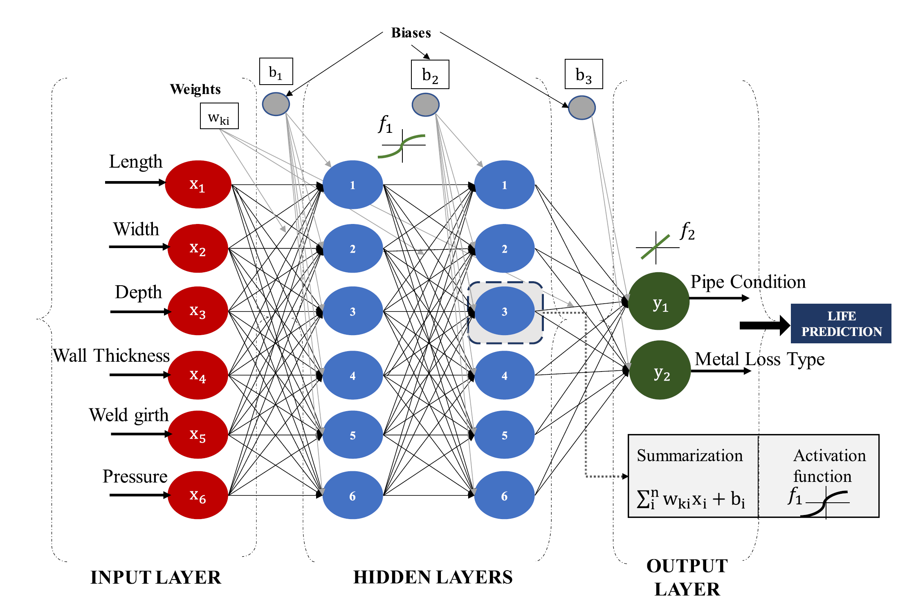
Figure 3.1 Architecture of ANN model with two hidden layers
Therefore, after the above process, the model was able to predict the life condition of the pipeline. For pipeline, the inputs of the ANN model are different factors including the pipeline properties and environment conditions. The output is the pipeline condition and the remaining useful life. The ANN model can predict corrosion growth and the remaining useful life for pipelines. Also, it can clearly show the different corrosion stages, which are uniform corrosion at the early phases and pitting corrosion at the later phases. It is suitable for predicting pipelines at different sections. However, the prediction accuracy of ANN model is different in different cases because it is highly dependent on the input factors. For other situations that have different internal and external factors, the model performance may have great differences.
To consider the variability in model parameters and structures, Bayesian prediction models have been widely used in material degradation and structural failure such as fuel, miter gates, etc. [49, 50]. It is useful for damage prediction due to the limited amount of data available to build a reliable prediction model. Bayesian network as an advanced probabilistic model is widely applied to reliability analysis of complex systems. Application of BN signiﬁcantly reduces the method complexity and computational time of inference, by factorizing the joint probability distribution of the parameters of interest based on local dependencies. Conventional Bayesian networks are directed acyclic graphs used for reasoning under uncertainty by considering the causal relationships among a number of random variables [51]. While the Bayesian neural networks are essentially neural networks with a prior distribution on their network parameters [52].
BNN uses Bayesian theorem to regularize the weights, and its structure is similar to the feedforward network such as MLP. BNN assumes that all parameters are random variables that follow the Gaussian distribution in the network, and they are updated in the form of probability distributions. The final output of the network also follows the Gaussian distribution. A typical BNN structure can be seen in Figure 3.2.
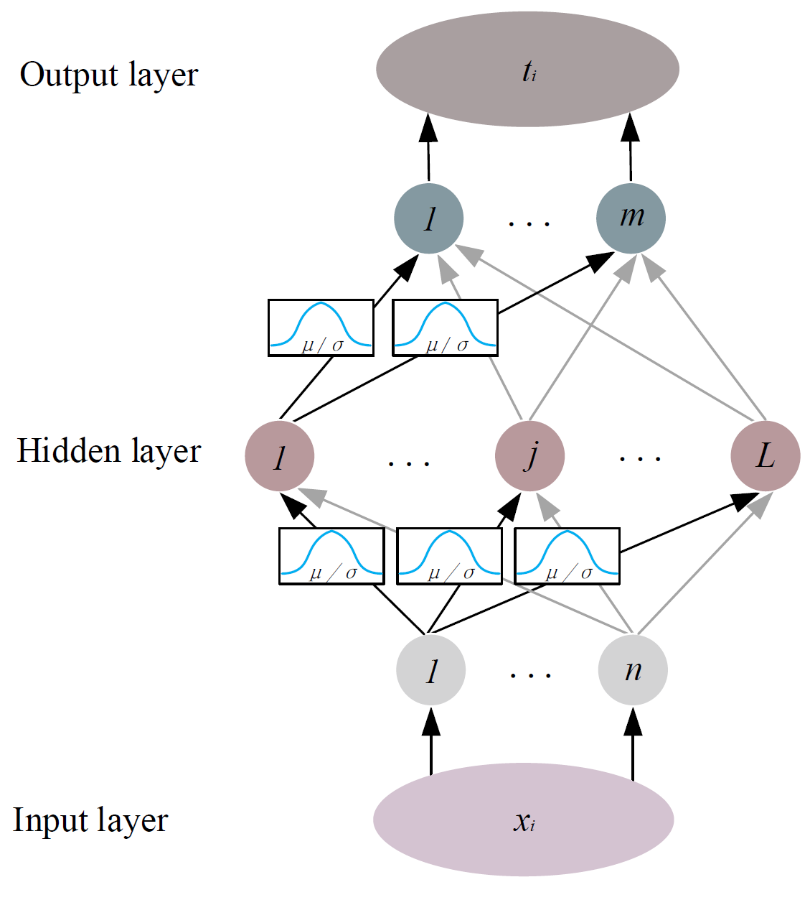
Figure 3.2 Architecture of BNN model
BNN has the potential to combine the scalability, flexibility, and predictive performance of neural networks with principled Bayesian uncertainty modelling. With a joint prior distribution on the network parameters, the joint posterior distribution of the network parameters will be kept updated after observing a set of training data. With the calculated posterior distribution, BNN can predict an output distribution. In the training process, the optimization of the parameters of a typical ANN is traditionally implemented with the back-propagation algorithm. The BNN is parametrized with twice the number of parameters than a typical ANN. The optimization process of the network architecture and hyper-parameters has been performed through the same steps as for the ANN, with repeated k-fold cross validation and early stopping during training.
Compared with the traditional ANN, BNN pay attention to the probability distribution of the whole parameter space. If it is found that an input variable contributes little to the output result, then the weights associated with that input will be automatically adjusted to a value close to zero during training. In BNN, through calculating the posterior probability of the weights, the weights of important inputs are automatically adjusted [53]. Therefore, BNN possesses a strong generalization ability and the advantages of automatically adjusting network parameters. Therefore, BNN can be trained using limited and noisy data, while ANN typically tends to require more training data with low noise for equivalent performance.
For the field inspection data of pipelines, measurement uncertainties and frequently updated inspection data are common. Therefore, using BNN may be an effective method for the prediction of pipeline degradation since it is suitable for dataset with high-complexity and high-dimensionality. The challenge for effectively applying BNN to pipeline degradation prediction is to choose a meaningful prior distribution over network weights because the practical effectiveness of BNN is limited by the ability to specify meaningful prior distributions and the intractability of posterior inference.

Variability Consideration in Corrosion Growth
Corrosion damage evolution models have been developed to predict either corrosion rate of a defect or corrosion defect size at a specific moment in time. To assess the corrosion rate accurately, having (at least) two measurements of the same defect taken at different time points is necessary. However, finding matched defects from two inspection runs could be challenging. To match defects, there are two common approaches: box to box (B2B) matching and signal matching [54]. B2B matching can be performed at single metal loss, child feature, and cluster levels, where a rectangular box is considered around a feature with an extra length and width (e.g., 20 mm) to account for the measurement error. If the boxes from two different ILI run overlap, the boxes are called matched, and the corresponding corrosion growth rate is calculated. In case there are multiple matches (e.g., when a box from an old ILI run overlaps with more than one box from the new ILI run), the minimum or maximum possible Growth/Corrosion Rate (GCR) can be considered based on the possible matches. In the signal matching approach, however, the signals obtained by ILI tool from consecutive inspections for every metal loss are compared and matched before converting them into feature sizes. Therefore, it is more accurate than the B2B matching but requires more expertise for analyzing the signals and inspection tools from the same ILI vendor. Otherwise, the B2B matching becomes the only option. However, considering the significantly higher uncertainty of B2B matching approach, using B2B matching for corrosion rate evaluation can result in either pipeline failure or costly and unnecessary mitigation measures [54, 55]. In addition, in some cases like pipelines subject to high internal corrosion densities matching too many individual defects is either impractical or unreliable [56]. Because of the challenges of matching defects, the defect growth models that do not necessarily require matched features can be beneficial.
Due to the typically extensive length of pipelines and the potential considerable variation in soil properties along their route, external corrosion growth model should be location dependent in addition to being time dependent. In view of this, a pipeline can be divided into multiple short-length segments and for each segment homogenous corrosion growth is then assumed (e.g., [57, 58]). On the other hand, some researchers incorporated spatial variability of the underground environment properties into the defect growth model formulation. For example, in Velázquez, Caleyo, Valor and Hallen [41], the model parameters in a power-law growth model were related to the characteristics of the soil and pipe through a multivariate regression model; however, their study assumed one constant corrosion initiation time for all defects located in different pipes for a given soil classification. Likewise, Alamilla, Espinosa-Medina and Sosa [42] incorporated different soil and environmental properties in their power function; however, they simply assumed corrosion initiation time is the same as pipeline installation time. However, these assumptions may not be accurate to represent the realistic field condition.
To tackle the spatial variability, some previous studies (e.g., [28, 59-61]) employed hierarchical (a.k.a. multilevel) Bayesian methodology to combine information from inspection data of multiple locations; the spatial variability is considered by assuming model parameters are defect specific, but they follow identical independent distributions (whose distribution parameters are called hyperparameters). This methodology also has been employed to utilize inspection information from other locations when limited measurements are available for the location of interest [59]. However, incorporating additional model parameters (i.e., hyperparameters) significantly increases the dimension of the model and computational cost [59]; therefore, it limits the application of this methodology to datasets that only have a few numbers of features [28], making this methodology impractical.
Lastly, when using inspection data for growth model development, one also should incorporate the potential measurement errors. Generally, there are different types of measurement error associated with ILI results including: false negative error (a.k.a. detection error, where ILI fails to detect an existent metal loss with a likelihood dependent on the true depth of the feature known as probability of detection), false call error (where ILI incorrectly detects a non-existent feature), reporting threshold (where only features with depth above this threshold are reported, usually 10% wall thickness), and sizing error (i.e., measurement error, the discrepancy between the actual and measured size) [28, 54, 56]. Smith, Martin, Peussner and Taylor [54] showed that probability of detection and reporting threshold have minimal effect on measured corrosion growth rate and dominant source of uncertainty comes from the sizing error. Thus, other types of error than sizing error is usually disregarded in the literature [28, 56]. The accuracy of ILI tools is usually specified by vendors as ILI performance specification. High resolution MFL tools have typically a standard measurement accuracy of ±10-15% of wall thickness at an 80% certainty level [56]. This sizing error is commonly considered as normally distributed with mean of zero (i.e., no measurement bias) and standard deviation of 7.8% of wall thickness (for ±10% of wall thickness error with 80% confidence). However, systematic bias can exist as well. For example, through a simulation study, Dann and Huyse [56] showed that even though the standard MFL ILI tool is unbiased on average over the population of features (i.e., the sizing error has a mean value of zero), the top percentiles of the measured defect depth (i.e., the largest reported values) are actually oversized. This overestimation of the actual feature depth for the top percentile measurements is also confirmed in pipeline industry.

Pipeline Maintenance and Risk Management
An effective pipeline risk management plan should achieve the balance between maintaining pipeline reliability to avoid catastrophic failures, and reducing the costs associated with inspection and repair. However, to achieve such objective is exceptionally challenging, as it involves many factors (e.g., pipeline age, pipeline design and attributes, operation condition, and history, environmental condition, maintenance and repair budget, maintenance and repair options and scheduling) and needs to consider the related uncertainties (e.g., variability in material degradation and inspection data). In addition, the cost-effectiveness of maintenance and repair actions need to be modeled appropriately, as they mitigate the risk at various degrees and their associate costs are different. Thus, the decision-making variables (e.g., the next inspection time, repair criteria) should be determined using probabilistic risk-based approaches to incorporate all relevant influencing factors and uncertainties.
Pipeline maintenance is defined as the actions taken to restore pipelines to a condition where it can fulfill their designated functions [62]. The goals of a maintenance strategy include planning maintenance efforts efficiently, enhancing equipment reliability and performance, reducing failures, controlling deterioration, ensuring safe and proper operation, and optimizing operational costs while maintaining a satisfactory level required by safety. Maintenance strategies can be classified into four types: corrective, preventive, predictive, and proactive, as illustrated in Figure 3.3 [63].
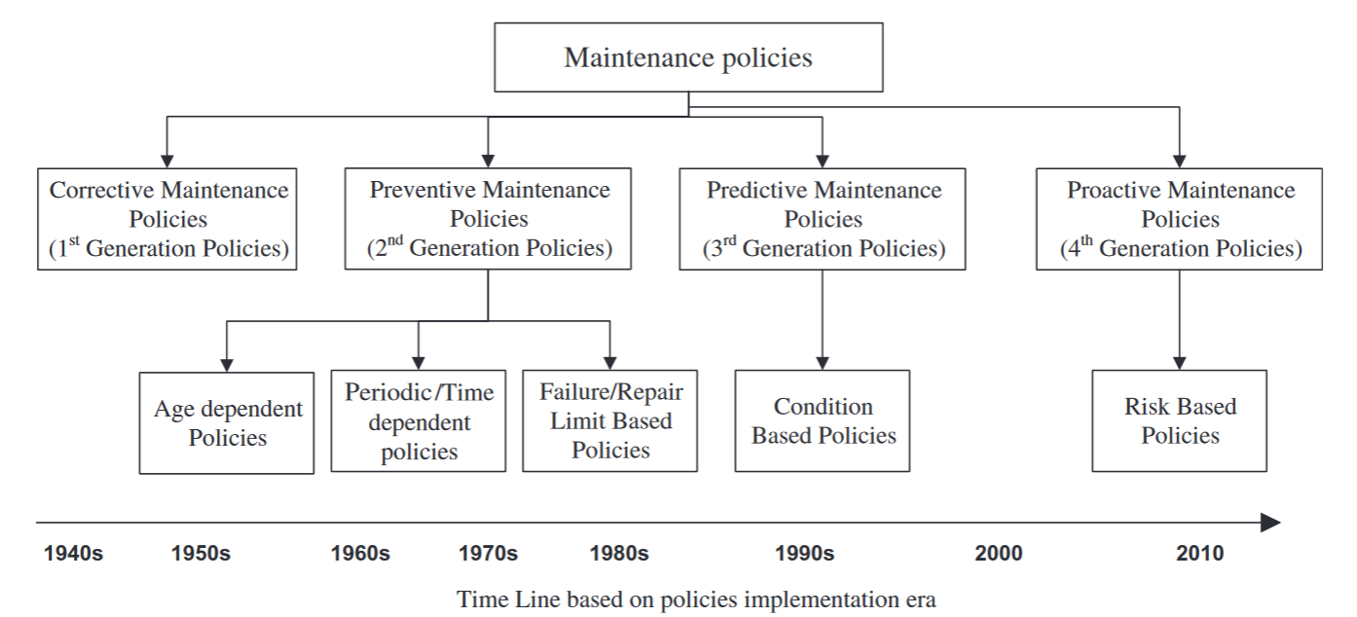
Figure 3.3 Evolution of maintenance policies from 1940 to present
In the first phase, corrective maintenance is a reactive policy that fix it after a failure event. In the second phase, preventative maintenance focused on using actions to reduce failure occurrences. Further to this strategy, predictive maintenance approach has been developed. It is a condition-based strategy that maintenance decisions were made based on monitored pipeline conditions. Once the pipeline segment reaches a predefined threshold, the maintenance will be conducted. Recently, risk-based proactive maintenance has been recognized as the most adaptive approach. It aims to avoid failure and mitigate the causes before the failure happens by emphasizing on high consequences causes, areas and more vulnerable parts of an infrastructure. The detailed descriptions of these four phases are elaborated in the following.

Corrective maintenance
Corrective maintenance (CM) is initially seen as cost-effective since it involves fixing equipment after a failure. However, for oil and gas pipelines, CM is not acceptable due to the regulatory requirements, as well as the consequence of an incident on people and environment and the resulted significant financial impacts. Repairing offshore pipelines, for example, is particularly difficult, expensive, and time-consuming, often taking weeks to months.

Preventive maintenance
Preventive maintenance (PM) is the periodic repair or replacement of pipelines while they are in service before failure. These policies are based on scientific data analysis. Most PM practices rely on experiences and original equipment manufacturer recommendations. Therefore, optimization methods are usually introduced in PM to make consistent decisions based on pipeline age, service time, and number of repairs or breakdowns. It aims to find the optimal start time and intervals between two preventive maintenances.

Condition-based maintenance
Condition-based maintenance (CBM) is the improvement of traditional preventive maintenance. CBM assumes that a system subjects to a random deterioration process and its main objective is to perform timely condition assessment to decide the timing of maintenance and reduce life-cycle costs [64]. The condition of infrastructure is monitored through field inspection at regular intervals for future maintenance decisions [65]. This approach is cost-effective as it facilitates better planning of maintenance activities and prevents unexpected failure. The cost saving depends on inspection intervals and critical replacement threshold values.

Risk-based maintenance
Pipeline risk management requires timely preventative maintenance strategies, which can be broadly divided into time-based maintenance and condition-based maintenance (CBM). Many studies have shown that CBM is a much more cost-effective approach to maintain reliability and reducing its catastrophic consequences and management costs [66, 67]. To optimize decision variables in CBM, one could set one or multiple objectives in terms of cost, service life, and reliability. For example, Liu, Zheng, Fu, Ji and Chen [68] developed the optimum inspection based on the utility of inspection information with consideration of the attitude and preferences of decision makers toward the inspection outcome. Li, Baji and Yang [69] optimized the number of inspection actions and critical damage level at which repair is performed, using the total expected cost in a given lifetime as the objective function. Abubakirov, Yang and Khakzad [70] formed a utility function by combining both the annual cost of inspection program and the risk (calculated as the product of probability of failure and the cost of failure) to determine the optimal inspection interval. Kim, Ge and Frangopol [71] determined maintenance planning by performing multi-objective optimization to minimize both the expected maintenance delay and total inspection cost for fatigue-sensitive structures. However, few studies have focused on risk management using ILI inspection data. In addition, the optimization in the previous studies typically involves heavy simulation to consider all the possible events and uncertainty in the damage evaluation.
Risk management is a systematic approach to characterize the possible risk to existing systems, decrease the probability of harmful events and reduce the harmful consequences of the occurred events [72]. A typical risk assessment model begins with hazard identification followed by the modelling of causes, estimation of the likelihood of effects and estimation of impacts using qualitative, quantitative or semi-quantitative methods. Risk models estimate absolute and relative risk, major risk contributors, and compare risk factors. Stages of risk analysis are hazard analysis, consequence estimation, likelihood estimation, risk estimation, risk acceptance criteria and maintenance planning. Risk-based maintenance (RBM) is an advanced approach to pipeline integrity management and can be considered as an extension of CBM. The basic difference between CBM and RBM is that decisions mainly focus on the condition of equipment whereas the latter considers the risk of failure.
Risk-based maintenance is a need-based strategy to prioritize an inspection and maintenance plan based on risk ranking; it helps managers to execute informed testing and inspection without affecting public safety [73]. High-risk pipeline segments should be inspected more frequently. The priority of risk-based maintenance for a pipeline is determined by the likelihood of failure and consequence of failure [74]. Reliability standards are set as a function of time and compared with reliability levels while taking maintenance decisions [75].
The general process of risk assessment can be seen in Figure 3.4 [76]. In the figure, qualitative techniques identify the hazards and model the cause and effect. Their output is a qualitative ranking for the recommendations about hazard identification and control. While quantitative techniques are usually used to estimate the likelihood and the impact.
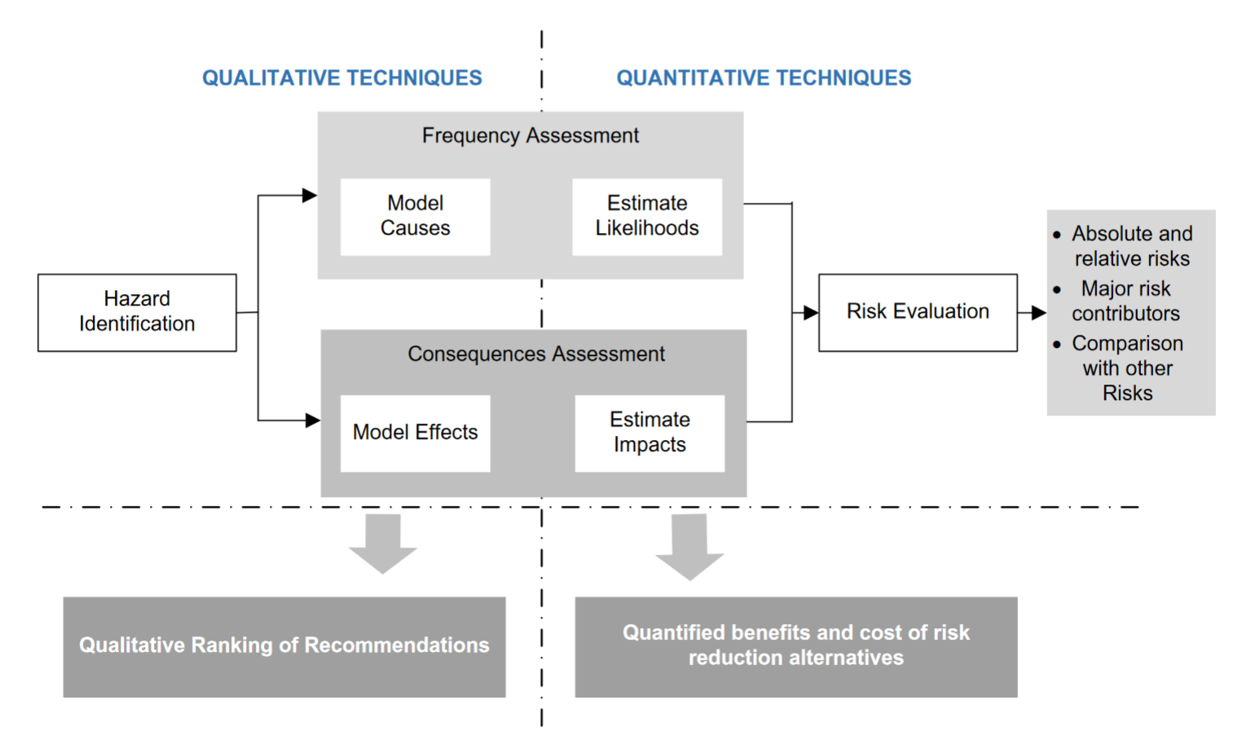
Figure 3.4 General process of risk assessment
Given there are many maintenance strategies that can be applied to pipeline systems, the comparison of them is shown in Table 3.1.
Table 3.1 Comparison among different maintenance strategies of pipelines
Maintenance strategies |  | Pros | Cons
Corrective maintenance |  | - Less cost of inspection | - Long downtime due to failure
Preventative maintenance |  | - Reduction in production loss | -Subjective decisions
Condition-based maintenance |  | - Real-time assessment of pipelines | - High inspection cost  - Uncertainties of inspection  - Challenges for determining the inspection intervals
Risk-based maintenance | Dynamic Bayesian Network | - Good at probability inference and handling uncertainty | - Complexity in modeling  -  Dependent on data quality
Risk-based maintenance | Discrete event simulation | - Can consider pipeline unavailability effect | - Hard to capture continuous degradation processes  - Not suitable for large and complex pipeline networks
Risk-based maintenance | Heuristically genetic algorithm | - Can handle multi-stage defects  - Global search capability | - Highly dependent on model parameters  -Specific knowledge required
Risk-based maintenance | Non-dominated sorting genetic algorithm II (NSGA II) | - Can handle multi-objective problems  - Can consider effects of different maintenance methods | - Large computation cost  - Not suitable for dynamic environments

Application of AI for Decision Making
With the recent advances of AI tools, one could utilize AI to deal with the computation demand in this sequential decision-making problem where the maintenance decisions have a persistent dynamic influence that impacts the current and future performance of the pipeline. Very few has explored the application of AI tools in the infrastructure integrity management. Haladuick and Dann Markus [77] utilized genetic algorithms to seek the optimal repair time for corrosion defect in pipeline, where the objective function is the expected utility that equal to the expected benefit minus all the expected costs over its lifetime.
Decision-making is an important part of pipeline integrity management. Reinforcement Learning (RL) is an approach of using AI for solving complex and sequential decision-making problems. In the general RL setting, a decision-maker (often called agent) interacts with an uncertain environment to achieve a goal. The environment is influenced by the agent’s actions, and the agent can observe the influence through some observation signals as well as a reward signal. The reward signal should reflect the aptness of the previous actions, and the agent learns to improve and optimize its decisions by learning from the previous rewards. The underlying assumption in all RL problems is that we can express the agent’s goal as the cumulative rewards throughout the agent-environment interaction. Therefore, RL is a promising approach to optimize pipeline maintenance strategy. The following are current applications of reinforcement learning on pipeline network and segments.
Reinforcement Learning is an AI approach associated with data-driven modeling, dealing with sequential decision-making problems under uncertainties for establishing an automated pipeline integrity management system [78]. RL has several advantages to make it suitable for reliable decision making in pipeline integrity management: (1) RL algorithms are capable of learning from historical and online data, and they may learn optimal condition-based repair as more data are collected from field inspection; (2) while most maintenance actions tend to induce delayed indications of efficiency that complicates the optimization in pipeline integrity management, RL algorithms are able of analyzing the consequence of delayed maintenance actions; (3) RL algorithms can interact and learn in a stochastic environment, such as unpredictable soil environmental and operating conditions of pipeline; (4) more importantly, RL could significantly reduce the time-consuming simulation involved in the typical decision-making optimization and facility autonomous implementation. In this regard, Mahmoodzadeh, Wu, Droguett and Mosleh [79] investigated the potential of deploying RL to the maintenance planning of dry gas pipelines considering uniform and pitting corrosion, where the results indicated that the proposed condition-based maintenance scheduler could reduce up to 58% of maintenance costs as compared to a periodic maintenance policy and better ensure pipeline reliability.
Kerkkamp, Bukhsh, Zhang and Jansen [80] proposed a novel Deep Reinforcement Learning (DRL) framework based on Graph Convolutional Networks (GCN) to perform grouping maintenance actions based on underground sewer pipeline network. They chose a subset of 942 pipes for evaluation of the DRL framework. The available features for each pipe included geographical location, material, length, and age. The geographical location of the pipes was used to construct the distance function. The DRL agent receives, at each time step, a representation of the network state from a simulated environment and uses the GCN to select the next action to take based on this state (i.e., which pipes to maintain/replace). It then applies the action to the environment and receives the next state and a reward to evaluate the action taken. The interaction between the DRL agent and the environment is depicted in Figure 3.5 [80]. The overall objective is to plan maintenance for the set of assets in a way that the assets do not deteriorate to near failure while the overall cost is minimized.
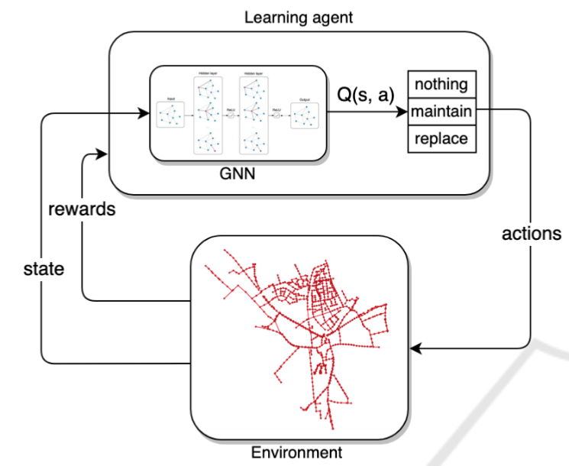
Figure 3.5 The deep reinforcement learning framework using GCN
Kongkijpipat, Sandee, Vachirapaneegul, Sumetpipat and Vatiwutipong [81] combined Deep Q-learning and epsilon-greedy policy to develop the pipeline maintenance scheduling system. The method is separated into two main parts according to the RL algorithm. First, the RL environment is created for test bench, and the state and reward are defined. Test bench consists of a pipeline environment simulation, corrosion simulation, and reliability model for calculating damage in a pipeline. In each simulation episode, a stochastic environment creates a pipeline system; then, the corrosion occurs in the system in each day. After that, at the end of each month, the agent will check whether it has any damage or not, and the agent will choose the action from its policy that can be estimated by Q-learning algorithm until the simulation is ended. Thereafter, the program will loop more episodes until it reaches the assigned number of episodes. This workflow is shown in Figure 3.6 [81].
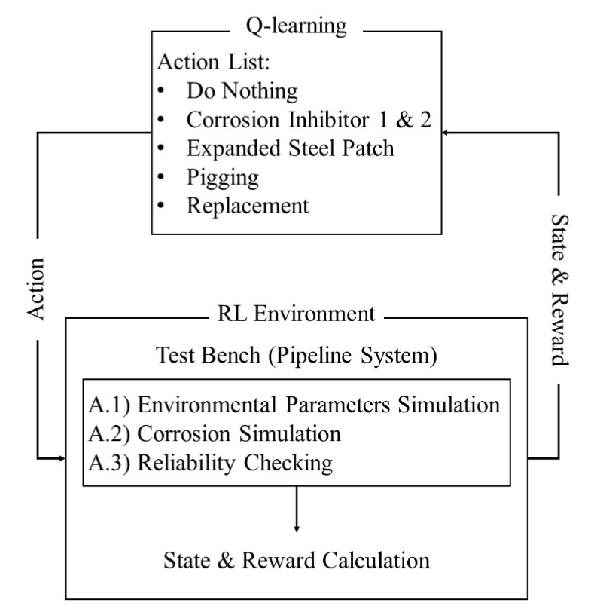
Figure 3.6 Deep Q-learning framework for pipeline maintenance

Data Collection from Industry

First Dataset from Pipeline Operator
The first dataset is for a 12-mile transmission pipeline that was originally built in 1974. Based on the history of replacements and relocations, the pipeline was divided into several segments (a-g), as listed in Table 4.1. The ILI data for this pipeline are obtained from magnetic flux leakage (MFL) inspections in 2005, 2012 and 2016, respectively. The external corrosion defects were selected for analysis since it is the major defect observed. The magnetic MFL tool provides measurements of wall thickness and metal loss depth/length/orientation. The count of corrosion defects from three inspections is shown in Table 4.2. The total number of external corrosions increases from 2005 to 2016 due to the generation of new defects.
Table 4.1 General information about the pipeline
Line segment No. | Length (feet) | Outer diameter (in.) | Wall thickness (in.) | Pipe grade | Year installed
a | 51,241 | 30 | 0.562 | 5L×42 | 1974
b | 613 | 24 | 0.438 | 5L×42 | 1974
c | 772 | 20 | 0.375 | 5L×42 | 1982
d | 5,910 | 30 | 0.562 | 5L×60 | 2005
e | 1,698 | 30 | 0.562 | 5L×60 | 2005
f | 41 | 6.625 | 0.28 | 5L×42 | 1974
g | 654 | 30 | 0.562 | 5L×42 | 2002

Table 4.2 Number of external corrosion defects found in different inspection years
Inspection year | Defects count no.
2005 | 792
2012 | 1345
2016 | 2508

The pipeline consisted of 1,955 girth welds in total. Corrosions did not occur in every segment of all girth weld numbers. Therefore, only the girth weld numbers with corrosion defects were extracted from the ILI dataset. From 2005 to 2016, about 400 pipe segments indicated by the girth weld numbers showed external corrosion. Each record of ILI included girth weld number, absolute distance, peak depth, length and orientation.
To compare the distribution of corrosion defects, the number of these defects in each girth weld number along the pipeline was counted, as shown in Figure 4.1. Each girth weld represents 30-40 ft pipe length. As expected, the numbers of corrosion defects in different segments were found greater in 2016 as compared to the previous two inspections, which is consistent with the change in total number of defects. The increase of corrosion defects around several pipe segments (indicated by girth weld numbers) was found more significant, indicating the environment for high corrosion potential. However, the soil survey data was not available along the pipeline.
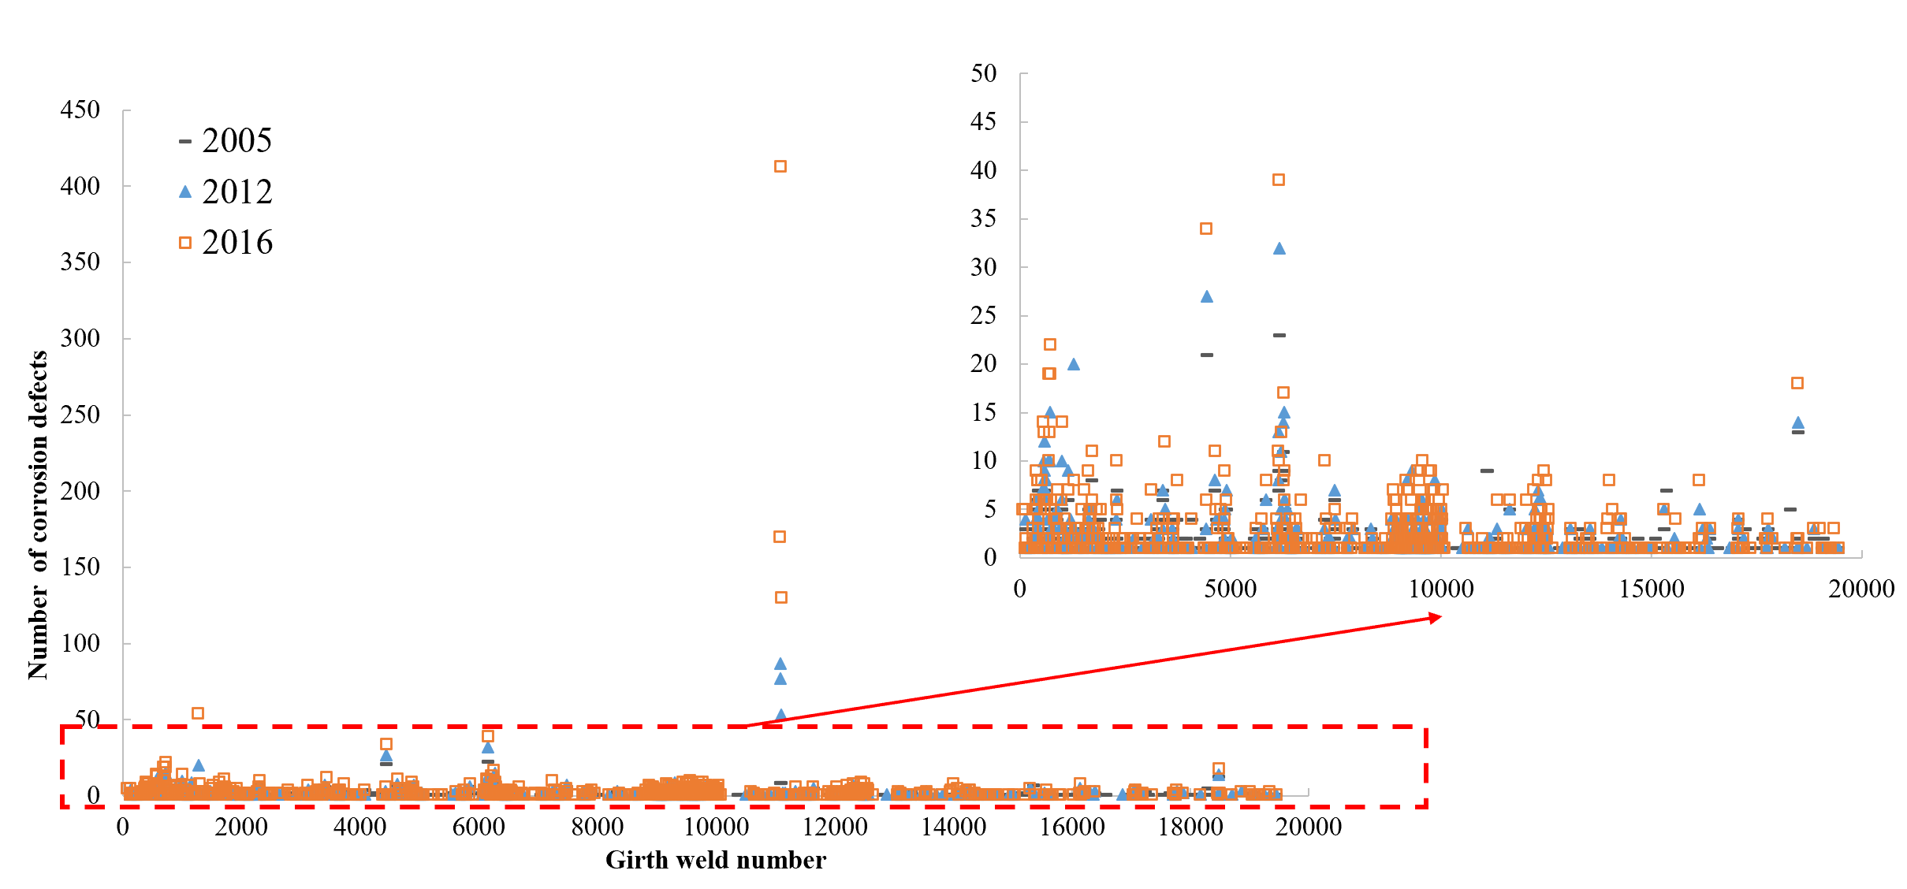
Figure 4.1 Number of external corrosion defects along the pipeline in different inspection years
To better understand of the severity level, all the corrosion defects were analyzed using k-means clustering based on defect depth and length. In the same cluster, the characteristics of defect depth and length are more similar than those in other clusters. The clustering results are shown in Figure 4.2, and the number of defects is listed in Table 4.3. The results show that the corrosion defects can be divided into four clusters along the length of pipeline, which indicates the potential impact of soil environment on external corrosion assuming the same CP level and coating condition. The number of defects in each cluster tends to increase over the years, and this trend is the most significant in cluster 3.
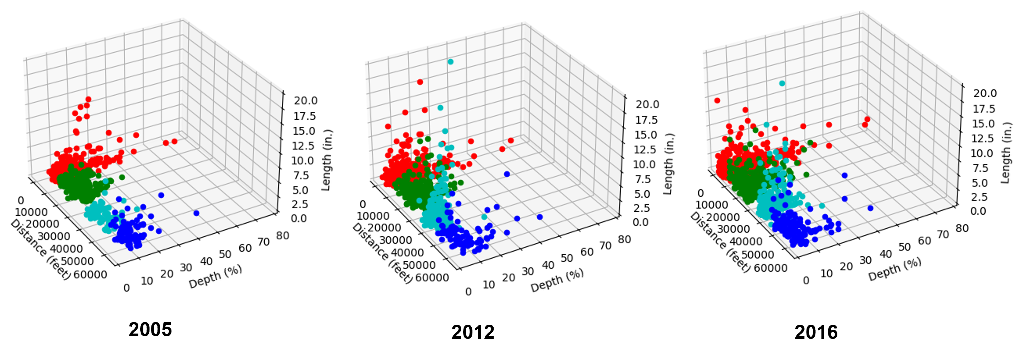
Figure 4.2 Clustering plot of corrosion defects in different inspection years
Table 4.3 Number of external corrosion defects in different clusters
Cluster | Inspection year
Cluster | 2005 | 2012 | 2016
1 | 273 | 376 | 588
2 | 306 | 331 | 426
3 | 124 | 535 | 1332
4 | 89 | 103 | 162

Furthermore, statistical analysis was performed on the original dataset to compare corrosion depth that is represented by the percent of wall thickness. In addition to the number of defects increased from 2005 to 2016 (as shown in Table 4.3), the generation of large numbers of small corrosion defects was found in 2012 and 2016. In addition, the decrease of corrosion depth from 2005 to 2016 may be attributed to the repairs of pipelines.
Ideally, the corrosion depth would increase over the years if no repair is placed. However, this trend was not observed at each inspection location. The variations can be caused by the changes in measurement accuracy and reporting criteria of ILI tools and the advances in technology in different inspections. Another reason of causing this variation is the mismatch of absolute distance from different inspections. Therefore, the original dataset was processed to obtain reasonable subsets for further analysis.

Second Dataset from Pipeline Operator
The second dataset is for a transmission pipeline made of grade X52 steel, with a total length of 112 km. The outside diameter of 457.2 mm and the wall thickness is 6.4 mm. It has been in service since 1969. ILI inspections were conducted using MLF technology in 2005 and straight beam ultrasound technology in 2010. During the inspections, external corrosion information was collected, including corrosion depth (in mm), and corrosion length (in mm). However, data on the pipeline coating condition was not available.
Figure 4.3 presents the corrosion depth and corrosion length based on ILI data collected in 2005 and 2010. It is worth noting that some pipeline segments were replaced between 2001 and 2005, during which initial corrosion may have occurred. These early defects with material loss (corrosion depth) and corrosion length were detected in the 2005 inspection but not in the 2010 data. One possible reason is that the 2010 inspection was not performed for these segments. However, the 2005 data were included in the analysis to fully reflect the effect of soil environment on corrosion defects.

(a)

(b)
Figure 4.3 Scatter plot of pipe damage along the length of the pipeline for the original dataset (a) corrosion depth, (b) corrosion length
Defect observations from two inspections were matched by zone in the original dataset and reorganized to create the zone-based dataset. To investigate the impact of soil properties on defect propagation, the most representative defect in each zone was included in this dataset. First, the dataset was preprocessed by removing the samples with missing values in the inspection data either in 2005 or 2010 or both. Then, the dataset was structured by grouping defect observations based on Zone-ID and inspection year. In each group, the defect with the maximum corrosion depth was selected as the representative defect for that zone. However, the defect with the maximum depth does not necessarily have the maximum length in the same zone. Therefore, future work should consider both corrosion depth and length in selection of most critical defects at each zone. By using this method, 511 samples representing the most severe defects in different zones and inspection years were extracted as the zone-based dataset. Figure 4.4 shows a scatter plot of corrosion defects along the pipeline length in this zone-based dataset.
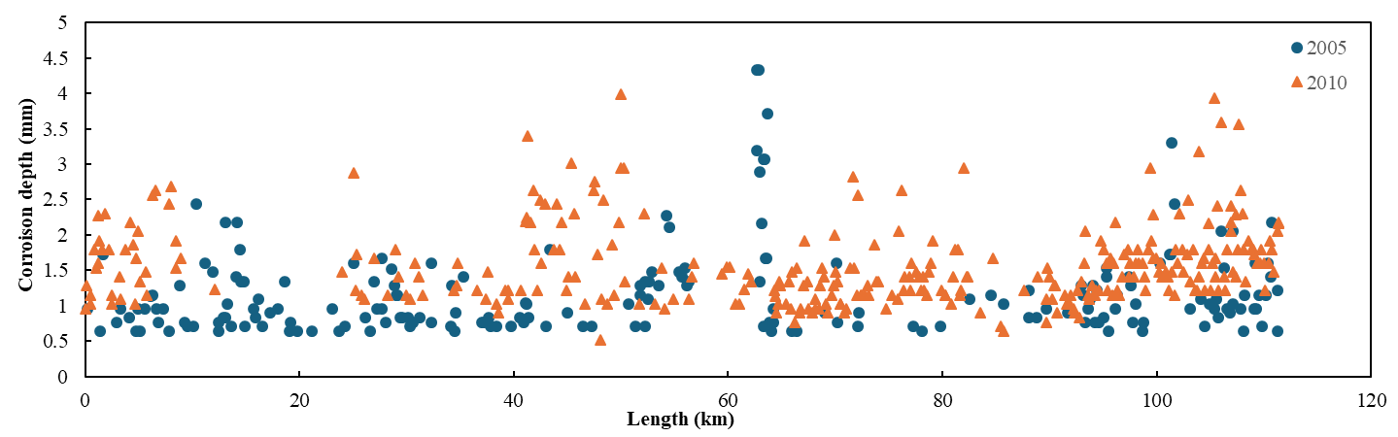
(a)
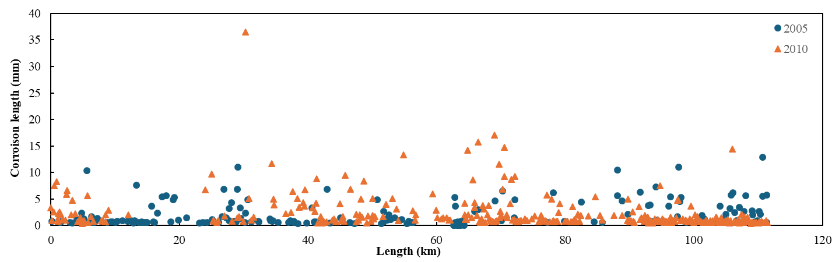
(b)
Figure 4.4 Scatter plot of corrosion defects along pipeline length for the zone-based dataset (a) corrosion depth, (b) corrosion length
External corrosion is influenced by various soil parameters, including moisture content, resistivity, pH, aeration, and bacterial activity. A soil survey conducted in 2012 at intervals of 200 meters along the pipeline (defined as one zone) measured several properties, including Eh (soil redox potential), resistance, resistivity, pH, CO₃²⁻ concentration, HCO₃⁻ concentration, Cl⁻ concentration, SO₄²⁻ concentration, soil moisture, and soil type. There are totally 559 soil zones with different soil properties, moisture contents, and soil types. Soil redox potential indicates soil overall oxidizing or reducing capacity. Soil resistance indicates the capability of providing safe path for fault current, and the soil with high resistance tends to provide unsafe path for fault current and increase the risk of equipment failure. Soil resistivity reflects the soil capacity to resist electric current, and the lower resistivity may imply salty groundwater. It is noted that the soil type number (1-10) was used to represent typical soil groups, such as clay, sandy, silty, peaty, chalky, loamy, etc., but the specific soil type for each number was not known. Table 4.4 presents the statistical summary of soil survey data.
Table 4.4 Summary of soil survey data
Soil Parameters | Min. | 25% percentile | Median | 75% percentile | Max. | Mean | Std.
Potential Redox¹ (mV) | -595 | -506 | -461 | -411 | -150 | -455 | 64
Calculated electrode potential² (mV) | -443 | -357 | -314 | -287 | -120 | -317 | 56
Eh (mV) | -395 | -306 | -261 | -211 | 50 | -255 | 64
Resistance @ 1m (Ω) | 0.89 | 3.2 | 9.2 | 23 | 490 | 29.1 | 57
Resistance @ 2m (Ω) | 0.32 | 1.6 | 3.9 | 11 | 180 | 12.8 | 25
Resistivity @ 1m (Ωcm) | 559 | 2011 | 5781 | 14451 | 307876 | 18310 | 35871
Resistivity @ 2m (Ωcm) | -1530 | 2285 | 5495 | 18490 | 447677 | 21310 | 44536
pH | 2.03 | 4.86 | 5.31 | 6.03 | 7.49 | 5.35 | 0.95
CO₃²⁻ (mol/L) | 0.00 | 0.00 | 0.86 | 1.55 | 3.44 | 0.87 | 0.80
HCO₃⁻ (mol/L) | -1.38 | 1.50 | 2.50 | 3.47 | 15.91 | 2.76 | 1.88
Cl⁻ (mol/L) | 0.75 | 2.25 | 3.00 | 3.75 | 32.00 | 3.17 | 1.85
SO₄²⁻ (mol/L) | 0.04 | 0.04 | 0.06 | 0.09 | 2.81 | 0.10 | 0.19
Soil Moisture | 0.2366 | 0.2666 | 0.2743 | 0.2803 | 0.2846 | 0.2710 | 0.0119
Soil Type³ | 1 | - | 5 | - | 10 | - | -
- Potential Redox = Eh – 200mv
- Calculated electrode potential is theoretical value based on a set of standard conditions
3. Categorical parameter

Probabilistic Modeling of Pipeline Corrosion Growth

Data Analytics of Pipeline Corrosion Defects

5.1.1 Analysis methodology
In this study, the agglomerative algorithm was used to analyze clustering of corrosion defects. It can determine the potential overlap between observations of each cluster by measuring the distance between them. Smaller distance indicates higher overlap. Therefore, the clustering algorithm merges the two clusters with the shortest distance between them to construct the clustering tree. Measurements of distance between clusters can be conducted through different methods, such as single, complete, centroid, average and ward linkages. Single linkage clustering calculates the distance between two clusters as the shortest distance between any two data points in each cluster. In contrast, complete linkage clustering uses the maximum distance between any two data points in each cluster. Average linkage clustering calculates the average distance between all pairs of data points in each cluster. Centroid linkage clustering calculates the distance between the centroids of each cluster. These linkage methods may be sensitive to anomalous data points and easy to generate unreasonable clustering. However, data points of corrosion defects have many outliers. Therefore, ward linkage was used in this study. Ward linkage can minimize the loss of combining clusters each time. It calculates the Error Sum of Squares (ESS) of each cluster. Small ESS value means agglomerative data points. Therefore, clusters can be combined to fewer clusters by minimizing the increase of ESS.
To find the relationship between defect location parameters and severity levels, different machine learning methods were used, including k-nearest neighbors (KNN), support vector machine (SVM), random forest (RF), and light gradient boosting machine (LightGBM). KNN is a supervised learning method proposed by Fix and Hodges [82]. In classification, an unlabeled data point will be assigned to the label that is most found among the k-nearest training data points from the target data point. Therefore, the selection of cluster value and measurement of distance are important for KNN. SVM is initially a binary classification approach which is aimed to construct an optimal separation hyperplane [83]. The hyperplane has the maximum distance from the nearest sample points (called support vector) on both sides. Therefore, SVM can balance the learning ability and the complexity of the model. By means of kernel functions, SVM is capable of mapping data from a low-dimensional space to a higher-dimensional space. There are three commonly used kernel functions, including the linear kernel, polynomial kernel and radial basis function (RBF) kernel [84]. RF was proposed to solve classification, clustering, and prediction problems. It is a decision tree-based machine learning algorithm evolved from the bagging ensemble learning. Firstly, a decision tree consisting of multiple independent forests is randomly generated. Then, features are selected by calculating the information gain. From the root node, the tree is split according to the feature partitioning condition and the principle of minimum node purity until the rule is satisfied. Usually, information entropy is used to measure the purity of data [85]. Different from the single decision tree method, Random Forest randomly selects subsamples from the original dataset with put-back. And then it will train a single decision tree with randomly selected features. The optimal features are chosen from these k features to split the nodes. After that, decision trees can be constructed by repeating the above process multiple times. The final prediction result is a weighted average of each decision tree. LightGBM is a boosting tree algorithm in the ensemble learning [86]. It utilizes a leaf-wise approach to select the best split, allowing it to identify the leaf node with the highest split gain out of all the leaf nodes in the decision tree. LightGBM optimizes training data points based on the gradient of each data point. Data point with larger gradient means larger contributions to the information gain. The algorithm employs a histogram-based method to convert continuous feature values into k integers, thereby allowing for the creation of a histogram with a width of k. Subsequently, the algorithm will iterate through the training data to compute the cumulative statistics for each discrete value present in the histogram. In this case, only discrete values of the sorted histogram are required to be traversed when choosing the splitting point of feature. Therefore, LightGBM can decrease the computation cost significantly.
For binary classification, accuracy, precision, recall and F1 score are usually used to evaluate model performance. Accuracy, as defined by Baldi, Brunak, Chauvin, Andersen and Nielsen [87], is the proportion of correctly classified samples in the testing dataset out of all the samples. Precision, on the other hand, is the percentage of true positive samples among all the predicted positive samples. Recall is the percentage of truly predicted positive samples out of all truly positive samples. F1 score is a balanced score that combines precision and recall. These metrics can be calculated as shown in Eq. (5.1) to (5.4) [88].
(5.1)
(5.2)
(5.3)
(5.4)
where, TP represents number of positive samples correctly predicted as positive; TN represents number of negative samples correctly predicted as negative; FP is number of negative samples incorrectly predicted as positive; FN is number of positive samples incorrectly predicted as negative.
For multi-classification, it can be regarded as multiple binary classifications. Therefore, average value of them can be used to evaluate the model performance. In this study, weighted F1 score was calculated, because it takes into account the importance of different categories [89].
Gumbel distribution is useful in fitting the distribution of extreme values. Since maximum corrosion depth is the extreme value, Gumbel distribution was selected to fit corrosion depth data. Gumbel distribution is derived from the extreme value theory that developed by Fisher and Tippett [90]. The probability distribution function of the maximum value for each sample converges to the generalized extreme value (GEV) distribution. Gumbel distribution is a special form of GEV distribution, as expressed in Eq. (5.5) [91].
(5.5)
where, G_{t}(z) is the density when the maximum corrosion depth is equal to z; and z is the maximum corrosion depth in this study; μ is the location parameter; σ is the scale parameter; and t is the inspection year.
Weibull distribution is a non-stationary distribution that follows Cole’s method [92]. It is usually used to model reliability. Weibull distributions can model right-skewed data, left-skewed data, or symmetric data [93]. In this study, corrosion number density is an index that reflects the number of defects per unit distance. In different segments, the number density has a large difference. Corrosion number density below 5 was the most, leading to left-skewed ILI data. In this case, Weibull distribution can be of great help. The expression of Weibull distribution is shown in Eq. (5.6) [91].
(5.6)
where, W_{t}(x) is the density when the corrosion number density is equal to x; and x is the corrosion number density; ξ is the shape parameter; σ is the scale parameter; and t is the inspection year.

5.1.2 Interaction of adjacent defects
To compare the distribution of corrosion defects, the number of defects in each girth weld number along the pipeline was counted, as shown in Figure 5.1. Each girth weld represents 30-40 feet pipe length. It can be seen that the average number of defects increased from 2005 to 2016, which is consistent with the change in total number of defects. In addition, the increase of corrosion defects within several pipe segments (indicated by girth weld numbers) was found to be more significant. For example, the number of defects in the pipe segment around girth weld number 11080 was 9 in 2005. However, it increased to 77 and 170 in 2012 and 2016, respectively, indicating the soil environment in these segments for high corrosion potential. However, the soil survey data and the information on CP levels and coating conditions are not available to analyze their contributions on corrosion defects.
(a)

(b)
Figure 5.1 Number of defects from 2005 to 2016 in (a) scatter plot, (b) boxplot
The comparison of corrosion depth was based on peak depth in each girth weld number. The peak depth is defined as the maximum depth of the corrosion divided by the wall thickness at the location of the corrosion. Therefore, the larger peak depth means more severe corrosion conditions. The peak corrosion depths along the pipeline are plotted using scatter plots in Figure 5.2(a); while the box plots in Figure 5.2(b) show the spread of data range using a box with the boundaries of 25th and 75th percentile in addition to the median in the middle. Interestingly, the average corrosion depth was observed to decrease from 2005 to 2016. This is reasonable because there were a lot of small corrosion defects generated in 2012 and 2016, which reduced the average depth. However, the average corrosion depth is not suitable to analyze the failure risk of pipeline since failure would happen at the location having the highest pitting corrosion depth. Ideally, the corrosion depth would increase over years if no repair is done. However, this trend was not observed at each inspection location. The variations can be caused by the changes in instrument performance of ILI tools and the maintenance or repair activities between different inspections. However, information of these changes was not available in this study. Therefore, establishing the corrosion depth growth model based on raw ILI data was not suitable.

(a)
(b)
Figure 5.2 Corrosion depth from 2005 to 2016 in (a) scatter plot, (b) boxplot
For the localized segment, corrosion depth presented certain increasing trend. As shown in Fig. 5.2(a), the corrosion depths were the most severe around the distance of 4500-5000 feet. Therefore, 2D contours of the peak corrosion depth were plotted in these segments, as shown in Figure 5.3. In Figure 5.3, x-axis was the absolute distance to the original location; y-axis was the orientation degree in the circumferential direction. For example, 0° and 360° represented the top of pipeline, while 180° denoted the bottom of pipeline. It shows that the area of maximum peak depth increased a lot in 2016, compared to 2005. In addition, it was found that maximum peak corrosion depths were located at around 4600 and 4800 feet with circumferential degrees of 150°-200°.
(a)
(b)
(c)
Figure 5.3 2D contour plot of peak corrosion depth from ILI in (a) 2005, (b) 2012, (c) 2016
To have better understanding of the corrosion distribution, the density plots of axial and circumferential locations of corrosion defects were shown in Figure 5.4. It was found that external corrosions were more likely to occur at 10 and 30 feet relative to the pipeline girth weld joint. The circumferential degree was mainly around 180°, indicating external corrosion tended to happen at the bottom of steel pipe.

Figure 5.4 Density plots of (a) longitudinal locations of corrosion defects; (b) circumferential locations of corrosion defects from ILI

Classification of corrosion severity level
ILI data in 2016 was used to investigate the relationship between corrosion severity level and defect location parameters. In addition to corrosion depth, the Estimated repair factor (ERF) is defined as the ratio of maximum allowable operating pressure (MAOP) of pipeline to the safe working pressure. Both peak depth and ERF are the significant indicators about corrosion severity level. Higher peak depth and ERF indicate defects that are more dangerous. Therefore, all defects were divided into several clusters through hierarchical clustering method based on defect depth and ERF, as shown in Figure 5.5.
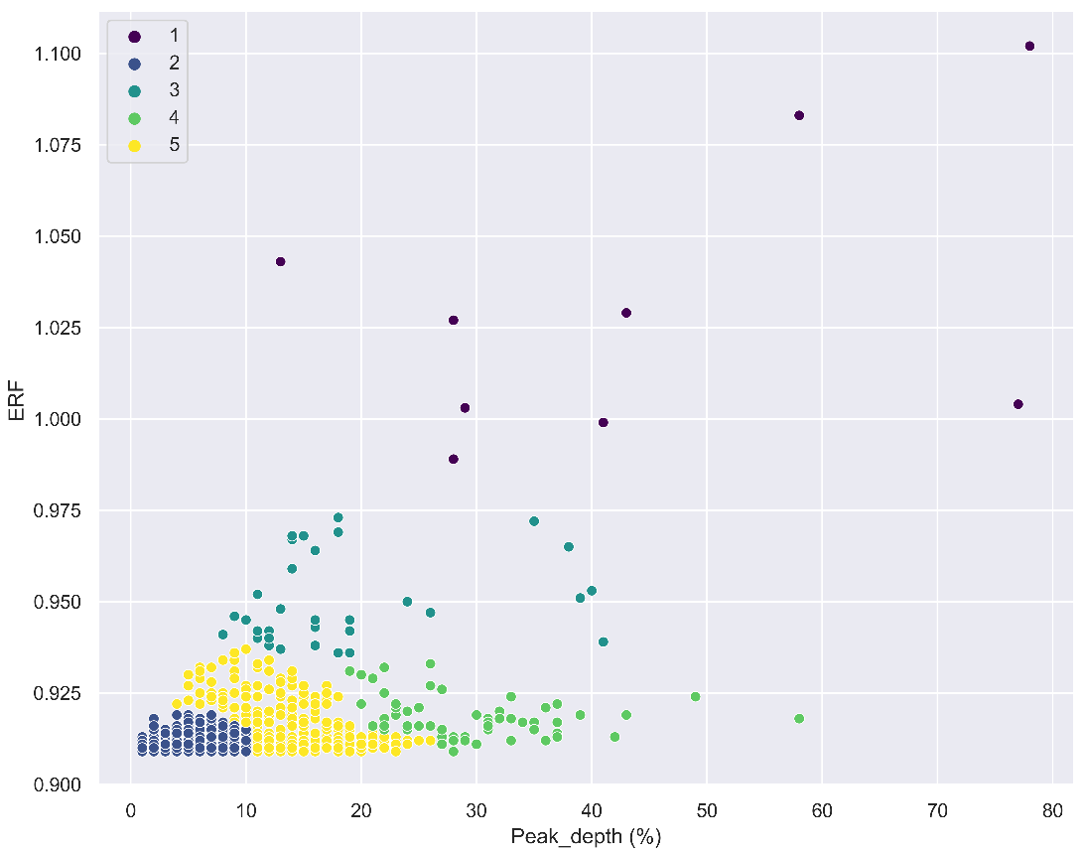
Figure 5.5 Hierarchical clustering of corrosion defects based on peak depth and ERF
To better characterize the corrosion severity level, these five clusters are merged to represent three categories. Clustering methods can capture characteristics of data distribution based on distance criteria. However, to obtain reasonable severity levels, empirical methods should also be considered. Therefore, cluster 1, cluster 3 and cluster 4 were combined to represent the highest defect level, because these clusters had the highest value in peak depth or ERF. On the other hand, cluster 5 was used to represent medium severity level and cluster 2 for the low severity level. It should be noted that the low, medium, and high severity levels here are relative in this ILI dataset.
Table 5.1 shows the classification results of severity level. From the table, it is obvious that the average value of peak depths, ERF, length and width were the most in high severity level. This is reasonable, as higher values mean higher risk of failure. Therefore, defects at high severity level should be prioritized in the maintenance scheduling. Furthermore, the geographical distribution of corrosion defects in three severity levels is plotted in Figure 5.6. Defects with high severity level were mainly found in the pipe segments at low latitudes, indicating the soil environment in low latitudes may have high corrosion potential (assuming the CP level and coating condition are similar).

Table 5.1 Classification results of corrosion severity levels
Severity level | Average value of peak depths (%) | Average ERF | Average length (in.) | Average width (in.)
Low | 4.34 | 0.910 | 1.4 | 1.7
Medium | 14.05 | 0.913 | 1.4 | 1.9
High | 27.31 | 0.937 | 3.3 | 4.8

Figure 5.6 Geographical distribution of corrosion severity levels
Relationship between corrosion location parameters and severity level
Corrosion severity level was classified based on defect depth and ERF. These two indicators are geometric parameters related to defects and do not consider the interactions between multiple defects. It has been found that interacting effect of adjacent defects may have significant impact on severity level [94, 95]. Therefore, three location parameters were selected to represent the interacting effect of adjacent defects, including OD, S_{c} and S_{L}. It noted that OD denotes the relative distance between the centroid of corrosion defect and pipeline girth weld (not the outside diameter in this specific analysis). S_{c} is the distance between two adjacent corrosion defects in the circumferential direction, while S_{L} is the distance between two adjacent corrosion defects in the longitudinal direction. Detailed illustrations of these parameters are depicted in Figure 5.7.
Figure 5.7 Illustration of location parameters on a 2D plane for one pipe segment
It should be noted that final values of OD, S_{c} and S_{L} were the minimum of upstream and downstream values. This is because the interacting effect of adjacent defects is mainly caused by the nearest ones. After obtaining location parameters, the correlation between these factors should be analyzed first to avoid co-linearity. Figure 5.8 (a) shows the correlation between each two variables. It can be observed that the scatter data points of them distributed randomly. No obvious linear or nonlinear relationship were found. From Figure 5.8 (b), correlation coefficients between each pair were also small, indicating that the co-linearity did not exist in these variables. Therefore, there is no need to reduce the dimensionality of these variables.
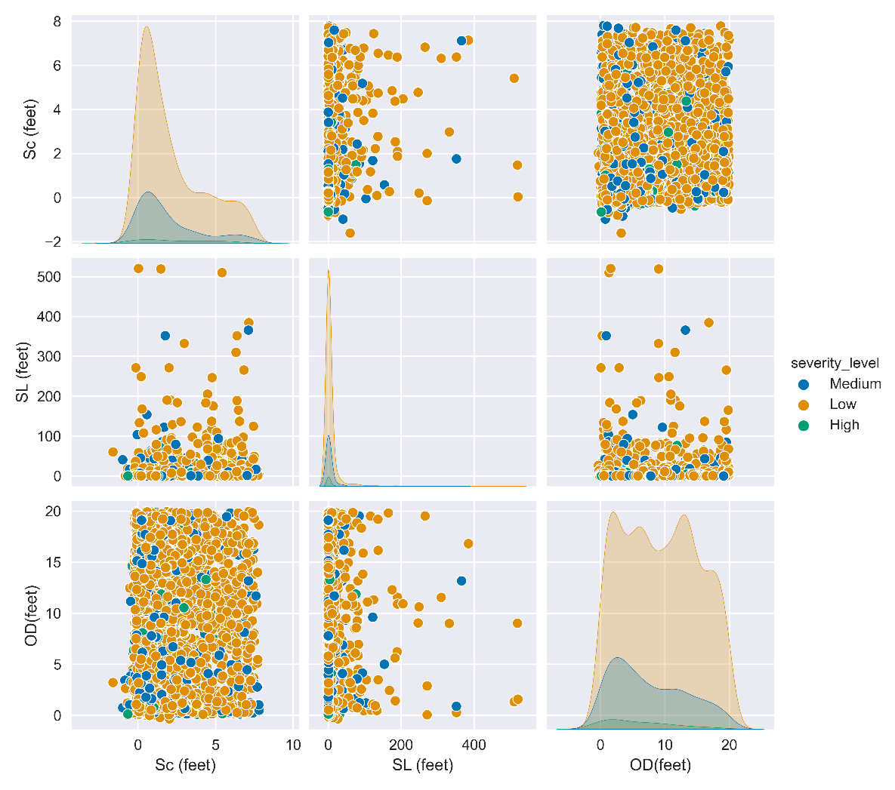
(a)

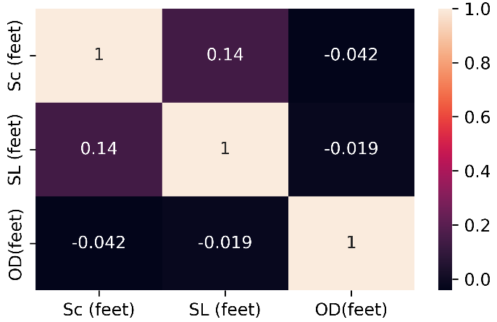
(b)
Figure 5.8 Correlation plots between three input variables: (a) scatter pair plot, (b) heat map of correlation coefficients
Machine learning methods were used to analyze the relationship between location parameters and severity of corrosion. Taking OD, S_{c} and S_{L} as the input variables and three severity levels as responses, the fitting results using four different machine learning methods (KNN, SVM, RF, LightGBM) were listed in Table 5.2. As can be seen, random forest shows the best performance among all methods.
Table 5.2 Performance of different machine learning methods
Metrics | KNN | SVM | RF | LightGBM
Accuracy | 72.71% | 74.24% | 74.83% | 74.15%
Weighted F1 | 0.67 | 0.69 | 0.71 | 0.69

The importance of three location parameters was further analyzed using random forest model. Shapley Additive Explanation (SHAP) was used to interpret the classification results. It is a method derived from coalitional game theory [96]. Initially, SHAP value is developed to evaluate the contributions from each player to the game. In the model interpretation, the prediction made by a model can be explained as the sum of the contribution or attribution values of each input variable used in the model. Therefore, the impact value of each feature can be calculated as SHAP value. A higher SHAP value indicates a more important feature.
In Figure 5.9 (a), class 0 represented the low severity level, class 1 represented the medium severity level, class 2 represented the high severity level. It can be seen that OD had the most significant impact on the classification, followed by S_{L} and S_{c}. Furthermore, positive and negative correlations between location parameters and severity level can be interpreted. As shown in Figure 5.9 (b), high feature values of OD, S_{L} and S_{c} mainly distributed in regions greater than 0. That means greater value of OD, S_{L} and S_{c} can make more defects belong to low severity level. Similarly, in Figure 5.9 (d), high feature values of OD, S_{L} and S_{c} mainly distributed in regions smaller than 0, which means smaller value of OD, S_{L} and S_{c} can make more defects belong to high severity level. When considering the location parameters OD, S_{L}, and S_{c}, smaller values of these parameters indicate a higher potential for more critical corrosion defects. A smaller value of OD implies that the corrosion defect is located closer to the pipeline girth welt joint, increasing the likelihood of a high severity issue. Similarly, smaller values of S_{L} and S_{c} indicate that the corrosion defects are located closer together in the longitudinal and circumferential directions, respectively, which can lead to a higher potential for interaction and a more severe combined effect. Therefore, smaller values of these location parameters suggest that the corrosion defects may be more critical and require closer attention.
It has been reported that severe defects were more likely to occur when adjacent defects were closer to each other [97], which is consistent with our findings.
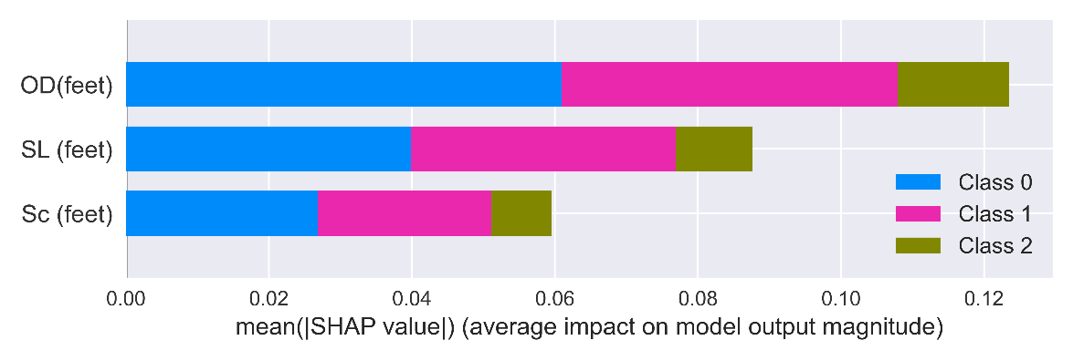
(a)
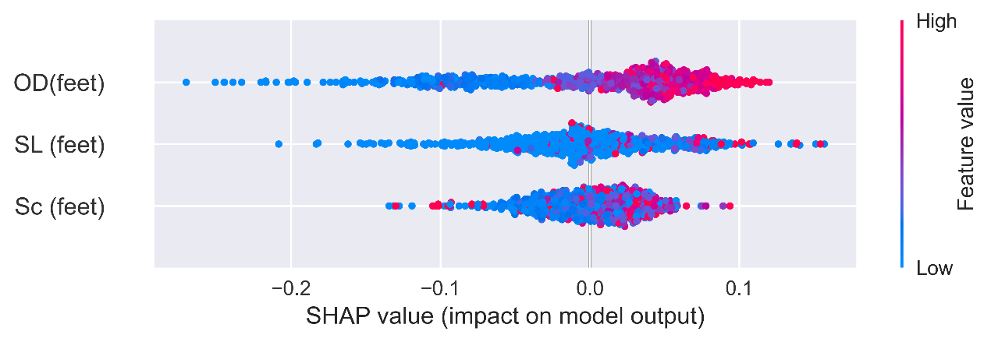
(b)
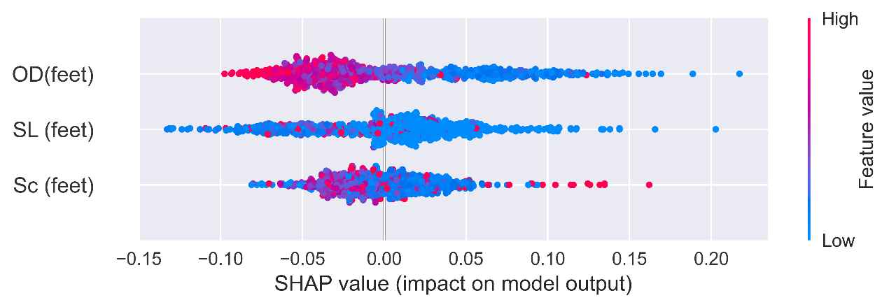
(c)
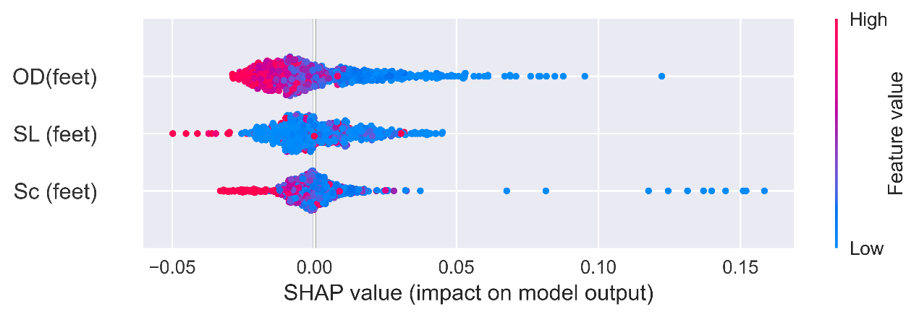
(d)
Figure 5.9 Impacts of input variables (a) importance of input variables on three severity levels; (b) impact of input variables on low severity level; (c) impact of input variables on medium severity level; (d) impact of input variables on high severity level
Maximum corrosion depth
To predict the growth of maximum corrosion depth, the raw dataset was processed to obtain the reasonable subsets for further analysis. Relative distance to the girth weld number was used to locate the defect location; For the defects at the close locations, only the data that shows the continuous growth trend of maximum corrosion depth over inspection years were selected. That means, if the maximum corrosion depth keeps growing, it can be considered that this location was most susceptible to external corrosion. This approach resulted in a smaller and more conservative data subset, which was used to analyze the growth of maximum corrosion depth. The density and box plot of the extracted data subset are shown in Figure 5.10. It shows that the maximum corrosion depth increases over time and can be used for growth prediction.
Figure 5.10 Plot of maximum corrosion depth (a) density plot, (b) boxplot
Considering that the Gumbel distribution is useful in representing the probability distribution of the maximum value in a sample, the corrosion depths in the subset were ﬁtted to the Gumbel distribution. The theoretical and empirical quantiles were compared through the histogram and Q-Q plots as shown in Figure 5.11. The data points are close between theoretical and empirical quantiles, indicating the fitted Gumbel distribution has high accuracy. The fitting parameters are shown in Table 5.3.
(a) (b)
Figure 5.11 Fitting of Gumbel Distribution in different inspection years: (a) histogram plot, (b) Q-Q plot

Table 5.3 Fitting parameters of Gumbel distributions
Inspection year | Location parameter (μ) | Scale parameter (σ)
2005 | 16.53 | 7.68
2012 | 18.83 | 7.96
2016 | 22.47 | 8.97

Using the linear regression to fit the Gumbel distribution parameters over the inspection year, the fitted line can be seen in Figure 5.12. It can be found that the location and scale parameters have an increasing trend that indicates the growth of maximum corrosion depths. The linear model can be expressed in Eq. 5.7 and 5.8. After obtaining the two parameters, the Gumbel distribution can be used to calculate the density of maximum corrosion depth at the year of interest.
μ(t)=0.5161t-1018.7 | (5.7)
σ(t)=0.1085t-210.1 | (5.8)
where, μ is the location parameter; σ is the scale parameter; and t is the inspection year.

Figure 5.12 Fitted lines of Gumbel distribution parameters (a) location parameter; (b) scale parameter with respect to inspection years

Corrosion number density
In this study, corrosion number density denotes the number of defects per unit distance. Therefore, the number of corrosion defects in each segment of girth weld was used to construct the probabilistic model for growth prediction. As stated in Section 4.1.1, the number of corrosion defects tended to increase over time. However, there were some outliers in raw data, which had negative effect on the fitting of growth distribution parameters. Therefore, raw data for the number of defects were processed to filter these outliers. Data points that deviated from the mean value by more than three times the standard deviation were deleted assuming the normal distribution is satisfied for the number of corrosion defects in each segment. It is possible that the pipe around the girth weld has higher corrosion number density than the pipe body, however, this effect was not considered to in this study.
The density and box plot of the processed data can be seen in Figure 5.13. Then, Weibull distribution was used to fit the corrosion number density. As shown in Figure 5.14, most of the observations were located in the tails, which was consistent with non-stationary assumption of Weibull distribution [92]. In addition, it can be observed that the percentage of corrosion number density with high values increased over time. Therefore, more corrosion defects could be found in the same segment in 2016 than in 2005 and 2012.

Figure 5.13 Plot of corrosion number density (a) density plot, (b) boxplot
(a) (b)
Figure 5.14 Fitting of Weibull Distribution in different inspection years: (a) histogram plot,
(b) Q-Q plot
The fitted parameters of Weibull parameters can be seen in Table 5.4. And the linear regression of these parameters is shown in Figure 5.15. It was found that the shape parameter decreased over time, but the scale parameters had an increasing trend. The linear model is expressed in Eq. (5.9) and (5.10). After obtaining the two parameters, the Weibull distribution can be used to calculate the density of corrosion number density at the year of interest.
ξ(t) = -0.021t+43.56 | (5.9)
σ(t) =0.1313t-260.94 | (5.10)
Table 5.4 Fitting parameters of Weibull distributions
Inspection year | Shape parameter (ξ) | Scale parameter (σ)
2005 | 1.52 | 2.40
2012 | 1.37 | 2.94
2016 | 1.29 | 3.92

Figure 5.15 Fitted lines of Weibull distribution parameters (a) shape parameter; (b) scale parameter with respect to inspection years

5.1.3 Findings
This study used statistical analysis and data analytics to analyze ILI data of pipeline corrosions. Firstly, the distributions of corrosion depths and the number of corrosions on raw data were visualized. Then, the corrosion severity levels were classified based on the clustering of corrosion depth and ERF. Relationship between location parameters and corrosion severity level considering interactive effects were explored. In addition, raw ILI data were processed to obtain useful data for establishing stochastic growth prediction models on maximum corrosion depth and corrosion number density.
The number of corrosion defects increased significantly over years. However, average corrosion depths decreased due to the occurrence of small corrosions and maintenance activities. In the longitudinal direction, corrosions were more likely to occur at 10 and 30 feet relative to pipeline joint; while in the circumferential direction, corrosions were prone to occur at the bottom of pipeline. In the segment of each girth weld number, the locations with shorter distance between adjacent defects along the longitudinal direction and the locations close to the girth weld were more prone to severe corrosions.
The growth trend of two corrosion characteristics: maximum corrosion depth and corrosion number density were observed. Gumbel and Weibull distribution parameters of stochastic growth models can be used to predict different corrosion evolutions of pipelines. Smaller values of OD, SL and S_{c} indicated a higher potential for more critical corrosion defects. Specifically, OD has the most significant effect on corrosion severity level. Locations with smaller OD, SL and S_{c} values should therefore be given closer attention, as they are more likely to produce severe corrosion defects. This study presents a detailed approach on how to obtain valid information from ILI data in practice, which can be further used for failure prediction and maintenance planning in pipeline integrity management system.

Defect Growth Modeling with Bayesian Neural Network

5.2.1 Development of Bayesian Neural Network
As BNN quantifies and propagates uncertainty, it is preferred over deterministic mathematical models like ANN, and is more robust against overfitting and applicable for limited and noisy data [98]. Compared to Gaussian process regression to establish Bayesian prediction models, BNN is more suitable for dataset with high-complexity and high-dimensionality.
Neural network consists as a set of nodes with connections between them and is defined by the architecture of the neural network (e.g., the number of hidden layers and number of neurons per layer). Figure 5.16 illustrates the framework of BNN model for probabilistic modeling of degradation. where β are the network parameters. If using w and b to be the weight and bias for each neuron, the output of neuron y can be predicated by Eq. (5.11).
$$y=f\left(w∙x+b\right)$$ | (5.11)
where, f (·) refers to an activation function. In BNN, $β=\left\{w,b\right\}$ are modelled as random variables sampled from probabilistic distributions. With a joint prior distribution on the network parameters, the joint posterior distribution of the network parameters (including the covariance matrix with assumed zero mean error) will be kept updated after observing a set of training data. With the calculated posterior distribution, BNN can predict an output distribution.
In BNN, there are two popular approximation methods: Markov chain Monte Carlo (MCMC) and variational inference (VI). Due to the limitation of dealing with high-dimensional posterior distribution using MCMC, VI is usually implemented as a mathematical model of nonlinear mapping between inputs and outputs to interfere the space of parameters in the BNN [99].
Figure 5.16 Illustration of BNN model for probabilistic modeling of corrosion growth
In this study, the BNN is constructed using TensorFlow Probability, using probabilistic layers and a customized loss function to improve model robustness. The model architecture consists of two fully connected hidden layers with ReLU activation functions and dropout layers to introduce variability during training. The output layer employs a probabilistic distribution layer. This layer also includes a Kullback-Leibler (KL) divergence regularization term to ensure the posterior distribution does not deviate significantly from the predefined prior, a standard normal distribution. The KL divergence acts as a Bayesian regularizer, preventing overfitting by constraining the learned parameters.
A key modification in this BNN implementation is the loss function, which goes beyond the traditional negative log-likelihood. The loss function is defined as Eq. (5.12).
(5.12)
where, -logP is the negative log-likelihood; θ is the learned parameters of BNN, including weights and biases; λ is an implicit weighting factor that balances the contribution of the negative log-likelihood term and the nonlinear penalty term; E(y) is the predicted mean of the output distribution; ε is the error term; p is the hyperparameter defining the curvature of the nonlinear penalty term.
Compared to traditional loss function, it incorporates a nonlinear penalty term to reduce the impact of extreme outliers in predictions. Traditional loss functions rely only on maximizing the likelihood of observed data, which can be sensitive to noisy measurements and large deviations, leading to unstable predictions in datasets with high variance. By adding the nonlinear penalty, the modified loss function introduces an adaptive error adjustment mechanism that penalizes larger residuals more smoothly than standard squared or absolute loss functions. This approach prevents the model from overreacting to minor noise while still emphasizing significant discrepancies. Since corrosion depth and length predictions in pipeline often involve uncertainty and noise, this modification ensures more reliable and interpretable uncertainty quantification.
The BNN model used in this study is a purely data-driven approach. While BNN is effective in learning complex patterns and providing uncertainty information, their performance depends heavily on the amount and quality of training data. In this case, only two inspection records were available. Due to the limitation in the input data, the BNN predictions showed fluctuations and struggle to accurately predict corrosion before the first inspection year.
To overcome these limitations, a power-law model is introduced as a post-processing step to fit the BNN-predicted corrosion data. Pipeline corrosion typically follows a nonlinear growth pattern, with the corrosion rate gradually slowing over time. This characteristic matches the mathematical behavior of power-law functions, which are suitable for modeling such nonlinear growth. By applying power-law fitting, the predicted corrosion curve becomes smoother and better aligned with corrosion growth pattern.
To address the challenges of prediction variability, data sparsity, and limited extrapolation capability, the power-law model was used to fit the BNN results. The formulation of the adopted power-law model can be seen in Eq. (5.13).
(5.13)
where, y(t) represents the corrosion depth or length at year t; a is the fitted parameter that scales the corrosion magnitude; t₀ is the initiation time of corrosion in each zone; b is the fitted exponent parameter between 0 and 1 that characterizes the decelerating nature of corrosion growth over time.

5.2.2 Defect growth prediction using BNN
The original and zone-based datasets were used to establish BNN models for the prediction of corrosion depth and corrosion length. The dataset was divided into the training set (80%) and test set (20%) for cross-validation. The inputs included the soil parameters (Eh, resistivity, pH, concentration, soil moisture, and soil type), age of pipe segment after initial installation or replacement, elevation, and wall thickness. The growth of corrosion depth and length was modeled separately in this study, considering that their growth trends were found not the same even under the same environmental conditions. The depth growth of corrosion defects is mainly governed by localized corrosion mechanisms, while corrosion length growth reflects how corrosion spreads along the pipe surface.
Figures 5.17 and 5.18 illustrate the performance of BNN model in predicting corrosion depth and corrosion length using the original dataset and the zone-based dataset, respectively. Table 5.5 list the R² values for all BNN model results. A notable difference is observed in the predictive accuracy between the two datasets. For the original dataset, predictions for both corrosion depth and length exhibit substantial variability, as evidenced by lower R² values (0.58 for corrosion depth and 0.38 for corrosion length). This indicates that the original dataset struggles to capture the underlying patterns governing these defect features effectively. In addition, the uncertainty bounds in predictions for the original dataset are significantly wider, reflecting higher uncertainty in the model outputs.
In contrast, the zone-based dataset demonstrates a significant improvement in the prediction performance. The R² value increases obviously to 0.77 for corrosion depth and 0.96 for corrosion length, indicating a much stronger correlation between the predicted and actual values. Furthermore, the narrower uncertainty bounds in the zone-based dataset highlight greater model confidence in its predictions. By mitigating the noise and variability exist in the original dataset, the zone-based dataset enables the BNN to identify and learn more consistent patterns.
(a)
(b)
(c)
(d)
Figure 5.17 BNN fitting results of original dataset (a) prediction of corrosion depth; (b) prediction of corrosion length at different locations; (c) predicted vs. measured corrosion depth; (d) predicted vs. measured corrosion length
(a)
(b)
(c)
(d)
Figure 5.18 BNN fitting results of zone-based dataset (a) prediction of corrosion depth; (b) prediction of corrosion length at different zones; (c) predicted vs. measured corrosion depth; (d) predicted vs. measured corrosion length
Table 5.5 Summary of R² for corrosion depth and length
Dataset | Defect Type | R²
Original data | Corrosion depth | 0.58
Original data | Corrosion length | 0.38
Zone-based data | Corrosion depth | 0.76
Zone-based data | Corrosion length | 0.94

Using the zone-based dataset, the importance ranking of input parameters for corrosion depth and corrosion length is illustrated in Figure 5.19, respectively. In the figure, the mean absolute SHAP values represent the average impact of each feature on the model output. As shown in Figure 5.19 (a), pipeline age is the most significant factor, indicating that older pipelines are much more susceptible to metal loss due to longer exposure to corrosive environments and material degradation over time. Followed by SO₄²⁻ and CO₃²⁻, they represent aggressive chemical agents that accelerate corrosion through complex electrochemical reactions. Elevation impacts metal loss by potentially influencing drainage patterns and moisture retention, which in turn affect corrosion rates. Resistivity at 1m and 2m depths and soil moisture are key environmental factors that govern the conductivity of the soil, directly impacting the electrochemical processes driving corrosion. Similarly, in Figure 5.19 (b), elevation, soil resistivity at 1m depth, pH, pipeline age and redox potential are the most important factors to influence defect length growth.

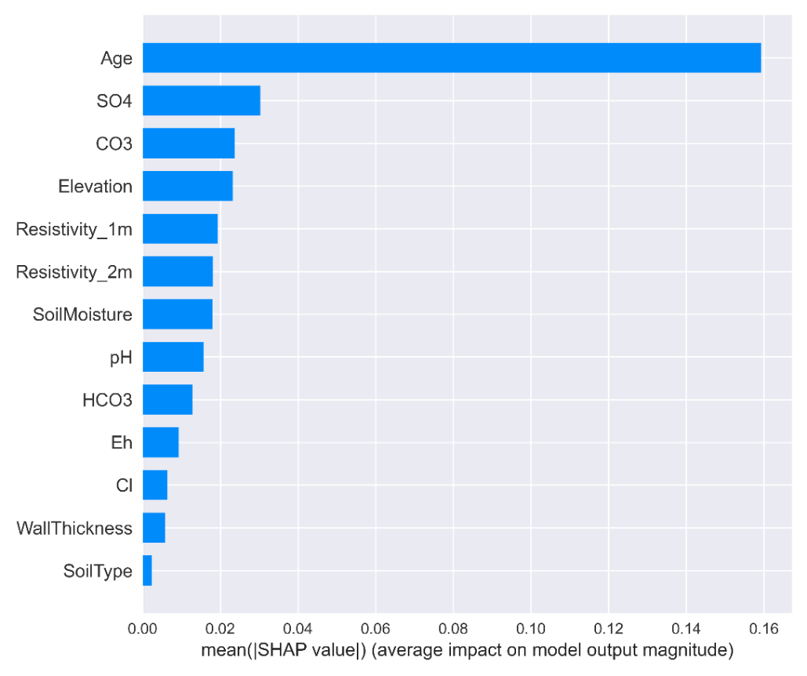
(a)

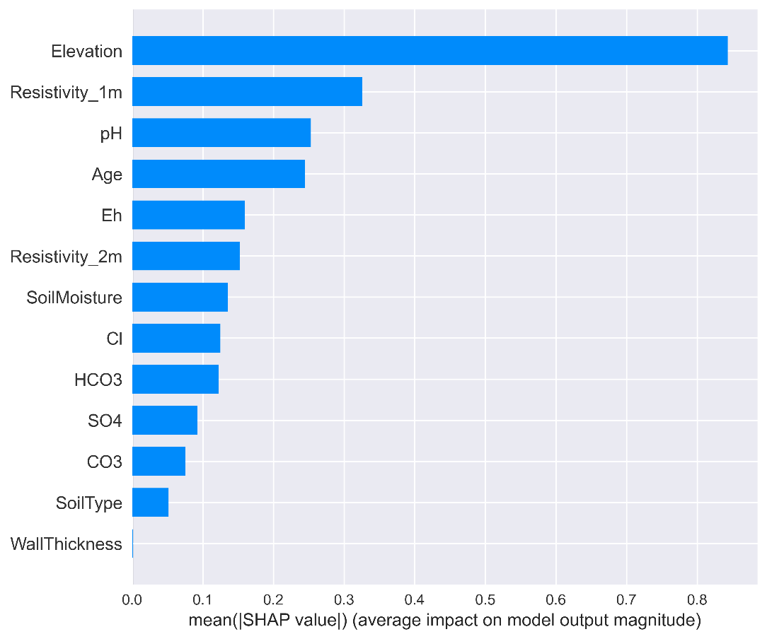
(b)
Figure 5.19 Importance ranking of influencing factors on (a) corrosion depth, (b) corrosion length
Figure 5.20 (a) shows the predicted growth of corrosion depth over time using the established BNN model. Since the pipeline has been in service since 1969, its service life ranges from 36 to 81 years during the period from 2005 to 2050. The red and blue curves represent the upper and lower bounds of the predicted peak depth, while the shaded area indicates the uncertainty bounds. In earlier years, inspection data points, shown as blue dots, align closely with the prediction curves. It demonstrates that the model can accurately predict corrosion depth during this period. Over time, the model predicts an increasing corrosion depth, with the upper bound growing significantly faster than the lower bound, reflecting potential variability in corrosion growth under different conditions. The wider uncertainty bounds beyond 2030 indicate increased uncertainty in long-term predictions. This prediction shows that the BNN model can capture both the growth and uncertainty of corrosion depth in the future. Similarly, defect length shows an increasing trend over time, as presented in Figure 5.20 (b). However, more inspection data points fall outside the upper and lower bounds around 2010, indicating areas where predictions deviate from observed values. Both corrosion depth and corrosion length predictions suggest that pipelines are likely to experience significant degradation over time. In addition, the prediction uncertainty will become much larger in the long term. Therefore, it is important to perform regular inspections and updates to the model.

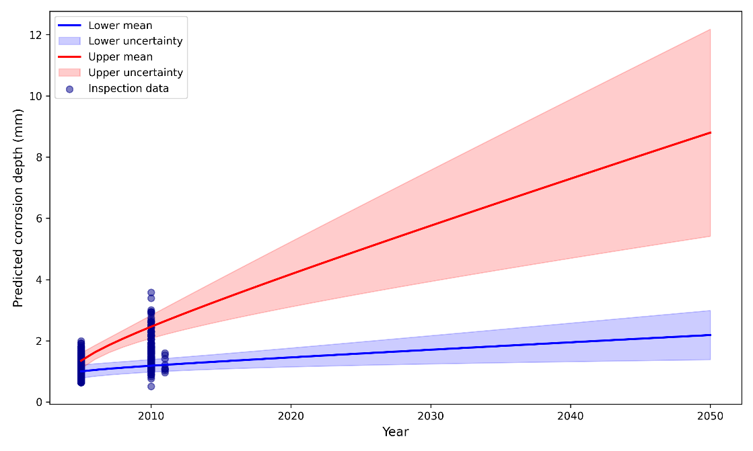
(a)
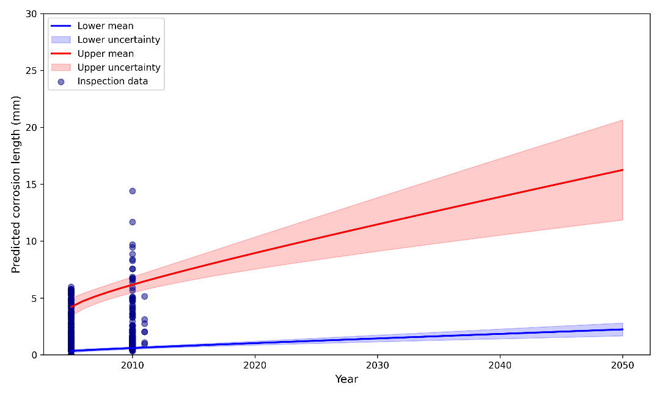
(b)
Figure 5.20 Prediction of corrosion growth over time (a)corrosion depth, (b) corrosion length

5.2.3 Findings
This study utilized advanced AI techniques to enhance pipeline integrity management, focusing on detecting corrosive soil environment and predicting the growth of corrosion defects. Specifically, ILI data and soil environmental parameters were employed to build machine learning models for defect detection and BNN models for predicting corrosion depth and corrosion length over time. The findings of this study can be summarized as follows:
- Machine learning methods such as XGBoost, random forests, and gradient boosting effectively identified pipeline defects, especially when oversampling techniques were applied to address dataset imbalance.
- The BNN model demonstrated robust predictions for both corrosion depth and defect length, capturing the uncertainty and variability of corrosion progression over time.
- Zone-based datasets significantly improved model accuracy and reduced uncertainty compared to the original dataset.
- Pipeline corrosion is more likely to occur in soil environments with high moisture content, low pH and high redox potential.
- The most influential factors for corrosion depth and length show differences when they are modelled separately. The uncertainty of the model to predict corrosion growth in longer term increases significantly due to the dynamic and stochastic nature of corrosion growth.

Defect Growth Modeling with Probabilistic Power Models
Considering the limitations of the growth models developed in previous studies, this study proposes a novel methodology for developing a simple probabilistic nonlinear corrosion damage evolution model that offers distinctive characteristics:
- Soil properties specific to each defect location are explicitly incorporated into the model formulation to consider spatial variability.
- This methodology predicts defect size directly and is applicable for matched or non-matched defect data.
- Two different approaches are proposed for modeling corrosion initiation time.
- The methodology can incorporate the correlation between defect depth and length models and the measurement error, and if new inspection becomes available model updating can be performed.

5.3.1 Modeling methodology
In this study, a power-law function of time model formulation, which can reflect a non-constant damage growth rate over time, is employed for both corrosion maximum depth and length, and the model formulation is expressed as:
$$Y_{k}\left(t\right)=C_{1,k} { \left(t-t_{0,k}\right)}^{C_{2,k}} e_{k} or log\left(Y_{k}\left(t\right)\right)=log\left(C_{1,k}\right)+C_{2,k}\log\left(t-t_{0,k}\right)+log⁡\left(e_{k}\right)$$ | (5.14)
where k = types of defect quantity (e.g., k = D and k = L for the maximum defect depth and length, respectively), Y_{k}(t) = defect dimension (e.g., maximum defect depth or length) at a time instant t, t₀ = corrosion initiation time, and e_{k} = multiplicative model error. If e_{k} is assumed to follow a lognormal distribution with mean of 1, then log(e_{k}) follows a normal distribution with mean of 0 and an unknown standard deviation, σ_{k}.
To consider the spatial dependency, the model parameters (i.e., C_{1,k} and C_{2,k}) are considered as functions of soil properties measured in the field along the pipeline, and the functions are assumed to be as follows:
$$C_{1,k}\left(θ_{1}^{(k)},x_{1}^{(k)}\right)=θ_{1,0}^{(k)}+\sum_{i}{θ_{1,i}^{(k)} x_{1,i}}$$ | (5.15)
$$C_{2,k}\left(θ_{2}^{(k)},x_{2}^{(k)}\right)=\frac{exp⁡(θ_{2,0}^{(k)}+\sum_{j}{θ_{2,j}^{(k)} x_{2,j}})}{1+exp⁡(θ_{2,0}^{(k)}+\sum_{j}{θ_{2,j}^{(k)} x_{2,j}})}$$ | (5.16)
where θ = {θ₁, θ₂} = unknown model parameters, x_{1,i} and x_{2,i} = influencing soil properties. It is noted that Eq. (5.15) is the general form of linear regression [100]. Note that since a protective oxide film is formed on the corrosion defect over time, the growth rate is expected to decrease gradually with time. To model such phenomena, the exponent in the power term of the growth model (i.e., C_{2,k}) needs to be constrained between zero and one to ensure that the evolution model provides a decreasing growth rate over time; thus, the transformation expressed in Eq. (5.16) is adopted with the inspiration of the logistic regression concept [100].

Two ways to model defect initiation time
Based on previous research [57, 101], the occurrence of defects can be assumed to follow a homogeneous Poisson process characterized by a rate parameter, and also it is assumed that the defects with larger detected sizes occur earlier than those with smaller dimensions. Therefore, the initiation time of each defect (time distance from a fixed point in time) is sum of exponential distributions between successive occurrences and follows a gamma distribution [102]; that is, t_{0,k} ~ Gamma (α_{k}, β_{k}). As a result, the gamma distribution scale parameter, β_{k}, is an unknown model parameter to be estimated and the shape parameter, α_{k}, represents the ranking of each defect based on its dimension. Consequently, one can also predict the number of newly generated defects since the last inspection using this Poisson process.
To further clarify the idea, Figure 5.21 illustrates the relationship of initiation times of individual defects, where the blue circles represent corrosion features and bigger circles represent deeper (or longer) defects, and it is assumed that deeper (or longer) defects occur earlier than others. According to the porbability theory, if the number of occurred corrosion defects at time t follows a Poisson distribution by a rate paramter λ, then the time interval between the initiation time of defects T_{i} - T_{i-1} follows the exponential distribution (i.e. T_{i} - T_{i-1} ~ Exp (λ)), and the initiation time of each defect, T_{i}, follows a gamma distribution (i.e. T_{i} ~ Gamma (α, β)) in which α (=1, 2, …) is the known ranking of each defect with α = 1 being the deepest (or longest) defect, and β is an unknown model parameter that will be estimated along with other unknown model parameters through MCMC simulation.
Figure 5.21 The relationship between initiation times of individual defects
When using MCMC simulation approach (which is described in the next subsection) to estimate unknown parameters in the model, the defect initiation time, t₀, is sampled randomly from the corresponding gamma distribution. However, the generated gamma random number that represents the pit initiation time (t_{0,k}) may exceed the inspection time, which is physically meaningless and not acceptable. To address this issue, truncated gamma distributions are employed by setting the upper bound of the distributions to be equal to the inspection time. Furthermore, it is observed that when employing MCMC to explore the posterior distribution of unknown parameters, the convergence can be exceedingly slow or even unattainable because of the significant variability in the randomly generated defect initiation times, even when the parameter β_{k} remains the same. To address this challenge, one solution is to utilize the mean value of the truncated gamma distribution as the defect initiation time (t_{0,k}) at each iteration of the MCMC process. This mean value can be estimated by applying principles of probability theory as below [102]:
$$E[t_{0,k}]=\int_{0}^{t_{Insp}}{x \frac{1}{{β_{k}}^{α_{k}} Γ(α_{k})} x^{α_{k}-1} e^{-\frac{x}{β_{k}}}} dx$$ | (5.17)
where Γ(.) is the gamma function and t_{Insp} = inspection time. Note that for non-truncated gamma distribution, the mean value is the product of α_{k} and β_{k}, while for truncated gamma distribution, integration as expressed in (5.17) is required. Fortunately, the analytical solution for the above integration can be obtained.
The derivation of the expectation value of the nth order of a truncated gamma random variable X ~ Gamma (α, β) is described here. In general, the expectation value of the nth order of a gamma random variable X ~ Gamma (α, β) is defined as [102]:
$$E\left[X^{n}\right]=\int_{-∞}^{∞}{x^{n}∙f(x) dx}$$ | (5.18)
in which f (.) is the PDF of the gamma distribution as below:
$$f\left(x\right)=\frac{1}{β^{α} Γ(α)} x^{α-1} e^{-\frac{x}{β}} for x, α,β>0$$ | (5.19)
It can be shown that (5.20) can be simplified as:
$$E\left[X^{n}\right]=\frac{Γ(n+α)}{β^{n}∙Γ(α)}$$ | (5.20)
which corresponds to the complete gamma distribution. For the incomplete (truncated) gamma distribution, however, the lower incomplete gamma function needs to be employed as:
$$E\left[X^{n}\right]=\frac{Γ(n+α, β∙t_{Insp})}{β^{n}∙Γ(α)}$$ | (5.21)
in which t_{Insp} is the inspection time, i.e., the truncation points of the gamma distribution. Finally, to obtain the mean value (the 1st order expectation) of the truncated gamma distribution, the parameter n in (5.22) is set equal to unity as
$$t_{0}=E\left[X\right]=\frac{Γ(1+α, β∙t_{Insp})}{β∙Γ(α)}$$ | (5.22)
Note that (5.23) cannot be further simplified since the numerator is incomplete gamma function but the denominator is complete gamma function.
When n = 1, the mean value of t_{0,k} is calculated by
$$t_{0,k}\left(α_{k},β_{k}\right)≈E[t_{0,k}]=\frac{Γ(1+α_{k}, β_{k}∙t_{Insp})}{β_{k}∙Γ(α_{k})}$$ | (5.23)
Alternatively, one can assume the pit initiation time is a linear function of soil properties, as shown below
$$t_{0,k}\left(θ_{3}^{(k)},x_{3}^{(k)}\right)=θ_{3,0}^{(k)}+\sum_{i}{θ_{3,i}^{(k)} x_{3,i}}$$ | (1.24)
where θ₃ = unknown model parameters, and x_{3,i} = influencing soil properties. Modeling through Eq. (5.24) is suitable particularly for cases where operators have the defects data of a pipeline network, and the relative location of defects is not known, or all the defects do not belong to the same segment of pipeline. In those situations, the Poissonian assumption used in Eq. (5.23) cannot be made; instead, one can use Eq. (5.24) to model the initiation time. As shown in Eq. 5.24), the initiation time is distinct for the defects that are exposed to different soil environment, which is a reasonable assumption for external corrosion.

Bayesian statistics
Bayesian updating framework [103] and MCMC simulation technique are utilized to estimate the joint probability density function (PDF) of the unknown parameters, Θ, that includes θ, β_{k} (if t_{0,k} is assumed to follow a Poissonian process) and σ_{k}. If X denotes the vector of data used to update the model parameters, the posterior joint PDF of Θ, p′′(Θ), can be written as [103]:
$$p''\left(Θ\right)=κ L\left(\left.Θ\right|X\right) p'\left(Θ\right)$$ | (5.25)
where $κ={\left[\int{L(\left.Θ\right|X)p'(Θ)dΘ}\right]}^{-1}$, $L(\left.Θ\right|X)=$ likelihood function, p′(Θ) = prior joint PDF of Θ. When the model error, e_{k}, in Eq. (5.14) is assumed to follow a lognormal distribution, considering the correlation coefficient between depth and length model error standard deviations, ρ, the likelihood function can be written as a bi-variant normal distribution as expressed below:
$$L\left(\left.Θ\right|X\right)={\left[\prod_{i=1}^{N_{d}}{2π·σ_{D}·σ_{L}·\sqrt{1-ρ^{2}}}\right]}^{-1}· \exp\left(\frac{1}{2\left(1-ρ^{2}\right)}\sum_{i=1}^{N_{d}}{\left[\frac{{\left(\log{Y_{D,i}}-\log{{\overset{̑}{Y}}_{D,i}}\right)}^{2}}{σ_{D}^{2}}-\frac{2ρ\left(\log{Y_{D,i}}-\log{{\overset{̑}{Y}}_{D,i}}\right)\left(\log{Y_{L,i}}-\log{{\overset{̑}{Y}}_{L,i}}\right)}{σ_{D}·σ_{L}}+\frac{{\left(\log{Y_{L,i}}-\log{{\overset{̑}{Y}}_{L,i}}\right)}^{2}}{σ_{L}^{2}}\right]}\right)$$ | (5.26)
where N_{d} is the number of defects in a given pipeline segment. To efficiently estimate the posterior statistics, a sampling-based technique such as MCMC simulations can be employed [104]. In this study, DRAM [105], which combines the Delayed Rejection (DR) and Adaptive Metropolis (AM) methods, was used as an efficient adaptive MCMC sampling. Also, for the convergence to the posterior PDFs, the Geweke criterion [106] is used in this study.

Selection of soil properties in model development
To consider the spatial variability of soil properties along the pipeline length and the soil influence on defect growth, the soil parameters (i.e., x₁ and x₂) are integrated into the growth models through C_{1,k} and C_{2,k}. To select the soil properties that contribute to the modeling, a simple procedure is proposed here.
First, the entire length of the pipeline is divided into shorter segments of equal length resulting in q segments. The segment length is selected such that it is short enough so that the variation in soil properties is small (i.e., homogeneity) within each segment; however, the segment should be long enough to contain enough number of defects. In this way, one can consider that the defects within each segment follow the same corrosion growth model but just with different initiation times. A damage growth model is derived for each segment without using soil characteristics and thus q sets of C_{1,k} and C_{2,k} are obtained. Afterwards, a regression analysis is conducted to determine if the values of C_{1,k} and C_{2,k} have statistical relationships with any soil properties by considering mean values of soil properties in a given segment as predictors and C_{1,k} or C_{2,k} as the regression response. This procedure is followed for C_{1,k} and C_{2,k} in depth and length dimensions separately.
One should avoid inclusion of too many soil properties (thus too many unknown parameters) in the model, since it may result in chains convergence issue in the MCMC sampling. Therefore, model selection methods (e.g., best subset selection [100]) should be applied building the regression relationships with most concise forms. One can employ nonlinear regression analysis using all available soil properties in C_{1,k}, C_{2,k}, and t_{0,k} formulations followed by a model reduction technique (e.g., best subset selection) to reduce the complexity of the model.

Measurement error implementation
In this subsection, the procedure of implementing a known measurement error in the model development framework is described. Given the inherent uncertainty of ILI tools, there are always discrepancies between the “true” corrosion dimensions and the measured ones. To capture such uncertainty, the following relation can be considered:
$$log\left(Y_{ILI,k}\right)=log\left(Y_{k}\right)+e_{m,k}$$ | (5.27)
where Y_{ILI,k} = ILI-measured dimension, Y_{k} = true dimension, and e_{m,k} = measurement error, which is commonly assumed as normal distribution, that is, e_{m,k} ~ N (b_{m,k}, σ_{m,k}) where b_{m,k} and σ_{m,k} are bias and standard deviation of the measurement error, respectively.
On the other hand, Eq. (5.27) can be rewritten as
$$log\left(Y_{k}\right)=log\left({\hat{Y}}_{k}\right)+log⁡\left(e_{k}\right)$$ | (5.28)
where $\log\left({\hat{Y}}_{k}\right)=log\left(C_{1,k}\right)+C_{2,k}\log\left(t-t_{0,k}\right)$ = point estimation of damage quantity predicted by the model. With the assumption of e_{m,k} ~ N (b_{m,k}, σ_{m,k}) and log(e_{k}) ~ N (0,σ_{k}), the incorporation of measurement error changes the likelihood function to be:
$$L\left(\left.Θ\right|X\right)={\left[\prod_{i=1}^{N_{d}}{2π·\sqrt{{σ_{D}}^{2}+{σ_{m,D}}^{2}}·\sqrt{{σ_{L}}^{2}+{σ_{m,L}}^{2}}·\sqrt{1-ρ^{2}}}\right]}^{-1}· \exp\left(\frac{1}{2\left(1-ρ^{2}\right)}\sum_{i=1}^{N_{d}}{\left[\frac{{\left(\log{Y_{ILI,D,i}}-b_{m,D}-\log{{\overset{̑}{Y}}_{D,i}}\right)}^{2}}{{σ_{D}}^{2}+{σ_{m,D}}^{2}}-\frac{2ρ\left(\log{Y_{ILI,D,i}}-b_{m,D}-\log{{\overset{̑}{Y}}_{D,i}}\right)\left(\log{Y_{ILI,L,i}}-b_{m,L}-\log{{\overset{̑}{Y}}_{L,i}}\right)}{\sqrt{{σ_{D}}^{2}+{σ_{m,D}}^{2}}·\sqrt{{σ_{L}}^{2}+{σ_{m,L}}^{2}}}+\frac{{\left(\log{Y_{ILI,L,i}}-b_{m,L}-\log{{\overset{̑}{Y}}_{L,i}}\right)}^{2}}{{σ_{L}}^{2}+{σ_{m,L}}^{2}}\right]}\right)$$ | (5.29)

5.3.2 Growth model development
This ILI dataset is obtained from an onshore pipeline that spans a total length of 112 km and has been under operation since 1969 near the Gulf of Mexico. The pipeline has an outside diameter of 18 inches and a nominal wall thickness of 0.252 inches, and it is made of X52 steel. A total of 2,583 defects are identified through two ILI runs, one completed in 2005 utilizing MFL technology and the other completed in 2010 and 2011 utilizing UT technology, and depth and length of these anomalies were measured.
Figure 5.22 (a) and Figure 5.22 (b) show the depth and length of defects, respectively, with respect to the location of identified defects along the pipeline length, where wt represents wall thickness. Note that no measurement data is available between 56.9 km and 53.3 km, and such interval is marked by the vertical dashed lines shown in Figure 5.22. This lack of data was due to the fact this pipeline segment is non-piggable. In addition, Figure 5.22 (c) shows the scatter plot of defect depth vs length; neither positive nor negative correlation between the measured depth and length are observed. Figure 5.23 shows the histogram of the defect dimensions obtained from the two inspections in terms of counts. As shown in Figure 5.23, for both inspections almost one third of the detected defects are in the range of 0.15-0.20 wt in depth and most defects have lengths less than 1 mm. In addition, it is observed that more defects are detected in the 2nd inspection (1,973 detected) compared to the 1st inspection (610 detected) and the defects identified in the 2nd inspection generally have higher dimensions.
(a)
(b)
(c)
Figure 5.22 Distribution of identified defects in the Mexico1 dataset along the pipeline: (a) depth, (b) length, and (c) scatter plot of defect depth vs. length
(a)
(b)
Figure 5.23 Histogram of identified defects dimension in the Mexico1 dataset: (a) depth and (b) length
The analysis was first conducted using all the defects, but the fitting was found not good. It was observed there were small amounts of data having corrosion length greater than 10mm (as shown in Figure 5.23) and the fitting accuracy improved after excluding those data. Therefore, the defects longer than 10 mm were removed from the dataset, and the analyses are based on the remaining defects (i.e., 597 and 1,926 defects in the 1st and 2nd inspections, respectively). However, no reasonably matched defects could be identified when comparing the defect locations obtained from the 1st and 2nd inspections. This is not surprising given that two different technologies are employed for the inspections, and inherent measurement errors (in terms of defect detection, location, and dimension measurement) always exist in the ILI technologies.
In addition, at the location of each detected defect, information regarding soil properties is available including soil moisture, pH level, sulfate (SO₄) content, resistance, redox potential, carbonate (CO₃) concentration, etc. As expected, the soil properties vary along the pipeline length. For instance, the variations of soil moisture and pH throughout the entire length of the pipeline is shown in Figure 5.24. It is anticipated that such spatial variability in the surrounding environment properties contribute to the spatial variability of the corrosion defect growth.
(a)
(b)
Figure 5.24 Variations of soil properties along the pipeline: (a) moisture and (b) pH

Model development
Note that when using Eq. (5.14) to model defect growth, no matched defects are needed. Before developing a growth model for the whole pipeline, one needs to investigate if any soil property contributes to defects growth. The 112 km pipeline is divided into 56 segments, with each segment spanning a length of 2 km. Then, 56 pairs of C_{1,k} and C_{2,k} values are obtained by using Eq. (5.14) without using soil properties. Subsequently, linear regression analyses are performed by using C_{1,k} and C_{2,k} as the response variables and the mean values of the soil parameters for each segment as the predictors. A best subset model selection process [100] identifies soil moisture (M) and soil resistance (R) as the influential quantities for depth growth, whereas HCO₃ and Cl for length growth. Correspondingly, Eqs. (5.15) and (5.16) are obtained for Mexico1 dataset as Eqs. (5.30) to (5.33):
$$C_{1,D}\left(θ_{1},M\right)=θ_{1,0}+θ_{1,1} M$$ | (5.30)
$$C_{2,D}\left(θ_{2},M,R\right)=\frac{\exp\left(θ_{2,0}+θ_{2,1} M+θ_{2,2} R\right)}{1+\exp\left(θ_{2,0}+θ_{2,1} M+θ_{2,2} R\right)}$$ | (5.31)
$$C_{1,L}\left(θ_{1},{HCO}_{3}, Cl\right)=θ_{1,0}+θ_{1,1} {HCO}_{3}+θ_{1,2} Cl$$ | (5.32)
$$C_{2,L}\left(θ_{2},{HCO}_{3}, Cl\right)=\frac{\exp\left(θ_{2,0}+θ_{2,1} {HCO}_{3}+θ_{2,2} Cl\right)}{1+\exp\left(θ_{2,0}+θ_{2,1} {HCO}_{3}+θ_{2,2} Cl\right)}$$ | (5.33)
With the identified soil properties, the unknown model parameters in Eqs. (5.14), (5.15), and (5.16), Θ = {θ, β_{k}, σ_{k}}, are then estimated using MCMC simulations. It is noteworthy that the initiation time for corrosion depth and length growth are assumed to be different (that is, β_{D} can be different from β_{L}) in this study. Such assumption is reasonable, because: (1) the deeper defects are not necessarily longer, which can be easily observed from the scatter plots of depth and length dimensions (as shown in Figure 5.22 (c)); and (2) the damage evolution can be different in different directions such as in the wall thickness and longitudinal directions.
One could use the inspection data for the whole length to develop one growth model or use inspection data of multiple segments to develop multiple models correspondingly. If the segment is too long, the model may not be accurate; on the other hand, if it is too short, the inspection data may not be sufficient to develop an accurate model, and thus multiple models have to be developed. In this study, the 112 km pipeline is divided into two halves with 56km for each, and two models are developed respectively. Specifically, the first half pipeline includes 705 defects (323 & 382 from the 1st and 2nd inspections, respectively), and the second half pipeline includes 1,818 defects (274 & 1,544 from the 1st and 2nd inspections, respectively). For simplicity, only the results of the first half pipeline are shown below.
Table 5.6 provides a summary of the statistical characteristics derived from the posterior distribution of the model parameters for the first half of the pipe, assuming no prior knowledge for the unknown model parameters for the Bayesian updating. The correlation coefficient between the errors of the depth and length models is found to be approximately 21%. This indicates that depth and length models should be developed jointly with consideration of the correlation coefficient between the errors in the likelihood function (as shown in Eq. (5.21)). In addition, Figure 5.25 shows the scatter plot of predicted versus measured defect dimension in the logarithmic space, where the solid line corresponds to the unity line and the dashed lines represent 80% confidence interval. As shown in Figure 5.25, most dots fall within the 80% confidence interval for both depth and length. Nevertheless, the accuracy of length predictions diminishes with increasing measured lengths, and this can be explained by the impact of the measurement error, which is discussed next.

Table 5.6 Posterior distribution statistics of model parameters for the first half of the pipeline
 | Model parameter | Corresponding random variable | Mean | Stdv | Coefficient of variation  (%) | Median | Geweke
depth | θ_{1,0} | Intercept | 0.379 | 0.055 | 14.5 | 0.382 | 0.962
depth | θ_{1,1} | Soil Moisture | -1.126 | 0.205 | -18.2 | -1.142 | 0.938
depth | θ_{2,0} | Intercept | 9.823 | 2.661 | 27.1 | 9.820 | 0.938
depth | θ_{2,1} | Soil Moisture | -16.095 | 10.325 | -64.2 | -14.656 | 0.932
depth | θ_{2,2} | Resistance | -0.041 | 0.021 | -52.5 | -0.044 | 0.828
depth | β_{D} | - | 0.710 | 0.012 | 1.6 | 0.709 | 0.983
depth | σ_{LnD} | - | 0.148 | 0.006 | 3.7 | 0.148 | 0.987
length | θ_{1,0} | Intercept | 0.135 | 0.013 | 9.7 | 0.134 | 0.983
length | θ_{1,1} | HCO₃ | 0.002 | 0.003 | 190.2 | 0.002 | 0.801
length | θ_{1,2} | Cl | -0.005 | 0.002 | -40.7 | -0.005 | 0.820
length | θ_{2,0} | Intercept | 5.880 | 2.451 | 41.7 | 6.130 | 0.812
length | θ_{2,1} | HCO₃ | 34.923 | 14.530 | 41.6 | 38.313 | 0.848
length | θ_{2,2} | Cl | 14.331 | 5.255 | 36.7 | 14.339 | 0.953
length | β_{L} | - | 0.283 | 0.003 | 1.0 | 0.283 | 0.994
length | σ_{LnL} | - | 0.336 | 0.014 | 4.2 | 0.334 | 0.985

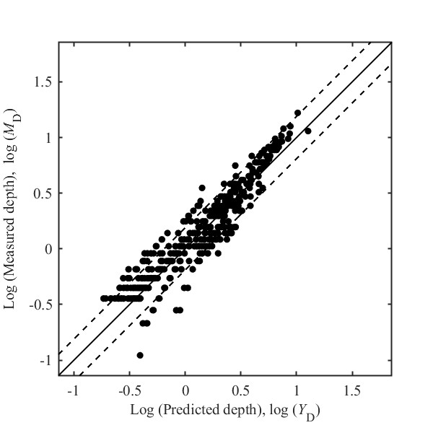
(a)

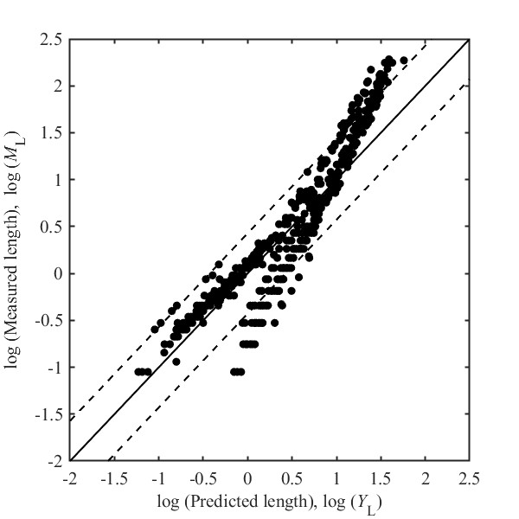
(b)
Figure 5.25 Comparison between predicted vs. measured defect dimension: (a) depth and (b) length
Effects of soil properties and measurement error
In order to demonstrate the effectiveness of soil properties inclusion in the growth models and also the impact of measurement error on the growth modeling, two additional sets of growth models (named as Models 2 and 3, respectively) are developed and compared with the previously developed models (named as Model 1) shown in Eq. (5.14) and Eqs. (5.30) – (5.33). For the first additional set (Model 2), depth and length models are developed without incorporating the soil properties by treating C_{1,k} and C_{2,k} as constants in Eq. (5.14). For the second additional set of models (Model 3), the likelihood function shown in Eq. (5.29) is applied to incorporate the measurement error.
Regarding the detection accuracy, a few studies [56, 107, 108] found that deeper features have tendency to be oversized by ILI; thus, measurement error non-constant biases shown in Figure 5.26 is assumed in this study in order to illustrate the incorporation of error bias in the proposed probabilistic framework. Specifically, as shown in Figure 5.26 (a), for measured depth between 20 and 30%wt, an oversizing bias is assumed to be linearly varied from 0 to 10%wt, and for measured depths beyond 30%wt, a constant bias of 10%wt is assumed. As shown in Figure 5.26 (b), for measured length between 5 and 10 mm, an oversizing bias is assumed to vary linearly from 0 to 3 mm, and for measured lengths beyond 10 mm, a constant bias of 3 mm is considered. In addition, standard deviations of the measurement error are also assumed to be 7.8%wt and 2.34 mm for depth and length respectively, so that the probability that the depth measurement error is between ±10%wt is 80% (consistent with studies [54, 56, 109]) and the probability that the length measurement error is between ± 3 mm is also 80%.
(a)
(b)
Figure 5.26 Considered measurement error bias in measured (a) depth and (b) length
Model performance
The performance of three sets of models are evaluated and compared using three quantitative measures summarized in Table 5.7, growth evolution of defects given in Figure 5.27, and scatter plots of the predicted and measured sizes presented in Figure 5.28 and Figure 5.29.
Table 5.7 Summary of quantitative measures for prediction performance of three sets of models
Model | Soil properties incorporated? | Measurement error incorporated? | Corrosion quantity | R² | MAPE | MSE
1 | √ | − | Depth | 0.90 | 11.41 | 0.03
1 | √ | − | Length | 0.74 | 27.82 | 0.90
2 | − | − | Depth | 0.87 | 15.10 | 0.04
2 | − | − | Length | 0.73 | 29.06 | 0.95
3 | √ | √ | Depth | 0.88 | 9.06 | 0.01
3 | √ | √ | Length | 0.80 | 26.71 | 0.51
Inspection data Predicted growth curve
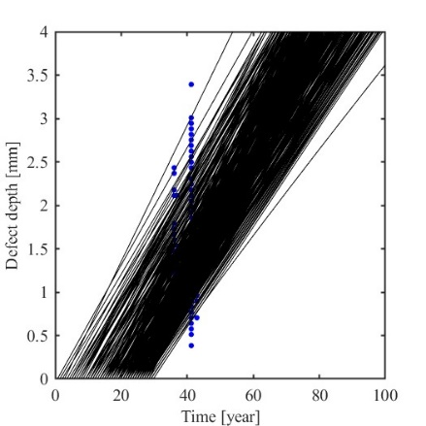 |  | 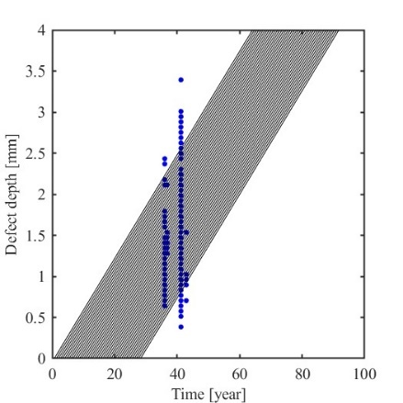 |  | 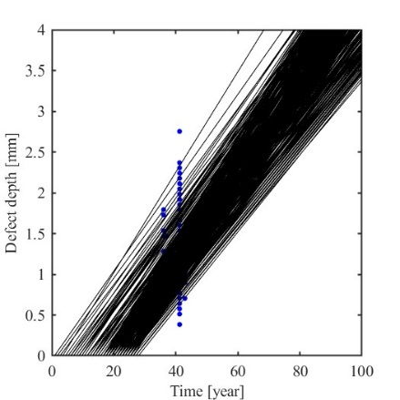
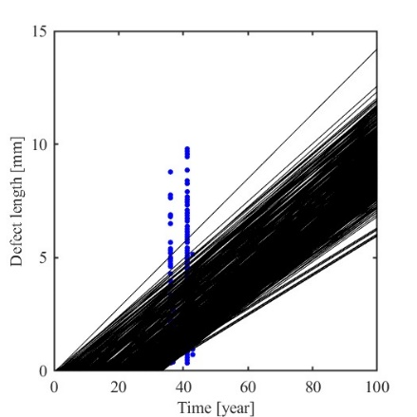 |  | 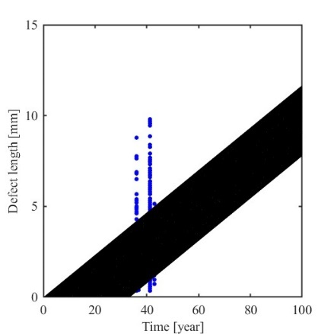 |  | 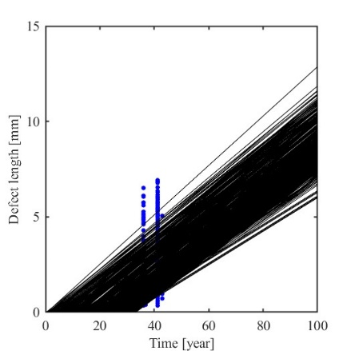
(a) |  | (b) |  | (c)
Figure 5.27 Predictive evolution of corrosion depth (top) and length (bottom) over time: (a) considering soil properties and no measurement error, (b) without considering soil properties and measurement error, and (c) considering soil properties and measurement error
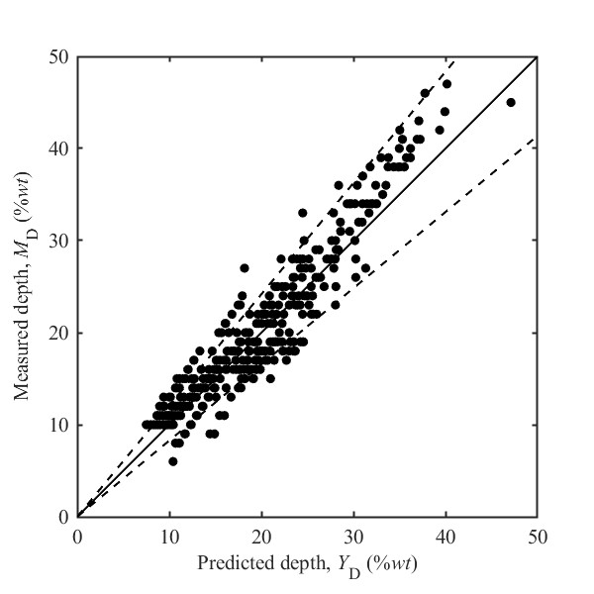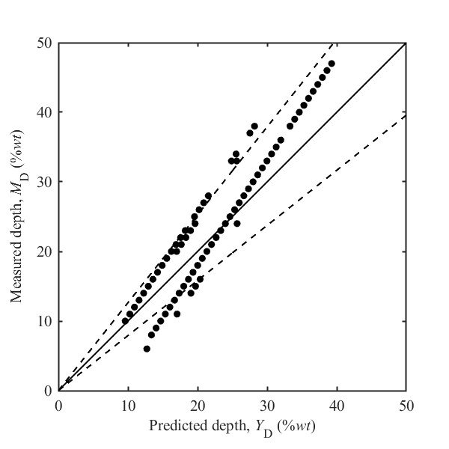
(a) (b)
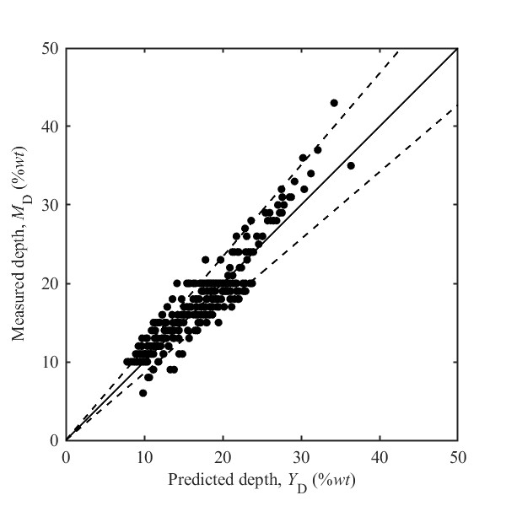
(c)
Figure 5.28 Scatter plot of predicted vs. measured defect depth: (a) Prediction model considering soil properties and no measurement error; (b) Prediction model without considering soil properties and measurement error; (c) Prediction model considering soil properties and measurement error
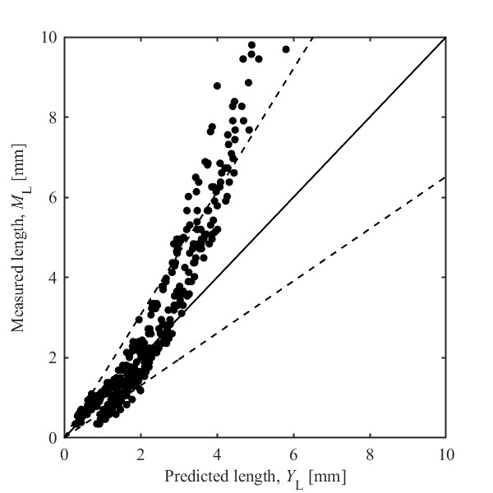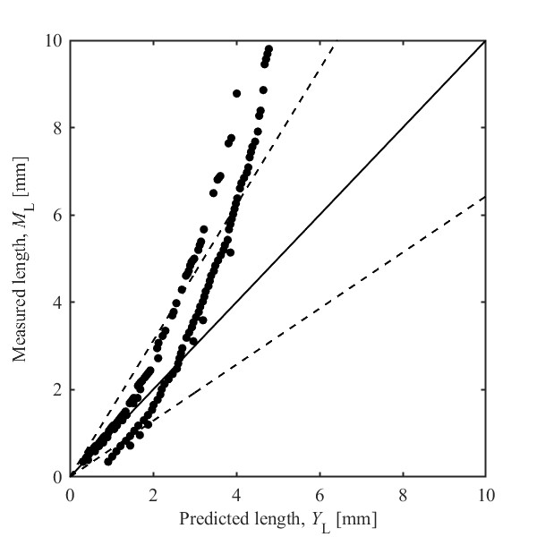
(a) (b)
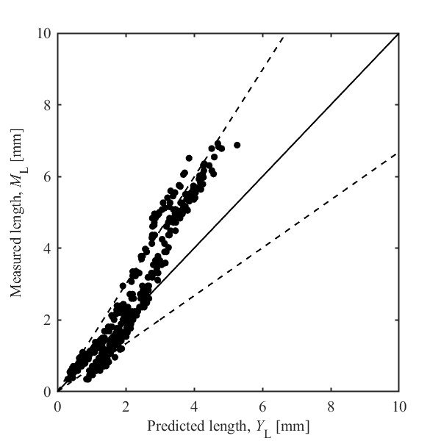
(c)
Figure 5.29 Scatter plot of predicted vs. measured defect length: (a) Prediction model considering soil properties and no measurement error; (b) Prediction model without considering soil properties and measurement error; (c) Prediction model considering soil properties and measurement error
The quantitative measures used in Table 5.7 are the absolute fraction of variation, also known as coefficient of determination (R²), the mean absolute percentage error (MAPE), and the mean squared error (MSE). While the R² values indicate the goodness of fitting, the MAPE and MSE provide intuitive measures of the model prediction accuracy; they are calculated using the following equations:
$$R^{2}=1-\frac{\sum_{i=1}^{N_{s}}{{(Y_{k,i}-{\hat{Y}}_{k,i})}^{2}}}{\sum_{i=1}^{N_{s}}{{(Y_{k,i}-\overline{Y})}^{2}}}$$ | (5.34)
$$MAPE=\frac{100}{N_{s}} \sum_{i=1}^{N_{s}}{\frac{\left|(Y_{k,i}-{\hat{Y}}_{k,i})\right|}{Y_{k,i}}}$$ | (5.35)
$$MSE=\frac{\sum_{i=1}^{N_{s}}{{(Y_{k,i}-{\hat{Y}}_{k,i})}^{2}}}{N_{s}}$$ | (5.36)
where N_{s} = number of samples and $\overline{Y}$= sample mean.
As presented in Table 5.7, the prediction accuracy of corrosion depth is higher than length for all three sets of models in terms of all three measures. Model 1 (incorporating soil properties) has better prediction accuracy than Model 2 (without incorporating soil properties), indicating that incorporating soil properties can play an important role in the growth modeling even though the models without incorporating soil properties provide a decent performance with R² of 0.87 and 0.73 for depth and length, respectively. Moreover, Model 3 (that considers both soil properties and measurement error) has better prediction accuracy than Model 1 (that considers only soil properties) particularly in terms of MSE and MAPE, indicating that measurement error in the model development can capture the bias and variation that may not be explained by the model formula, resulting in higher prediction accuracy.
Figure 5.27 compares the growth evolution curves predicted by Models 1, 2, and 3. For Model 2 (without considering soil properties), growth evolutions for different defects are only different in initiation time, i.e. curves are just shifted along the time axis as shown in Figure 5.27 (b). However, when soil properties are incorporated as shown in Figure 5.27 (a) and (c), the shape of each curve can be unique and changes from one defect to another. In addition, Figure 5.27 (c) also shows that by removing the oversizing bias from the defects dimension, the blue dots become less spread which in turn leads to higher model prediction accuracy as mentioned in Table 5.7.
Figure 5.28 and Figure 5.29 compare the scatter plots of the predicted and the measured defect depth and length, respectively, in the original space using the three sets of models, where the solid line is the unity line, and the dashed lines refer to 80% confidence interval. First, for all three models, the majority of predictions lie within the 80% confidence interval for both depth and length; however, the length prediction accuracy considerably decreases as the measured length increases. After removing the oversizing bias for deep and long defects in Model 3, as shown Figure 5.28(c) and Figure 5.29(c), considerable improvement in prediction accuracy is observed. When no soil properties are considered in Model 2 (as shown in Figure 5.28(b) and Figure 5.29(b)), the accuracy of prediction seems to be as good as Models 1 and 3 (where soil properties are considered as shown Figure 5.28 (a), (c) and Figure 5.29 (a), (c)), but Model 2 has much less spread in the prediction. This is because for two individual defects that are measured with the same dimensions in ILI, Model 2 will predict the same value for the two defects; however, Model 1 or Model 3 can distinguish between the two defects based on their location in terms of soil properties and provide two different predictions.
Figure 5.30 further illustrates the impact of incorporating soil properties in the growth model using growth evolution curves for 12 defects that all have the same measured depth of 20%wt in ILI but with different inspection-to-installation time interval. In Figure 5.30, the black solid lines are the 12 different growth paths predicted by Model 1 that considers soil properties, while the red dashed line is one growth path for all the 12 defects predicted by Model 2 that does not consider soil properties. As shown in this figure, soil properties can differentiate between the growth path, despite all the defects have the same measured dimension in ILI, and therefore leading to 12 different growth paths.
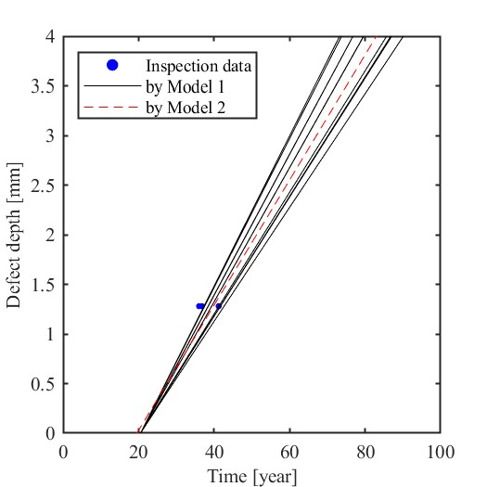
Figure 5.30 Effect of soil properties inclusion in the prediction model on the defect growth

5.3.3 Findings
Time-dependent reliability analysis is an integral part of planning cost-effective strategies for pipeline inspection, maintenance, and rehabilitation. A key aspect of this analysis is the development of a dependable probabilistic model for the time-evolution of corrosion sizes in pipelines. The proposed methodology in this study offers a novel approach to develop external corrosion damage evolution models for buried steel pipelines using ILI data, and two ways to model defect initiation time are also proposed. The advantages of the proposed approach are highlighted below:
- By incorporating a Poisson process for corrosion initiation time, no uniform pitting initiation time is assumed for all defects, and newly generated defects can also be predicted and considered in the performance evaluation.
- By directly using corrosion defect dimensions not corrosion rate, the methodology does not require matched defects, thus providing more accurate and flexible modeling of corrosion growth.
- By integrating soil properties explicitly into the growth models, the spatial variability of surrounding environment properties along the pipeline length is accounted for without making segmentation or homogeneous assumptions, and defect-specific prediction models are then obtained. Therefore, the developed models are both time- and space-dependent.
- By incorporating soil properties, the developed models can also be extended to use for non-piggable segments of a pipeline where ILI cannot be performed.
- Defects depth and length correlation are considered through the likelihood function in the Bayesian framework; and this study shows that such correlation is not negligible.
In addition, ILI measurement uncertainty and the procedure of propagating this uncertainty into the defect dimension prediction are discussed and illustrated. The methodology introduced in this study is applied to one dataset of field ILI, and the probability of failure of the pipeline over time was estimated considering two failure modes of small leak and burst. The following conclusions can be drawn:
- The proposed methodology led to unbiased, reasonably accurate results, which demonstrates its suitability in developing corrosion growth models.
- Incorporating the soil properties in the model can differentiate between the growth path of different defects and hence can lead to more accurate predictive estimates of probability of failure.
- Incorporating the measurement error and oversizing bias of ILI devices can further improve prediction accuracy.

Identification of Corrosive Soil Environment

5.4.1 Anomaly Detection with Machine Learning
Anomaly detection is to identify unusual conditions that may pose a threat to the safe and efficient operation of pipelines. By detecting potential issues at an early stage, defect detection enables timely maintenance and reducing the risk of accidents. In this study, several machine learning models were used to identify anomalies in the soil environment, including extreme gradient boosting (XGBoost), random forest, decision trees, adaptive boosting (AdaBoost) and gradient boosting. These machine learning methods are rooted in ensemble learning, where multiple models are combined to improve prediction accuracy and robustness. Techniques like random forests and decision trees build models that capture non-linear relationships and feature interactions. The boosting methods such as AdaBoost, XGBoost, and gradient boosting iteratively enhance performance by focusing on previously misclassified data.
When the number of normal samples differs significantly from the number of defect samples, an imbalanced data problem arises. To address this problem, different techniques can be used, such as resampling methods, algorithmic modifications, and ensemble methods. In this study, to increase the number of minority classes in the dataset, oversampling methods were used. This approach adds more samples of the minority class, either by duplicating existing samples or generating synthetic ones. Two methods, Synthetic Minority Over-sampling TEchnique (SMOTE) and Conditional Generative Adversarial Network (cGAN), were employed as data augmentation methods. SMOTE is an approach used to address the problem of imbalanced datasets by generating synthetic samples for the minority class. cGAN is an extension of the original GAN framework, designed to generate data samples conditioned on certain information, such as class labels.
To classify normal and defect classes, all soil environment parameters mentioned above were used as inputs in the machine learning model. Three metrics including accuracy, precision, and recall were used to evaluate the model performance, as shown in Eq. 5.37 to 5.39. Accuracy measures the proportion of total correct predictions. Precision indicates the proportion of positive predictions that are correct. Recall measures the proportion of actual positive cases that were correctly identified.
(5.37)
(5.38)
(5.39)
where, TP is number of positive (defect) samples correctly predicted as positive; TN is number of negative (normal) samples correctly predicted as negative; FP is number of negative samples incorrectly predicted as positive; FN is number of positive samples incorrectly predicted as negative.

5.4.2 Augmented Datasets and Analysis Results
Based on the ILI dataset, the locations having observations with pipe corrosion defects were considered as corrosive soil environment (defect data), while those without corrosion were classified as normal data. The number of samples in the normal data was found much greater than that in the defect data in the original dataset, while the number of defect samples was slightly greater than the number of normal samples in the zone-based dataset. To address the problem of imbalanced data, SMOTE and cGAN were employed to generate new data for minority class. It should be noted that these data augmentation methods would not be effective in extreme cases, such as a pipe with no defects or one that is fully corroded.
Datasets before and after using oversampling methods can be seen in Figure 5.31. The number of defect class and normal class became more equivalent after oversampling.

(a)

(b)
Figure 5.31 Number of observations before and after data augmentation for the (a) original dataset, (b) zone-based dataset
The analysis results based on classification accuracy using various machine learning techniques are shown in Table 5.10 and 5.11, respectively, for the original and zone-based dataset. The performance metrics of the best model among five machine learning models (XGBoost, random forest, decision trees, AdaBoost and gradient boosting) are presented for the baseline dataset and the ones after data augmentation.
Although most methods achieved an accuracy above 80%, the precision and recall values of these models were quite low before data augmentation. This indicates that machine learning methods were biased towards the majority class (normal class) as they aimed to minimize overall error. Therefore, the performance in detecting defects was poor, resulting in a high rate of false negatives. The primary cause of this issue can be attributed to the imbalanced nature of the original dataset. Similar analysis was conducted on the zone-based dataset. The recall and precision values for the zone-based dataset were considerably higher, suggesting that the issue of imbalance was less pronounced in this dataset. This indicates that the zone-based approach may mitigate the impact of data imbalance, leading to improved defect detection performance.
Table 5.8 Model performance before and after data augmentation (original dataset)
Metrics | Baseline | SMOTE | cGAN
Accuracy | 87% | 78% | 87%
Recall | 0.36% | 54% | 50%
Precision | 12.5% | 30% | 32%

Table 5.9 Model performance before and after data augmentation (zone-based dataset)
Metrics | Baseline | SMOTE | cGAN
Accuracy | 78% | 80% | 85%
Recall | 72% | 75% | 76%
Precision | 83% | 91% | 90%

After data augmentation, the baseline model achieved the highest accuracy, followed by cGAN and SMOTE for the original dataset. However, accuracy is not the most suitable metric for evaluating performance in the context of imbalanced data. When considering recall and precision, both SMOTE and cGAN outperformed the baseline model. Although the recall and precision values remain relatively low, they represent significant improvement over the baseline, indicating that oversampling methods can effectively enhance defect detection performance. For the zone-based dataset, all methods demonstrated satisfactory performance. The cGAN method produced superior results by improving both recall and precision without significantly impacting accuracy.
Sophisticated machine learning algorithms can provide accurate predictions, but it is challenging to interpret the model. In this study, Shapley Additive Explanation (SHAP) was applied for global interpretation of the model, providing insights into the positive and negative correlations between features and predictions. The SHAP framework assigns an important value to each feature by computing its marginal contribution. This is done by systematically removing and adding features to the model and evaluating the impact on predictions. The final SHAP value represents the average contribution of a feature in all possible feature subsets. As shown in Figure 5.32, SHAP values provide an ordered ranking of feature importance in the model. The descending order of soil parameters reflects their relative influence on corrosion defects, from the most to the least significant factors. Each point represents a data sample. The horizontal position of each point indicates the impact of a feature on the prediction, while color encoding represents the feature value (red for high and blue for low). If a point is positioned to the right of zero, the feature positively contributes to the prediction, while a position to the left indicates a negative contribution.

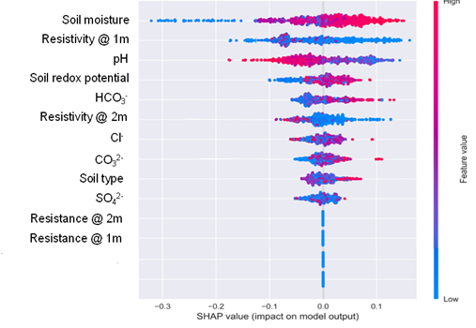
Figure 5.32 Importance of parameters on corrosive soil environment based on SHAP plot.

Positive SHAP values indicate that a feature increases the likelihood of corrosion, whereas negative SHAP values suggest a reduced likelihood of corrosion. Based on Figure 5.32, it can be observed that soil moisture has the highest impact on corrosive environment. Higher moisture levels significantly increase corrosion likelihood, due to the enhanced conductivity facilitating electrochemical reactions. Soil resistivity at both 1m and 2m depths is another critical factor; lower resistivity values correlate with increased corrosion risk. Parameters like pH and soil redox potential also play significant roles. Most red dots of pH locate in the negative region, indicating a negative correlation between pH and corrosion growth. In contrast, soil redox potential is positively correlated with corrosion growth. Therefore, lower pH values and higher redox potentials would accelerate corrosion growth. Other chemical components, such as HCO₃⁻, Cl⁻, and SO₄²⁻, have varying influences, with higher concentrations typically increasing corrosion risk due to their aggressive chemical behavior.

5.4.3 Findings
Based on ILI and soil survey data, machine learning models with data augmentation were employed to detect anomalies by identifying corrosive soil environment at an early stage. Different machine learning methods such as XGBoost, random forests, and gradient boosting were analyzed for anomaly detection. The application of data augmentation techniques improved their effectiveness by addressing the problem of data imbalance. The results show that pipeline corrosion was more likely to occur in soil environments with high moisture content, low pH and high redox potential.

Quantification of Probability of Failure

Pipe Capacity before and after Composite Wrap Repair
For pipelines, probability of failure refers to the likelihood that a pipeline will experience some form of failure within a specified period of time [110]. It is a conditional probability of reaching or exceeding the specified limit state of pipelines for a given condition boundary. Probability of failure is usually used in risk-based inspection and maintenance planning to prioritize efforts and resources based on where they will be most effective in preventing failures and their associated consequences.
A pipeline under pressure that has corrosion defects will mainly experience two types of failures: leakage and burst failure [57, 111]. Small leak failure will occur when the corrosion depth exceeds the pipeline thickness. Its probability of failure before repair can be calculated as shown in Eq. (6.1).
(6.1)
where, d_{w} is the original wall thickness of pipeline; d is the maximum corrosion depth.
After applying a composite wrap repair, the effective wall thickness of the pipeline system changes. The composite wrap acts as an additional reinforcing layer, enhancing the structural integrity and increasing the resistance to leakage failure. The effective wall thickness after repair is defined as Eq. (6.2).
(6.2)
where, d_{eff} is the effective wall thickness after repair; d_{wrap} is the thickness of composite wrap; β is the effectiveness coefficient of wrap, representing the degree to which the wrap contributes to the effective wall thickness.
Therefore, the leakage failure probability after repair is calculated by modifying the limit state to reflect the increased effective wall thickness, as shown in Eq. (6.3).
(6.3)
Burst failure refers to a scenario where the operation pressure of a pipeline exceeds its pressure capacity. The probability of burst failure can be quantified as presented in Eq. (6.4).
(6.4)
where, P_{b} is the burst pressure capacity of corroded pipeline; P_{p} is the operation pressure.
For an accurate burst pressure capacity estimation, it is crucial to predict the remaining strength of pipelines with corrosion defects. Amaya-Gómez, Sánchez-Silva, Bastidas-Arteaga, Schoefs and Muñoz [112] evaluated various prediction models for pipeline remaining strength, focusing on uncertainties in operating conditions and material properties. Generally, the methods to assess the remaining strength of corroded pipelines can be divided into three categories [113]. Level 1 uses just the deepest point and the estimated length of a defect for evaluation. Level 2 considers the possible interactions between defects. Level 3 employs a nonlinear finite element (FE) analysis. Level 3 method can usually produce predictions with around a 5% margin of error with comprehensive dataset, which is more accurate.
The general form of remaining strength model can be seen as Eq. (6.5) [114].
(6.5)
where, P_{b} is the burst pressure capacity of corroded pipeline; P₀ is the burst failure pressure of intact pipelines, which can be estimated assuming the hoop stress as the ultimate strength of pipeline materials; d is the corrosion depth; t is the wall thickness; M is the Folias factor.
To be consistent with the prediction model after repair, the Folias factor M was calculated based on modified ASME B31G criterion (also known as RSTRENG 0.85), as expressed in Eq. (6.6).
(6.6)
where, l is the corrosion length; D is the outer diameter of pipeline.
Using Level 3 method, the general structure of burst pressure reliability model before repair can be reorganized as Eq. (6.7) [114, 115].
(6.7)
where, σ_{flow} is the flow stress of pipe material; D is the diameter of the pipe; d is the corrosion depth; l is the corrosion length; k₁ and k₂ are fitted constants which can be determined through FE analysis.
To obtain the fitting values of k₁ and k₂, Phan, Dhar and Mondal [114] used the optimized method to minimize the Sum of the Squares of Errors based on the FE database. And the fitted equation of burst pressure capacity before repair is shown in Eq. (6.8) [114, 116].
(6.8)
Eq. (6.8) was found to provide the most reasonable estimation of the burst pressure reduction factor with respect to the FE results. It provides conservative values of the burst pressure with respect to the experimental burst test results available in literature. Therefore, for the burst pressure estimation before repair, Eq. (6.8) will be used in this study.
The pipeline corrosion investigated here is primarily steel corrosion that refers to the material degradation due to environmental reactions. These degradation processes are fundamentally electrochemical, though factors like erosion and stress corrosion are influenced by both chemical and mechanical elements. Traditional approaches to repair the corroded steel pipe include using a protective coating, welding, replacement or bolting steel plates [117], which is labor-intensive or expensive. As a result, for pipelines showing partial-wall metal loss, a widely adopted solution is to wrap the defect section with a composite wrap, complemented by an interlayer adhesive filler [118]. The basic idea of this repair approach is the strategic transfer of hoop stress, which is induced by the internal fluid pressure within the pipeline. This stress is effectively redirected from the defect areas of pipelines to the stabilizing composite wraps, providing a critical layer of support and protection.
As an effective composite material, fiber-reinforced polymers (FRP) have been widely used in composite wrap [119, 120]. It is reported that repairing with FRP is an ideal method for damaged pipelines due to its lightweight, high-pressure capacity and corrosion resistance [121, 122]. A lot of studies have focused on using different types of FRP to repair corroded pipelines. The advantages of using FRP composite repairs are that there is no need for high temperatures to apply them. They could be applied even when the pipe is in operation. Watanabe Junior, Reis and da Costa Mattos [122] employed FRP composites to repair damaged pipelines from localized corrosion using experimental performance evaluations. They found that FRP could reliably prevent leaks in pipelines with substantial metal loss (up to 80% wall thickness) and even those with defects reaching half the diameter, without inducing any bending. In addition, Mazurkiewicz, Małachowski, Damaziak and Tomaszewski [123] pointed out that pipeline repaired with the composite wrap made of 12 layers of glass fiber-reinforced polymer (GFRP) could withstand loads comparable to the intact pipe. Al-Abtah, Mahdi and Gowid [124] found that GFRP composites could strengthen the welded steel pipes effectively. They illustrated the mitigation of the impacts of heat-affected zones on the pressure and degradation capacities of welded pipes, utilizing a GFRP overwrap system via 5-axes filament winding. Similarly, carbon fiber-reinforced polymers (CFRP) have been employed to structurally repair, strengthen, and rehabilitate onshore steel pipelines. Mahdi and Eltai [125] investigated the behavior of repaired metal pipelines under internal pressure by wrapping CFRP in specific orientations. Their innovative approach involved a wrapping mechanism permitting system adjustments during winding over defect areas. Therefore, using the composite wrap method with fiber-reinforced materials such as GFRP and CFRP is a reliable and effective solution to repair the corroded pipelines.
Figure 6.1 Illustration of pipe-composite wrap system
For the burst pressure capacity after composite wrap repair, it is essential to model the pipe-composite system. As shown in Figure 6.1, assuming that the corrosion defect is localized and material behavior is elastic far from corrosion defects, the repaired pipe can be modeled as two concentric thin elastic cylinders subjected to internal pressure [126]. The corrosion defect is localized and the stress-strain fields far from the defect region are not affected by the localized plastic deformation. Thus, the behavior of the pipe away from corroded portion is elastic in nature. The repaired pipe system is modeled as two concentric thin elastic cylinders subjected to internal pressure. The expressions are obtained for the contact pressure at the interface by assuming the same radial displacement at the interface of the two cylinders.
(6.9)
(6.10)
(6.11)
(6.12)
(6.13)
(6.14)
where, u_{rp} and u_{rs} are the radial displacement for pipe and wrap; ε_{p} and ε_{s} are the hoop strain for pipe and wrap; σ_{p} and σ_{s} are the hoop stress for pipe and wrap; a is the internal radius of original pipe; b is the external radius of original pipe; c is the external radius of pipe-composite system; P_{con} is the contact pressure; P_{int} is the internal pressure; γ is the ratio of contact pressure and internal pressure and can be calculated as depicted in Eq. (6.15).
(6.15)
where, E_{s} is the modulus of composite wrap; E_{p} is the modulus of pipe substrate.
Therefore, the burst pressure capacity of the repaired pipeline with composite wrap can be determined as shown in Eq. (6.16) [127, 128].
(6.16)
By replacing the remaining strength factor in Eq. (14), the burst pressure capacity after composite wrap repair can be organized as Eq. (6.17).
(6.17)

Probability of Failure
The probability of failure can be quantified by assessing the likelihood that burst pressure capacity P_{b} is less than the operating pressure P_{p}. Therefore, the probability of failure before and after repair can be calculated as expressed in Eq. (6.18) and (6.19).
(6.18)
(6.19)

Monte Carlo simulation was used to calculate the likelihood of failure. Since the obtained corrosion depth and length have a probability distribution, the Monte Carlo simulation can help estimate the uncertainty in the prediction model. By using random sampling method, values were sampled from the probability distributions of the input variables, providing a set of parameters for single iteration. For each set of random parameters, the performance of pipelines was evaluated. Multiple iterations were conducted until they achieved the required accuracy, with each iteration representing a distinct scenario based on random inputs. After all iterations are completed, the probability of failure was estimated based on the simulated percentage of pipeline failures. For each sample, the limit state function was evaluated to determine if a configuration was desired or undesired. The probability of failure is then represented by the ratio of undesired configurations to the total number of samples, as shown in Eq. (6.20).
(6.20)
where, I is an indicator function that is equal to 1 if g(X)≤0 and 0 otherwise.
The probability of failure can be estimated by interpreting the expected value of the indicator function I as expressed in Eq. (6.21).
(6.21)
The Crude Monte Carlo simulation (CMC) is the simplest form and corresponds to a direct application. It involves simulating a large number n of samples for the random variable set X. All samples that lead to a failure are counted. Upon completing all simulations, the probability of failure can be determined using Eq. (6.22).
(6.22)
where, n_{f} is the counted number of failure simulations; n is the number of all simulations.
Using the pipeline corrosion depth and length predicted by ensemble BNN as an example, the probability of failure of different zones in 2020 (equivalent to 51 years of pipeline age) is calculated as shown in Figure 6.2.
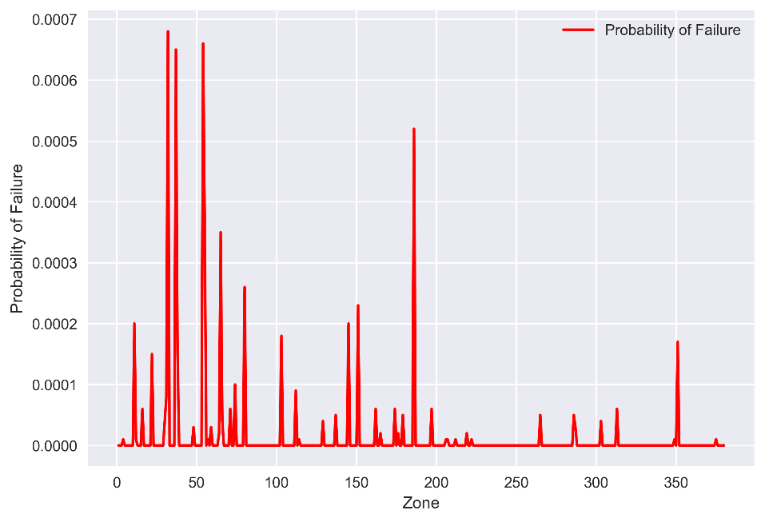
Figure 6.2 Pipeline probability of failure in each zone section before repair
Figure 6.2 reveals that the probability of failure differs across various zone sections. The calculated probability of failure should be lower than the target failure probabilities to meet safety standards. The Det Norske Veritas (DNV) standard (2012) sets target failure probabilities for four limit state types: serviceability (SLS), ultimate (ULS), fatigue (FLS), and accidental (ALS). These are further categorized into three safety classes: low, medium, and high, as detailed in Table 6.1 [57]. For evaluating the performance of existing pipelines, the selected limit state type and safety class should align with those chosen during the design phase. Therefore, this study considers the ULS target failure probabilities to maintain consistency with the design phase. According to the standard, all failure probabilities were below 7×10⁻⁴, with the majority being even lower. To assess the efficiency of repairs, the following section compares the probability of failure after repair, using the current condition of the pipeline as a benchmark.
Table 6.1 Target probability of failure
Limit state | Safety class
Limit state | Low | Medium | High
Service-ability limit state (SLS) | 10⁻² | 10⁻³ | 10⁻³
Ultimate limit state (ULS) | 10⁻³ | 10⁻⁴ | 10⁻⁵
Fatigue limit state (FLS) | 10⁻³ | 10⁻⁴ | 10⁻⁵
Accidental limit state (ALS) | 10⁻⁴ | 10⁻⁵ | 10⁻⁵

The mechanisms for repairing defects of operating pipelines with composite wraps are complex because the tensile properties of composites are quite different from those of steel. Even though composite wraps and pipeline steel have comparable strength, composite wraps possess a significantly lower modulus of elasticity or stiffness [129]. For a comprehensive comparison, a diverse range of thickness and modulus of composite wrap materials was chosen for pipeline repair in this section.

Effects of composite wrap thickness
The common thickness of composite wrap used in pipeline repair may vary based on the specific requirements of the repair. Factors influencing wrap thickness include the type and size of the defect, the operating pressure of the pipeline, the material properties of the wrap, and the desired service life of the repair. The common thickness for GFRP wraps can range from a few millimeters to over a centimeter, depending on the repair scenario [130]. For CFRP, the thickness usually starts at around 1.5 mm for a single layer and can go up depending on the number of layers applied. Multi-layer applications of GFRP and CFRP are common to ensure the repaired section has strength and stiffness. To assess the influence of thickness, we examined a range from 2 mm to 10 mm, maintaining a consistent modulus of 20 GPa. The calculated results using Monte Carlo simulations were presented in Figure 6.3.
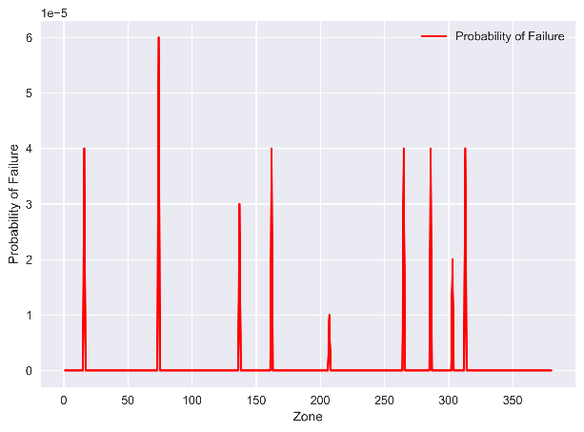
(a)
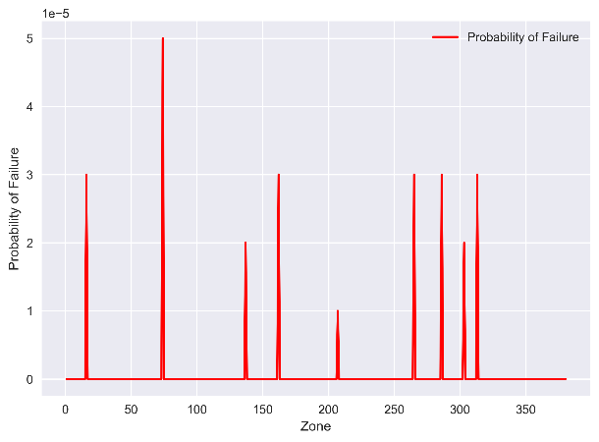
(b)
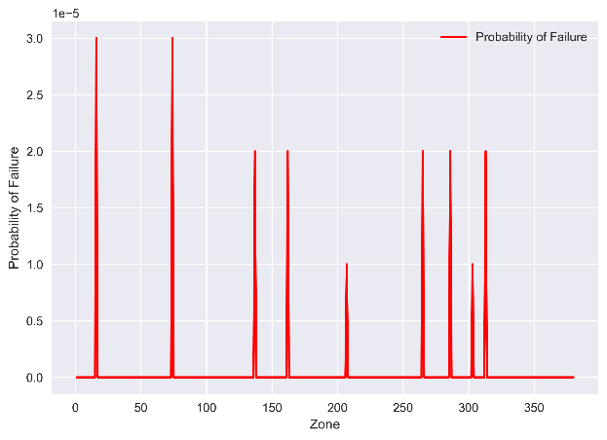
(c)
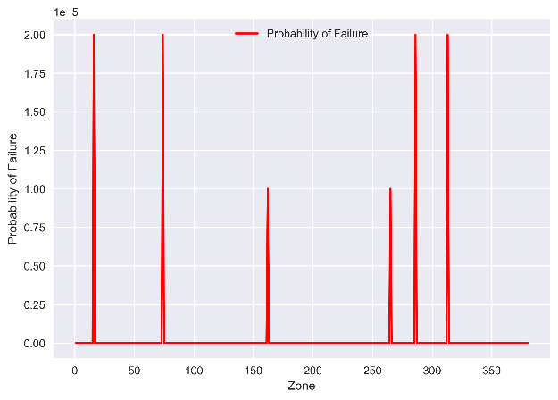
(d)
Figure 6.3 Pipeline probability of failure after repair in each zone (indicated by zone number) with different repair thickness (a) 2 mm, (b) 4 mm, (c) 7 mm, (d) 10 mm
Generally, there is a decrease in the probability of failure as the repair thickness increases at the same location. Using zone 194 as an example, the relationship between thickness and the probability of failure is illustrated in Figure 6.4.

Figure 6.4 Probability of failure versus repair thickness in zone #194
Figure 6.4 illustrates a decreasing trend in pipeline failure probability as the thickness of the composite wrap increases. Specifically, as the wrap thickness rises from 2 mm to 10 mm, the probability of failure drops markedly. This demonstrates that thicker composite wraps provide more substantial reinforcement to corroded pipeline sections, enhancing structural integrity and effectively mitigating failure risk. The improved performance is likely due to the increased load-bearing capacity and stress redistribution enabled by the additional material layers. These findings suggested that increasing wrap thickness can be an effective strategy to enhance pipeline safety.

Effects of composite wrap modulus
Steel generally has an elastic modulus between 200-222GPa. However, composite materials commonly used for wraps, such as GFRP, have an elastic modulus ranging from 17-41GPa. CFRP has an elastic modulus nearly double that of GFRP [131]. For this study, the elastic modulus for composites selected in this study varies from 20-80GPa and a consistent thickness of 2 mm. The results derived from Monte Carlo simulations are presented in Figure 6.5.
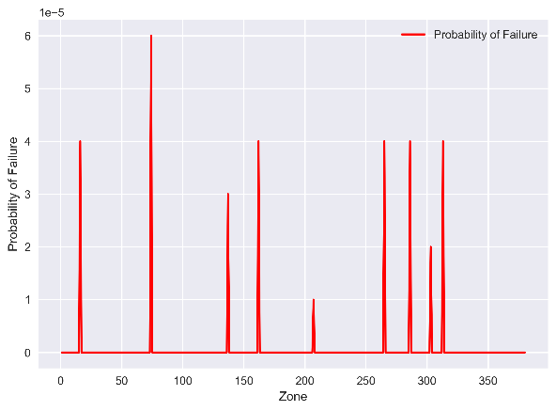
(a)
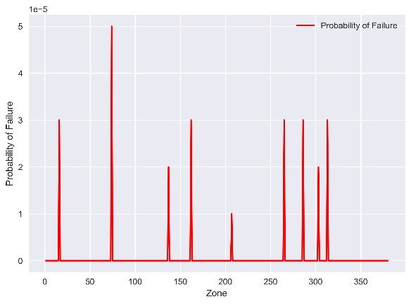
(b)
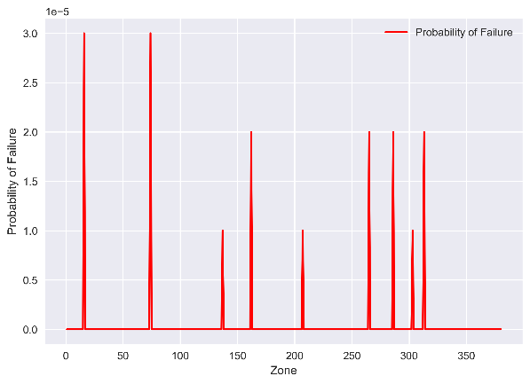
(c)
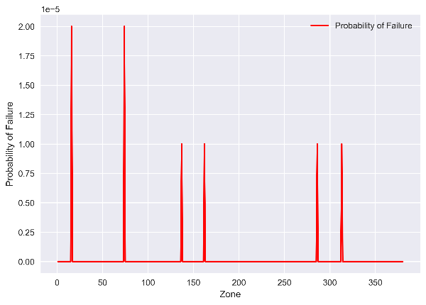
(d)
Figure 6.5 Pipeline probability of failure after repair in each zone section with different material modulus (a) 20GPa, (b) 40GPa, (c) 60GPa, (d) 80GPa
In Figure 6.5, it can be observed that the failure of probability decreased as material modulus increased at the same location. Taking the location of zone #194 as an example, the relationship between modulus and probability of failure is shown in Figure 6.6.

Figure 6.6 Probability of failure versus material modulus in zone #194
The analysis reveals a clear inverse relationship between the material modulus of the composite wrap and the probability of pipeline failure. As the modulus increases from 20GPa to 80GPa, the failure probability decreases significantly. This trend indicates that stiffer composite materials can provide improved structural reinforcement when used to repair corrosion defects in pipelines. Higher-modulus materials more effectively redistribute internal stresses away from defect zones, thereby enhancing the integrity of the repaired section. These results suggest that using high-modulus composites can substantially improve repair performance and reduce failure risk.

Findings
The assessment and mitigation of pipeline failure risks are essential for ensuring long-term pipeline integrity and operational safety. This section presents a comprehensive methodology for quantifying the probability of failure in corroded steel pipelines before and after composite wrap repair, emphasizing the dual failure modes of leakage and burst. The proposed models utilized advanced structural reliability techniques and high-fidelity Monte Carlo simulations to account for uncertainties in corrosion dimensions and material behavior. The main findings are summarized as follows:
- By integrating the effectiveness of composite wrap materials into the limit state functions, the methodology enables more accurate estimation of leakage and burst failure probabilities after repair.
- By incorporating material-specific parameters such as wrap thickness and modulus, the methodology captures the influence of composite wrap configurations on failure probability, providing quantitative insights into design optimization.
- By using predicted corrosion depth and length, and incorporating these predictions into the probabilistic analysis, the method ensures spatially resolved, zone-specific evaluations of pipeline integrity.
- It demonstrates that increasing the composite wrap thickness and modulus significantly reduces failure probabilities, with results benchmarked against the target failure thresholds.
The developed probabilistic framework of quantifying the probability of failure provides a practical and effective tool for planning and evaluating composite wrap repairs and decision-making in future pipeline maintenance.

Decision Making of Inspection and Repair Strategy

Optimized Inspection and Repair Strategy using Reinforcement Learning

7.1.1 Reinforcement learning framework
This section employs a RL framework for optimizing pipeline maintenance decisions, as illustrated in Figure 7.1. The system consists of three integrated components: an agent using Dueling Deep-Q network (DQN), an RL environment modeling the pipeline system, and a cost approximator that helps balance reliability and cost in the maintenance strategy.
The pipeline simulation environment acts as a test bench, combining corrosion growth model and reliability model. This environment processes three possible maintenance actions, including do nothing, composite wrap, and replacement. It also generates state information and rewards for the agent.
Compared with traditional DQN, the Dueling DQN can be more efficient and stable in pipeline maintenance decision-making. This is because some states have similar Q-values regardless of the chosen maintenance action. Dueling DQN separates the Q-value into a state value and an action advantage [132], helping the agent better understand which states are more valuable. This also helps the agent deal with delayed rewards more effectively. Delayed rewards are common in maintenance planning from which the maintenance actions often provide long-term benefits after implementation. Therefore, Dueling DQN encourages preventive maintenance strategies that improve long-term performance and reduce costs.

Figure 7.1 Overall framework of RL-based maintenance plan
The goal is to find an optimal policy as shown in Eq. (7.1) [133].
(7.1)
where, π is a policy and π* is the optimal policy; E[·] is the expectation operator; γ is the discounted factor; R_{t} is the immediate reward at time step t.
The life-cycle cost for each zone can be calculated as Eq. (7.2). And the total cost is the sum of life-cycle cost of each zone.
(7.2)
where, n_{in} is the inspection times; C_{in} is the inspection cost for one zone; t_{ini} is the year when i_{th} inspection for the corresponding zone occurs; n_{s} is the number of times the composite wrap is used; C_{s} is the composite wrap cost; r is the annual discount rate, which is 0.03 in this case; t_{si} is the year when i_{th} composite wrap repair occurs; n_{r} is the number of times the replacement is used; C_{r} is the replacement cost; t_{rj} is the year when j_{th} replacement occurs; ΔP_{li} is the is the incremental leakage failure probability in year i; C_{l} is the leakage failure cost; ΔP_{bi} is the is the incremental rupture failure probability in year j; C_{b} is the rupture failure cost.

State space
The state space is designed to comprehensively represent the condition of pipelines. Each state is a multi-dimensional vector that includes time, failure probabilities, maintenance history, corrosion metrics, and cumulative costs. This structure provides the agent with the information needed to make optimal maintenance decisions by capturing both current deterioration and past interventions. It also helps the neural network recognize patterns between corrosion growth, maintenance actions, and failure risks, leading to more accurate Q-value predictions.
The state at time t is defined as Eq. (7.3).
(7.3)
where, Δt is the year since simulation starts; M_{s} is the maintenance history for each zone; d is the corrosion depth; l is the corrosion length; r_{remain} is the remaining service life ratio; C_{cum} is the cumulative discounted cost at time t.

Action space
The action space includes three discrete maintenance options: (i) Do nothing, allowing the pipeline to continue degrading without intervention, (ii) Apply a composite wrap to slow down corrosion, or (iii) Replace the pipeline section to fully restore its condition. These actions create a clear trade-off mechanism between immediate maintenance costs and future expected failure costs. It enables the agent to dynamically balance preventive and corrective maintenance strategies based on changing condition of the pipeline.
The discrete action space includes three options as presented in Eq. (7.4).
(7.4)
where, A is the action space; 0, 1, 2 represent the action index.

Reward function
The reward function is designed to guide the agent toward optimal maintenance decisions through multiple weighted components. The primary component is the negative increase in total lifecycle cost, encouraging actions that minimize cumulative cost. Bonus rewards are given when the agent selects economically optimal actions, while severe penalties are applied for allowing high-risk states with high failure probabilities. At each time step, the environment calculates the most cost-effective action based on current failure probabilities, maintenance costs, and future risks. The action with the lowest total expected cost is identified as the economically optimal choice.
The reward received after action a_{t} is shown in Eq. (7.5).
(7.5)
where, ΔC_{cum} represents the increase in cumulative discounted cost due to action a_{t}; b_{opt} is a bonus for choosing economically optimal actions; p_{risk} is a penalty if failure probability exceeds the threshold.

Learning algorithms
The neural network structure includes two dense layers with 256 neurons and batch normalization, followed by a layer with 128 neurons and a dropout rate of 0.3. This structure then splits into separate value and advantage streams, each containing 64 neurons. The learning algorithm uses a Dueling DQN with prioritized experience replay to improve sample efficiency and learning stability. An epsilon-greedy policy with biased exploration favors preventive actions during the early stages of training. Early stopping is implemented based on the stabilization of lifecycle costs, ensuring convergence without overfitting. The target network is updated every ten episodes to support stable learning. The reward function penalizes increases in cost while providing bonuses for economically optimal decisions and for maintaining pipelines within safe operational conditions. The training process also incorporates early stopping with a patience threshold to further guard against overfitting. The pseudocode of the implemented Dueling DQN algorithm for optimal pipeline maintenance plan is shown in Figure 7.2.
Figure 7.2 Pseudocode of the Dueling DQN algorithm
The Q-value is calculated as Eq. (7.6) [132].
(7.6)
where, Q(s,a) represents Q-value at state s and action a; V(s) represents the state value function; D(s,a) is the advantage function; |A| is the number of possible actions; a’ represents all possible actions in the action space A.
It implements prioritized experience replay where experiences are stored with priority p_{i}, as shown in Eq. (7.7) [134].
(7.7)
where, δ_{i} is the temporal difference error; ε is a small positive constant to ensure nonzero probability; α controls the level of prioritization.
The loss function used to train the network is the Huber loss, as shown in Eq. (7.8) [135].
(7.8)
where, L(θ) is the loss function that measures the error between the predicted Q-value and the target value during training; θ is the parameters of neural network; y_{t} is the target value at time t; δ is the Huber threshold.

7.1.2 Case study
The dataset used here was obtained from a buried gas pipeline with a total length of 112 km, the second dataset collected from the pipeline operator as introduced before. The pipeline has been in service since 1969 and is made of grade X52 steel. It has an outside diameter of 457.2 mm and a wall thickness of 6.4 mm. Two ILI inspections were conducted, one in 2005 using MFL technology and the other in 2010 or 2011 using straight beam ultrasound technology. These inspections recorded external corrosion data, including corrosion depth and length.
External corrosion was influenced by soil conditions along the pipeline. In 2012, a soil survey was conducted at 200-meter intervals along the pipeline, dividing it into 559 zones. Of these, 390 zones contained recorded corrosion defects. The survey measured several soil parameters, including redox potential, resistance, resistivity, pH, carbonate and bicarbonate concentrations, chloride and sulfate concentrations, soil moisture, and soil type. In each zone, all these soil properties were assumed to be the same.

Multi-zone maintenance plan
To simulate maintenance optimization in this case, cost values for each activity should be determined. For inspection, the average cost of unit inspection with ILI is calculated to be $33,000/mile [136], although the average inspection cost for short length pipeline would be higher. Therefore, the unit inspection cost is about $4,100 for each zone. The repair cost includes labor, equipment, and indirect expenses. Based on the guideline of composite repair from one contractor [137], the composite wrap for a 18-inch diameter pipeline is about $6,510, while the replacement cost is about $35,251 for each zone. Failure costs can vary widely depending on the severity of the incident, making it difficult to define a representative value. According to data from the Pipeline and Hazardous Materials Safety Administration (PHMSA), the consequence costs of rupture due to pipe burst in gas pipelines are summarized in Table 7.1. These costs include property damage cost (the total cost of public and non-operator private property damage, operator’s property damage and repairs, and lost commodities) and the costs for emergency response and environmental remediation, but it does not include civil penalty by violation of federal pipeline safety regulations, fatalities, and injuries.
It is noted few field data are found available for small leakage cost. Thus, the small leakage cost was assumed to be 10% of the consequence cost of burst failure. For the baseline case simulation, the median cost of burst failure of $396,261 was selected, while other values were used later in a sensitivity analysis. Table 7.2 summarizes all cost values used for the baseline case.
Table 7.1 Statistics summary of consequence costs of burst failure in gas pipelines (from PHMSA database)
Percentile | Minimum | 25th | Median | 75th | Maximum
Cost value ($) | 31,500 | 101,835 | 396,261 | 978,273 | 66,046,140
Table 7.2 Summary of different types of cost data
Inspection (per zone) | Composite wrap  (per zone) | Replacement  (per zone) | Small leakage | Burst
$4,100 | $6,510 | $35,251 | $3,963 | $396,261
After composite wrap repair, the corrosion environment around the defected area is significantly improved due to the isolation from external corrosive agents such as moisture, oxygen, and soil electrolytes. However, minor corrosion may continue over time because of potential imperfections in wrap installation or material aging effects. To reflect this behavior, it is assumed in this study that the post-repair corrosion rate decreases substantially compared to the pre-repair corrosion rate. In the base case, a corrosion reduction factor of 0.1 was applied, indicating that the corrosion rate was reduced to 10% of its original level after composite wrap repair. After the replacement, the corrosion condition of pipeline in that zone is reset to its initial state in 1969, and the subsequent corrosion growth follows the same trend as that of a newly installed pipeline. To reflect practical constraints, the same corrosion defect is allowed to receive at most one composite wrap repair over the entire lifecycle. If a zone has already undergone a composite wrap repair, future maintenance actions must be replaced. The initial failure probability threshold was set as 10⁻² to reflect the serviceability limit state for lower safety class based on the Det Norske Veritas (2012) standard. Sensitivity analysis is conducted on the threshold from 10⁻⁵ to 10⁻² to cover all safety classes and to evaluate the robustness of the optimized plans under more conservative risk criteria. The maintenance planning horizon was from 2010 to 2050, covering a 40-year period.
Another important parameter for simulation is the operating pressure of the pipeline. When all other parameters remain constant, an increase in operating pressure significantly raises the risk of failure. If the operating pressure is too low, the burst failure probability becomes negligible. In such cases, the burst failure cost has little impact on the maintenance plan, making it ineffective in guiding optimization decisions. As reported by Dana, Brian, David and Pye [138], typical operating pressure for natural gas pipelines ranges from 1.5 to 10.5 MPa. Therefore, an operating pressure of 8.5 MPa was selected for case study here, which is about 63% of yield stress (13.42MPa) based on the steel type, outside diameter, and wall thickness of pipeline in the second dataset. This relatively high value helps demonstrate the efficiency of the RL model under more critical conditions.
After determining the numerical parameters mentioned above, Figure 7.3 presents the optimized maintenance results for multiple zones using the proposed RL model.
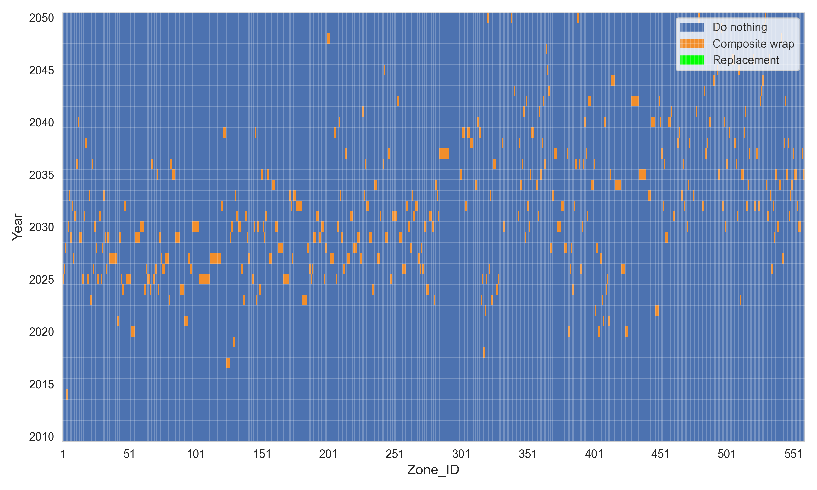
(a)
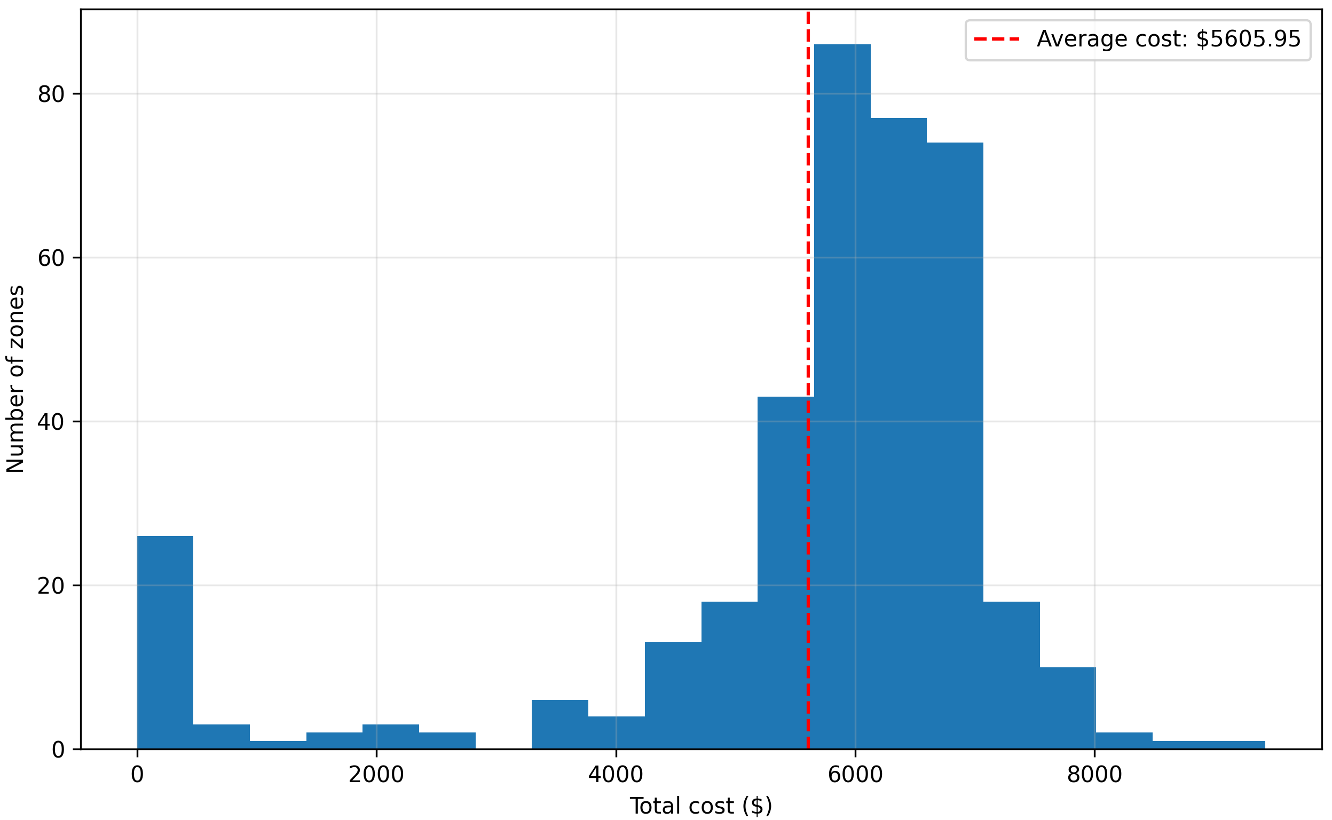
(b)
Figure 7.3 (a) Maintenance matrix for multiple zones; (b) Cost distribution for multiple zones
The maintenance matrix in Figure 7.3 (a) visualizes the spatial-temporal distribution of maintenance actions from 2010 to 2050. In the figure, blue cells represent zones where no maintenance is needed, orange cells indicate the application of composite wrap repairs, and green cells correspond to replacement repairs. It is evident that most of the pipelines remained in acceptable condition, as shown by the predominance of blue areas. Maintenance activities were more frequently scheduled between 2025 and 2035. Interestingly, there were no zones needed to be replaced according to this figure, indicating that the composite wrap repair was enough in this case. The x-axis shows maintenance actions distributed irregularly across the pipeline, implying that corrosion-prone areas were scattered rather than localized. In total, the planned maintenance interventions for all affected zones were estimated to cost $ 2,186,320.
Taking Zone 531 as an example, Figure 7.4 shows the changes in failure probability from 2010 to 2050. The selected maintenance year was 2031, and the maintenance action was composite wrap. Before 2031, both leakage and burst failure probabilities increased. After maintenance in 2031, the failure probabilities dropped to near zero, indicating the repair successfully restored the condition of pipeline. The choice of 2031 and composite wrap by the RL model suggested this maintenance plan could provide the lowest life-cycle cost.

Figure 7.4 Changes in failure probability over time
Compared to traditional strategies such as periodic maintenance, RL provides a more adaptive and efficient approach to pipeline maintenance. Unlike fixed-interval methods that apply the same maintenance schedule regardless of actual pipeline conditions, RL continuously learns from the system state and optimizes decisions based on long-term rewards. It considers the evolving condition of each zone and selects maintenance actions that minimize the total life-cycle cost.

Effects of failure costs
Fig. 7.5 presents the sensitivity analysis of consequence costs on the total life-cycle costs. As the consequence cost increased, a clear shift in cost distribution was observed. As the consequence cost of pipe burst was $396,261, the total cost reached $2,186,320. In this case, with relatively moderate spending on inspection and repairs, the life-cycle costs are optimized to achieve the probability of failure lower than the limit. As the consequence cost increased to $978,273, the RL model became more proactive. This resulted in more frequent inspections and repairs with higher costs for inspection and composite wrap repair. As the consequence cost increased to $66,046,140, the model became highly conservative. It significantly increased the frequency of inspections and repairs to avoid costly failures. Inspection costs increased to $920,932, and composite wrap repair costs reached $1,462,261. Meanwhile, the failure cost dropped to $86,503. These results show that when the consequence cost is very high, spending more on preventive maintenance becomes a more economical choice. This is because the substantial reduction in failure cost can offset the additional inspection and repair cost.

Figure 7.5 Impact of consequence costs of pipe burst on life-cycle costs (log-scale at x axis)
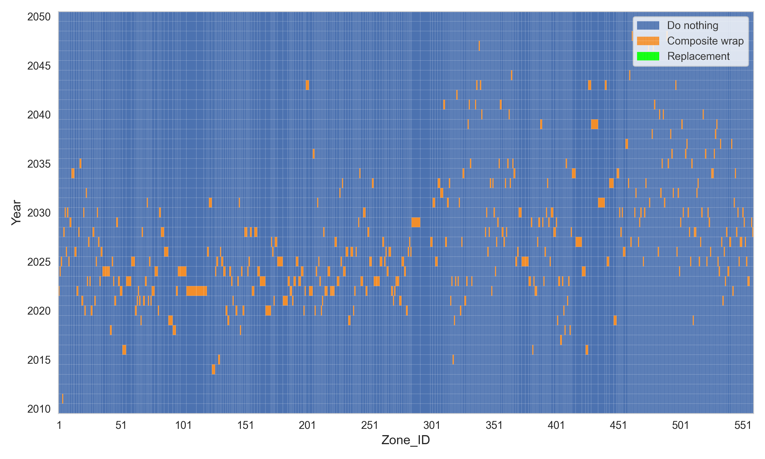
(a)
(b)
Figure 7.6 (a) Maintenance matrix using maximum failure cost; (b) density distribution of maintenance actions using different failure costs
Figure 7.6 (a) presents the optimized maintenance matrix using maximum failure cost. Figure 7.6 (b) shows the distribution of maintenance actions under three different failure cost levels. When the failure cost was set at median value ($396,261), the peak of maintenance actions occurred around 2030. The model allowed moderate corrosion growth before repairs, as the cost of failure (consequence) was relatively low. At the 75th percentile failure cost ($978,273), the peak shifted to an earlier time. The model became more conservative and scheduled repairs earlier to reduce the risk of failure. At the highest failure cost of $66,046,140, maintenance actions happened even earlier, with a peak around 2025. The RL model prioritized early intervention to avoid severe consequences. Repairs were scheduled before the corrosion defects grow to severe condition.
This change reflected a more proactive strategy focused on minimizing the risk of costly failures. The comparison showed that the failure costs could significantly impact on maintenance planning. The RL model was able to adapt maintenance timing based on changing failure cost. As the cost of failure increased, the model prioritized earlier actions to reduce failure risks.

Effect of failure probability threshold
Figure 7.7 shows the impact of different failure probability thresholds on life-cycle costs. As the threshold increases, the model becomes more tolerant to the failure risk, which leads to changes in cost distribution.

Figure 7.7 Impact of failure probability threshold on life-cycle cost
At a strict threshold of 10⁻⁵, the model adopted a conservative strategy. The total cost reached its highest value of $2,451,649. This is due to high inspection and repair efforts. Failure cost remained minimal at $190, indicating that the model avoided failure through early intervention. As the threshold was relaxed to 10⁻⁴ and 10⁻³, both inspection and composite wrap costs gradually decreased. At the highest threshold of 10⁻², the model allowed for a higher risk of failure. Preventive actions were reduced, with inspection and composite wrap costs reaching their lowest levels. The failure cost increased significantly, while the total cost was still the lowest at $2,186,320.
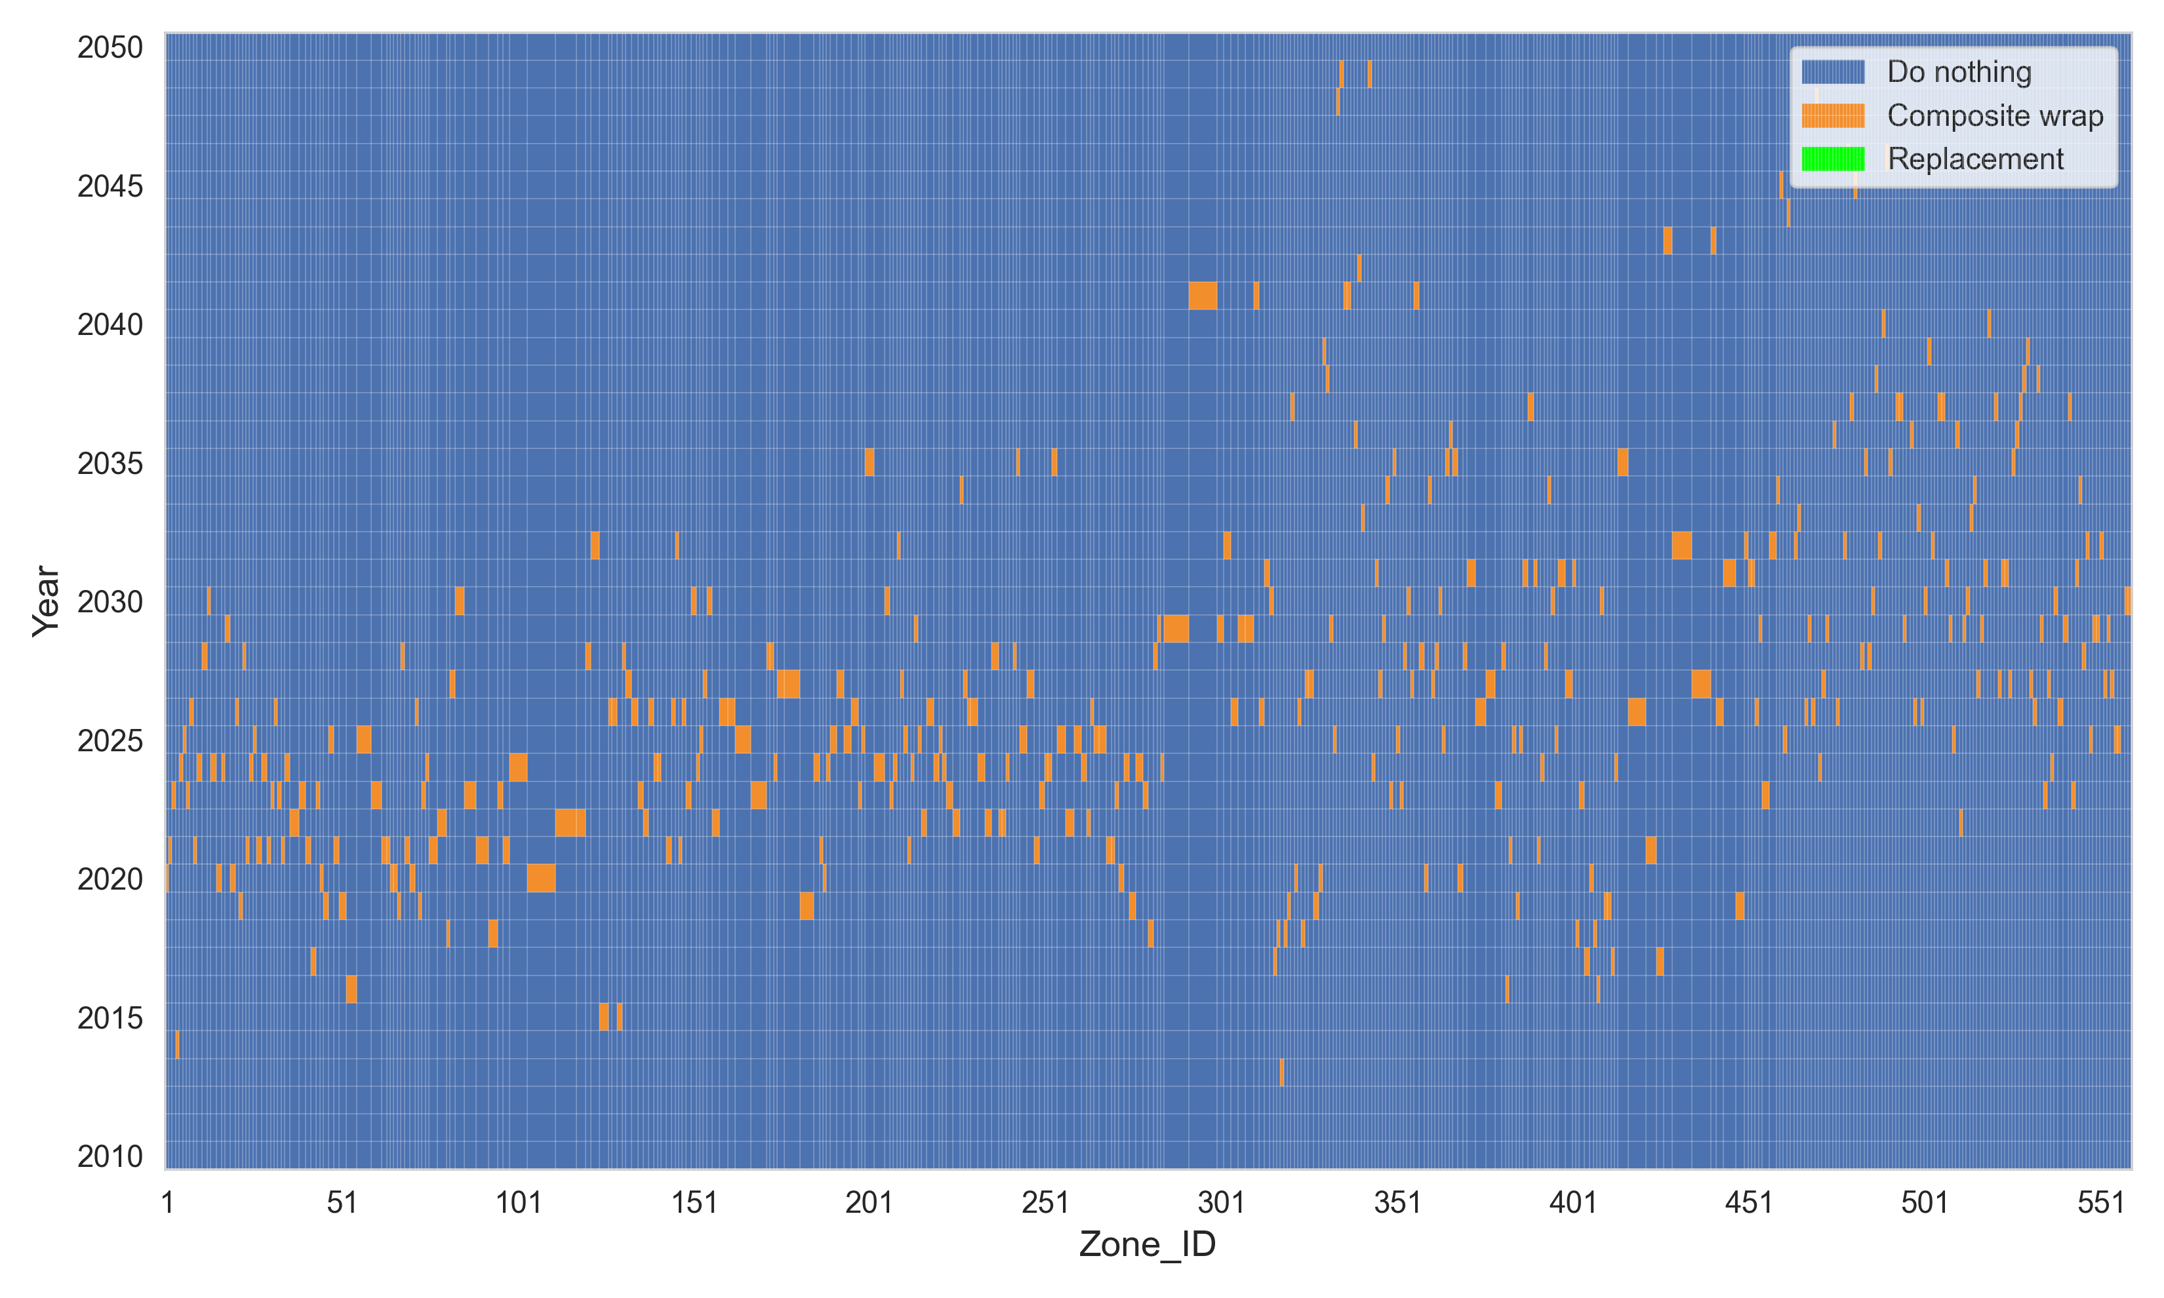
(a)
(b)
Figure 7.8 (a) Maintenance matrix using 10⁻⁵ threshold; (b) density distribution of maintenance actions using different thresholds
Figure 7.8 illustrates how different failure probability thresholds affect the timing and distribution of pipeline maintenance actions. In Figure 7.8 (a), most zones received composite wrap repairs early, particularly between 2020 and 2030. This suggested that under the requirement of lower threshold of failure probability, the model encouraged early interventions to reduce the risk of failure. Figure 7.8 (b) presents the density distribution of maintenance actions under four different thresholds. As the threshold became more relaxed, the peak of maintenance actions shifted to later years. Under the strictest threshold of 10⁻⁵, the peak occurred around 2025, indicating proactive scheduling. With thresholds of 10⁻³ and 10⁻², the peaks were further delayed toward 2030 to optimize the life-cycle costs with the necessary maintenance scheduled at the tolerable risks.
These results showed that the choice of failure probability threshold significantly influenced the timing of maintenance actions. Stricter thresholds led to early interventions, while relaxed thresholds would delay maintenance to later years.

Effect of unit inspection costs
Figure 7.9 presents the impact of unit inspection cost on the overall life-cycle cost of the pipeline system. As the unit inspection cost increased, total life-cycle costs increased accordingly due to more inspections are required to reduce the probability of failure with tolerable risks. However, the numbers of inspections and the subsequent composite repairs are adjusted to optimize the overall cost and failure costs increased slightly due to the higher probability of failure by the reduced numbers of inspections and the repairs.

Figure 7.9 Impact of unit inspection cost on life-cycle cost.
Changes in unit inspection cost had limited influences on the maintenance schedule. When the unit inspection cost was zero, the total life-cycle cost was $1,344,257. The RL model at this point adopted a strategy of frequent inspections and repairs to reduce failure risk. As the unit inspection cost increased to $2,000, the total cost increased to $1,754,457. The composite wrap cost dropped slightly to $1,224,927, suggesting that the number of repairs did not decrease significantly. At the highest unit inspection cost of $8,000, the total life-cycle cost reached its maximum, but the composite wrap cost further decreased to $1,205,434. These results indicate that increasing inspection cost reduced the numbers of inspections and repairs slightly. However, inspection and repair are still necessary to prevent failures, which are determined by the failure probability threshold. Even at high unit cost of inspection, the model continues to recommend necessary inspections to ensure safety.

Effect of corrosion reduction factor
Figure 7.10 shows the impact of corrosion reduction rate on life-cycle costs. The reduction rate reflected the effectiveness of composite wrap repair in slowing down subsequent corrosion.
At a reduction factor of 0.1, the total life-cycle cost was the lowest. No replacement actions were needed. Most zones require only one composite wrap repair. The composite wrap was highly effective and kept failure risk under control. This scenario represented the ideal condition where repair performance was strong enough to prevent further deterioration. When the reduction factor was over 0.4, the total cost increased significantly. However, the composite wrap cost remained constant, suggesting that the same number of wrap actions was applied. In contrast, both replacement and failure costs increased. This shift occurred because the reduced repair effectiveness cannot sufficiently slow down the corrosion growth, leading the model to adopt more expensive replacement actions.

Figure 7.10 Impact of corrosion reduction factor on life-cycle costs

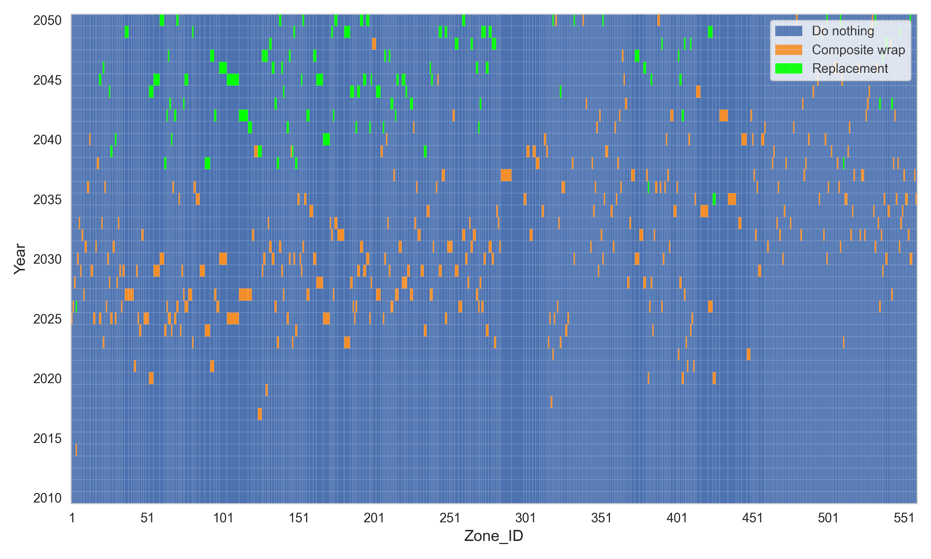
(a)
(b)
Figure 7.11 (a) maintenance matrix at a reduction factor of 0.5; (b) density distribution of maintenance actions using different reduction factors
Figure 7.11 demonstrates how the effectiveness of composite wrap repair influences the scheduling of maintenance actions. In Figure 7.11 (a), the maintenance matrix at a reduction factor of 0.5 shows a wider spread of maintenance actions, with a noticeable portion of replacements occurring after 2040. This indicated that when the repair was less effective, some zones required more aggressive interventions like replacements due to continued deterioration.
Figure 7.11 (b) shows the density distribution of maintenance actions under five reduction factors ranging from 0.1 to 0.5. A lower reduction factor means that the corrosion rate is significantly reduced after composite wrap, while a higher factor means less reduction in corrosion.
In all scenarios, the first round of composite wrap repairs was concentrated around the year 2030. This indicated that the model identified this period as the most effective window for initial maintenance. When the reduction factor was low, the composite wrap repair could slow down the corrosion growth effectively. Therefore, most zones required only one maintenance action, and no further maintenance was needed throughout the remaining service life. In contrast, when the reduction factor increased to 0.4 or higher, the effectiveness of repair decreased a lot. Many zones began to experience continued deterioration after the initial repair. This led to a second round of maintenance actions, especially after 2040. The model had to use replacements to prevent failure, even though replacements were more expensive.
The results showed that the effectiveness of repair had significant impact on optimal maintenance plans. Weaker repair effectiveness caused the model to schedule more frequent and costly maintenance.

Effect of operating pressure
Figure 7.12 presents the impact of changing pipeline operating pressure on total life-cycle cost and its individual components. The results show that total life-cycle cost increased significantly with higher operating pressure. This increase was primarily driven by the increase in failure cost and composite wrap cost. As the pressure increased, the risk of burst failure in corroded zones became more severe, leading to higher expected failure costs. At high pressure levels, RL recommended more frequent inspections to manage increasing risk. Interestingly, replacement cost remained zero at lower pressure levels but became non-negligible at 10.5 MPa. This indicated that at very high pressure, composite wrap repairs were not sufficient to ensure reliability.

Figure 7.12 Impact of operating pressure on life-cycle cost
Figure 7.13 shows the impact of different operating pressure levels on maintenance scheduling strategies. In Figure 7.13 (a), some zones scheduled replacement as early as 2010. This suggested that the RL model found replacement in the first year to provide higher long-term benefits than using composite wrap. Under extremely high pressure, the remaining strength of these zones was insufficient to withstand future loading, even after composite wrap repair. Composite wrap could only delay failure for a short period in these cases. In contrast, replacement restored the pipeline to a new condition, eliminating failure risk and reducing the need for repeated maintenance. It showed the ability of RL model to minimize total life-cycle cost rather than just save short-term cost.
As shown in Figure 7.13 (b), when the operating pressure was highest at 10.5 MPa, most maintenance actions were scheduled around 2015. As the operation pressure decreased, the peak of maintenance actions shifted to later years. For example, the peak appeared around 2030 for 8.5 MPa. while the peaks of maintenance actions under 6.5 MPa and 7.5 MPa are shown after 2030. This trend indicated that higher operation pressure increased the failure risk significantly and required earlier interventions to prevent failure.
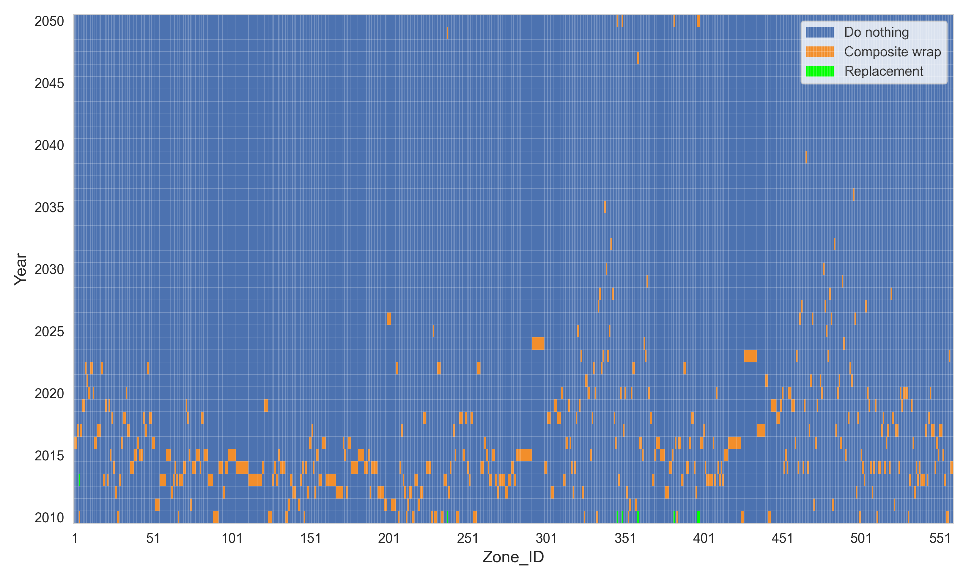
(a)
(b)
Figure 7.13 (a) Maintenance matrix using 10.5 MPa operating pressure; (b) density distribution of maintenance actions at different pressure levels

7.1.3 Findings
This section developed a multi-zone pipeline maintenance strategy based on reinforcement learning. BNN-based corrosion growth models were developed to represent corrosion conditions in different zones. The Dueling DQN algorithm was used to find the optimal maintenance schedule for each zone by minimizing total life-cycle costs. Based on the analysis, the following conclusions can be drawn:
- The proposed RL model provides an adaptive and efficient approach to pipeline maintenance considering the corrosion growth uncertainty. It adjusts the maintenance strategy for each zone according to its specific corrosion conditions, which can achieve better long-term cost-effectiveness.
- Failure cost values have a significant influence on maintenance scheduling. As the failure cost increases, the RL model adjusts its strategy by scheduling repairs earlier to prevent high-consequence failures.
- The choice of failure probability threshold significantly influenced the timing of maintenance actions. Stricter thresholds lead to early interventions, while relaxed thresholds will delay maintenance to later years.
- The effectiveness of composite wrap repair has significant impact on maintenance planning. Weaker repair effectiveness causes the model to schedule more frequent and expensive maintenance.
- Higher operating pressure significantly increases failure risk and total life-cycle cost. The RL model tends to schedule earlier and more frequent maintenance actions under such conditions. At high pressure level like 10.5 MPa, using replacement in the beginning can provide greater long-term benefits than using composite wrap.
This study proposed an innovative RL-based approach for long-term maintenance decision-making in multi-zone pipeline systems. The current model relies on several assumptions, including estimated cost values and repair effectiveness. For application in real-world projects, it is necessary to obtain accurate cost data and validate the actual performance of maintenance actions. Therefore, this study serves primarily as a conceptual framework, and further refinement is required before implementation in practice.

Analytical Framework for Time-Dependent Failure Modeling Under Repair
Pipelines operating under corrosive or degrading conditions are subject to time-dependent structural deterioration that may eventually lead to failure. Accurate prediction of failure probability over the service life is essential for planning inspection intervals, setting repair thresholds, and optimizing life-cycle maintenance strategies. In this context, a probabilistic analytical framework is presented that models the evolution of failure probability for pipelines with growing defects, while accounting for potential repair actions performed at scheduled inspections.

7.2.1 Theory background
The core of the framework is a decision tree structure that represents all possible sequences of inspection outcomes and corresponding repair decisions throughout the service life of the asset. Each branch of this tree corresponds to a unique combination of repair actions, and the cumulative distribution function (CDF) of failure is computed recursively for each branch. By aggregating these branch-level CDFs according to their probabilities of occurrence, the total time-dependent CDF of failure under the impact of repairs can be obtained.
To model the evolution of failure probability over the service life, a decision tree is constructed that accounts for all possible combinations of repair actions at predefined inspection times. At each inspection, a binary decision is made: to repair or not using a predefined repair criterion. Repair only happens right after an inspection. This leads to 2^{n} possible branches for n inspections during service life. Each branch represents a distinct failure trajectory under a unique repair history. Figure 7.14 shows a decision tree where there are various scenarios (branches) due to possible failure occurrences and repair actions. As shown in Figure 7.14, failure can occur before any scheduled inspection time. If no failure occurs (marked as event $\overline{F}$), before the first inspection time t₁, an inspection is conducted at t₁, and a repair action is performed (marked as event R_{1,1}) if the defect size meets the repair criterion. After the 1st inspection and/or repair, the consecutive inspection and repair actions are performed if no failure occurs before the inspection time t₂. Whenever a failure happens (marked as event F), it is assumed that a replacement will take place, and one can reset t = 0 as if the system restarts from the initial state.
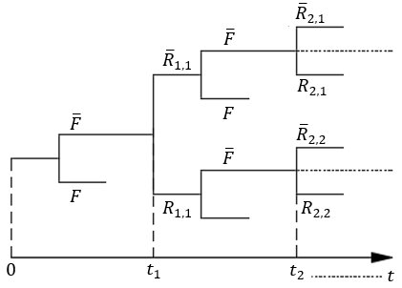
Figure 7.14 Decision tree (F: failure, $\overline{F}:$survival, Ri,j: repair conducted at t_{i} on branch j (j = 1, 2, …2^{i-1})
The probability of failure, P_{f}, is defined as the conditional probability of attaining or exceeding prescribed limit states given a set of boundary variables, and can be written as:
$$P_{f}\left(t\right)=\int_{C\left(t\right)-D\left(t\right)≤0}^{.}{f\left(X\right)dX}$$ | (7.9)
Where, f(X) is the joint probability density function of a vector of random variables, X; C(t) ‒ D(t) ≤ 0 refers to the failure domain in which C is the capacity of the pipe for the failure mode considered, and D is the demand. For example, for small leak failure, C is usually defined as 0.8 of the wall thickness and D refers to maximum depth of the corrosion defect at time t; for burst failure, C refers to the burst pressure capacity and D refers to the operating pressure. Let T_{f} be the time at which failure occurs since the initial state, then the event of T_{f} > t is equivalent to the event of C(t) >D; thus, P(T_{f} ≤ t) = P(C(t) ≤ D) = P_{f}(t). In other words, P_{f}(t) can be considered as the cumulative distribution function (CDF) of T_{f}. Based on Kere and Huang [139], one can derive the distribution functions of time to the m^{th} failure using the distribution function of T_{f}. Thus, deriving the distribution function of T_{f} is the critical component for the analytical approach.
Figure 7.15 shows the probability of T_{f} over time for a pipeline when two inspections are performed at Year 7 and Year 14 during a lifetime of 20 years, assuming there is no failure occurrence and replacement is conducted once the pipe condition meets the failure criterion. Considering the potential repair at each inspection, there are four scenarios: no repair at both inspection times, only repair at the 1st inspection time, only repair at the 2nd inspection time, and repair at both inspection times. Figures 7.15 (a-d) show probability of T_{f} for the four scenarios over time, respectively. As shown in Figure 7.15, when a repair or replacement action is performed, $F_{Tf}$(t) is reset to the initial state. In addition, Figure 7.15 (e) compares the CDF of T_{f}, $F_{Tf}$(t), with no repair actions (shown in solid line) with $F_{Tf}$(t) considering probabilities of branches (i.e., repair/no repair) at both inspections (as shown in dash-dotted line). As expected, Figure 7.15 (e) indicates that the possibility of conducting repair actions lower the $F_{Tf}$(t) values.

$$\overline{R}$$  $$\overline{R}$$  No repair at both inspection times | $$\overline{R}$$  $$R$$  Only repair at 1st inspection time
$$R$$  $$\overline{R}$$  Only repair at the 2nd inspection time | $$R$$  $$R$$  Repair at both inspection times
No maintenance actions  Under maintenance actions  Considering probabilities of repair at both inspection times | $R$ : repair or replacement action  $\overline{R}$ : no repair or replacement action
Figure 7.15 CDF of T_{f} with two inspections
The base of the decision tree is the top branch shown in Figure 7.14, which represents the case where no repairs are conducted during the service life. At each inspection, the failure probability is updated by conditioning on the assumption that the system has not failed and no repairs have occurred up to that point. This results in a time-dependent, recursive construction of the failure probability, where each new segment of the CDF accounts for the incremental risk after the previous inspection. This process continues across all inspection intervals and produces the cumulative distribution of failure for the no-repair case, which forms the base of the overall decision tree framework.
To compute the CDF of T_{f} for each branch between two consecutive inspections, as discussed previously, all possible repair histories are simulated using a binary decision tree and recursively compute branch-level failure probabilities. Each branch corresponds to a unique sequence of repair and no-repair decisions at inspection times. In this context, each branch needs two items: (1) the probability of each branch (characterized by the repair actions at each inspection) and (2) the CDF of T_{f} for the time points between two consecutive inspections. The likelihood of a branch depends on the sequence of inspection outcomes and whether a repair is performed or not at each point. These probabilities are computed using conditional probabilities derived from the time since the last repair and the repair strategy adopted. As a result, each branch has a unique weight representing its overall contribution to the total system behavior. The failure probability along each branch is determined by tracing the impact of repairs on defect growth. If a repair effect is assumed to reset the degradation process, the cumulative probability of failure along a branch is thus built from a series of intervals between repairs, considering the system must survive earlier intervals to fail in later ones.
After calculating the CDF of T_{f} for each branch in the decision tree, the overall CDF of T_{f} is computed using the weighted average of the branch CDFs, where the weight corresponds to the probability of corresponding branch.

7.2.2 Case study
A simple case study is used here to validate the proposed analytical framework to estimate the time-dependent failure probability of a corroded pipeline under an inspection and repair strategy using Monte-Carlo simulation approach. The system is evaluated over a total service life of 50 years, during which in-line inspections are conducted every 5 years. Therefore, 9 inspections are conducted before the end of service life. The system involves a single joint with growth of single defect over time. At each inspection, a repair is triggered if the measured defect depth at a given time t, d(t), exceeds 80% of the pipe wall thickness, d_{w} (i.e., d(t) > 0.8⋅d_{w}). Meaning that if the defect depth at any inspection exceeds this threshold, the pipe joint is assumed to be repaired. It is also assumed that the repairs are perfect meaning that the pipe is restarted from initial condition, which can be considered as a replacement. The degradation process of defect depth at any time t is modeled as:
(7.10)
Where, d₀ = the initial defect depth, and a = defect growth rate. The probability of failure, P_{f}(t), is defined as the likelihood of leaking pipeline when the defect depth at time t, d(t), becomes greater than the wall thickness of the pipe, d_{w}, which can be expressed as:
(7.11)
The random variables considered in this case study are listed in Table 7.3.
Table 7.3 Statistical parameters of random variables used in the case study
Random variable | Distribution | Mean | C.O.V. (%)
Nominal wall thickness, d_{w} (mm) | Normal | 14.06 | 1.5
Initial defect depth, d₀ (mm) | Weibull | 0.582 | 72
Defect depth growth rate, a (mm/year) | Weibull | 0.576 | 70.3

In the Monte Carlo simulation approach, a large number of defects are simulated by random sampling from Table 7.3. For each simulated defect, the depth is projected over time. At each time step, the simulated defect depth is compared against the sampled wall thickness (d_{w}) to determine whether failure has occurred. In addition, at each scheduled inspection, the defect depth is compared to a predefined repair threshold, and if it exceeds this criterion, the defect is assumed to be repaired, effectively resetting the defect depth. This process is repeated for a large number of samples (e.g., one million), and the failure probability at each time to be estimated as the proportion of defects that have exceeded the wall thickness. This empirical distribution of failure times serves as a benchmark to validate the analytical results derived from the proposed decision-tree-based framework.
Figure 7.16 presents a comparison the CDF of T_{f} obtained from the analytical approach (shown in solid line) and Monte Carlo simulation (shown in dash-dotted line) considering a fix inspection interval of 5 years over a 50-year service life. Overall, there is a strong agreement between the two CDF curves, showing the proposed analytical approach is validated. In addition, both curves exhibit a stepwise increase corresponding to inspection intervals (every 5 years), highlighting the effect of possible repair after each inspection. The sharp increases after certain inspections (e.g., t = 10, 15) suggest that a notable portion of the population in simulation reaches critical defect depths during those intervals which are similarly reflected in analytical approach, reaffirming the importance of timely inspection scheduling. Notably, the plateaus between steps in both approaches indicate periods where the reduced possibility of failure are expected due to possible repairs by resetting the defect progression at prior inspections.
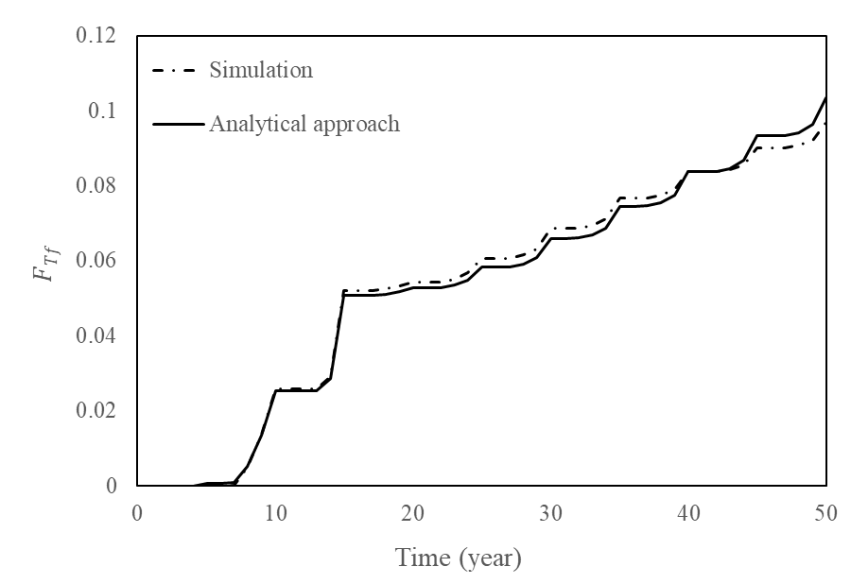
Figure 7.16 Comparison of CDF of corroded pipeline under repair for analytical approach and simulated defect growth

7.2.3 Findings
This section presents an analytical framework for evaluating the time-dependent reliability of corroded pipelines under periodic inspections and repairs. The decision tree-based model successfully captures all possible repair scenarios and computes the cumulative failure probability using a recursive probability framework. A case study involving linear growth of a defect in a single pipeline, and realistic repair thresholds validates the analytical approach against Monte Carlo simulations. The results of probability distribution of failure time demonstrate excellent agreement between analytical and simulation-based methods, confirming the accuracy, and practical utility of the proposed method.
This probability distribution of failure time serves as the basis for life-cycle cost (LCC) analysis, which can be used in the LCC framework developed previously by Kere and Huang [44]. With this analytical approach, one can easily incorporate other repair effects and other uncertainties such as probability of detection and measurement error in inspection into the analysis. In addition, since the number of branches (i.e., 2^{n}) increase significantly when the number of inspections, n, increases; thus, the strategies for how to reduce the computational effort will be explored in the future before it is applied to multiple joints with multiple defects.

LCC of Pipeline with Multiple Joints and Defects
In this section, Monte Carlo simulation methodology is adopted to determine LCC of the entire Mexico pipeline network with multiple defects under the impact of inspection and maintenance planning. The pipeline network consists of a series of joints with each joint length of 12m. Totally 372 joints are identified with defects ranging from 1 defect to a maximum of 18 defects, and with an average of 1.89 defects per joint within the defected joints. The overall profile of the number of defects per joint over the joint numbers is shown in Figure 7.17. Each pipeline joint has a nominal wall thickness of 6.4 mm and a diameter of 457.2 mm. The pipeline is made from API 5 L grade X70 steel with a specified minimum yield strength of 400 MPa and a specified minimum tensile strength 532 MPa.
Figure 7.17 Number of defects per joint with at least one defect

7.3.1 Assumptions
In this study, the LCC of the entire pipeline under the impact of inspections, repairs and failures are determined by calculating the LCC for each joint and aggregating it on entire pipeline network. The failure considered here refers to burst failure. It is assumed that when there is a failure due to a defect, the joint where the defect is located will be replaced; when there is a defect within a joint reaches the repair criteria at inspection time, the entire joint will be repaired. For simplicity, it is also assumed that after replacement or repair, the same number of defects will re-start growing following the same growth models with the same initiation times; the inspection time follows a fixed interval, and all joints follow the same inspection time. The lifecycle cost is calculated in terms of the initial cost of construction, C₀, and the corresponding inspections, repairs and failure costs are determined as factors of C₀. The factors considered for inspection, repair and failure in this case study are 0.002, 0.02, and 0.47.
Each defected pipeline joint comprises of defects that grow in two dimensions i.e., depth and length and are modeled by utilizing growth, where the initiation times and growth model parameters associated with the defect depth and defect length are estimated in Section 2. The initiation times for the depth growth range from 0.71-27.74 years and the length growth range from 0.28-33.43 years. The mean values of C₁ and C₂ parameters for each joint are estimated based on the soil properties associated with the corresponding joint. The complete statistics of the random variables adopted in this study are listed in Table 7.4 and the corrosion defect model parameters related statistics utilized in the case study are highlighted in Table 7.5.
Table 7.4 Distribution parameters of random variables used in the case study
Random variable | Mean value | COV (%) | Distribution
Outside diameter of pipe, D (mm) | 457.2 | 3 | Normal
Wall thickness, d_{w} (mm) | 6.4008 | 3 | Normal
Yield strength, σ_{y} (MPa) | 400 | 3 | Normal
Ultimate strength, σ_{u} (MPa) | 532 | 3 | Normal
Operating pressure, P_{op} | 10 | 15 | Normal
Burst pressure model error, χ | 0 | 1.8442* | Normal
*Values highlighted with * are standard deviation

Table 7.5 Corrosion defect model parameters statistics used in the case study
Random variable | Mean value | COV (%) | Distribution
C_{1,D} | 0.06-0.08 | 50 | Normal
C_{2,D} | 0.95-1 | 50 | Normal
C_{1,L} | 0.09-0.14 | 50 | Normal
C_{2,L} | 1 | 50 | Normal
Model error for depth growth, e_{D} | 0 | 0.148* | Normal
Model error for length growth, e_{L} | 0 | 0.336* | Normal
*Values highlighted with * are standard deviation

The burst failure is considered as a failure mechanism that is triggered when the pressure capacity of the pipeline is less than the operating pressure. The pressure capacity of the pipeline can be determined by the following equation developed by Kere and Huang [45]:
$$C_{b}=1.8469+1.0281\left(\frac{2 d_{w}σ_{u}}{D}\left[1-\frac{1.2468{Y_{D}\left(t\right)}/{d_{w}}}{1+12.6739{d_{w}}/{Y_{L}\left(t\right)}}\right]\right)+χ$$ | (7.12)
Where, Y_{D} and Y_{L} are the defect depth and length, respectively.
At each inspection, the defect growth of each identified defect is determined, and the pressure capacity of the joint is calculated based on Eq. (7.12). Repairs on a particular joint of the pipeline network are conducted if any one of the two-repair criteria are met: (1) defect growth is larger than a threshold and (2) pressure capacity is less than a threshold. These two criteria can be written as follows:
$$\begin{aligned}Y_{D} ≥ α∙dw \\ C_{b}≤ β∙P_{op}\end{aligned}$$ | (7.13)
Where, $α$ and $β$ = repair factors, where different values of $α$ will be investigated in this case study and $β$ repair factor is selected as 1.39.

7.3.2 Monte Carlo simulation results
The first step is to select the inspection interval, i.e., the inspections are carried out at equal intervals during the life of the pipeline network. For instance, a 5-year inspection interval, i.e., Δt = 5 years would require inspections on the entire pipeline network every 5 years to determine if the defect depth, or the pressure capacity of the pipeline falls below the set threshold repair criteria. In that case, repairs are conducted on a particular joint of the pipeline network for which the threshold criteria are met. Also, failure of the joint may be triggered anytime when the pressure capacity is reduced below the operating pressure and replacement will take place immediately. Finally, the total number of repairs and failures are recorded, and subsequent costs are determined and accumulated to calculate the total lifecycle cost of the entire pipeline network during the investigated time considering discount factor of 2%. Note that the total number of inspections and inspection costs can be calculated simply based on the preset Δt, not through simulation.
In this case study, a total of 10,000 samples is used to simulate defect growth and pressure capacity modeling, and to estimate the failure and repair times. The failure times for all the samples can be utilized to estimate the probability of failure for joints. For instance, Figure 7.18 shows the probability of first and second failures for all the joints in the pipeline network considering Δt = 5 years and α = 0.8. The probability of failure is negligible at the start as the defects have not grown to a point of failure. After around 20 years of the investigated time, few of the samples start to fail. It is seen that in the year 50, the probability of first failure ranges from negligible to 0.1 i.e., 0-10% of the samples have failed for different joints in the pipeline network. The probability of second failure is considerably lower than the probability of first failure.
(a) | (b)
Figure 7.18 Probability of failure of joints with defects under Δt = 5 years and α = 0.8: (a) first failure and (b) second failure
For a given joint, the mean and standard deviation of failure times can be estimated, which is shown in Figure 7.19 considering Δt = 5 years and α = 0.8. It is shown that average first failure is around 50 years with a standard deviation maximum of 77.86 years and a standard deviation minimum of 22.38 years. After the first failure, the pipeline joint is repaired and subsequently it will fail again, and similar trends can be observed for the second failure with different failure times.

(a) | (b)
Figure 7.19 Time of failures with uncertainties under 5-year inspection interval: (a) first failure and (b) second failure
In addition, Figure 7.20 shows the means of the first three repair times along with their standard deviations for all the joints considering Δt = 5 years and α = 0.8. As shown, on average the first repair takes place at 48.89 years with a standard deviation of 21.55, second repair takes place at 76.48 years with a standard deviation of 18.85, and third repair takes place at 84.33 years with a standard deviation of 15.12. It is shown that the 1st repair has the largest uncertainty while the 3rd repair has the lowest uncertainty.
(a) | (b) | (c)
Figure 7.20 Time of repairs with uncertainties under Δt = 5 years and α = 0.8: (a) 1st repair, (b) 2nd repair, and (c) 3rd repair
To calculate the LCC of the whole pipeline network, the costs associated with the inspections, repairs and failures for all the joints are added. The inspections, repairs and failures occur at a specific year for a given sample and are adjusted herein by a discount factor. Figure 7.21 shows the repair and failure costs for all the joints with defects along with the uncertainties for Δt = 5 years and α = 0.8. As shown, considering 100 years of the investigated time, on average the repair costs per joint having defects are around 0.7% of the initial costs of construction of a single joint (C₀) with a standard deviation of 0.66%. Similarly, average failure costs associated with joints with defects are around 0.56%⋅C₀ with a standard deviation of 3.21%. Contrarily, inspection costs are fixed costs every 5 years and the total cost of inspection during the investigated time of 100 years discounted for 2% rate is 1.63%⋅C₀.

(a) | (b)
Figure 7.21 Time of repairs with uncertainties under Δt = 5 years and α = 0.8: (a) first failure and (b) second failure
To understand the impact of inspection intervals, and the probability of failures are compared against different inspection intervals of 5-year, 8-year, 10-year, and 15-year. Figure 7.22 shows mean probability of failures considering all the joints with defects under different inspection intervals. As expected, increasing the inspection interval increases the probability of failure during the investigated time for both first and second failures showing positive correlation between the inspection intervals and failure probabilities.
(a) (b)
Figure 7.22 Mean probability of failure across all the joints with defects under different inspection intervals with α = 0.8: (a) first failure and (b) second failure
Figure 7.23 shows the expected cost components associated with the inspections, repairs and failures for different inspection intervals. As seen, increasing the inspection intervals reduces the average inspection cost per joint from 1.6%⋅C₀ cost for Δt = 5 years to 1%⋅C₀, 0.8%⋅C₀, and 0.5%⋅C₀ for Δt = 8, 10, and 15 years, respectively. Contrarily, the failure costs increased from 0.6%⋅C₀ to 0.7%⋅C₀, 0.9%⋅C₀ and 1.3%⋅C₀ by increasing Δt from 5 to 8, 10, and 15 years, respectively.

Figure 7.23 Expected LCC components under α = 0.8 and different inspection intervals: (a) 5-year, (b) 8-year, (c) 10-year and (d) 15-year
The total lifecycle of the pipeline network is calculated by adding LCC of all the joints. Figure 7.24 shows the LCC of the pipeline network for different inspection intervals. As shown, the expected LCC associated with the 5-year inspection interval are higher as compared to other inspection intervals. This shows that although increasing the inspection intervals increases the probability of failure of the pipeline network, it may reduce the total LCC due to less inspection and repair costs. However, this may not be true if the cost failure increases.
Figure 7.24 Expected LCC over investigated time under α = 0.8 and different inspection intervals
Figure 7.25 shows the comparison of expected LCC with ± 1 standard deviation (shown in error bars) under different inspection intervals for the pipeline network under the investigated time of 100 years. As shown, the expected LCC given a 5-year inspection interval is the highest, is approximately 10.73⋅C₀. It is also observed that increasing Δt to 8 years and 10 years subsequently decreases the LCC, but when Δt = 15 years, LCC becomes larger again. Hence, in this case study, the optimal inspection interval is around 8 to 10 years, considering the random variables, repair criteria, growth models, and associated costs as highlighted in the case study.
Figure 7.25 Expected LCC under α = 0.8 and different inspection intervals considering investigated time of 100 years
A comparison of the expected LCC under different repair factors (𝛼 values) for the pipeline network under the investigated time of 50 years is shown in Figure 7.26. As shown, increasing the repair factor value decreases the expected LCC values. Increasing 𝛼 values from 0.4 to 0.6 decreases the total LCC slightly from 14.31 to 14.13 of C₀ but then decreases significantly to 7.41 by further increasing 𝛼 to 0.8. This reduction is because when 𝛼 is too low, it results in too many repairs even though it can decrease the probability of failure but not enough to offset the repair cost.

Figure 7.26 Expected LCC of pipeline network under Δt = 5 years and different repair factors (𝛼) values

7.3.3 Findings
Monte Carlo simulation-based methodology was adopted to determine the lifecycle costs of deteriorating pipeline network consisting of numerous pipeline joints. A total of 372 joints were identified with varying number of defects ranging from 1 defect to 18 defects. The simulation considered defect depth growth modeling, burst pressure, and inspection and repair strategies given repair criteria to calculate the total lifecycle costs of the pipeline network. Considering the random variables adopted in the study, it is concluded that, although more frequent inspections such as 5 years of inspection interval results in lower failure probabilities but higher total lifecycle costs due to increased inspections and repairs during the investigated time of the pipeline network. Conversely, increasing the inspection intervals results in increased failure probabilities but reduced total lifecycle costs. The costs associated with the inspections, repairs, and failures are uncertain due to the variability in the defect growth parameters mostly but also due to the model error and considered random variables. The optimal lifecycle costs of 8.39 times the initial construction cost was achieved for a 10-year inspection interval and increasing the inspection interval further to 15 years increases the total lifecycle cost to 8.62. Furthermore, increasing the repair factor (α) also results in reduced lifecycle costs, emphasizing the importance of selecting effective repair thresholds.

Conclusions
This research aims to develop AI-enabled modeling and decision-making tools for quantitative pipeline risk management. The study began with the collection and preprocessing of ILI data and environmental soil parameters. Subsequently, unsupervised and supervised machine learning techniques were applied to classify corrosion severity and explore the spatial distribution of defects. A BNN was then developed to model the probabilistic growth of corrosion depth and length, incorporating uncertainty quantification and zone-based segmentation for improved prediction accuracy. A method for quantifying the probability of failure was determined to evaluate the effectiveness of composite wrap repairs. Finally, an optimized repair strategy was proposed to minimize the life-cycle cost of pipeline system based on the predicted corrosion growth and repair effectiveness using the customized RL algorithm. On the other hand, a power law-based probabilistic growth model was developed by accounting for corrosion generation, soil effects, and ILI measurement errors. An analytical framework for evaluating the time-dependent reliability of corroded pipelines under periodic inspections and repairs is further developed using the statistical growth model of corrosion for analysis of life-cycle cost.
In summary, the following conclusions can be drawn:
- This study used ILI data to classify corrosion severity and analyze how defect location influences severity, especially when defects are close together. Corrosion defects increased over time, particularly near girth welds and at the pipe bottom regions. Growth models showed that the defects with smaller distances to welds or the neighboring defects are more likely to be severe and need closer monitoring.
- Machine learning-based classification with data augmentation was employed to identify corrosive soil environment based on the existence of corrosion in ILI data. Pipeline corrosion is more likely to occur in soil environments with high moisture content, low pH, and high redox potential.
- BNN can effectively predict corrosion growth with uncertainty quantification. Key influencing factors include pipeline age, soil moisture, pH, and chemical properties. Long-term prediction uncertainty highlights the need for regular inspections and model updates.
- A novel time-dependent power function for modeling pipeline corrosion growth using ILI data was proposed. The approach incorporates a Poisson process for defect initiation, directly models defect dimensions without requiring matched data, and accounts for soil property variability to produce defect-specific, time- and space-dependent predictions. Applied to real ILI data, the method proved accurate and effective for predicting failure probabilities due to both leaks and bursts, especially when soil effects and ILI errors were included.
- A robust method to quantify pipeline failure probability before and after composite wrap repair was proposed. By incorporating composite wrap properties such as thickness and modulus into the analysis, the model can provide accurate, zone-specific failure predictions.
- A RL-based approach for optimizing long-term maintenance strategies in multi-zone pipeline systems was developed. Using BNN-based corrosion growth models to represent zone-specific conditions, the Dueling DQN algorithm was employed to determine optimal maintenance schedules that minimize life-cycle costs. The RL model adaptively adjusts maintenance actions based on factors such as corrosion severity, failure cost, repair effectiveness, and operating pressure.
- An analytical framework for assessing the time-dependent reliability of corroded pipelines under periodic inspections and repairs was introduced. A decision tree-based model is developed to capture all possible repair paths and calculate cumulative failure probability through recursive probability calculations. This failure time distribution supports LCC analysis and can accommodate additional uncertainties such as detection probability and measurement errors.
- The analysis incorporated defect growth modeling, burst pressure calculations, and inspection and repair strategies under different criteria. Results show that shorter inspection intervals reduce failure probabilities but lead to higher overall costs due to more frequent interventions, while longer intervals lower inspection costs but increase failure risks.

Future Work
Based on the study findings, several recommendations are proposed in future work to enhance pipeline integrity management. High-risk areas, such as regions near girth welds at the bottom of the pipeline, should be prioritized for monitoring due to the higher likelihood of severe external corrosion. Incorporating soil and environmental parameters into corrosion prediction and failure risk allows for more accurate time- and location-specific assessments.
More regular updates of ILI data are needed to increase the accuracy of corrosion prediction models using statistical or machine learning methods. Data processing needs to be improved in several aspects: 1) selection of critical defects at each soil zone considering both corrosion depth and length for the zone-based dataset; 2) Separation of corrosion defects at the pipe body and around the girth weld; 3) including the defects with high corrosion lengths in the development of the probabilistic growth model.
The appropriate utilization of ILI data is critical for decision-making of pipeline integrity management. First, it is important to consider ILI data quality (including probability of detection and sizing error) in developing the corrosion growth model and then propagate the ILI uncertainty into reliability analysis. Second, careful data preparation and segmentation is critical since raw data from ILI often contains noise and inconsistencies. The appropriate ways of data processing, such as filtering outliers, segmenting based on soil properties, and selecting critical defects for zone-based analysis, need be studied before predictive modeling. Third, an extensive dataset from multiple inspection records would yield higher performance in modeling corrosion depth and length, reducing predictive uncertainty, and providing a more reliable basis for decision-making.
For application of LCC framework for optimization of decision-making for pipeline repair, Monte Carlo simulation can be a straightforward way to incorporate the uncertainties of pipeline defects, pipe geometry and material, and operation pressure to evaluate the probability of failure. However, it is found such simulation can be computationally prohibitive when considering various management strategies for hundreds of segments of pipeline and multiple defects in each segment, which are usually the case for a pipeline network. Thus, analytical approaches are worth exploring for less computational effort and providing insight into LCC performance.
It is recommended to develop robust statistical and machine learning models for prediction of pipeline defects and customized reinforcement learning models for optimization of pipeline inspection and repair strategies to ensure pipeline operation safety with minimize costs. Computational efficiency of reinforcement learning algorithm and analytical decision-tree models should be improved for complex pipeline networks. The inspection interval and failure probability threshold of pipeline should be carefully balanced to achieve cost-effectiveness.

Lessons Learned
This study provided several valuable lessons that highlight both technical advancements and strategic insights into pipeline integrity management. Corrosion severity was found to be highly influenced by environmental factors such as soil moisture, pH, and chemical composition. The study results that prediction models lose reliability over extended forecasting horizons, underlining the need for iterative model updates through regular inspections due to the dynamic nature of corrosion processes. Combining data-driven insights with practical knowledge allows pipeline operators to better anticipate pipeline degradation trends and implement timely and cost-effective maintenance strategies. It is important to develop rational procedures of data matching and noise/outlier reduction for pipeline in-line-inspection data collected in different years for accurate modeling of defect growth.
For the power-law based probabilistic growth model of corrosion defects, one can also incorporate a corrosion occurrence model to consider the generation of new defects over time when applying Monte Carlo simulation on LCC. However, it is expected that significant simulations are needed to capture the defect generation and their growth over time. Another aspect that can be incorporated into simulations is the defect interaction, which requires defect growth and location modeling of defect generation. The current analytical approach developed for the probability distribution of failure time considering repair and inspection is based on a decision-tree model, and the number of branches increases significantly when the number of inspections increases. Thus, the strategies of how to reduce computational effort need to be investigated in the future. In addition, the analytical approach needs to be further explored for application on multiple joints with multiple defects.
One major takeaway is the importance of integrating AI techniques, such as BNN and reinforcement learning, into the existing practice of pipeline corrosion management. These methods enable better prediction of pipeline corrosion defects by analyzing non-homogeneous datasets and modeling defect growth under uncertainty for quantifying pipe failure risk. The ability of reinforcement learning to suggest optimized inspection and repair schedules is essential in improving pipeline safety and minimizing life-cycle costs. The current decision-making model relies on several assumptions, including estimated cost values and repair effectiveness. For application of the proposed model in real-world projects, it is necessary to obtain accurate cost data and validate the actual performance of maintenance actions based on field projects.

References
[1] L.G. Rankin, Pipeline Integrity Information Integration, Materials performance, 43 (2004) 56-60.
[2] L. Manian, A. Hodgdon, Pipeline integrity assessment and management, Materials performance, 44 (2005) 18-22.
[3] S. Koduru, R. Adianto, J. Skow, Critical Review of Candidate Pipeline Risk Models, Final Report, (2016).
[4] American Society of Mechanical Engineers, Managing System Integrity of Gas Pipelines, in, 2018.
[5] G. Frankel, Pitting corrosion of metals: a review of the critical factors, Journal of the Electrochemical society, 145 (1998) 2186.
[6] Y. Wang, G. Cheng, W. Wu, Q. Qiao, Y. Li, X. Li, Effect of pH and chloride on the micro-mechanism of pitting corrosion for high strength pipeline steel in aerated NaCl solutions, Applied Surface Science, 349 (2015) 746-756.
[7] E. Verink, R. Heidersbach, Evaluation of the tendency for dealloying in metal systems, in: PROC ASTM, 1972, pp. 303-322.
[8] Q. Ma, G. Tian, Y. Zeng, R. Li, H. Song, Z. Wang, B. Gao, K. Zeng, Pipeline in-line inspection method, instrumentation and data management, Sensors, 21 (2021) 3862.
[9] R. Heidary, S.A. Gabriel, M. Modarres, K.M. Groth, N. Vahdati, A review of data-driven oil and gas pipeline pitting corrosion growth models applicable for prognostic and health management, International Journal of Prognostics Health Management, 9 (2018).
[10] (!!! INVALID CITATION !!! [7-9]).
[11] F. Caleyo, J. Velázquez, A. Valor, J. Hallen, Markov chain modelling of pitting corrosion in underground pipelines, Corrosion Science, 51 (2009) 2197-2207.
[12] H. Vanaei, A. Eslami, A. Egbewande, A review on pipeline corrosion, in-line inspection (ILI), and corrosion growth rate models, International Journal of Pressure Vessels Piping, 149 (2017) 43-54.
[13] M. Al-Amin, W. Zhou, S. Zhang, S. Kariyawasam, H. Wang, Bayesian model for calibration of ILI tools, in: International Pipeline Conference, American Society of Mechanical Engineers, 2012, pp. 201-208.
[14] S. Zhang, W. Zhou, Bayesian dynamic linear model for growth of corrosion defects on energy pipelines, Reliability Engineering System Safety, 128 (2014) 24-31.
[15] C.-y. Ren, W. Qiao, X. Tian, Natural gas pipeline corrosion rate prediction model based on BP neural network, in: Fuzzy Engineering and Operations Research, Springer, 2012, pp. 449-455.
[16] P. Thodi, F. Khan, M. Haddara, Risk based integrity modeling of offshore process components suffering stochastic degradation, Journal of Quality in Maintenance Engineering, (2013).
[17] A. Senouci, M. Elabbasy, E. Elwakil, B. Abdrabou, T. Zayed, A model for predicting failure of oil pipelines, Structure Infrastructure Engineering, 10 (2014) 375-387.
[18] M.S. El-Abbasy, A. Senouci, T. Zayed, F. Mirahadi, L. Parvizsedghy, Artificial neural network models for predicting condition of offshore oil and gas pipelines, Automation in Construction, 45 (2014) 50-65.
[19] R.E. Melchers, Extreme value statistics and long-term marine pitting corrosion of steel, Probabilistic Engineering Mechanics, 23 (2008) 482-488.
[20] X. Liu, J. Zheng, J. Fu, J. Ji, G. Chen, Multi-level optimization of maintenance plan for natural gas pipeline systems subject to external corrosion, Journal of Natural Gas Science Engineering, 50 (2018) 64-73.
[21] X.-S. Si, W. Wang, C.-H. Hu, D.-H. Zhou, Remaining useful life estimation–a review on the statistical data driven approaches, European journal of operational research, 213 (2011) 1-14.
[22] J.M. Van Noortwijk, A survey of the application of gamma processes in maintenance, Reliability Engineering System Safety, 94 (2009) 2-21.
[23] Z.-S. Ye, N. Chen, The inverse Gaussian process as a degradation model, Technometrics, 56 (2014) 302-311.
[24] A. Valor, F. Caleyo, L. Alfonso, J. Velázquez, J. Hallen, Markov chain models for the stochastic modeling of pitting corrosion, Mathematical Problems in Engineering, 2013 (2013).
[25] H.P. Hong, Inspection and maintenance planning of pipeline under external corrosion considering generation of new defects, Structural safety, 21 (1999) 203-222.
[26] E. Camacho, E. Frutuoso, P. Melo, P. Saldanha, E. Da Silva, A fokker-planck model of pitting corrosion in underground pipelines to support risk-informed decision making, in: Advances in Safety, Reliability and Risk Management-Proceedings of the European Safety and Reliability Conference, ESREL,(2012), 2012, pp. 2993-2999.
[27] S. Zhang, W. Zhou, System reliability of corroding pipelines considering stochastic process-based models for defect growth and internal pressure, International Journal of Pressure Vessels Piping, 111 (2013) 120-130.
[28] M.A. Maes, M.H. Faber, M.R. Dann, Hierarchical modeling of pipeline defect growth subject to ILI uncertainty, in: International Conference on Offshore Mechanics and Arctic Engineering, 2009, pp. 375-384.
[29] W. Zhou, H. Hong, S. Zhang, Impact of dependent stochastic defect growth on system reliability of corroding pipelines, International Journal of Pressure Vessels Piping, 96 (2012) 68-77.
[30] C.I. Ossai, B. Boswell, I. Davies, Markov chain modelling for time evolution of internal pitting corrosion distribution of oil and gas pipelines, Engineering failure analysis, 60 (2016) 209-228.
[31] F.A.V. Bazán, A.T. Beck, Stochastic process corrosion growth models for pipeline reliability, Corrosion Science, 74 (2013) 50-58.
[32] S. Zhang, W. Zhou, H. Qin, Inverse Gaussian process-based corrosion growth model for energy pipelines considering the sizing error in inspection data, Corrosion Science, 73 (2013) 309-320.
[33] X. Wang, D. Xu, An inverse Gaussian process model for degradation data, Technometrics, 52 (2010) 188-197.
[34] A. Marc, Corrosion growth models and ILI-based estimation procedures for reliability-based and deterministic pipeline integrity assessments, Pipeline Research Council International, (2013).
[35] S. Zhang, W. Zhou, Probabilistic characterisation of metal-loss corrosion growth on underground pipelines based on geometric Brownian motion process, Structure and Infrastructure Engineering, 11 (2015) 238-252.
[36] J. Alamilla, E. Sosa, Stochastic modelling of corrosion damage propagation in active sites from field inspection data, Corrosion Science, 50 (2008) 1811-1819.
[37] S.-X. Li, S.-R. Yu, H.-L. Zeng, J.-H. Li, R. Liang, Predicting corrosion remaining life of underground pipelines with a mechanically-based probabilistic model, Journal of Petroleum Science Engineering, 65 (2009) 162-166.
[38] M.M. Salama, M.A. Maes, Assessment of pipeline integrity based on successive inspection data, in: International Conference on Offshore Mechanics and Arctic Engineering, American Society of Mechanical Engineers, 2014, pp. V005T003A035.
[39] H. Ma, W. Zhang, Y. Wang, Y. Ai, W. Zheng, Advances in corrosion growth modeling for oil and gas pipelines: A review, Process Safety Environmental Protection, 171 (2023) 71-86.
[40] F. Caleyo, J.C. Velázquez, A. Valor, J.M. Hallen, Probability distribution of pitting corrosion depth and rate in underground pipelines: A Monte Carlo study, Corrosion Science, 51 (2009) 1925-1934.
[41] J.C. Velázquez, F. Caleyo, A. Valor, J.M. Hallen, Predictive model for pitting corrosion in buried oil and gas pipelines, Corrosion, 65 (2009) 332-342.
[42] J. Alamilla, M. Espinosa-Medina, E. Sosa, Modelling steel corrosion damage in soil environment, Corrosion Science, 51 (2009) 2628-2638.
[43] M. Nahal, R. Khelif, Failure probability assessment for pipelines under the corrosion effect, American Journal of Mechanical Engineering, 2 (2014) 15-20.
[44] S.A. Miran, Q. Huang, H. Castaneda, Time-dependent reliability analysis of corroded buried pipelines considering external defects, Journal of Infrastructure Systems, 22 (2016) 04016019.
[45] G. De Masi, R. Vichi, M. Gentile, G. Gabetta, A Neural Network Predictive Model of Pipeline Internal Corrosion Profile, in: First International Conference on Systems Informatics, Modelling and Simulation, 2014, pp. 20-25.
[46] C.I. Ossai, A Data-Driven Machine Learning Approach for Corrosion Risk Assessment—A Comparative Study, Big Data and Cognitive Computing, 3 (2019).
[47] N.R. Burhani, M. Muhammad, N.S. Rosli, Combined Experimental and Field Data Sources in a Prediction Model for Corrosion Rate under Insulation, Sustainability, 11 (2019).
[48] G. Canonaco, M. Roveri, C. Alippi, F. Podenzani, A. Bennardo, M. Conti, N. Mancini, Corrosion prediction in oil and gas pipelines: A machine learning approach, in: 2020 IEEE International Instrumentation and Measurement Technology Conference, I2MTC 2020, May 25, 2020 - May 29, 2020, Institute of Electrical and Electronics Engineers Inc., Dubrovnik, Croatia, 2020, pp. IEEE; IEEE Instrumentation and Measurement Society.
[49] T.V. Dang, P.G. Morato, Q.A. Mai, P. Rigo, Optimal inspection and repair scheduling for mitre lock gates, in: Proceedings of the Institution of Civil Engineers-Maritime Engineering, Thomas Telford Ltd, 2019, pp. 95-103.
[50] V. Mariani, L. Pulga, G.M. Bianchi, G. Cazzoli, A Bayesian neural network methodology to predict the liquid phase diffusion coefficient, International Journal of Heat Mass Transfer, 161 (2020) 120309.
[51] P. Arora, D. Boyne, J.J. Slater, A. Gupta, D.R. Brenner, M.J. Druzdzel, Bayesian networks for risk prediction using real-world data: a tool for precision medicine, Value in Health, 22 (2019) 439-445.
[52] R.M. Neal, Bayesian learning for neural networks, Springer Science & Business Media, 2012.
[53] P. Lauret, E. Fock, R.N. Randrianarivony, J.-F. Manicom-Ramsamy, Bayesian neural network approach to short time load forecasting, Energy conversion management, 49 (2008) 1156-1166.
[54] M. Smith, J. Martin, M. Peussner, K. Taylor, Optimising corrosion growth predictions from ILI data using Bayesian inference, Journal of Pipeline Engineering, 17 (2018).
[55] G. Langlois-Rahme, M. Ibrahim, M. Safari, Y. Li, C. Okoloekwe, A Comprehensive Empirical Evaluation of Probabilistic Corrosion Growth Rate Models, in: AMPP CORROSION, AMPP, 2023, pp. AMPP-2023-18883.
[56] M.R. Dann, L. Huyse, The effect of inspection sizing uncertainty on the maximum corrosion growth in pipelines, Structural Safety, 70 (2018) 71-81.
[57] A. Miran Seyedeh, Q. Huang, H. Castaneda, Time-Dependent Reliability Analysis of Corroded Buried Pipelines Considering External Defects, Journal of Infrastructure Systems, 22 (2016) 04016019.
[58] H. Wang, A. Yajima, R.Y. Liang, H. Castaneda, A clustering approach for assessing external corrosion in a buried pipeline based on hidden Markov random field model, Structural Safety, 56 (2015) 18-29.
[59] D. Di Francesco, M. Chryssanthopoulos, M. Havbro Faber, U. Bharadwaj, Bayesian Multi-Level Modelling for Improved Prediction of Corrosion Growth Rate, in: ASME 2020 39th International Conference on Ocean, Offshore and Arctic Engineering, 2020.
[60] M. Al-Amin, W. Zhou, S. Zhang, S. Kariyawasam, H. Wang, Hierarchical Bayesian Corrosion Growth Model Based on In-Line Inspection Data, Journal of Pressure Vessel Technology, 136 (2014).
[61] K. Kim, G. Lee, K. Park, S. Park, W.B. Lee, Adaptive approach for estimation of pipeline corrosion defects via Bayesian inference, Reliability Engineering & System Safety, 216 (2021) 107998.
[62] R. Ahmad, S. Kamaruddin, An overview of time-based and condition-based maintenance in industrial application, Computers & Industrial Engineering, 63 (2012) 135-149.
[63] H. Iqbal, S. Tesfamariam, H. Haider, R. Sadiq, Inspection and maintenance of oil & gas pipelines: a review of policies, Structure and Infrastructure Engineering, 13 (2017) 794-815.
[64] A. Gupta, C. Lawsirirat, Strategically optimum maintenance of monitoring‐enabled multi‐component systems using continuous‐time jump deterioration models, Journal of Quality in Maintenance Engineering, 12 (2006) 306-329.
[65] E. Zio, Prognostics and health management of industrial equipment, Diagnostics and prognostics of engineering systems: methods and techniques, (2013) 333-356.
[66] S. Alaswad, Y. Xiang, A review on condition-based maintenance optimization models for stochastically deteriorating system, Reliability Engineering and System Safety, 157 (2017) 54-63.
[67] R. Ahmad, S. Kamaruddin, An overview of time-based and condition-based maintenance in industrial application, Computers and Industrial Engineering, 63 (2012) 135-149.
[68] X. Liu, J. Zheng, J. Fu, J. Ji, G. Chen, Multi-level optimization of maintenance plan for natural gas pipeline systems subject to external corrosion, Journal of Natural Gas Science and Engineering, 50 (2018) 64-73.
[69] C.-Q. Li, H. Baji, W. Yang, Optimal Inspection Plan for Deteriorating Structural Members Using Stochastic Models with Application to Buried Pipelines, Journal of Structural Engineering, 145 (2019) 04019119.
[70] R. Abubakirov, M. Yang, N. Khakzad, A risk-based approach to determination of optimal inspection intervals for buried oil pipelines, Process Safety and Environmental Protection, 134 (2020) 95-107.
[71] S. Kim, B. Ge, D.M. Frangopol, Effective optimum maintenance planning with updating based on inspection information for fatigue-sensitive structures, Probabilistic Engineering Mechanics, 58 (2019) 103003.
[72] C. Opila Mary, N. Attoh-Okine, Novel Approach in Pipe Condition Scoring, Journal of Pipeline Systems Engineering and Practice, 2 (2011) 82-90.
[73] W. Dawotola Alex, T.B. Trafalis, Z. Mustaffa, P.H.A.J.M. van Gelder, J.K. Vrijling, Risk-Based Maintenance of a Cross-Country Petroleum Pipeline System, Journal of Pipeline Systems Engineering and Practice, 4 (2013) 141-148.
[74] M.-K. Chang, R.-R. Chang, C.-M. Shu, K.-N. Lin, Application of risk based inspection in refinery and processing piping, Journal of Loss Prevention in the Process Industries, 18 (2005) 397-402.
[75] M. Nessim, H. Yue, J. Zhou, Application of Reliability Based Design and Assessment to Maintenance and Protection Decisions for Natural Gas Pipelines, in, 2010, pp. 625-634.
[76] N.S. Arunraj, J. Maiti, Risk-based maintenance—Techniques and applications, Journal of Hazardous Materials, 142 (2007) 653-661.
[77] S. Haladuick, R. Dann Markus, Decision Making for Long-Term Pipeline System Repair or Replacement, ASCE-ASME Journal of Risk and Uncertainty in Engineering Systems, Part A: Civil Engineering, 4 (2018) 04018009.
[78] S.R. S., B.A. G., Reinforcement learning: An introduction, 1999/03/01 ed., Cambridge: MIT press, 1998.
[79] Z. Mahmoodzadeh, K.-Y. Wu, E.L. Droguett, A. Mosleh, Condition-based maintenance with reinforcement learning for dry gas pipeline subject to internal corrosion, Sensors (Switzerland), 20 (2020) 1-26.
[80] D. Kerkkamp, Z. Bukhsh, Y. Zhang, N. Jansen, Grouping of maintenance actions with deep reinforcement learning and graph convolutional networks, in: 14th International Conference on Agents and Artificial Intelligence, ICAART 2022, SciTePress Digital Library, 2022, pp. 574-585.
[81] P. Kongkijpipat, C. Sandee, S. Vachirapaneegul, K. Sumetpipat, P. Vatiwutipong, Wet Gas Pipeline Maintenance Process Using Reinforcement Learning, in: 2022 19th International Joint Conference on Computer Science and Software Engineering (JCSSE), IEEE, 2022, pp. 1-6.
[82] E. Fix, J.L. Hodges, Discriminatory analysis. Nonparametric discrimination: Consistency properties, International Statistical Review/Revue Internationale de Statistique, 57 (1989) 238-247.
[83] A. Mathur, G.M. Foody, Multiclass and binary SVM classification: Implications for training and classification users, IEEE Geoscience remote sensing letters, 5 (2008) 241-245.
[84] A. Patle, D.S. Chouhan, SVM kernel functions for classification, in: 2013 International Conference on Advances in Technology and Engineering (ICATE), 2013, pp. 1-9.
[85] L. Breiman, Random forests, Machine learning, 45 (2001) 5-32.
[86] G. Ke, Q. Meng, T. Finley, T. Wang, W. Chen, W. Ma, Q. Ye, T.-Y. Liu, Lightgbm: A highly efficient gradient boosting decision tree, Advances in neural information processing systems, 30 (2017).
[87] P. Baldi, S. Brunak, Y. Chauvin, C.A. Andersen, H. Nielsen, Assessing the accuracy of prediction algorithms for classification: an overview, Bioinformatics, 16 (2000) 412-424.
[88] D.M. Powers, Evaluation: from precision, recall and F-measure to ROC, informedness, markedness and correlation, arXiv preprint arXiv:.16061, (2020).
[89] T. Mandl, S. Modha, P. Majumder, D. Patel, M. Dave, C. Mandlia, A. Patel, Overview of the hasoc track at fire 2019: Hate speech and offensive content identification in indo-european languages, in: Proceedings of the 11th forum for information retrieval evaluation, 2019, pp. 14-17.
[90] R.A. Fisher, L.H.C. Tippett, Limiting forms of the frequency distribution of the largest or smallest member of a sample, in: Mathematical proceedings of the Cambridge philosophical society, Cambridge University Press, 1928, pp. 180-190.
[91] F. Khan, R. Yarveisy, R. Abbassi, Cross-country pipeline inspection data analysis and testing of probabilistic degradation models, Journal of Pipeline Science Engineering, 1 (2021) 308-320.
[92] S. Coles, J. Bawa, L. Trenner, P. Dorazio, An introduction to statistical modeling of extreme values, Springer, 2001.
[93] M.N. Sharif, M.N. Islam, The Weibull distribution as a general model for forecasting technological change, Technological Forecasting Social Change, 18 (1980) 247-256.
[94] J. Sun, Y.F. Cheng, Assessment by finite element modeling of the interaction of multiple corrosion defects and the effect on failure pressure of corroded pipelines, Engineering Structures, 165 (2018) 278-286.
[95] R. Silva, J. Guerreiro, A. Loula, A study of pipe interacting corrosion defects using the FEM and neural networks, Advances in Engineering Software, 38 (2007) 868-875.
[96] S. Cohen, G. Dror, E. Ruppin, Feature selection via coalitional game theory, Neural Computation, 19 (2007) 1939-1961.
[97] X. Li, Y. Bai, C. Su, M. Li, Piping, Effect of interaction between corrosion defects on failure pressure of thin wall steel pipeline, International Journal of Pressure Vessels, 138 (2016) 8-18.
[98] R.M. Neal, Bayesian learning for neural networks, Springer, New York, 1996.
[99] S. Sun, G. Zhang, J. Shi, R. Grosse, Functional variational Bayesian neural networks, in: 7th International Conference on Learning Representations, ICLR 2019, May 6, 2019 - May 9, 2019, International Conference on Learning Representations, ICLR, New Orleans, LA, United states, 2019.
[100] Gareth James, Daniela Witten, Trevor Hastie, R. Tibshirani, An Introduction to Statistical Learning, Springer New York, NY, 2013.
[101] B. Zhang, J. Fan, Y. Gogotsi, A. Chudnovsky, A. Teitsma, Statistical and thermodynamic modeling of stress corrosion cracking in steel gas pipes, in: R.K. Penny, R.K. Penny (Eds.), Engineering Materials Advisory Services Ltd, 2000, pp. 381-397.
[102] J.R. Benjamin, C.A. Cornell, Probability, statistics, and decision for civil engineers, Dover edition ed., Dover Publications, Inc., Mineola, New York, 1970.
[103] G.E.P. Box, G.C. Tiao, Bayesian inference in statistical analysis, in, Wiley, New York, 1973.
[104] W.R. Gilks, S. Richardson, D. Spiegelhalter, Markov Chain Monte Carlo in Practice, CRC Press, 1995.
[105] H. Haario, M. Laine, A. Mira, E. Saksman, DRAM: Efficient adaptive MCMC, Statistics and Computing, 16 (2006) 339-354.
[106] G. John, Evaluating the accuracy of sampling-based approaches to the calculation of posterior momentsl, in, 1991.
[107] Farahani EM, H. Q., Probabilistic corrosion growth models of buried steel pipelines using inspection and soil survey data, in: 14th International Conference on Applications of Statistics and Probability in Civil Engineering, ICASP14. Dublin, Ireland, 2023.
[108] L. Huyse, J. Monroe, A. van Roodselaar, Effects of in-line inspection sizing uncertainties on in-the-ditch validation: Review of results, in: Rio Pipeline Conference & Exposition, 2011.
[109] G. Langlois-Rahme, M. Ibrahim, M. Safari, Y. Li, C. Okoloekwe, A Comprehensive Empirical Evaluation of Probabilistic Corrosion Growth Rate Models, in: AMPP Annual Conference + Expo, 2023.
[110] O.S. Lee, D.H. Kim, S.S. Choi, Reliability of buried pipeline using a theory of probability of failure, Solid State Phenomena, 110 (2005) 221-230.
[111] W. Zhou, System reliability of corroding pipelines, International Journal of Pressure Vessels and Piping, 87 (2010) 587-595.
[112] R. Amaya-Gómez, M. Sánchez-Silva, E. Bastidas-Arteaga, F. Schoefs, F. Muñoz, Reliability assessments of corroded pipelines based on internal pressure – A review, Engineering Failure Analysis, 98 (2019) 190-214.
[113] A. Guillal, M.E.A. Ben Seghier, A. Nourddine, J.A.F.O. Correia, Z. Bt Mustaffa, N.-T. Trung, Probabilistic investigation on the reliability assessment of mid- and high-strength pipelines under corrosion and fracture conditions, Engineering Failure Analysis, 118 (2020) 104891.
[114] H.C. Phan, A.S. Dhar, B.C. Mondal, Revisiting burst pressure models for corroded pipelines, Canadian Journal of Civil Engineering, 44 (2017) 485-494.
[115] Ľ. Gajdoš, M. Šperl, Determination of burst pressure of thin-walled pressure vessels, Engineering Mechanics, 67 (2012) 323-333.
[116] K.J. Kere, Q. Huang, Development of probabilistic failure pressure models for pipelines with single corrosion defect, International Journal of Pressure Vessels and Piping, 197 (2022) 104656.
[117] S. Jayasuriya, A. Bastani, S. Kenno, T. Bolisetti, S. Das, Rehabilitation of Corroded Steel Beams Using BFRP Fabric, Structures, 15 (2018) 152-161.
[118] Ł. Mazurkiewicz, J. Małachowski, M. Tomaszewski, P. Baranowski, P. Yukhymets, Performance of steel pipe reinforced with composite sleave, Composite Structures, 183 (2018) 199-211.
[119] S. Mitra, A. Bastani, S. Das, D. Lawn, Corroded steel beams with various corrosion aspect ratios – A rehabilitation technique using basalt fibre fabric, Engineering Structures, 221 (2020) 111075.
[120] C.S. Sirimanna, S. Banerjee, W. Karunasena, A.C. Manalo, L. McGarva, Analysis of retrofitted corroded steel pipes using internally bonded FRP composite repair systems, Australian Journal of Structural Engineering, 16 (2015) 187-198.
[121] M. Shamsuddoha, A. Manalo, T. Aravinthan, M. Mainul Islam, L. Djukic, Failure analysis and design of grouted fibre-composite repair system for corroded steel pipes, Engineering Failure Analysis, 119 (2021) 104979.
[122] M.M. Watanabe Junior, J.M.L. Reis, H.S. da Costa Mattos, Polymer-based composite repair system for severely corroded circumferential welds in steel pipes, Engineering Failure Analysis, 81 (2017) 135-144.
[123] Ł. Mazurkiewicz, J. Małachowski, K. Damaziak, M. Tomaszewski, Evaluation of the response of fibre reinforced composite repair of steel pipeline subjected to puncture from excavator tooth, Composite Structures, 202 (2018) 1126-1135.
[124] F.G. Al-Abtah, E. Mahdi, S. Gowid, The use of composite to eliminate the effect of welding on the bending behavior of metallic pipes, Composite Structures, 235 (2020) 111793.
[125] E. Mahdi, E. Eltai, Development of cost-effective composite repair system for oil/gas pipelines, Composite Structures, 202 (2018) 802-806.
[126] H.S. da Costa Mattos, J.M.L. Reis, L.M. Paim, M.L. da Silva, F.C. Amorim, V.A. Perrut, Analysis of a glass fibre reinforced polyurethane composite repair system for corroded pipelines at elevated temperatures, Composite Structures, 114 (2014) 117-123.
[127] V. Chandra Khan, G. Balaganesan, A. Kumar Pradhan, M.S. Sivakumar, Nanofillers Reinforced Polymer Composites Wrap to Repair Corroded Steel Pipe Lines, Journal of Pressure Vessel Technology, 139 (2017).
[128] M. Witek, Gas transmission pipeline failure probability estimation and defect repairs activities based on in-line inspection data, Engineering Failure Analysis, 70 (2016) 255-272.
[129] K. Leewis, S. Laughlin, Understanding Strain Performance Considerations in Composite Repair of Dents and SCC, in, Citeseer, pp. 913-921.
[130] J.M.L. Reis, A.R. Costa, H.S. da Costa Mattos, Repair of damage in pipes using bonded GFRP patches, Composite Structures, 296 (2022) 115875.
[131] V.M. Karbhari, Rehabilitation of pipelines using fiber-reinforced polymer (FRP) composites, Elsevier, 2015.
[132] W. Ziyu, S. Tom, H. Matteo, H. Hado, L. Marc, F. Nando, Dueling Network Architectures for Deep Reinforcement Learning, in, PMLR, pp. 1995-2003.
[133] ROBOT LEARNING, edited by Jonathan H. Connell and Sridhar Mahadevan, Kluwer, Boston, 1993/1997, xii+240 pp., ISBN 0-7923-9365-1 (Hardback, 218.00 Guilders, $120.00, £89.95), Robotica, 17 (1999) 229-235.
[134] T. Schaul, Quan, J., Antonoglou, I., Silver, D., Prioritized experience replay, arXiv preprint, arXiv:1511.05952 (2015).
[135] V. Mnih, K. Kavukcuoglu, D. Silver, A.A. Rusu, J. Veness, M.G. Bellemare, A. Graves, M. Riedmiller, A.K. Fidjeland, G. Ostrovski, S. Petersen, C. Beattie, A. Sadik, I. Antonoglou, H. King, D. Kumaran, D. Wierstra, S. Legg, D. Hassabis, Human-level control through deep reinforcement learning, Nature, 518 (2015) 529-533.
[136] E.N. Marigi, The Assessment of the Effects of Deposits and Corrosion on Flow Efficiency in Petroleum Products Pipelines for Integrity Management, in, University of South Wales (United Kingdom), 2024.
[137] U. EPA, Composite wrap for non-leaking pipeline defects, in: Lessons Learn. from Nat. Gas STAR Partners, 2006, pp. 1-11.
[138] L. Dana, J. Brian, S. David, R. Pye, Pipeline Blowdown Emissions and Mitigation Options, in, M.J. Bradley & Associates LLC, 2016.
[139] J. Kere Kiswendsida, Q. Huang, Life-Cycle Cost Comparison of Corrosion Management Strategies for Steel Bridges, Journal of Bridge Engineering, 24 (2019) 04019007.

