Public Quarterly Report

Date of Report: December 23, 2025 (4th Quarterly Report)
Contract Number: 693JK32410006POTA
Prepared for: PHMSA
Project Title: Advanced Leak Detection Capabilities for Compressible Hydrocarbon Products
Prepared by: Flowstate Solutions
Contact Information: Braden Fitz-Gerald | braden.fitzgerald@flowstatesolutions.ai | 307-399-7516
For quarterly period ending: December 31, 2025

1: Items Completed During this Quarterly Period:

Item # | Task # | Activity/Deliverable | Title | Federal Cost | Cost Share
10 | 3 | Perform controlled leak tests under various conditions and configurations to generate ground truth data for model validation and training. These tests provide critical data reflecting actual leak conditions. | Conduct Physical Withdrawal Tests | $135,179 | $4,863
14 | 3 | Perform controlled leak tests under various conditions and configurations to generate ground truth data for model validation and training. These tests provide critical data reflecting actual leak conditions. | Conduct Physical Withdrawal Tests | $137,373 | $6,484
15 | 7 | Implement and test various ML/AI models, signal processing techniques, and physical models to create POCs. Evaluate the false alarm rates and detection performance of each POC using physical withdrawal test data. POC development is crucial for feasibility testing. | Develop Proof-of-Concepts (POCs) | $12,223 | $9, 034
16 | 8 | Assess the performance of the POCs and select the most effective solution(s) for further development. Identifying the best solutions ensures the final leak detection system is both reliable and effective. | Evaluate and Select Viable Solutions | $8, 773 | $11,284
17 | 12 | 5th Quarterly Status Report | Submit 5th quarterly report | $2,210 | $1,633

2: Items Not-Completed During this Quarterly Period:

Item # | Task # | Activity/Deliverable | Title | Federal Cost | Cost Share
11 | 4 | Analyze and document the collected data, test conditions, and observations in detailed reports to inform model development. Detailed analysis and documentation ensure the reproducibility and understanding of data and tests. | Data Analysis and Documentation | $6,579 | $4,863

3: Project Financial Tracking During this Quarterly Period:
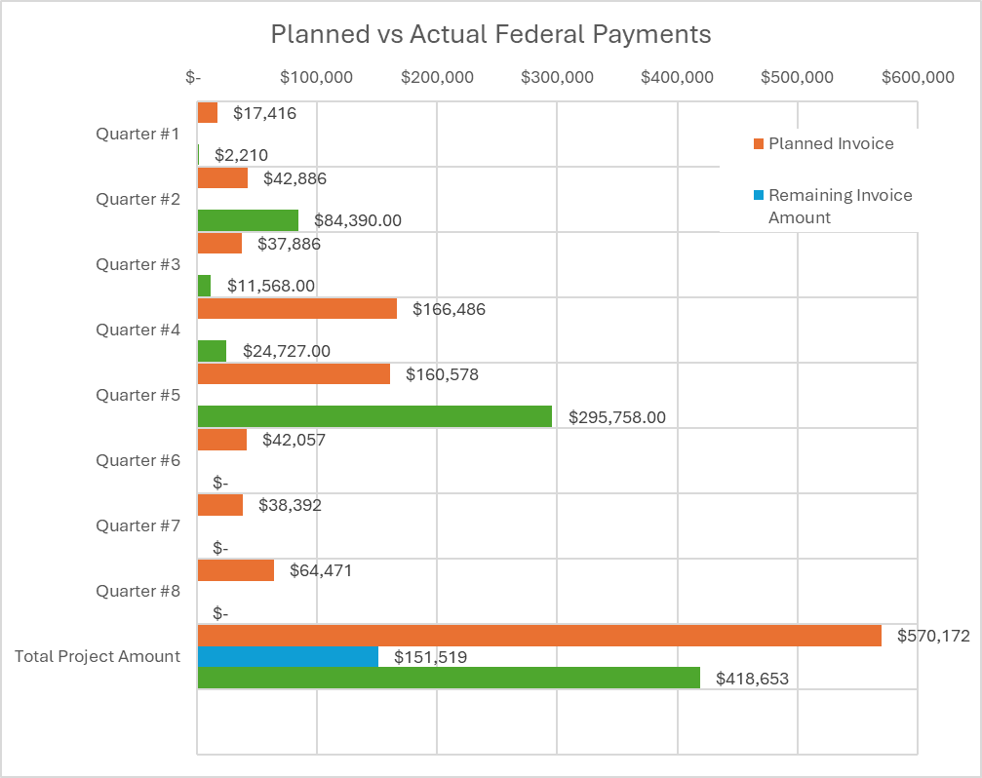

4: Project Technical Status –
Item #10, Task #3, Conduct Physical Withdrawal Tests
We successfully coordinated with an operational project partner to design, schedule, and execute a series of controlled physical withdrawal tests on an active system. The test campaign included withdrawals of varying magnitudes to characterize system sensitivity limits under realistic operating conditions. During each test, we collected raw sensor data from the system along with detailed ground truth information, including withdrawal timing, duration, and estimated leak size. These datasets provide critical validation inputs for model development and sensitivity assessment.

Item #14, Task #3, Conduct Physical Withdrawal Tests
We successfully coordinated with Southwest Research Institute (SWRI) to design, schedule, and execute a comprehensive series of controlled withdrawal tests on their test loop facility. The testing program included a wide range of withdrawal sizes conducted under diverse operational conditions and at multiple leak locations. In addition to leak data, we collected extensive normal operating data on the system. A complete suite of sensor measurements, operational schedules, and test logs was captured, providing a high quality ground truth dataset. These data enable detailed evaluation of detection sensitivity, accuracy, and robustness across a broad range of conditions.

Item #15, Task #7, Develop Proof-of-Concepts (POCs)
We continued development and implementation of machine learning based proof of concept models and evaluated their performance using both normal operating data and physical withdrawal test data from both systems. The POCs demonstrate strong performance in terms of leak detection sensitivity, low false alarm rates, and reliable detection timing across a range of leak sizes and operating conditions. These results further validate the feasibility of the selected ML approach for compressible pipeline leak detection.

Item #16, Task #8, Evaluate and Select Viable Solutions
We are actively evaluating POC results to assess trade offs across modeling approaches and refine implementation details. This includes targeted adjustments to model architecture, feature selection, and parameterization to optimize key performance indicators such as sensitivity, robustness, and false alarm control. Based on current results, we have strong confidence in the selected technical direction and are proceeding with minor refinements to further improve overall performance.

Item #17, Task #12, Submit 5th Quarterly Status Report
We completed and submitted the 5th quarterly status report in accordance with Item #17, Task #12, as specified in Attachment #3 and the Team Project Activities section covering quarterly and monthly reporting requirements.

5: Project Schedule
The project remains on track, with significant progress achieved during this reporting period. Comprehensive data collection and controlled withdrawal testing across multiple systems have validated our selected modeling approaches and confirmed strong performance under both normal and leak conditions. These results provide high confidence in the technical direction and support continued refinement of the proof of concept models. Efforts are now focused on final model optimization, solution selection, and translation of validated POC results into detailed software requirements to support integration into the commercial leak detection system.

Item #11, Task #4, Data Analysis and Documentation
We completed analysis of all collected datasets, including normal operating conditions and controlled withdrawal tests from both the operational partner system and the SWRI test loop. The analysis incorporates system behavior characterization, test condition documentation, and initial performance observations relevant to model development. The results have been compiled into a detailed technical document and are waiting on final approval to circulate to the Technical Advisory Panel (TAP).

Item #18, Task #7, Develop Proof-of-Concepts (POCs)
We will complete final implementation, refinement, and validation of the developed proof of concept models using physical withdrawal test data from both project systems, as well as additional relevant partner datasets not explicitly included within this project. This final phase of POC development will focus on confirming detection performance, false alarm behavior, robustness across operating conditions, and consistency across system types. The results will ensure that the feasibility and performance limits of the candidate approaches are well characterized prior to solution selection.

Item #19, Task #8, Evaluate and Select Viable Solutions
Following completion of POC development and analysis, we will perform a comprehensive evaluation of all candidate approaches to determine the most viable path forward. This evaluation will consider detection sensitivity, false alarm performance, robustness to operational variability, data quality dependencies, and scalability to commercial deployment. The selected solution(s) will be documented along with supporting performance results, trade off analysis, and rationale for selection. All findings will be compiled into a cohesive technical package summarizing the evaluated approaches and final recommendations.

Item #21, Task #9, Define Software Requirements
Upon selection of the final solution(s), we will translate the validated POC architecture, data requirements, and performance characteristics into detailed software requirements for integration into our commercial leak detection system. This will include definition of functional requirements, data interfaces, configuration parameters, performance expectations, and operational constraints. In parallel, we will begin scheduling and planning software development efforts to support implementation within the commercial LDS platform.

Risk Summary
With the completion of extensive data collection and the availability of a comprehensive dataset for validation, we do not identify any significant technical risks at this time. The POC results demonstrate robust performance and feasibility across diverse operating conditions, reducing uncertainty in model behavior and deployment readiness. Based on the maturity of the current POC implementations, integration into the commercial software platform is expected to be feasible, with no anticipated blockers beyond standard development and integration activities.

