Public Page Quarterly Report

Date of Report: 4th Quarterly Report, October 17, 2025
Contract Number: 693JK32410004POTA
Prepared for: DOT, NYSEARCH, PLIDCO, and Acuren
Project Title: Evaluate and Assess the Development of Pipeline System Repair and Maintenance Technologies in Hydrogen (H2), H2-Natural Gas Blends, and Natural Gas Pipelines
Prepared by: DNV
Contact Information: Matt Boring, matt.boring@dnv.com, 614-761-1214
For quarterly period ending: September 30, 2025

1: Items Completed During this Quarterly Period:

Item # | Task # | Activity/Deliverable | Title | Federal Cost | Cost Share
7 | 2 | Perform first set of in-service welding experiments on H₂ or H₂/natural gas blended pipelines | Provide the results of the welding experiments on H₂ or H₂/natural gas blended pipelines | 38,157 | 0
17 | 7 | 4th quarterly Status Report | Submit 4th quarterly report | 4,520 | 0

2: Items Not-Completed During this Quarterly Period:

The project is behind schedule. It does appear some of the testing will be caught up but the elastomer testing may require more time since the testing is based on an exposure time which may exceed the end date of the project. If it is determined that this is the case then a no cost time extension will be requested..

Item # | Task # | Activity/Deliverable | Title | Federal Cost | Cost Share
8 | 3 | Perform first set of LET experiments on the steel bolt-on repair sleeve elastomer in H₂ or H₂/natural gas blended environments | Provide LET testing results of the elastomer exposed in two environments | 64,143 | 0
9 | 4 | Perform permeability testing of three composite sleeve materials | Provide the permeability testing results in methane, H₂ or H₂/natural gas blended environments | 91,551 | 0
10 | 5 | Perform aging and hydrotesting of butt fusion joints | Provide the butt fusion hydrotesting results | 52,623 | 0
13 | 2 | Perform second set of in-service welding experiments on H₂ or H₂/natural gas blended pipelines | Provide the results of the welding experiments on H₂ or H₂/natural gas blended pipelines | 38,157 | 0
14 | 3 | Perform second set of LET experiments on the steel bolt-on repair sleeve elastomer in H₂ or H₂/natural gas blended | Provide the LET testing results of the elastomer exposed in one environment | 21,493 | 0
15 | 4 | Perform aging and mechanical testing of three composite sleeve materials | Provide the mechanical testing results of the mechanical testing of composites in air, methane, H₂, and H₂/natural gas environments | 32,115 | 0
16 | 5 | Perform aging and hydrotesting of electrofusion joints | Provide the electrofusion hydrotesting results | 52,623 | 0
18 | 7 | 5th Quarterly Status Report | Submit 5th quarterly report | 4,520 | 0
19 | 2 | Perform in-service welding experiments on extended exposure H₂ pipelines | Provide the results of the welding experiments on extended exposure H₂ pipelines | 26,279 | 0
20 | 6 | Prepare and submit draft final report | Submit draft final report | 45,745 | 0
21 | 7 | 6th Quarterly Status Report | Submit 6th quarterly report | 4,747 | 0
22 | N/A | Prepare and present paper at public event or publish paper in journal/magazine | Prepare and present paper at public event or publish paper in journal/magazine | 0 | 0
23 | N/A | Final virtually held information dissemination meeting | Final virtually held information dissemination meeting | 0 | 0
24 | 6 | Address comments and submit final report | Submit final report | 0 | 0
25 | 7 | Public version of final report | Submit public version of final report | 0 | 0
26 | 7 | Public research brief | Submit public research brief | 0 | 0

3: Project Financial Tracking During this Quarterly Period:

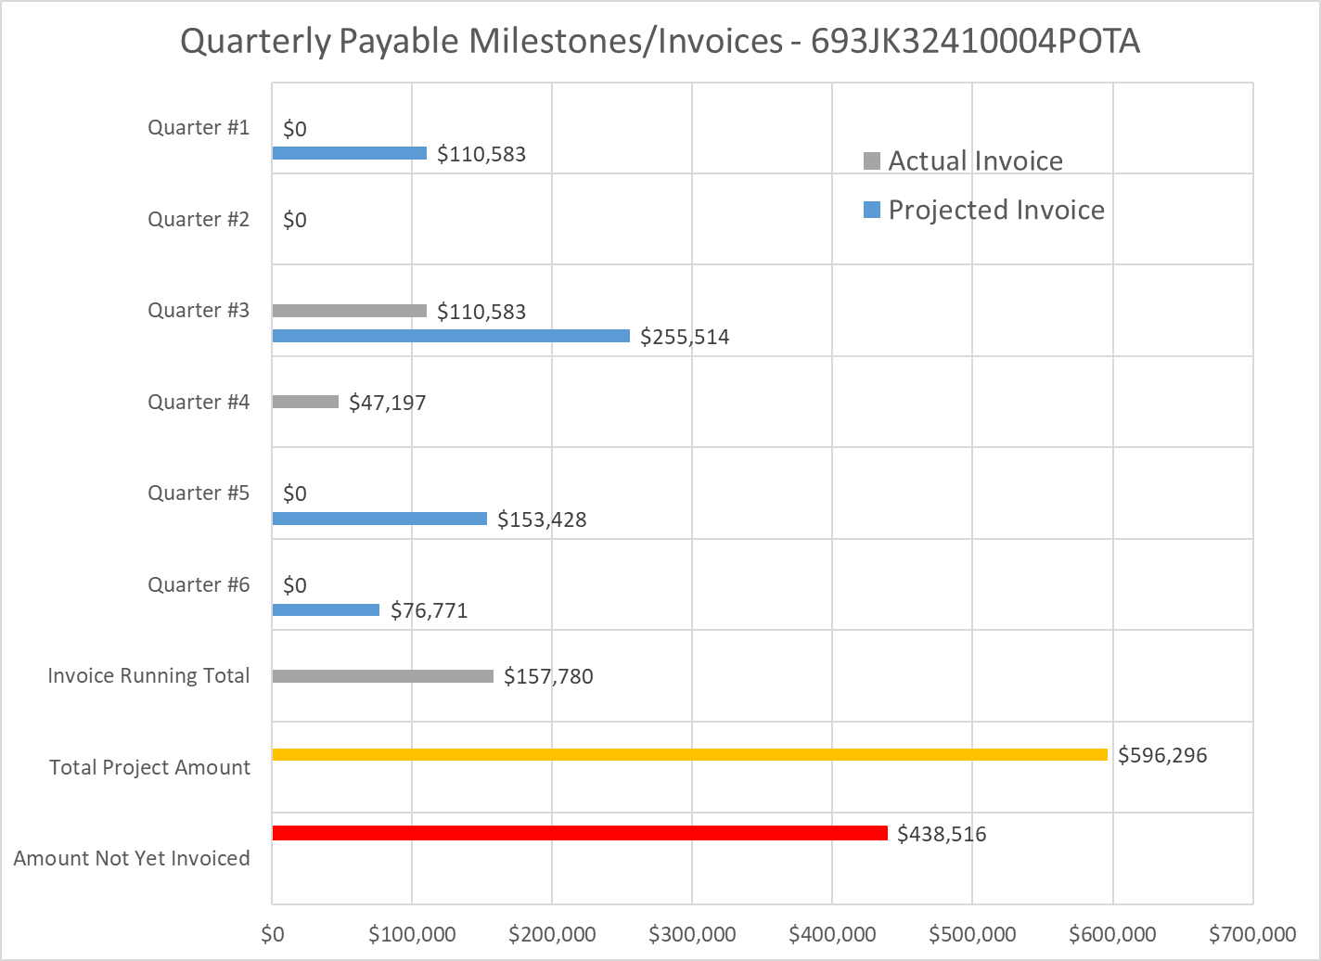

4: Project Technical Status

Task 1, Kick-off Meeting

The Project Team had a kick-off meeting that was held remotely via a TEAMS call on December 19, 2024. The meeting lasted an hour and a total of thirteen attendees, which included, interested parties, TAP members, and PHMSA representatives. The meeting primarily covered the proposed work scope and the early findings of some of the literature review tasks that have been on-going since the start of the project. The kick-off meeting slides have been uploaded as a separate file to the project website.

Task 2, Review of Research and Proposed Research to the use of Welded Steel Repair Sleeves

The welded steel repair sleeve literature review is completed and was compiled with the other literature reviews into a single document to review. The compiled literature review was uploaded as a draft to the project website on May 8, 2025.

The long-term exposure test vessels have been pressurized with 800 psi H₂ on March 28, 2025. These vessels will remain pressurized until the end of the project, at which time they will be used for the final set of simulated in-service welding trials.

The first set of experimental welds have been complete and the diffusible hydrogen analysis has been completed. The results are currently being analyzed so no results can be shared. One of the weld tests had a failure during the diffusible hydrogen test where a seal failed so no data could be generated.

The second set of experimental vessels have been completed and the second set of tests have been completed in early October after the end of Q4. Those results and results from the first set of experiments will be provided in the Q5 report.

Task 3, Review of Research and Proposed Research to the use of Bolt-on Steel Repair Sleeves

The bolt-on steel repair sleeve literature review is completed and was compiled with the other literature reviews into a single document to review. The compiled literature review was uploaded as a draft to the project website on May 8, 2025. Since the submission of the initial draft literature review, there have been additional references found on the hydrogen effect on different elastomers. These additional references will be included in a revised literature review.

The fixture that will be used for the LET testing is being manufactured to simulate the long-term exposure of the preferred elastomer that is used for bolt-on steel repair sleeves. The LET testing will include compressing the elastomer the same amount as would be expected on installed bolt-on steel sleeves. Once the fixture is received the first LET test will begin.

The PLIDCO clamp was received and was pressurized with 1,000 psi H₂ on April 24, 2025. The clamp will remain pressurized until the end of the project, at which time it will be disassembled, and the elastomer will be analyzed. The PLIDCO project has not been completed so no results can be shared from the cost-share effort.

No additional experimental testing has been completed so there are no experimental results can be shared.

Task 4, Review of Research and Proposed Research to the use of Composite Repair Sleeves

The composite repair sleeve literature review is completed and was compiled with the other literature reviews into a single document to review. The compiled literature review was uploaded as a draft to the project website on May 8, 2025.

The three composite repair system blanks have been fabricated by Acuren and were received by DNV for testing. The three composite repairs have been machined into test specimens for permeability and tensile testing.

The permeability testing has began on all three composites. The initial testing was performed using 1,000 psi H₂. Unfortunately the initial testing did not result in conclusive results so the experimental set up was modified and the permeability testing is currently being repeated.

No additional experimental testing has been completed so there are no composite repair sleeve experimental results that can be shared.

Task 5, Review of Research and Proposed Research for Plastic Pipe Repair

The plastic pipe repair literature review is completed and was compiled with the other literature reviews into a single document to review. The compiled literature review was uploaded as a draft to the project website on May 8, 2025.

Three of the 2 inch plastic pipe samples have been hydrostatically tested as-received to generate baseline data. The test specimens included a pipe section, a butt fused pipe section, and an electrofused pipe section. Figure 1 shows the pipe sections after hydrotesting. The two fused pipe sections failed away from the fuse joint in the pipe body indicating that the fused joints are stronger than the pipe body.

The test pressure data for the three hydrostatic pressure tests are shown in Figure 2. All the pipe section increased in pressure until a maximum pressure ranging between 669 and 687 psi at which time the pressure begin to decrease. The reduction in pressure was attributed to the global yielding of the pipe section. The reduction of the pressure continued with increasing water volume until there was a significant drop in pressure. That significant drop in pressure was attributed to the significant local yielding of the pipe section. The pressure continued to reduce as the water volume increased until failure. The failure occurred in the are of significant local yielding.

The NYSEARCH project is continuing testing and currently does not have any results that can be shared from the cost-share effort.

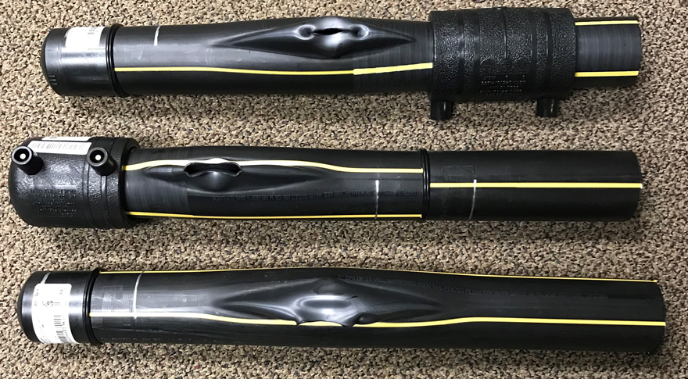
Pipe
Butt Fused Joint
Electrofusion Joint
Figure 1. Photograph of the Three As-Received Pipe Sections after Hydrostatic Pressure Testing

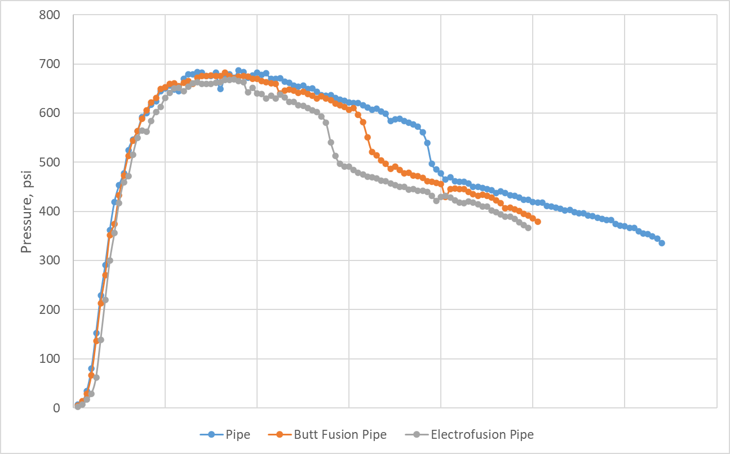
Figure 2. Hydrostatic Pressure Tests Data for the Three As-received Pipe Section Tests.
5: Project Schedule
The project is behind schedule, but it is not expected to impact the overall schedule of the project which is to end in Q1 of 2026.

Item 1, Task 1, Kick-off Meeting

Complete.

Item 2, Task 2, Steel Welded Repair Sleeves to Repair H₂ and H₂/Natural Gas blended Pipelines Literature Review

Complete.

Item 3, Task 3, Steel Bolt-on Repair Sleeves to Repair H₂ and H₂/Natural Gas blended Pipelines Literature Review

Complete.

Item 4, Task 4, Composite Repair Sleeves to Repair H₂ and H₂/Natural Gas blended Pipelines Literature Review

Complete.

Item 5, Task 5, Plastic Pipe Repairs to Repair H₂ and H₂/Natural Gas blended Pipelines Literature Review

Complete.

Item 6, Task 7, 1st Quarterly Status Report

Complete.

Item 7, Task 2, First Set of In-service Welding Trials

Complete.

Item 8, Task 3, First Set of LET Experiments on the Bolt-on Steel Sleeve Elastomers

The LET test fixture is being manufactured. Once completed the LET testing will begin.

Item 9, Task 4, Composite Repair Sleeve Material Permeability Testing

The initial permeation tests were inconclusive so the initial tests are being replicated.

Item 10, Task 5, Aging and Hydrotesting of Butt Fusion Joints

Hydrostatic pressure testing of the as-received pipe sections are completed. Pipe sections are being exposed in a test gas until saturated at which time they will be hydrostatic pressure tested.

Item 11, Task 7, 2nd Quarterly Status Report

Complete.

Item 12, Task 7, 3rd Quarterly Status Report

Complete.

Item 13, Task 2, Second Set of In-service Welding Trials

Completed but finished at the beginning of Q5.

Item 14, Task 3, Second Set of LET Experiments on the Bolt-on Steel Sleeve Elastomers

Not started.

Item 15, Task 4, Composite Repair Sleeve Aging and Tensile Testing

The composite sleeve material blanks have been manufactured and machined. The tensile testing specimens will begin to be aged and the baseline tensile tests in air are being scheduled.

Item 16, Task 5, Aging and Hydrotesting of Electrofusion Joints

Hydrostatic pressure testing of the as-received pipe sections are completed. Pipe sections are being exposed in a test gas until saturated at which time they will be hydrostatic pressure tested.

Item 17, Task 7, 4th Quarterly Status Report

Completed

Item 18, Task 7, 5th Quarterly Status Report

Not started.

Item 19, Task 2, In-service Welding Trials on Extended Exposure Pipe

The vessels have been fabricated and received. The vessels have been pressurized with 800 psi H₂ on March 28, 2025 to begin the long-term exposure. The vessels will remain pressured until 2026 Q1 which corresponds the Q6 of the project schedule before the in-service welding trials.

Item 20, Task 6, Project Report

On-going.

Item 21, Task 7, 6th Quarterly Status Report

Not started.

