Quarterly Report – Public Page

Date of Report: July 14, 2025
Contract Number: 693JK32310001POTA
Prepared for: DOT - Pipeline And Hazardous Materials Safety Administration
Project Title: A Comprehensive Study of Barriers for Underground Natural Gas Storage Wells
Prepared by: Pennsylvania State University
Contact Information: Arash Dahi Taleghani, Arash.Dahi@psu.edu , 814-865-5421
For quarterly period ending: June 30, 2025

1: Items Completed During this Quarterly Period:

Item # | Task # | Activity/Deliverable | Title | Federal Cost | Cost Share
13 | 7 | Evaluation of norms and standards for well integrity | Set of clear, concise  recommendations to be submitted to the appropriate standard development organizations (e.g.,API, ISO, etc.) for incorporation into the relevant consensus guides, standards, and recommended practices manuals | $29,958.50 | $7,514.30
14 | 5 | 7th Quarterly Status Report | Submit 7th quarterly report | $ $2,995.85 | $ 751.43

2: Items Not-Completed During this Quarterly Period:

Item # | Task # | Activity/Deliverable | Title | Federal Cost | Cost Share
15 | 5 | Reporting and Dissemination of Findings | Final report of the project outlining the results of the applicability assessment of norms and standards for well integrity in UNGS and gaps to be addressed will be delivered to USDOT | $29,958.50 | $7,514.30
16 | 5 | 8th Quarterly Status Report | Submit 8th quarterly report | $ 2,995.85 | $ 751.43

3: Project Financial Tracking During this Quarterly Period
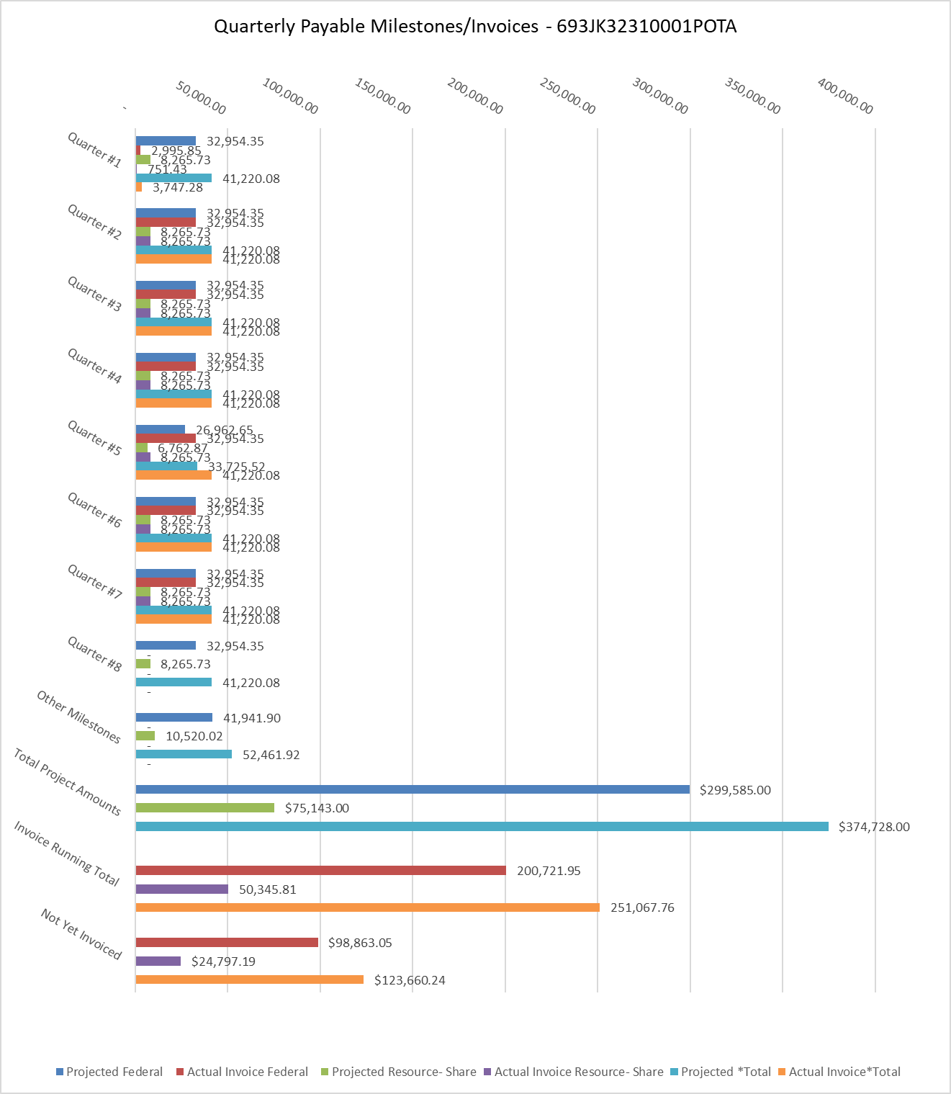

4: Project Technical Status –
Our research team has made significant progress in addressing zonal isolation challenges in Underground Gas Storage (UGS) wells. We have completed a comprehensive technical analysis of integrity issues in UGS operations, identifying microannulus formation, casing-cement debonding, and long-term cement degradation under pressure cycling as the principal causes of integrity loss. Our work has revealed critical limitations in conventional diagnostic methods, particularly showing that Cement Bond Logs (CBL) and Variable Density Logs (VDL) frequently miss behind-casing flow in gas-contaminated intervals. We have developed an improved decision-making framework for zonal isolation remediation that integrates risk-informed diagnostics with precision squeeze cement point detection. Additionally, we have established operational guidelines for squeeze cementing optimization based on fluid loss, injectivity factors, and filtration rates, while addressing the challenges posed by legacy wells that lack standardized integrity protocols. Currently, we are conducting experimental investigations on different geopolymer formulations as potential substitutes for Portland cement to enhance the long-term integrity of UGS wells under cyclic loading conditions. These geopolymer experiments are projected to be completed within the next six months, and the results will inform our recommendations for improved cementing practices in gas storage operations.

The PI is currently coordinating a panel of experts on methane emissions from wells for SPE ATCE in Houston, TX, on October 23. The panel will feature expertise in well integrity, emission measurement, and regulatory frameworks. To date, this project has resulted in three published papers, listed below:

Erguler, G., A. Dahi Taleghani, 2025, Geopolymers for integrity of geothermal and CO2 sequestration wells: A state-of-the-art review, Accepted for publication in Geoenergy Science and Engineering.
Erguler, G., A. Dahi Taleghani, 2025, Geopolymer Applications in Deep-Sea Energy and Mining
Infrastructure: A Review of Properties, Challenges, and Future Prospects, Accepted for publication in Environmental Earth Sciences
Kaya, G., A. Dahi Taleghani, 2025, Integrity Issues for Underground Gas Storage Wells, ASME Open J. Engineering ASME. vol. 4, p 040804 doi: https://doi.org/10.1115/1.4067764.

5: Project Schedule –
We are continuing work on the project; however, we need to request a no-cost extension for two quarters to complete the experiments outlined in the proposal. The delay was caused by material delivery issues and the need to adjust sealing procedures for cement testing required by the project. Furthermore, our expert panel is scheduled during the SPE ATCE conference in Houston, so we need this extension to hold this important meeting and share our project findings with the experts.

