Internal Quarterly Report

Date of Report: 3rd Quarterly Report, July 9, 2025
Contract Number: 693JK32410004POTA
Prepared for: DOT, NYSEARCH, PLIDCO, and Acuren
Project Title: Evaluate and Assess the Development of Pipeline System Repair and Maintenance Technologies in Hydrogen (H2), H2-Natural Gas Blends, and Natural Gas Pipelines
Prepared by: DNV
Contact Information: Matt Boring, matt.boring@dnv.com, 614-761-1214
For quarterly period ending: June 30, 2025

1: Items Completed During this Quarterly Period:

Item # | Task # | Activity/Deliverable | Title | Federal Cost | Cost Share
12 | 7 | 3rd Quarterly Status Report | Submit 3rd quarterly report | 4,520 | 0

2: Items Not-Completed During this Quarterly Period:

The project is behind schedule. It is expected to get back on schedule over the next quarter by reallocating internal resources.

Item # | Task # | Activity/Deliverable | Title | Federal Cost | Cost Share
7 | 2 | Perform first set of in-service welding experiments on H₂ or H₂/natural gas blended pipelines | Provide the results of the welding experiments on H₂ or H₂/natural gas blended pipelines | 38,157 | 0
8 | 3 | Perform first set of LET experiments on the steel bolt-on repair sleeve elastomer in H₂ or H₂/natural gas blended environments | Provide LET testing results of the elastomer exposed in two environments | 64,143 | 0
9 | 4 | Perform permeability testing of three composite sleeve materials | Provide the permeability testing results in methane, H₂ or H₂/natural gas blended environments | 91,551 | 0
10 | 5 | Perform aging and hydrotesting of butt fusion joints | Provide the butt fusion hydrotesting results | 52,623 | 0
12 | 7 | 3rd Quarterly Status Report | Submit 3rd quarterly report | 4,520 | 0
13 | 2 | Perform second set of in-service welding experiments on H₂ or H₂/natural gas blended pipelines | Provide the results of the welding experiments on H₂ or H₂/natural gas blended pipelines | 38,157 | 0
14 | 3 | Perform second set of LET experiments on the steel bolt-on repair sleeve elastomer in H₂ or H₂/natural gas blended | Provide the LET testing results of the elastomer exposed in one environment | 21,493 | 0
15 | 4 | Perform aging and mechanical testing of three composite sleeve materials | Provide the mechanical testing results of the mechanical testing of composites in air, methane, H₂, and H₂/natural gas environments | 32,115 | 0
16 | 5 | Perform aging and hydrotesting of electrofusion joints | Provide the electrofusion hydrotesting results | 52,623 | 0
17 | 7 | 4th Quarterly Status Report | Submit 4th quarterly report | 4,520 | 0
18 | 7 | 5th Quarterly Status Report | Submit 5th quarterly report | 4,520 | 0
19 | 2 | Perform in-service welding experiments on extended exposure H₂ pipelines | Provide the results of the welding experiments on extended exposure H₂ pipelines | 26,279 | 0
20* | 6 | Prepare and submit draft final report | Submit draft final report | 45,745 | 0
21 | 7 | 6th Quarterly Status Report | Submit 6th quarterly report | 4,747 | 0
22 | N/A | Prepare and present paper at public event or publish paper in journal/magazine | Prepare and present paper at public event or publish paper in journal/magazine | 0 | 0
23 | N/A | Final virtually held information dissemination meeting | Final virtually held information dissemination meeting | 0 | 0
24 | 6 | Address comments and submit final report | Submit final report | 0 | 0
25 | 7 | Public version of final report | Submit public version of final report | 0 | 0
26 | 7 | Public research brief | Submit public research brief | 0 | 0

3: Project Financial Tracking During this Quarterly Period:

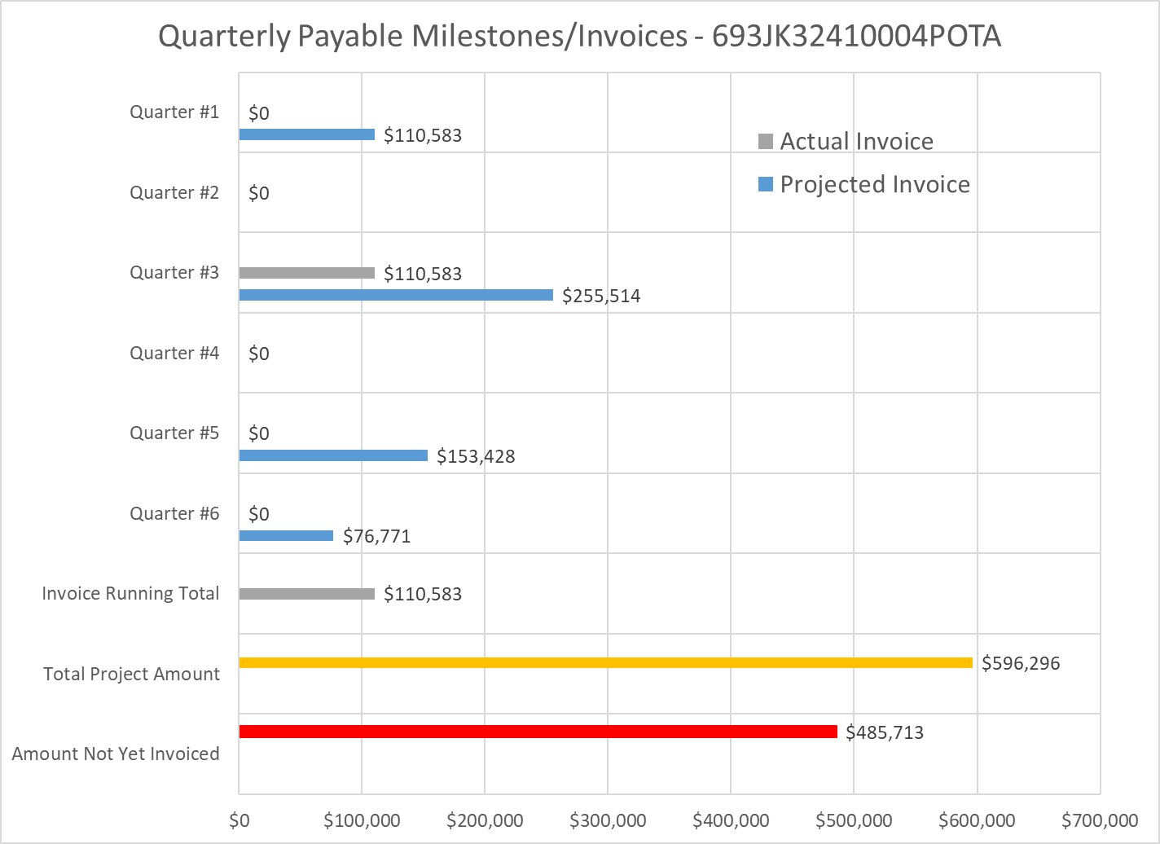

4: Project Technical Status

Task 1, Kick-off Meeting

The Project Team had a kick-off meeting that was held remotely via a TEAMS call on December 19, 2024. The meeting lasted an hour and a total of thirteen attendees, which included, interested parties, TAP members, and PHMSA representatives. The meeting primarily covered the proposed work scope and the early findings of some of the literature review tasks that have been on-going since the start of the project. The kick-off meeting slides have been uploaded as a separate file to the project website.

Task 2, Review of Research and Proposed Research to the use of Welded Steel Repair Sleeves

The welded steel repair sleeve literature review is completed and was compiled with the other literature reviews into a single document to review. The compiled literature review was uploaded as a draft to the project website on May 8, 2025.

The test vessels for the first set of simulated in-service welding trials and the long-term exposure trials have been fabricated and received. The long-term exposure test vessels have been pressurized with 800 psi H₂ on March 28, 2025. These vessels will remain pressurized until the end of the project, at which time they will be used for the final set of simulated in-service welding trials.

No additional experimental testing has been completed so there are no welded steel repair sleeve experimental results that can be shared.

Task 3, Review of Research and Proposed Research to the use of Bolt-on Steel Repair Sleeves

The bolt-on steel repair sleeve literature review is completed and was compiled with the other literature reviews into a single document to review. The compiled literature review was uploaded as a draft to the project website on May 8, 2025.

The fixture that will be used for the LET testing is being manufactured to simulate the long-term exposure of the preferred elastomer that is used for bolt-on steel repair sleeves. The LET testing will include compressing the elastomer the same amount as would be expected on installed bolt-on steel sleeves. Once the fixture is received the first LET test will begin.

The PLIDCO clamp was received and was pressurized with 1,000 psi H₂ on April 24, 2025. The clamp will remain pressurized until the end of the project, at which time it will be disassembled, and the elastomer will be analyzed. The PLIDCO project has not been completed so no results can be shared from the cost-share effort.

No additional experimental testing has been completed so there are no welded steel repair sleeve experimental results that can be shared.

Task 4, Review of Research and Proposed Research to the use of Composite Repair Sleeves

The composite repair sleeve literature review is completed and was compiled with the other literature reviews into a single document to review. The compiled literature review was uploaded as a draft to the project website on May 8, 2025.

The three composite repair system blanks have been fabricated by Acuren and were received by DNV for testing. The three composite repairs have been machined into test specimens for permeability and tensile testing.

No experimental testing has been completed so there are no composite repair sleeve experimental results that can be shared.

Task 5, Review of Research and Proposed Research for Plastic Pipe Repair

The plastic pipe repair literature review is completed and was compiled with the other literature reviews into a single document to review. The compiled literature review was uploaded as a draft to the project website on May 8, 2025.

The 2 inch plastic pipe samples have been received by a natural gas company for testing. The remaining hydrostatic pressure testing equipment is being ordered and it is expected that the hydrostatic pressure testing will being in August 2025.

The NYSEARCH project is continuing testing and currently does not have any results that can be shared from the cost-share effort.

No additional experimental testing has been completed so there are no composite repair sleeve experimental results that can be shared.

5: Project Schedule
The project is behind schedule, but it is not expected to impact the overall schedule of the project which is to end in Q1 of 2026.

Item 1, Task 1, Kick-off Meeting

Complete.

Item 2, Task 2, Steel Welded Repair Sleeves to Repair H₂ and H₂/Natural Gas blended Pipelines Literature Review

Complete.

Item 3, Task 3, Steel Bolt-on Repair Sleeves to Repair H₂ and H₂/Natural Gas blended Pipelines Literature Review

Complete.

Item 4, Task 4, Composite Repair Sleeves to Repair H₂ and H₂/Natural Gas blended Pipelines Literature Review

Complete.

Item 5, Task 5, Plastic Pipe Repairs to Repair H₂ and H₂/Natural Gas blended Pipelines Literature Review

Complete.

Item 6, Task 7, 1st Quarterly Status Report

Complete.

Item 7, Task 2, First Set of In-service Welding Trials

Vessels have been fabricated. The DNV JIP has determined the welding test conditions and the project team is currently determining the schedule to complete the first set of welding trials.

Item 8, Task 3, First Set of LET Experiments on the Bolt-on Steel Sleeve Elastomers

The LET test fixture is being manufactured. Once completed the LET testing will begin.

Item 9, Task 4, Composite Repair Sleeve Material Permeability Testing

The composite sleeve material blanks have been manufactured and machined. The permeation cells are being assembled to begin testing.

Item 10, Task 5, Aging and Hydrotesting of Butt Fusion Joints

The butt fusion joints have been produced and received by DNV. Hydrostatic pressure testing will commence once the remining test equipment is received.

Item 11, Task 7, 2nd Quarterly Status Report

Complete.

Item 12, Task 7, 3rd Quarterly Status Report

Complete.

Item 13, Task 2, Second Set of In-service Welding Trials

Not started.

Item 14, Task 3, Second Set of LET Experiments on the Bolt-on Steel Sleeve Elastomers

Not started.

Item 15, Task 4, Composite Repair Sleeve Aging and Tensile Testing

The composite sleeve material blanks have been manufactured and machined. The tensile testing specimens will begin to be aged and the baseline tensile tests in air are being scheduled.

Item 16, Task 5, Aging and Hydrotesting of Electrofusion Joints

The electrofusion joints have been produced and received by DNV. Hydrostatic pressure testing will commence once the remining test equipment is received.

Item 17, Task 7, 4th Quarterly Status Report

Not started.

Item 18, Task 7, 5th Quarterly Status Report

Not started.

Item 19, Task 2, In-service Welding Trials on Extended Exposure Pipe

The vessels have been fabricated and received. The vessels have been pressurized with 800 psi H₂ on March 28, 2025 to begin the long-term exposure. The vessels will remain pressured until 2026 Q1 which corresponds the Q6 of the project schedule before the in-service welding trials.

Item 20, Task 6, Project Report

On-going.

Item 21, Task 7, 6th Quarterly Status Report

Not started.

