**Public Quarterly Report**

**Date of Report:** *June 30, 2025 (3rnd Quarterly Report)*

**Contract Number:** *693JK32410006POTA*

**Prepared for:** *PHMSA*

**Project Title:** *Advanced Leak Detection Capabilities for Compressible Hydrocarbon Products*

**Prepared by:**  *Flowstate Solutions*

**Contact Information:**  *Braden Fitz-Gerald |* [*braden.fitzgerald@flowstatesolutions.ai*](mailto:braden.fitzgerald@flowstatesolutions.ai) *| 307-399-7516*

**For quarterly period ending:** *June 30, 2025*

**1: Items Completed During this Quarterly Period:**

|  |  |  |  |  |  |
| --- | --- | --- | --- | --- | --- |
| ***Item #*** | ***Task #*** | ***Activity/Deliverable*** | ***Title*** | ***Federal Cost*** | ***Cost Share*** |
| ***6*** | ***2*** | ***Collect operational data from multiple pipeline assets to understand normal behavior and reduce false positives in leak detection. Establishing a comprehensive dataset of normal behavior is essential for accurate leak detection.*** | ***Data Collection Under Normal Operating Conditions*** | ***$9,358*** | ***$111,752*** |
| ***5*** | ***12*** | ***2nd Quarterly Status Report*** | ***Submit 3rd quarterly report*** | ***$2,210*** | ***$1,633*** |

**2: Items Not-Completed During this Quarterly Period:**

|  |  |  |  |  |  |
| --- | --- | --- | --- | --- | --- |
| ***Item #*** | ***Task #*** | ***Activity/Deliverable*** | ***Title*** | ***Federal Cost*** | ***Cost Share*** |
|  |  |  |  |  |  |
|  |  |  |  |  |  |

**3: Project Financial Tracking During this Quarterly Period:**

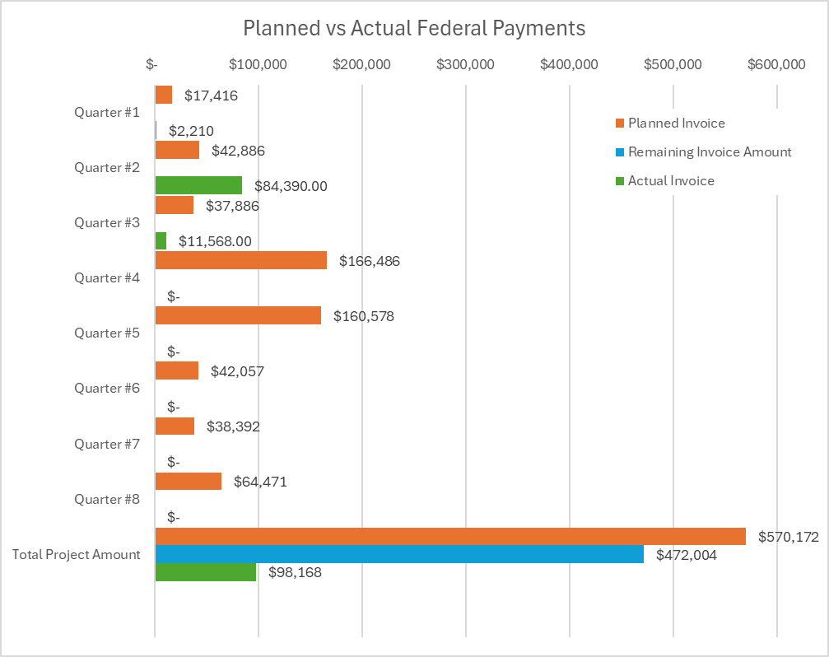

**4: Project Technical Status –**

Item #6, Task #2, Data Collection Under Normal Operating Conditions

During this quarter, we continued work on Item #6, Task #2 as outlined in Attachment #3, corresponding to Item #3 in the Team Project Activities section (Data Collection Under Normal Operating Conditions). Below is a summary of the activities and progress related to our data collection efforts:

**Work Completed**  
This quarter, we made progress on our data collection initiatives with both our Ethylene project partner and the Compressed Gas partner. For the Ethylene project, we maintained our data collection infrastructure, enabling continuous live sensor data streaming and the initiation of analytical work. We also completed the system configuration necessary to support data analysis and modeling. Concurrently, we continued engagement with our Compressed Gas partner to identify a viable segment for compressible product testing. While our initial approach using a decommissioned system was deemed unviable after cost and logistical review, we are actively pursuing an alternative with their support.

* **Ethylene Project**   
  We maintained an active data collection infrastructure that streams live sensor data from our Ethylene project partner’s pipeline segment. Throughout the quarter, we worked with their personnel to enhance our understanding of the pipeline’s topology, sensor configurations, and operational practices. This collaboration enabled us to complete the pipeline's configuration within our system, which will support ongoing data analysis and modeling.
* **Compressed Gas Project**Following our prior plan to use a decommissioned system with compressed air or nitrogen as a proxy for compressible products, we conducted a detailed cost and logistical assessment. This evaluation concluded that the original plan was not viable due to the high costs and equipment requirements. We are now working with our Compressed Gas partner to identify a smaller, more feasible alternative segment. Our pipeline engineering team remains actively engaged with their personnel to finalize the new plan and move toward implementation.

Item #5, Task #12, Submit 2nd Quarterly Report

We completed and submitted the 3rd quarterly report in accordance with Item #5, Task #12, as stated in Attachment #3 and corresponding to Item #13 in the Team Project Activities section (Quarterly and Monthly Reports).

**5: Project Schedule**

The project is currently progressing well and remains on a favorable trajectory. From a technical analysis and development standpoint, we are ahead of schedule. Completion of our technical literature review and experiment design earlier than planned has enabled us to initiate prototyping and evaluation efforts ahead of schedule. These early evaluations, using datasets from other operators not included in the scope of this project, have yielded promising initial results.

On the data collection front, the Ethylene system is fully configured and actively streaming data, supporting our analytical objectives. However, identifying a viable Compressed Gas pipeline segment for testing remains an open challenge. Despite this, our engineering team is optimistic that a suitable solution can be identified given the breadth of our Compressed Gas partners asset base. This aspect of the project currently represents our highest risk area, and we anticipate gaining clarity within the first half of the upcoming quarter regarding its potential impact on overall project timelines.

*Item #9, Task #2 – Data Collection Under Normal Operating Conditions*  
Data collection efforts are progressing as planned with our Ethylene project partner, with infrastructure in place and streaming actively. In parallel, we are working with our Compressed Gas partner to identify an alternative system suitable for data collection and withdrawal planning. While this process is ongoing and presents some risk, we are actively engaged in resolving it and remain on schedule overall.

*Item #10, Task #3 – Conduct Physical Withdrawal Tests*  
Initial engagements with the Ethylene project partner have begun, with more detailed planning and coordination anticipated for this quarter to define testing plans and evaluate operational considerations. In parallel, efforts continue with our Compressed Gas partner to finalize a viable pipeline segment and reassess logistics and cost implications. Progress is being made, though this area still carries some risk.

*Item #11, Task #4 – Operational Data Analysis*  
The pipeline segment from the Ethylene project partner is fully configured, with documentation nearly complete. Data analysis is underway and progressing as expected. Work continues with our Compressed Gas partner to identify a suitable segment and develop an associated analysis plan. Overall, analysis efforts are on track, though some uncertainty remains on the compressed gas side.

*Item #12, Task #7 – Develop Proof-of-Concepts (POCs)*We are making strong progress on machine learning solutions for modeling normal operations, using datasets from external operators not directly involved in this project. These models are being developed with transferability in mind and will be evaluated on our Ethylene project partner’s system during upcoming withdrawal testing. This task remains on track for completion within the scheduled timeframe.

*Risk Summary*

The primary area of project risk at this stage centers on our Compressed Gas partner’s system and the execution of physical withdrawal tests. Our original plan involving a decommissioned pipeline was determined to be infeasible due to cost and logistical constraints. While we are actively pursuing alternatives, identifying a suitable replacement has been challenging. Although we remain optimistic, there is a possibility that delays in securing a viable segment could impact the project timeline. We anticipate greater clarity on this within the current quarter. As part of our risk mitigation strategy, we have initiated discussions with the Southwest Research Institute to explore the use of their test facility for collecting operational and withdrawal test data. We are scheduling conversations to discuss technical feasibility, cost estimates, and logistics, and would serve as a fallback option should the Compressed Gas partner path prove prohibitive.

In parallel, initial discussions with our Ethylene project partner regarding withdrawal testing have been encouraging. That said, potential risks related to commercial, operational, or compliance factors could still delay or constrain execution. These considerations will be monitored closely as we move into the next phase of planning.

Summary

The project is progressing well overall, with technical development ahead of schedule and promising early modeling results from external datasets. Data collection from our Ethylene project partner is active and supporting ongoing analysis efforts. While our original testing plan with our Compressed Gas partner proved unfeasible, we are working collaboratively to identify a viable alternative. Initial discussions with the Ethylene partner around withdrawal testing are encouraging, though some risk remains related to potential commercial or operational constraints. We expect greater clarity on both testing pathways within the next quarter.