**Quarterly Report – Public Page**

**Date of Report:** *March 31, 2025 (2nd Quarterly Report)*

**Contract Number:** *693JK32410006POTA*

**Prepared for:** *PHMSA*

**Project Title:** *Advanced Leak Detection Capabilities for Compressible Hydrocarbon Products*

**Prepared by:**  *Flowstate Solutions*

**Contact Information:**  *Braden Fitz-Gerald |* [*braden.fitzgerald@flowstatesolutions.ai*](mailto:braden.fitzgerald@flowstatesolutions.ai) *| 307-399-7516*

**For quarterly period ending:** *March 31, 2025*

**1: Items Completed During this Quarterly Period:**

|  |  |  |  |  |  |
| --- | --- | --- | --- | --- | --- |
| ***Item #*** | ***Task #*** | ***Activity/Deliverable*** | ***Title*** | ***Federal Cost*** | ***Cost Share*** |
| ***1*** | ***1*** | ***Identify and finalize partnerships with pipeline operators to access data, facilitate physical withdrawal tests, and gain domain expertise. This is critical for obtaining real-world data and conducting physical tests.*** | ***Establish Partnerships*** | ***$15,206*** | ***$20,893*** |
| ***3*** | ***2*** | ***Collect operational data from multiple pipeline assets to understand normal behavior and reduce false positives in leak detection. Establishing a comprehensive dataset of normal behavior is essential for accurate leak detection.*** | ***Data Collection Under Normal Operating Conditions*** | ***$9, 358*** | ***$116,552*** |
| ***4*** | ***5*** | ***Conduct a thorough review of literature on hydraulics of compressible fluids, existing leak detection solutions, ML/AI techniques for time series and anomaly detection, physics-informed solutions, and relevant signal/frequency domain analysis. This review guides experimental design.*** | ***Technical and Literature Review*** | ***$31,318*** | ***$19,452*** |
| ***5*** | ***12*** | ***2nd Quarterly Status Report*** | ***Submit 2nd quarterly report*** | ***$2,210*** | ***$1,633*** |
| ***7*** | ***6*** | ***Define and plan a series of experiments to differentiate between normal and leak behaviors using collected data. Well-designed experiments help identify promising approaches for leak detection, setting the stage for proof-of-concept development.*** | ***Design Technical Experiments*** | ***$26,318*** | ***$19,452*** |

**2: Items Not-Completed During this Quarterly Period:**

|  |  |  |  |  |  |
| --- | --- | --- | --- | --- | --- |
| ***Item #*** | ***Task #*** | ***Activity/Deliverable*** | ***Title*** | ***Federal Cost*** | ***Cost Share*** |
|  |  |  |  |  |  |
|  |  |  |  |  |  |

**3: Project Financial Tracking During this Quarterly Period:**

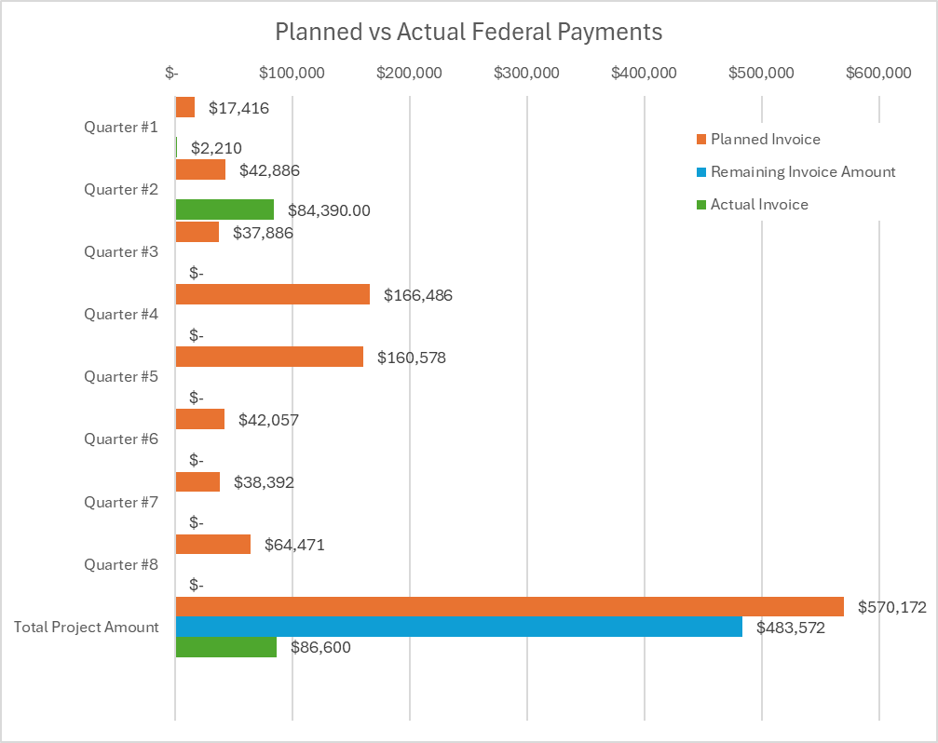

**4: Project Technical Status –**

Item #1, Task #1, Establish Partnerships

During this quarter, we completed the task of securing operator partnerships essential to project execution. This marks a slight deviation from the original plan due to the withdrawal of one of the initially proposed collaborators. In response, we added a new collaborator and executed agreements with both of our current project partners, allowing us to maintain alignment with the overall schedule and objectives.

* One of the originally proposed operator partners withdrew due to internal restructuring and resource limitations.
* We finalized one new operator partnership and reaffirmed collaboration with an existing partner, both of which will provide access to pipeline systems and operational data to support the project. These partnerships enable both physical and digital evaluation activities and contribute valuable technical expertise and in-kind resources.

Item #3, Task #2, Data Collection Under Normal Operating Conditions

Work this quarter also focused on establishing the technical and logistical framework for collecting operational data under normal conditions from partner pipeline systems.

* One partner is providing historical sensor data and supporting live data collection from an active pipeline system.
* Another partner is collaborating with the team to facilitate testing on a non-operational pipeline segment where controlled leak simulations will be conducted. Planning includes the use of inert gas as a proxy for hazardous product flow. Sensor configurations, pipeline parameters, and data logistics are actively being developed and finalized.

Item #4, Task #5, Technical and Literature Review

This task has been completed. The team conducted a comprehensive literature review spanning hydraulic modeling of compressible fluids, existing and emerging leak detection technologies, anomaly detection using time-series machine learning, and hybrid physics-informed modeling approaches.

* The review yielded insights into model accuracy, sensitivity to leak dynamics, and the tradeoffs between traditional and modern approaches.
* These findings are actively guiding our experimental and proof-of-concept development efforts.

Item #5, Task #12, Submit 2nd Quarterly Report

We completed and submitted the second quarterly internal report in compliance with project reporting requirements.

Item #7, Task #6, Design Technical Experiments

This task, originally scheduled for the following quarter, was completed ahead of schedule.

* The team developed a detailed experimental plan informed by both the literature review and operator consultations.
* Test designs cover both physical and digital leak simulation scenarios, capturing various operational configurations including different flow rates, pressure regimes, and pipeline conditions.
* Data requirements, sensor needs, and system parameters were specified, including geospatial data for modeling and validation.
* The plan includes performance metrics to evaluate model outputs against existing industry-standard methods.

**5: Project Schedule –**

As of this reporting period, the project remains on schedule with no anticipated delays. Initial challenges related to partnership finalization have been resolved, and progress has accelerated across several key technical and planning activities. Below is a summary of ongoing work and upcoming milestones.

Data Collection and Testing Planning

We are actively engaged in two parallel tracks for data collection and testing. With one operator, we are working through detailed planning efforts around the use of a decommissioned pipeline segment for controlled physical simulations, including research and logistical coordination. Simultaneously, we are in the midst of active data collection with another operator, involving real-time sensor data acquisition and preparations to obtain historical datasets for deeper analysis.

Proof-of-Concept Development

We are preparing to begin developing initial proof-of-concept models based on findings from our technical literature review and experiment design efforts. While originally slated for a future quarter, work is expected to begin ahead of schedule.

Operational Data Analysis

We plan to begin the analysis of collected operational data this quarter. This includes identifying early patterns or anomalies and implementing mitigation strategies where necessary. This work supports model training and evaluation and is progressing as ahead of schedule.

Physical Simulation Considerations

One area of risk we are monitoring involves the ability to conduct physical leak withdrawal tests. Operational constraints may prevent one of our partners from executing live withdrawal scenarios as originally envisioned. In this case, we are prepared to rely on digital simulations or alternative test procedures such as rerouting product or bypassing meters. These approaches will continue to support robust evaluation of our technical solutions, though with some limitations to direct physical validation.

Summary

With foundational partnership agreements in place and key planning activities well underway, the project remains on track. The upcoming period will focus on expanding data collection and initiating technical development activities.