**Public Quarterly Report**

**Date of Report:** 1st Quarterly Report - December 27, 2024

**Contract Number:** 693JK32410010POTA

**Prepared for:** DOT PHMSA

**Project Title:** Gap Analysis to Identify Opportunities to Inform Leak Detection and Repair (LDAR) Programs in LNG Facilities

**Prepared by:**  GTI Energy

**Contact Information:** Srijana Rai, [srai@gti.energy](mailto:srai@gti.energy), 847-768-0562

**For quarterly period ending:** December 31, 2024

**1: Items Completed During this Quarterly Period:**

|  |  |  |  |  |  |
| --- | --- | --- | --- | --- | --- |
| ***Item #*** | ***Task #*** | ***Activity/Deliverable*** | ***Title*** | ***Federal Cost*** | ***Cost Share*** |
| *1* | *1* | *Conduct kick-off team meeting to present and update project scope and procedure* | *Kickoff Meeting* | *3,479.00* | *-* |
| *2* | *3* | *Form Technical Advisory Panel* | *TAP Group* | *16,893.00* | *-* |
| *3* | *3* | *Draft Framework of Matrix Table* | *Draft Framework Matrix Table* | *30,843* | *-* |
| *4* | *1* | *Quarterly Status Report* | *Submit 1st Quarterly Report* | *16,853* | *-* |

**2: Items Not-Completed During this Quarterly Period:**

This project is on time.

**3: Project Financial Tracking During this Quarterly Period:**

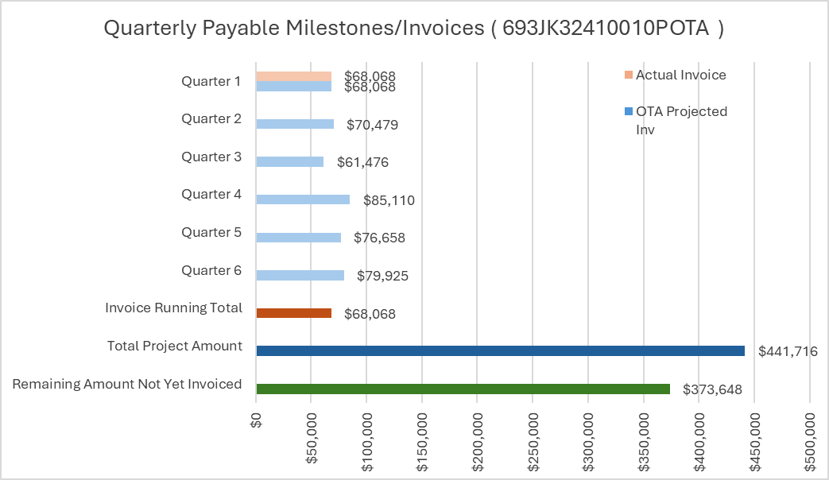

**4: Project Technical Status:**

|  |  |  |  |
| --- | --- | --- | --- |
| ***Item #*** | ***Task #*** | ***Activity/Deliverable*** | ***Title*** |
| ***1*** | ***1*** | ***Conduct kick-off team meeting to present and update project scope and procedure*** | ***Kickoff Meeting*** |

The kick-off call was held on November 22, 2024. The meeting was attended by GTI Energy and SLR teams that are performing the work along with the PHMSA representatives and some Technical Advisory Panel (TAP) members.

The presentation covered the project's background, goals, and tasks. The project's goal is to identify the gaps between federal and state regulations associated with LDAR for all LNG facilities, with the hope of achieving consistency in reporting requirements and managing the facilities consistently and safely. A survey will be sent to operators to gather information on best practices and regulations. A gap analysis will be done that compares state/federal/international to identify future opportunities for guidance. A feasibility study will be conducted for a centralized and publicly accessible portal.

The project tasks were reviewed along with the budget, schedule, project team and roles, and the TAP members and the role of TAP.

Several questions were asked and addressed in the meeting. The questions mainly had to do with scoping and it was highlighted that the focus on the identification and repair of leaks rather than the focus of EPA on quantifying that leak.

|  |  |  |  |
| --- | --- | --- | --- |
| ***Item #*** | ***Task #*** | ***Activity/Deliverable*** | ***Title*** |
| ***2*** | ***3*** | ***Form Technical Advisory Panel*** | ***TAP Group*** |

The TAP Group was created and held a kickoff meeting on December 17, 2024 to review roles, expectations, and the project's scope. All TAP requirements have been met in November with 7 industry representatives, 2 academics, and 1 PHMSA representative. The industry representation includes operators from upstream that provide gas to LNG facilities, pipeline operators that transport the gas the LNG facilities and LNG operators that liquefy and export the natural gas internationally.

The meeting began by reviewing the slides from the Kickoff call with PHMSA on November 22, 2024. A question was asked on how the team will find regulations at the city or county level, and it was brought up that the team will utilize artificial intelligence to find regulations and the team will review the documents and the keywords used to search for the regulations.

The Draft Framework of Matrix Table was reviewed in the kickoff call, and it was discussed that clarification is needed on whether the LDAR regulations should only focus on methane or all greenhouse gases.

The TAP members were told that they will be receiving SharePoint site access soon.

|  |  |  |  |
| --- | --- | --- | --- |
| ***Item #*** | ***Task #*** | ***Activity/Deliverable*** | ***Title*** |
| ***3*** | ***3*** | ***Draft Framework of Matrix Table*** | ***Draft Framework Matrix Table*** |

A draft framework for the matrix table of federal and state-level regulations was submitted to PHMSA on same day as the quarterly report, December 27th, 2024. The TAP reviewed this draft in their first meeting on December 17, 2024, and feedback was incorporated into the draft on question categories and specific questions to be explored. This matrix will continue to be developed as the project progresses and the team’s knowledge and understanding of the regulations increases.

**5: Project Schedule:**

The project is on schedule.