**CAAP 3rd Annual Report**

Date of Report: *10/06/2024*

Prepared for: *U.S. DOT Pipeline and Hazardous Materials Safety Administration*

Contract Number: *693JK32150001CAAP*

Project Title: *Pipeline Risk Management Using Artificial Intelligence-Enabled Modeling and Decision Making*

Prepared by: *Bingyan Cui (PhD student), Xingsen Yang (PhD student), Emad Farahani (PhD student), Dr. Hao Wang (PI), Dr. Qindan Huang (Co-PI)*

Contact Information: Hao Wang, [hw261@soe.rutgers.edu](mailto:hw261@soe.rutgers.edu), 848-445-2874

Qindan Huang, [qindan.huang@marquette.edu](mailto:qhuang@uakron.edu), 414-288-6670

For quarterly period ending: 10/1/2023 - 9/30/2024

**Business and Activity Section**

# Contract Activity

* Contract Modification

One-year NCE is approved to extend the project end date to 9/30/3025.

* Student Mentoring

PhD students at Rutgers University: Bingyan Cui and Xingsen Yang

PhD student at Marquette University: Emad Farahani

* Educational Activities

The PI introduced the knowledge of pipeline integrity management system in the graduate course – *Infrastructure Management System* taught at Rutgers University.

The Co-PI introduced the knowledge of pipeline failure prediction and risk management in the graduate course - *Engineering Risk Analysis* at Marquette University.

* Outreach Activities

The research team collected pipeline in-line inspection (ILI) data from the industry partners for developing defect growth models and shared the analysis findings with the industry partner.

The following paper has been published based on project findings:

*Cui, B.Y. and H. Wang*, Pipeline Corrosion Prediction and Analysis with an Ensemble Bayesian Neural Network Approach, Process Safety and Environmental Protection, 2024, Vol. 187, pp. 483-494.*

*Farahani, E.M., Q.D. Huang*, and H. Wang, A Probabilistic Framework for External Pitting Corrosion Growth Modelling for Buried Steel Pipelines Considering Soil Properties, International Journal of Pressure Vessels and Piping, 2024, Vol. 210, 105234.*

# Financial Summary

* Federal Cost Activities

The salary of PIs and graduate students and the tuition of graduate students are partially charged from the project during this reporting period.

* Cost Share Activities

Cost share contribution includes PIs’ academic salary and indirect costs at Rutgers University and Marquette University during this reporting period.

# Project Schedule Update

The updated schedule of research tasks is shown in the following table.

|  |  |  |  |  |  |  |  |  |  |  |  |  |  |  |  |  |
| --- | --- | --- | --- | --- | --- | --- | --- | --- | --- | --- | --- | --- | --- | --- | --- | --- |
| **Tasks** | **Year 1** | | | | **Year 2** | | | | **Year 3** | | | | **Year 4** | | | |
| ***Task 1*** *Literature Review* |  |  |  |  |  |  |  |  |  |  |  |  |  |  |  |  |
| ***Task 2*** *Data Collection from Literature and Industry Partners* |  |  |  |  |  |  |  |  |  |  |  |  |  |  |  |  |
| ***Task 3*** *Data-Driven Probabilistic Modeling of Pipeline Defects* |  |  |  |  |  |  |  |  |  |  |  |  |  |  |  |  |
| ***Task 4*** *Quantification of Probability of Failure* |  |  |  |  |  |  |  |  |  |  |  |  |  |  |  |  |
| ***Task 5*** *Decision Making with Reinforcement Learning* |  |  |  |  |  |  |  |  |  |  |  |  |  |  |  |  |
| ***Task 6*** *Final Report and Presentation* |  |  |  |  |  |  |  |  |  |  |  |  |  |  |  |  |

# Status Update of the 4th Quarter Technical Activities

**Quantification of Consequence of Pipeline Failure**

The Pipeline and Hazardous Materials Safety Administration (PHMSA) mandates that pipeline system operators in the United States submit a report within 30 days of a pipeline incident. PHMSA has compiled a comprehensive database of these incidents, which includes details on various factors such as pipeline specifications (e.g., material type, diameter, wall thickness, installation year, yielding stress), incident year, depth of soil cover, estimated volume of released commodities, location class, ignition or explosion occurrence, pipe pressure (accident pressure and maximum allowable operating pressure), failure modes (leak and rupture), causes of incidents, and more.

The consequences of pipeline incidents reported by PHMSA include total property damage, fatalities, and injuries. Total property damage encompasses the cost of public and private non-operator property damage, lost commodities, operator property damage and repair, emergency response, environmental remediation, and other associated expenses. Considering all causes of failures (e.g., equipment failure, corrosion, excavation damage, incorrect operation, material failure, natural force damage, other outside force damage causes), Figure 1 shows the boxplots of the total property damages categorized by failure modes (i.e., large leak and rupture) for hazardous liquid (HL) (shown in Figure 1(a)) and gas transmission and gathering (GTG) pipelines (shown in Figure 1(b)). In the boxplots, the central red line indicates the median of each group, and the bottom and top blue edges of the box indicate the 25th and 75th percentiles, respectively. The whiskers (i.e., black dashed line) extend to the most extreme data points that are not considered outliers, and the outliers are plotted individually using the '+' marker symbol. In total, there are 3,696 incidents due to leak and 107 incidents due to rupture in HL pipelines. For GTG pipelines, there are 633 incidents due to leak and 183 incidents due to rupture.

Similarly, Figure 2 shows the boxplots of total property damages considering failures caused by corrosion only and categorized by failure mode. Considering failure caused by corrosion, there are 808 incidents due to leak and 20 incidents are due to rupture in HL pipelines. For GTG pipelines, there are 224 incidents due to leak and 62 incidents due to rupture. In addition, Table 1 summarizes the statistics of data from the boxplots in Figures 1 and 2. The results are presented for all causes of failure, as well as for failures specifically caused by corrosion, considering both leak and rupture as failure modes.

Overall, the median of failures with rupture as the failure mode is higher than that of leak failures in Figures 1 and 2. Additionally, incidents with similar magnitudes of property damage can occur in both leak and rupture failure modes. This indicates that the failure mode alone does not necessarily predict higher property damages. Other variables and incident characteristics must be considered when assessing property damage. The wide variations in the property damage costs also suggest that factors beyond the failure mode significantly impact property damage and further investigation is needed in this regard.

|  |  |
| --- | --- |
|  |  |
| (a) | (b) |
| Figure 1. Boxplots of total property damages considering all causes in: (a) HL pipelines, and (b) GTG pipelines | |
|  |  |
| (a) | (b) |
| Figure 2. Boxplots of total property damages of incidents caused only by corrosion in: (a) HL pipelines, and (b) GTG pipelines | |

Table 1 summarizes statistics of property damages in HL and GTG pipelines. It is evident that corrosion failures can cause significant higher property damages than all other causes, not only within the 25th and 75th percentile but also in extreme cases. For example, in the HL pipeline system with leak failure mode, the maximum value ($143,000,000) shown in Table 1 is due to corrosion-related failure.

Table 1. Statistics of property damages in HL and GTG pipelines

|  |  |  |  |  |  |  |  |
| --- | --- | --- | --- | --- | --- | --- | --- |
| Failure cause | Pipeline system | Failure mode | Property Damage ($) | | | | |
| Minimum | 25th Percentile | Median | 75th Percentile | Maximum |
| All failure causes | HL | Leak | 6,248 | 6,248 | 22,912 | 115,831 | 143,000,000 |
| Rupture | 45 | 57,364 | 785,000 | 3,566,549 | 840,526,000 |
| GTG | Leak | 4,783 | 88,833 | 175,545 | 387,449 | 8,040,699 |
| Rupture | 17,575 | 139,093 | 455,000 | 1,456,963 | 558,363,000 |
| Corrosion | HL | Leak | 26,252 | 26,252 | 78,062 | 281,650 | 143,000,000 |
| Rupture | 14,916 | 155,673 | 979,795 | 3,227,000 | 21,819,000 |
| GTG | Leak | 11,550 | 156,026 | 248,536 | 466,439 | 2,272,952 |
| Rupture | 31,500 | 101,835 | 396,261 | 978,273 | 66,046,140 |

**Case Study of Pipeline Repair Strategy Using Reinforcement Learning**

A numerical example is provided to demonstrate the application of reinforcement learning (RL) for developing an optimal pipeline maintenance strategy. The corresponding parameters of pipelines are listed in Table 2, serving as the foundation for defining the structural properties within the simulation environment.

Table 2 Parameters of the pipeline

|  |  |
| --- | --- |
| **Parameters** | **Value** |
| Outside diameter (mm) | 457.2 |
| Wall thickness (mm) | 6.4 |
| Operation pressure (MPa) | 5.52 |
| Steel type | API 5L X52 |
| Yield stress (MPa) | 358.53 |

*Corrosion growth model*

To simplify the initial implementation of the reinforcement learning (RL) model, a linear corrosion growth model is employed here first to formulate the model and the BNN model developed based on Mexico pipeline data will be integrated later. This model assumes a constant rate of corrosion progression over time, which provides a manageable starting point for more complex future iterations. Based on the Mexico pipeline data, the average corrosion depth growth rate is 0.093 mm per year, with standard deviation of 0.058 mm per year, as illustrated in Figure 3. Similarly, the average corrosion length growth rate is 0.325 mm per year, with standard deviation of 0.775 mm per year. Taking 2010 as the beginning of maintenance period, the initial corrosion depth is 1.22 mm, with a standard deviation of 0.40mm. The initial corrosion length is 2.11 mm, with standard deviation of 4.40 mm.

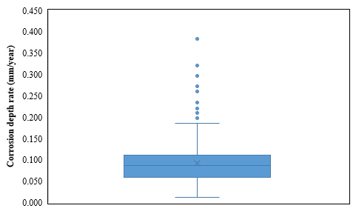

(a)

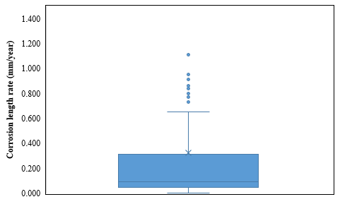

(b)

Figure 3 Corrosion growth rate using the Mexico dataset (a) corrosion depth, (b) corrosion length.

*Reliability model*

The reliability model involves calculating probability of failure *Pf*, including both leakage and burst failures. The probability of failure is defined as the conditional probability of reaching or exceeding the specified limit state of the pipelines within a given condition boundary.

Small leak failure will occur when the corrosion depth exceeds the pipeline thickness. Its probability of failure can be calculated as shown in Eq. (1).

 (1)

where, *dw* is the thickness of pipeline; *d*(*t*) is the maximum corrosion depth at time *t*.

Burst failure refers to a scenario where the operation pressure of a pipeline exceeds its pressure capacity. The probability of such a failure can be quantified as presented in Eq. (2).

 (2)

where, *Pb*(*t*) is the burst pressure capacity of pipeline at time *t*; *Pp* is the operation pressure.

The burst pressure capacity can be calculated as depicted in Eq. (3) based on ASTM B31G criterion [1, 2].

 (3)

where, *σ*is the ultimate tensile strength of pipe material; *l* is the corrosion length; *D* is the outer diameter of pipeline.

In this study, the failure probability of the pipeline is calculated using Monte Carlo Simulation (MCS). The process involves setting a number of simulations (*N*), determining the distribution parameters such as average and standard deviation from historical data, generating random samples based on these parameters, and using a limit state function to calculate the likelihood that the pipeline will fail, which is represented by *Pf* in Eq. (4).

 (4)

where, *Nf* is the number of simulations that limit state function is less than 0.

*Simulation parameters*

Specifically, the state space of RL is represented by two continuous variables, including corrosion depth and corrosion length, which represents the current level of corrosion. The action space consists of three discrete actions: 0 = do nothing; 1 = composite sleeve (slows down corrosion growth and reduces existing corrosion); 2 = Replacement (resets corrosion levels). A full episode is defined by starting from a new pipeline and simulating until either reaching the maximum number of steps or entering the terminal state.

According to target reliability levels commonly recommended in the literature [3, 4] for ultimate limit states (ULS) in pipelines, 10-4 is the target probability for medium safety class. Therefore, the failure probability threshold in this case is set to 10-4. This threshold represents the acceptable upper limit of the probability that the pipeline fails. During each step, the environment checks whether the failure probability exceeds this threshold. The objective is to minimize the total maintenance cost over a 50-year period. The optimized parameter is the maintenance action taken at each time step, including do nothing, composite sleeve and replacement. The Deep Q-Network (DQN) agent selects the optimal action from these three options at each step, aiming to achieve the lowest possible maintenance cost over the lifetime of the pipeline while ensuring reliability.

The cost function is the sum of failure cost and maintenance cost, as shown in Eq. (5). It should be noted that the failure cost is not accumulated every year. The failure cost is applied only when the failure probability exceeds the defined threshold, which is a one-time penalty. The maintenance cost includes the sleeve cost and replacement cost, which are used when the corresponding actions are taken. A discount factor of 0.95 is introduced to account for the time value of money, effectively reducing future maintenance costs to their present value. It should be noted that all costs should account for the discount factor to properly reflect their present value over time.

 (5)

where, *ns* is the number of times the composite sleeve is used; *Cs* is the sleeve cost; *nr* is the number of times the replacement is used; *Cr* is the replacement cost; *Pfi*is the failure probability of *i*th failure; *Cfi* is the failure consequence of *i*th failure, including leakage and rupture failures.

During the training process, the DQN agent is first trained in the custom pipeline maintenance environment for 100,000 steps, with each episode representing a 50-year simulation of pipeline corrosion and maintenance. The agent begins with an exploration rate (epsilon) of 1.0, which decays by 0.005 per episode until reaching 0.01, ensuring sufficient exploration in the early stages. This ensures that the agent explores a variety of actions during the early stages of training, and gradually shifts to exploiting the best-known actions as the training progresses. The DQN model uses a neural network with two hidden layers (24 neurons each) and a learning rate of 0.001. The batch sizes of 32 are used during training. After the training phase, the fully trained agent performance is evaluated over test episodes, using key performance metrics such as total costs and probability of failure for each year.

*Results analysis*

Assigning accurate cost values in the cost function is critical for effective maintenance decision-making. In this study, we simplified the problem by considering the relative maintenance costs for a one-mile pipeline segment, as shown in Table3. For the “do nothing” action, the cost is set at zero. The cost of replacing a pipeline is challenging to estimate accurately, so a value of $1,600,000 per mile was adopted based on the reference [5]. The cost of using a composite sleeve can vary depending on the material and thickness. According to the reference [6], the relative cost ratio between replacement and sleeve typically ranges from 1 to 1.5. Therefore, a composite sleeve cost of $1,200,000 per mile is selected for this analysis.

Two types of failure costs are considered. The cost of leakage is assumed to be three times the replacement cost, as a leaking pipeline requires not only replacement but also causes additional costs due to service interruptions. The cost of rupture includes replacement costs but it is significantly higher than the replacement cost alone. It should include the total impact and consequences of a rupture. These cost values will be updated later as more accurate information becomes available.

Table 3 Values of different types of costs in the unit of $10,000

|  |  |  |  |
| --- | --- | --- | --- |
| **Composite sleeve** | **Replacement** | **Leakage failure** | **Rupture failure** |
| 120 | 160 | 480 | 1760 |

To evaluate the performance of RL model, several periodic maintenance plans are also compared in Table 4. Table 4 presents a comparison of periodic and optimized maintenance plans for a pipeline, highlighting the maintenance schedules and associated costs for each scenario. Except for Periodic Plan 2, all plans successfully maintain the pipeline without failure throughout the entire 50 years. he RL-based plan proves to be the most cost-effective, with a total cost of 76.75, significantly lower than the other options. The RL-based plan involves applying a composite sleeve at year 17 and performing a full replacement at year 35. In contrast, the periodic maintenance plans lead to higher cost. For example, Periodic Plan 1 schedules three sleeve applications at years 15, 30, and 45, resulting in a total cost of 93.28. Periodic Plan 2 schedules a replacement at year 20, but by then the pipeline faces a high risk of rupture failure. Periodic plan 3 combines sleeve application at year 15 and a replacement at year 30, with a total cost of 89.94. These comparisons underscore that the RL-based plan minimizes costs and is the most efficient approach to pipeline maintenance.

Table 4 Comparison of periodic and optimized maintenance plan (unit: $10,000)

|  |  |  |
| --- | --- | --- |
| **Scenarios** | **Maintenance plan** | **Total cost** |
| RL-based plan | [17, sleeve], [35, replacement] | 76.75 |
| Periodic plan 1 | [15, sleeve], [30, sleeve], [45, sleeve] | 93.28 |
| Periodic plan 2 | [20, replacement], [40, replacement] | Failure |
| Periodic plan 3 | [15, sleeve], [30, replacement] | 89.94 |

For the effects of maintenance actions, it is assumed that the corrosion level decreases by 50% after applying a composite sleeve, and future corrosion growth is recalculated starting from the year of sleeve installation. This assumption need be further refined to consider the effectiveness of composite sleeve on pipe structural capacity and accordingly the failure probability, as well as the corrosion growth after repair. For pipeline replacements, corrosion level is reset to zero, as a new pipeline is installed. Corrosion growth is then recalculated starting from the year of replacement.

Regarding the corrosion evolution during the maintenance period, Fig. 2 shows the probability of failure changes over time with and without maintenance. In these figures, the probability of pipeline failure is shown over time for different maintenance strategies, with the failure probability threshold set at 10-4 (the red dashed line). It is noted that only the probability of failure higher than 1E-8 is plotted in the figure. The maintenance reduced the probability of failure to a small value (lower than 1E-8) and thus it is not shown in the figure.

For the “no maintenance” scenario, the probability of failure stays low for the first 10 years but then increases rapidly. Around year 20, it surpasses the threshold, continuing to rise until it reaches nearly 1 by year 50, indicating a very high likelihood of failure without any intervention.

In Periodic Plan 1, maintenance actions are performed at years 15, 30, and 45, effectively reducing the failure probability after each intervention. However, the frequent maintenance results in much higher costs compared to the RL-based plan, making it less cost-effective despite controlling failure probability.

Periodic Plan 2 delays the first replacement until year 20, leading to a sharp increase in the failure probability, which surpasses the 0.0001 threshold before any maintenance is carried out. This indicates a high risk of rupture failure before intervention, although the replacement reduces the failure probability afterward.

Periodic Plan 3 schedules maintenance at year 15 (composite sleeve) and year 30 (replacement), successfully keeping the failure probability below the threshold after each intervention. However, performing the maintenance actions relatively early in the timeline is less cost-effective, as it leads to unnecessary early interventions when the failure risk is still manageable.

In contrast, the RL-based plan provides the most stable control over the failure probability. With a composite sleeve applied at year 17 and a replacement at year 35, the failure probability consistently remains below the threshold throughout the 50-year period. This plan optimizes the timing of interventions and reduces their frequency, making it the most cost-effective strategy while maintaining a low failure risk over the long term.

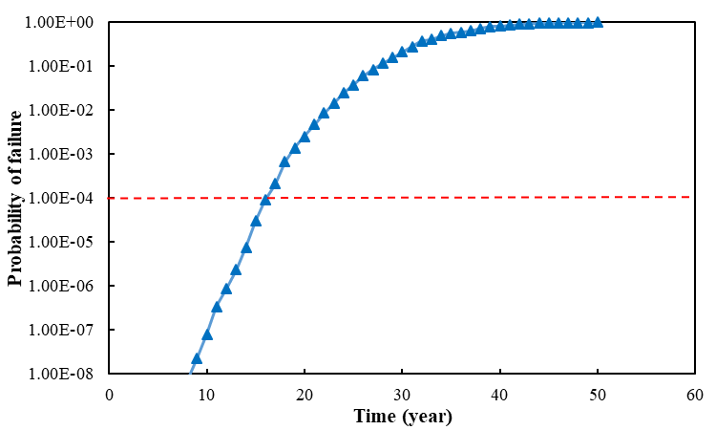

1. No maintenance

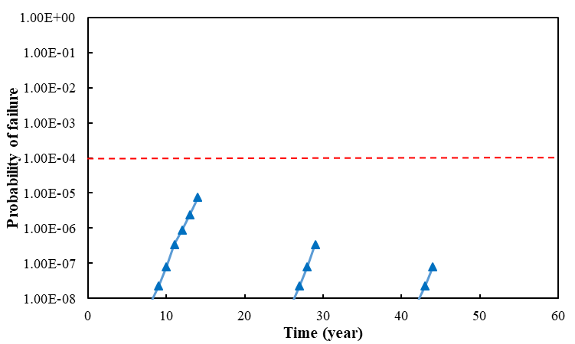

1. Periodic plan 1

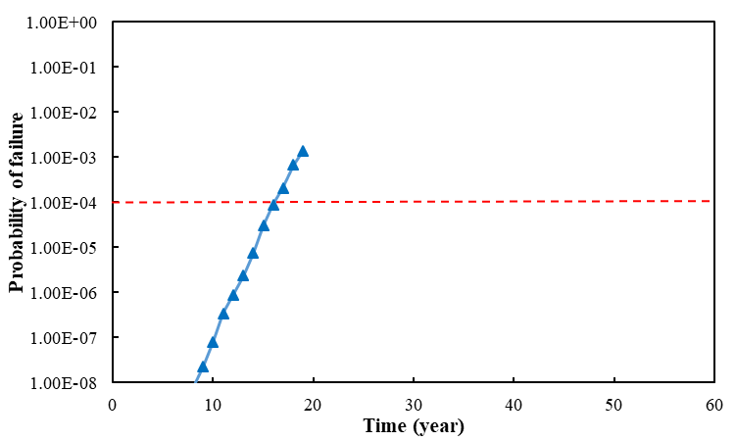

1. Periodic plan 2

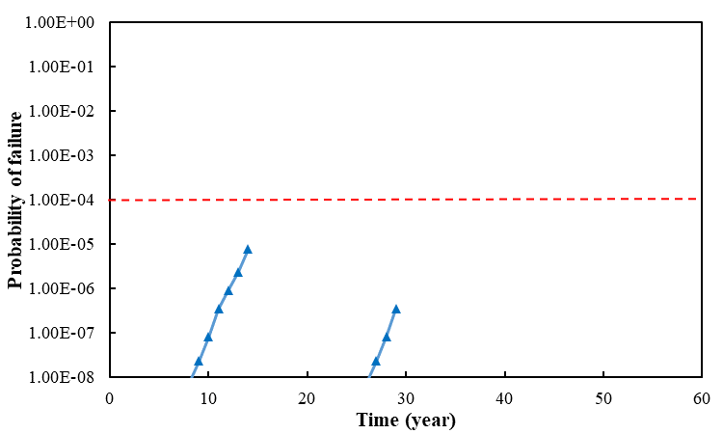

1. Periodic plan 3

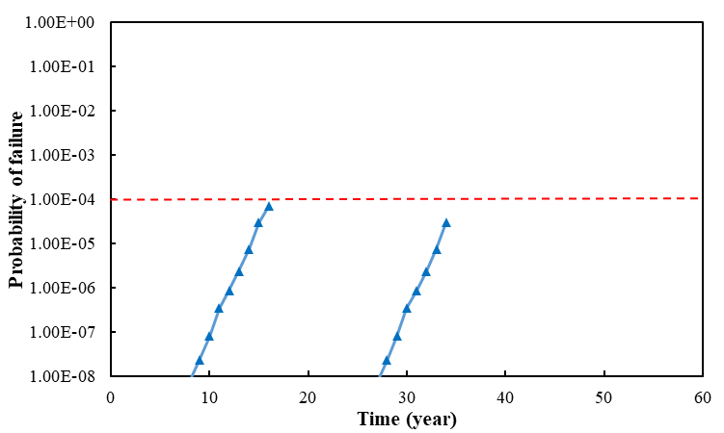

1. RL-based plan

Figure 4 Comparisons between failure probabilities under different maintenance plans.

**References:**

1. Kere, K.J. and Q. Huang, *Development of probabilistic failure pressure models for pipelines with single corrosion defect.* International Journal of Pressure Vessels and Piping, 2022. **197**: p. 104656.

2. Phan, H.C., A.S. Dhar, and B.C. Mondal, *Revisiting burst pressure models for corroded pipelines.* Canadian Journal of Civil Engineering, 2017. **44**(7): p. 485-494.

3. Zimmerman, T.J.E., Q. Chen, and M.D. Pandey, *Target Reliability Levels for Pipeline Limit States Design*. 1996. p. 111-120.

4. Miran Seyedeh, A., Q. Huang, and H. Castaneda, *Time-Dependent Reliability Analysis of Corroded Buried Pipelines Considering External Defects.* Journal of Infrastructure Systems, 2016. **22**(3): p. 04016019.

5. Mahmoodzadeh, Z., et al. *Condition-Based Maintenance with Reinforcement Learning for Dry Gas Pipeline Subject to Internal Corrosion*. Sensors, 2020. **20**, DOI: 10.3390/s20195708.

6. Xie, M., J. Zhao, and X. Pei, *Maintenance strategy optimization of pipeline system with multi-stage corrosion defects based on heuristically genetic algorithm.* Process Safety and Environmental Protection, 2023. **170**: p. 553-572.

**Detailed Technical Results in the Report Period**

# (a) Background and Objectives in the Annual Report Period

The work in 3rd year is to refine defect growth models using Bayesian Neural Network (BNN) and power-law based probabilistic function, quantify the probability of failure for the pipes with corrosion defects and after composite sleeve repair, and develop the framework of reinforcement learning (RL) for maintenance strategy optimization.

# (b) Research Progress

The following provides the summary of work for each task. The detailed data and analysis can be found in the quarterly reports.

*Task 1 Literature Review – completed in year 1*

*Task 2 Data Collection from Industry Partners and Literature – completed in year 1*

*Task 3 Data-Driven Probabilistic Modeling of Pipeline Defect Generation and Growth – completed in year 3*

A Bayesian Neural Network (BNN) is developed to predict defect growth and quantify uncertainty. The model is further refined with ensemble learning to improve model accuracy. The results show that ensemble learning improves prediction accuracy for metal loss but slightly affect prediction of defect length negatively. Considering the prediction accuracy for both metal loss and defect length, ensemble learning is still recommended.

A Power-law function of time model formulation is adopted to consider non-constant damage growth rate over time. To demonstrate the effectiveness of soil properties inclusion in growth models and the impact of measurement error on the growth modeling, the model accuracy is compared using three models: (a) considering soil properties and no measurement error, (b) without considering soil properties and measurement error, and (c) considering soil properties and measurement error.

*Task 4 Quantification of Probability of Failure* *– completed in year 3*

The steel pipeline failure modes can be small leak and burst (large leak or rupture). Small leak failure will occur when the corrosion depth exceeds the pipeline thickness. Burst failure refers to a scenario where the operation pressure of a pipeline exceeds its pressure capacity.

The pipeline remaining strength (also the burst pressure capacity of corroded pipeline) is calculated using modified ASME B31G criterion (also known as RSTRENG 0.85), in which corrosion length and depth are used as inputs. Monte Carlo simulation was used to calculate the likelihood of failure. For each sample, the limit state function was evaluated to determine if a configuration was desired or undesired. The probability of failure is then represented by the ratio of undesired configurations to the total number of samples. The calculated probability of failure should be lower than the target failure probabilities to meet safety standards, such as the Det Norske Veritas (DNV) standard (DNV 2012).

The composite sleeve method with fiber-reinforced materials such as GFRP and CFRP is a reliable and effective solution to repair the corroded pipelines. The burst pressure capacity of the repaired pipeline is estimated by modeling the pipe-composite system as two concentric thin elastic cylinders subjected to internal pressure with the assumption that the corrosion defect is localized and material behavior is elastic far from corrosion defects (da Costa Mattos et al. 2014). Then, the probability of failure after using composite sleeve can be determined. For comprehensive comparison, a diverse range of thickness and modulus of composite materials was chosen sensitivity analysis.

*Task 5 Decision Making of Inspection and Repair Strategy using Reinforcement Learning – ongoing*

An AI-based reinforcement learning (RL) method will be used for pipeline maintenance planning, including maintenance timing, methods, and locations. Fig. 1 shows the proposed framework of pipeline maintenance strategy using RL. The RL environment is the test bench of pipeline system, including the pipeline environmental parameters collection, corrosion growth model development and reliability model. The agent represents the deep Q-learning decision-maker. Actions consist of possible maintenance action, such as doing nothing, composite sleeve with different thickness and materials, and replacement. Under the influence of the action, the current state transfers and a reward can be obtained. By properly choosing the actions sequentially, the goal is to maximize the expected cumulative rewards. The constraint is to satisfy the failure probability to ensure safe pipeline operations, and the objective is to minimize the total cost of maintenance. In each simulation episode, a pipeline system is created by a stochastic environment. Then, at the end of each month, the agent will check whether the failure probability exceed the threshold. After that, the agent will choose the action from its policy until the simulation is ended. Thereafter, the program will loop more episodes until it reaches the assigned number of episodes. The following sections describe each component in detail.



**Fig. 1** Proposed framework for pipeline maintenance using reinforcement learning.

A case study is conducted to demonstrate the application of reinforcement learning (RL) for developing an optimal pipeline maintenance strategy. The assumptions are simplified in the case study to test the developed algorithm, which will be refined later to consider more realistic conditions.

# (c) Future Work

Future work will continue developing the RL model for maintenance strategy optimization of the pipeline network with different soil conditions along the pipe, which will be compared to the analytical formulation of life-cycle cost analysis results.