Quarterly Report – Public Page

Date of Report: October 10, 2024
Contract Number: 693JK32310001POTA
Prepared for: DOT - Pipeline And Hazardous Materials Safety Administration
Project Title: A Comprehensive Study of Barriers for Underground Natural Gas Storage Wells
Prepared by: Pennsylvania State University
Contact Information: Arash Dahi Taleghani, Arash.Dahi@psu.edu , 814-865-5421
For quarterly period ending: September 30, 2024

1: Items Completed During this Quarterly Period:

Item # | Task # | Activity/Deliverable | Title | Federal Cost | Cost Share
5 | 3 | Research and test new materials for establishing a barrier | Report detailing the findings for various non-cementitious materials to be used to obtain well integrity | $29,958.50 | $7,514.30
8 | 5 | 4rd Quarterly Status Report | Submit 4th quarterly report | $2,995.85 | $751.43

2: Items Not-Completed During this Quarterly Period:
The first deliverable is due after the second quarter of the project. The rest of the project is moving according to the plans.

Item # | Task # | Activity/Deliverable | Title | Federal Cost | Cost Share
7 | 4 | Develop workflows for assessment and testing novel tools and methods for detecting micro-annulus in wells | Workflow for designing and testing a novel tool for micro-annulus detection in cemented wells | $29,958.50 | $7,514.30

3: Project Financial Tracking During this Quarterly Period
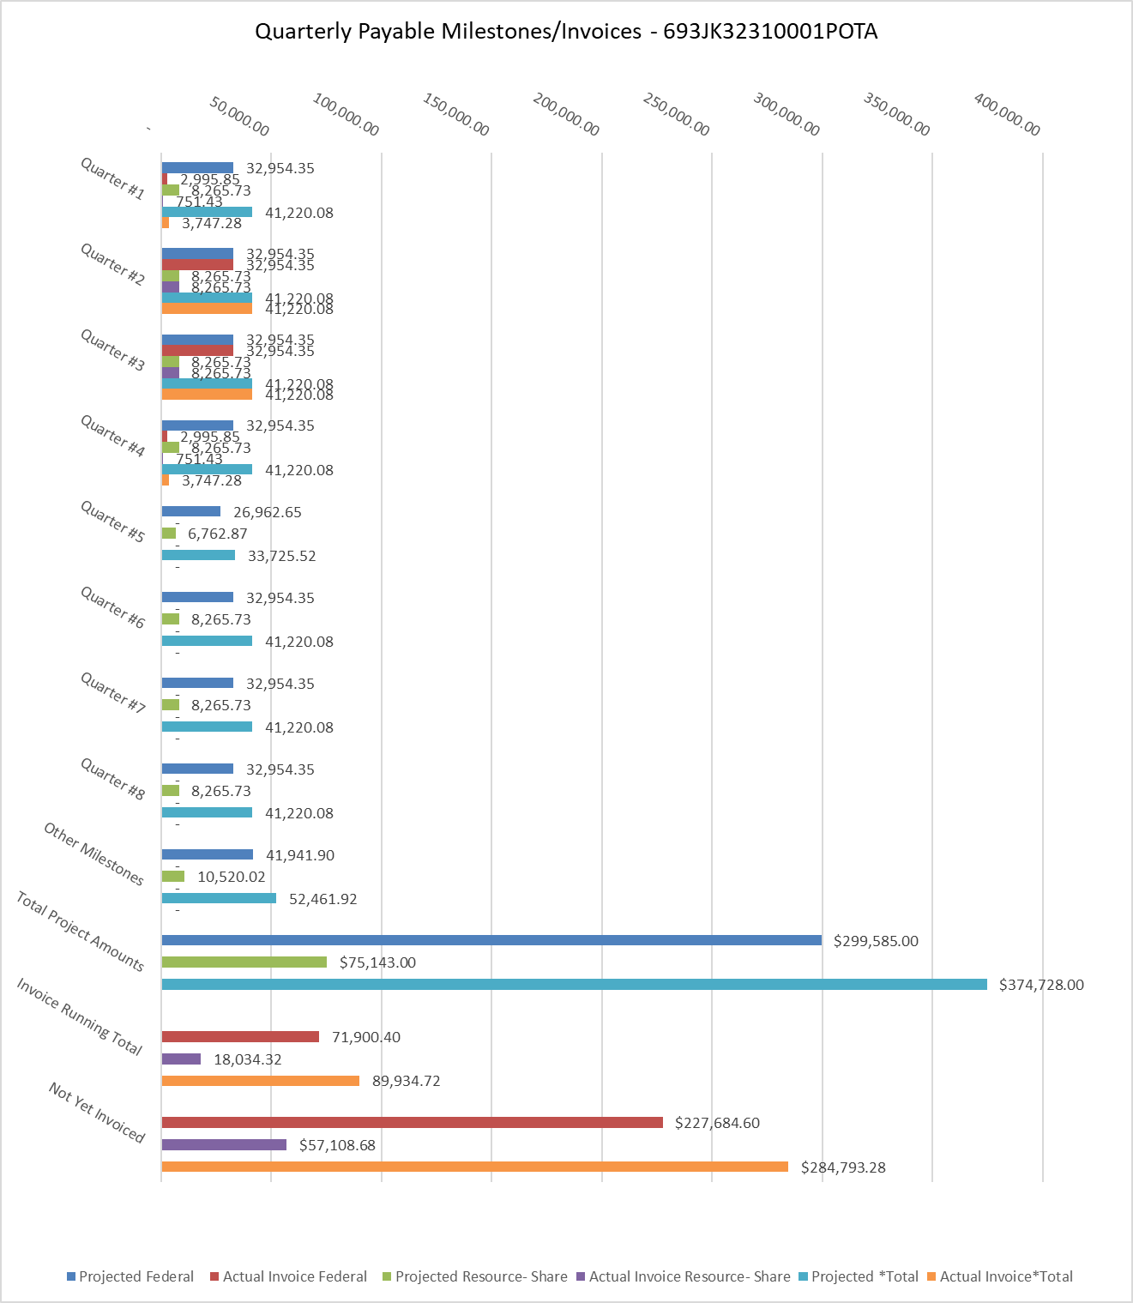

4: Project Technical Status –
We continued the fourth quarter of the project focused on remedial non-cementing materials for gas storage wells and their differences from remedial cementing or similar materials in other wells.
The research explored non-cementitious materials as alternatives to traditional cement for sealing underground gas storage (UGS) wells, addressing concerns about cement degradation in CO2-rich environments. Key alternatives investigated include geopolymers, bentonite, low-melting-point metals like bismuth, resins, and activated slag. Geopolymers showed particular promise due to their superior mechanical properties, chemical resistance, and durability under extreme conditions. The incorporation of nanomaterials, such as nano-SiO2, nano-Al2O3, and nano-TiO2, into geopolymer formulations demonstrated potential for further enhancing performance.
While these alternative materials show promise, each presents unique challenges that require further research. Geopolymers need optimization for pumpability and long-term performance under pressure cycling. Bentonite requires more data on high-temperature performance. Bismuth systems face energy input challenges for heating. Resins lack comprehensive data on long-term durability in harsh environments. The report emphasizes the need for continued research to address these challenges and optimize formulations for UGS well applications. Additionally, the development of multi-functional spacers and advanced monitoring strategies are highlighted as crucial for ensuring long-term well integrity and sealing capacity.

5: Project Schedule –
In the third quarter of the project, everything is on the track. The scheduled deliverable is going to be submitted to USDOT. The team is working to deliver the next item by the end of the second quarter.

