Quarterly Report – Public Page

Date of Report: 3rd Quarterly Report, June 28, 2024
Contract Number: 693JK32310010POTA
Prepared for: Government Agency: DOT and Co-funders
Project Title: Standardize the Application of Vapor Corrosion Inhibitors
Prepared by: Pipeline Research Council International (PRCI), Inc.
Contact Information: Janie Norton, jnorton@prci.org 703-205-1600 ext: 105
For quarterly period ending: June 30, 2024

1: Items Completed During this Quarterly Period:

Item # | Task # | Activity/Deliverable | Title | Federal Cost | Cost Share
1 | 5 | Kick-off meeting with all stakeholders | Meeting summary and action items to be included in the quarterly report | $7,644 | $1,911
5 | 2 | Procure materials and supplies for the VCI qualification testing | Summary of the materials and supplies to be included in the quarterly report | $87,640 | $21,910
10 | 5 | 3rd quarterly status report & project management | Submit 3rd quarterly report | $7,985 | $1,996

2: Items Not Completed During this Quarterly Period:

Item # | Task # | Activity/Deliverable | Title | Federal Cost | Cost Share
2 | 1 | Conduct literature review of the VCI qualification and related testing methods | Summary of the literature review to be included in the first quarterly report | $10,424 | $2,606
4 | 2 | Development of the test matrix for VCI qualification tests | Summary of the test matrix to be included in the quarterly report | $12,000 | $3,000
8 | 3 | Develop plans for the VCI effect experiments | Summary of the VCI effect experiment plan to be included in the quarterly report | $3,127 | $782
6 | 3 | Initiate Control Tests | Summary of the control tests started in the second quarter to be included in the quarterly report | $16,000 | $4,000
9 | 3 | Analyze the monitoring data from the VCI control tests | Results to be included in the quarterly report | $3,127 | $782

3: Project Financial Tracking During this Quarterly Period:

Note that this chart reflects Federal share only:

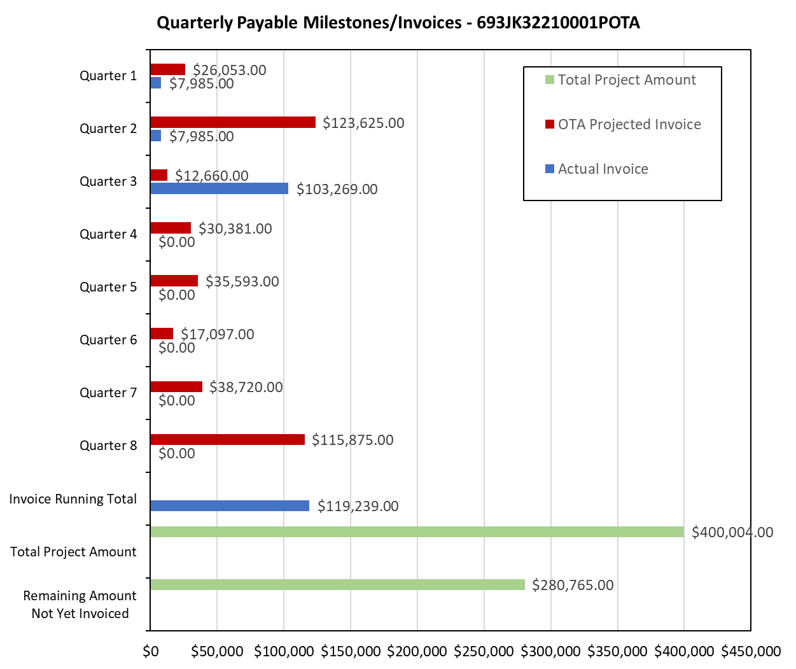

4: Project Technical Status –

Item 1, Task 5 ⎯ Kick-off meeting with all stakeholders. Meeting summary and action items to be included in the quarterly report: The kick-off meeting was held on 4/3/2024. The stakeholders included tank operators, VCI vendors, and PHMSA staff. No specific action items were identified in the meeting. This item links to item 1 in Attachment 1 Team Project Activities. This item links to item 1 in Attachment 2 Project Deliverables.

Item 5, Task 2 ⎯ Procure materials and supplies for the VCI qualification testing. Summary of the materials and supplies to be included in the quarterly report: Orders were placed for procuring twenty ER probes and 400 mass-loss coupons. The coupons are 1-inch diameter, 0.25 inch thick. Ten ER probes and 200 mass-loss coupons have been received. Other supplies needed to start the control, VCI effect, and the migration experiments are being procured. Sufficient materials are available to start the control tests. This item links to item 3 in Attachment 1 Team Project Activities. This item links to item 4 in Attachment 2 Project Deliverables.

Item 10, Task 5 ⎯ 3rd quarterly status report & project management. Submit 3rd quarterly report: The third quarter meeting was held on June 6, 2024. This report satisfies this item. This item links to item 13 in Attachment 1 Team Project Activities. This item links to item 13 in Attachment 2 Project Deliverables.

5: Project Schedule –

Item 2, Task 1 ⎯ Conduct literature review of the VCI qualification and related testing methods. Summary of the literature review to be included in the first quarterly report: The following documents were reviewed: NACE TM0208, German Test Method TL 8135-002, AMPP C2023-19169 conference paper, ASTM D5534 Test Method, and PRCI reports on VCIs. Both NACE TM0208 and TL 8135-02 are designed to evaluate VCIs’ ability to inhibit corrosion in vapor phase for the ferrous materials. AMPP C2024-20747 provides additional suggestions on using carbon steel grade that could be more economical and consistent while using NACE TM0208 and TL 8135-002. ASTM D5534 is focused on automobile application. The PRCI report works (Shukla et al., 2018, 2022) are directly focused on evaluating VCIs for tank bottom application. In the PRCI studies, the following parameters were controlled: temperature, sand moisture level (mostly set at 75% of the saturation), and coupon material was the carbon steel grade A36. The sand salt content was sometimes controlled, and not controlled, in the PRCI studies. The sand grain size distribution was not controlled. Regarding field application, VCIs are estimated to have been applied in 700-1000 tanks worldwide, with approximately 50/50 distribution between the two commercially available products. Most operators use VCIs to either supplement CP or when CP is suboptimal. This item links to item 2 in Attachment 1 Team Project Activities. This item links to item 2 in Attachment 2 Project Deliverables. Milestone is ready and will be submitted for the Project team to review and approve in next quarter.

Item 4, Task 2 ⎯ Development of the test matrix for VCI qualification tests. Summary of the test matrix to be included in the quarterly report: The test matrix was developed based on the analysis of 255 sand samples and prior experience. The chloride concentration of 10 ppm was selected based on API 651. This item links to item 4 in Attachment 1 Team Project Activities. This item links to item 3 in Attachment 2 Project Deliverables. Milestone is ready and will be submitted for the Project team to review and approve in next quarter.

Item 8, Task 3 ⎯ Develop plans for the VCI effect experiments. Summary of the VCI effect experiment plan to be included in the quarterly report: The test matrix for the VCI effect experiments is provided in Table 2. These experiments will be started once ER probe data from the control experiments is available. It is estimated that the VCI effect experiments will be started during the 5th quarter. This item links to item 4 in Attachment 1 Team Project Activities. This item links to item 3 in Attachment 2 Project Deliverables. Milestone is ready and will be submitted for the Project team to review and approve in next quarter.

Item 6, Task 3 ⎯ Initiate Control Tests. Summary of the control tests started in the second quarter to be included in the quarterly report: Preparation is underway to start the control tests and it expected that all of the control experiments will be started by early 4th quarter, i.e., next quarter. The revised plan is to finish this item by the next quarter.

Item 9, Task 3 ⎯ Analyze the monitoring data from the VCI control tests. Results to be included in the quarterly report: The control tests have not yet been started, therefore monitoring data is not yet available for analysis. All control experiments are expected to be started by early 4th quarter, i.e., next quarter. Sufficient amount of ER probe monitoring data will become available within 2 months of starting the control experiments. The revised plan is to finish this item by the next quarter.

The project is behind schedule. The project team plans to catch up as much as possible in the next quarter.

