CAAP Quarterly Report
4/10/2024
Project Name: Pipeline Risk Management Using Artificial Intelligence-Enabled Modeling and Decision Making
Contract Number: 693JK32150001CAAP
Prime University: Rutgers University
Prepared by: Bingyan Cui (PhD student), Emad Farahani (PhD student), Dr. Hao Wang (PI), Dr. Qindan Huang (Co-PI)
Reporting Period: 1/1/2024 – 3/31/2024

Project Activities for Reporting Period:
Task 1 Literature Review (Completed)

Task 2 Data Collection from Industry Partners (Completed)

Task 3 Data-Driven Probabilistic Modeling of Pipeline Defects (Completed)

Task 4 Quantification of Probability of Failure

Probability of Failure Calculation
For pipelines, probability of failure refers to the likelihood that a pipeline will experience some form of failure within a specified period of time [1]. It is a conditional probability of reaching or exceeding the specified limit state of pipelines in each condition boundary. Probability of failure is usually used in risk-based inspection and maintenance planning to prioritize efforts and resources based on where they will be most effective in preventing failures and their associated consequences.
A pipeline under pressure that has corrosion defects will mainly experience two types of failures: leakage and burst failure [2, 3]. Small leak failure will occur when the corrosion depth exceeds the pipeline thickness. Its probability of failure can be calculated as shown in Eq. (1).
(1)
where, d_{w} is the thickness of pipeline; d(t) is the maximum corrosion depth at time t.
Burst failure refers to a scenario where the operation pressure of a pipeline exceeds its pressure capacity. The probability of such a failure can be quantified as presented in Eq. (2).
(2)
where, P_{b}(t) is the burst pressure capacity of pipeline at time t; P_{p} is the operation pressure.
Based on the above equations, the calculation of small leak probability is straightforward. Therefore, most research has focused on developing different models to estimate the probability of burst failure. For an accurate failure probability estimation, it is crucial to predict the remaining strength of pipelines with corrosion defects. Amaya-Gómez, Sánchez-Silva [4] evaluated various prediction models for pipeline remaining strength, focusing on uncertainties in operating conditions and material properties. Generally, the methods to assess the remaining strength of corroded pipelines can be divided into three categories [5]. The first type of method uses just the deepest point and the estimated length of a defect for evaluation. It overlooks the defect's form and the potential interactions from grouped corrosion defects, often resulting in conservative estimates. The second type takes into account the possible interactions between defects. The third type employs a nonlinear finite element (FE) analysis. This detailed method needs comprehensive data on material properties and defect specifics, typically producing predictions with around a 5% margin of error.
The general form of remaining strength model using the corrosion depth can be seen as Eq. (3) [6].
(3)
where, P_{b} is the burst pressure capacity of corroded pipeline; P₀ is the burst failure pressure of intact pipelines, which can be estimated assuming the hoop stress as the ultimate strength of pipeline materials; d is the corrosion depth; t is the wall thickness; M is the Folias factor.
To be consistent with the prediction model after composite repair, the Folias factor M was calculated based on modified ASME B31G criterion (also known as RSTRENG 0.85), as expressed in Eq. (4).
(4)
where, l is the corrosion length; D is the outer diameter of pipeline.
The corresponding burst pressure capacity can be calculated as depicted in Eq. (5) [7, 8].
(5)
where, σ_{flow} is the flow stress of pipe steel, which is equal to σ_{y} +69MPa with σ_{y} as yield tensile strength.
Therefore, based on Eq. (5), the burst pressure capacity of a corroded pipeline can be determined. Then, the failure probability can be estimated by assessing the likelihood that burst pressure capacity P_{b} is less than the operating pressure P_{p}.
In this study, Monte Carlo simulation was used to calculate the likelihood of failure. Since the obtained corrosion depth and length have a probability distribution, the Monte Carlo simulation can help estimate the uncertainty in the prediction model. By using random sampling method, values were sampled from the probability distributions of the input variables, providing a set of parameters for single iteration. With each set of random parameters, the performance of pipelines was evaluated. Multiple iterations were conducted until achieving the required accuracy, with each iteration representing a distinct scenario based on random inputs. After all iterations are completed, the probability of failure was estimated based on the simulated percentage of pipeline failures. For each sample, the limit state function was evaluated to determine if a configuration was desired or undesired. The probability of failure is then represented by the ratio of undesired configurations to the total number of samples, as shown in Eq. (6).
(6)
where, I is an indicator function that is equals to 1 if g(X)≤0 and 0 otherwise.
The probability of failure can be estimated by interpreting the expected value of the indicator function I as expressed in Eq. (7).
(7)
The Crude Monte Carlo simulation (CMC) is the simplest form and corresponds to a direct application. It involves simulating a large number n of samples for the random variable set X. All samples that lead to a failure are counted. Upon completing all simulations, the probability of failure can be determined using Eq. (8).
(8)
where, n_{f} is the counted number of failure simulations; n is the number of all simulations.
Using the pipeline corrosion depth and length predicted by ensemble Bayesian neural network (BNN) as an example, the probability of failure of different zones in 2020 (equivalent to 51 years of pipeline age from the installation year of 1969) is calculated as shown in Fig. 1.
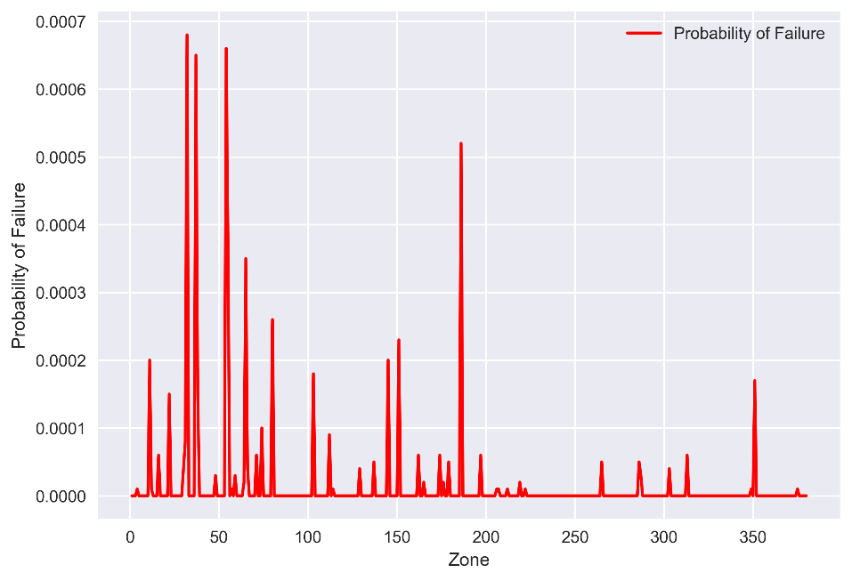
Fig. 1 Pipeline probability of failure in each zone section before repair.
Fig. 1 reveals that the probability of failure differs across various zone sections. The calculated probability of failure should be lower than the target failure probabilities to meet safety standards. The Det Norske Veritas (DNV) standard (DNV 2012) sets target failure probabilities for four limit state types: serviceability (SLS), ultimate (ULS), fatigue (FLS), and accidental (ALS). These are further categorized into three safety classes: low, medium, and high, as detailed in Table 1 [3]. For evaluating the performance of existing pipelines, the selected limit state type and safety class should align with those chosen during the design phase. Therefore, this study considers the ULS target failure probabilities to maintain consistency with the design phase. According to the standard, all failure probabilities were below 7×10⁻⁴, with the majority being even lower.
Table 1 Target probability of failure
Limit state | Safety class
 | Low | Medium | High
Serviceability limit state (SLS) | 10⁻² | 10⁻³ | 10⁻³
Ultimate limit state (ULS) | 10⁻³ | 10⁻⁴ | 10⁻⁵
Fatigue limit state (FLS) | 10⁻³ | 10⁻⁴ | 10⁻⁵
Accidental limit state (ALS) | 10⁻⁴ | 10⁻⁵ | 10⁻⁵

Probability of Failure After Composite Repair
The pipeline corrosion investigated here is primarily steel corrosion that refers to the material degradation due to environmental reactions. These degradation processes are fundamentally electrochemical, though factors like erosion and stress corrosion are influenced by both chemical and mechanical elements. Traditional approaches to repair the corroded steel pipe include using a protective coating, welding, replacement or bolting steel plates [9], which is labor-intensive or expensive. As a result, for pipelines showing partial-wall metal loss, a widely adopted solution is to wrap the defect section with a composite sleeve, complemented by an interlayer adhesive filler [10]. The basic idea of this repair approach is the strategic transfer of hoop stress, which is induced by the internal fluid pressure within the pipeline. This stress is effectively redirected from the defect areas of pipelines to the stabilizing composite sleeves, providing a critical layer of support and protection.
As an effective composite material, fiber-reinforced polymers (FRP) have been widely used in composite sleeve [11, 12]. It is reported that repairing with FRP is an ideal method for damaged pipelines due to its lightweight, high-pressure capacity and corrosion resistance [13, 14]. A lot of studies have focused on using different types of FRP to repair corroded pipelines. The advantages of using FRP composite repairs are that there is no need for high temperatures to apply them. They could be applied even when the pipe is in operation. Watanabe Junior, Reis [14] employed FRP composites to repair damaged pipelines from localized corrosion using experimental performance evaluations. They found that FRP could reliably prevent leaks in pipelines with substantial metal loss (up to 80% wall thickness) and even those with defects reaching half the diameter, without inducing any bending.
In addition, Mazurkiewicz, Małachowski [15] pointed out that pipeline repaired with the composite sleeve made of 12 layers of glass fiber-reinforced polymer (GFRP) could withstand loads comparable to the intact pipe. Al-Abtah, Mahdi [16] found that GFRP composites could strengthen the welded steel pipes effectively. They illustrated the mitigation of the impacts of heat-affected zones on the pressure and degradation capacities of welded pipes, utilizing a GFRP overwrap system via 5-axes filament winding. Similarly, carbon fiber-reinforced polymers (CFRP) have been employed to structurally repair, strengthen, and rehabilitate onshore steel pipelines. Mahdi and Eltai [17] investigated the behavior of repaired metal pipelines under internal pressure by wrapping CFRP in specific orientations. Their innovative approach involved a wrapping mechanism permitting system adjustments during winding over defect areas.
Therefore, using the composite sleeve method with fiber-reinforced materials such as GFRP and CFRP is a reliable and effective solution to repair the corroded pipelines. To estimate the probability of failure after using composite sleeve, it is essential to model the pipe-composite system. Assuming that the corrosion defect is localized and material behavior is elastic far from corrosion defects, the repaired pipe can be modeled as two concentric thin elastic cylinders subjected to internal pressure [18]. The burst pressure capacity of the repaired pipeline with composite sleeve can be determined as shown in Eq. (9) [19, 20].
$P_{b}=\frac{σ_{flow}t}{α_{0}(a-γb)}$ (9)
where, α₀ is the remaining strength factor and can be obtained based on Eq. (10); a is the internal radius of original pipe; b is the external radius of original pipe; c is the external radius of pipe-composite system; γ is the ratio of contact pressure and internal pressure and can be calculated as depicted in Eq. (11).
(10)
(11)
where, E_{s} is the modulus of composite sleeve; E_{p} is the modulus of pipe substrate.
Therefore, based on Eq. (9) to (11), the burst pressure capacity can be derived. And then, using the Monte Carlo simulation method, the probability of failure after repair can be obtained. For example, when considering a composite sleeve with a thickness of 2 mm and a modulus of 20 MPa, the calculated probability of failure after repair for different zones in pipelines was shown in Fig. 2. It can be seen that the probability of failure in each zone section decreases after using composite sleeve.
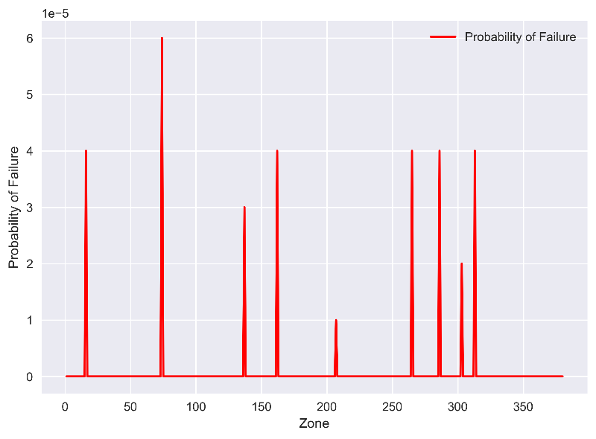
Fig. 2 Pipeline probability of failure in each zone section after repair

Sensitivity Analysis of Composite Repair on Probability of Failure
The mechanisms for repairing defects of operating pipelines with composites are complex because the tensile properties of composites are quite different from those of steel. Even though composites and pipeline steel have comparable strength, composites possess significantly lower modulus of elasticity or stiffness [21]. For comprehensive comparison, a diverse range of thickness and modulus of composite materials was chosen for pipeline repair in this section.
Effects of composite thickness
The common thickness of composite sleeves used in pipeline repair may vary based on the specific requirements of the repair. Factors influencing sleeve thickness include the type and size of the defect, the operating pressure of the pipeline, the material properties of the sleeve, and the desired service life of the repair. The common thickness for GFRP sleeves can range from a few millimeters to over a centimeter, depending on the repair scenario [22]. For CFRP, the thickness usually starts at around 1.5 mm for a single layer and can go up depending on the number of layers applied. Multi-layer applications of GFRP and CFRP are common to ensure the repaired section has strength and stiffness. As shown in Fig. 2, a composite sleeve with a modulus of 20 GPa and a thickness of 2mm can mitigate the probability of failure. To assess the influence of thickness, we examined a range from 2 mm to 10 mm, maintaining a consistent modulus of 20 GPa. The calculated results for pipeline probability of failure after repair in each zone section with different composite thicknesses are presented in Fig. 3.
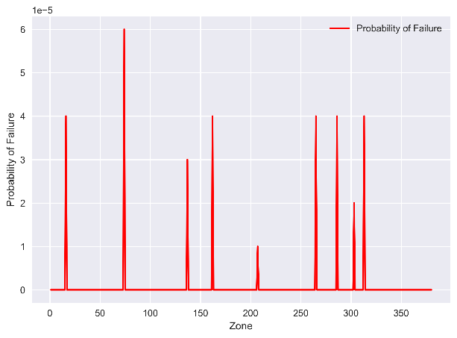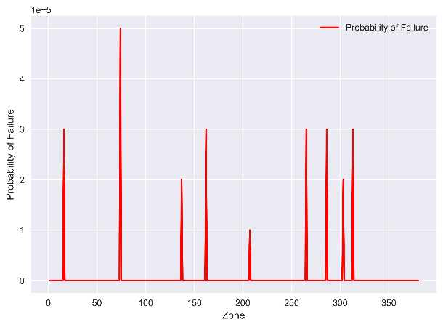
(a) (b)
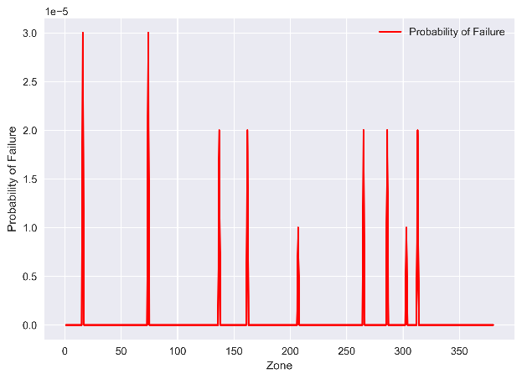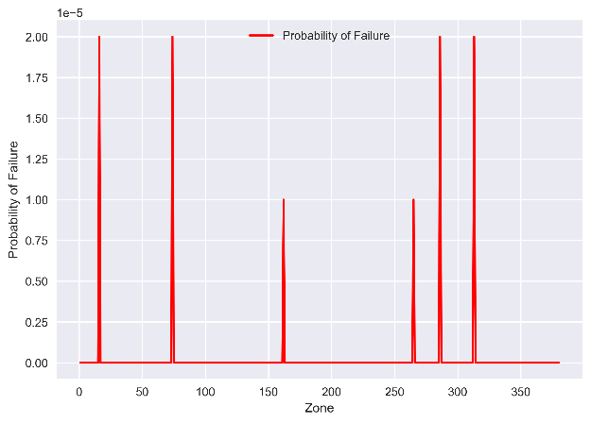
(c) (d)
Fig. 3 Pipeline probability of failure after repair in each zone section with different repair thicknesses: (a) 2 mm, (b) 4 mm, (c) 7 mm, (d) 10 mm.
Generally, there is a decrease in the probability of failure as the repair thickness increases at the same location. Using the zone 194 as an example, the relationship between the thickness of composite sleeve and the probability of failure is illustrated in Fig. 4.

Fig. 4 Probability of failure versus repair thickness in zone 194.

3.2 Effects of composite modulus
Steel generally has an elastic modulus between 200-222 GPa. However, composite materials commonly used for sleeves, such as GFRP, have elastic modulus ranging from 17-41 GPa. CFRP has an elastic modulus nearly double that of GFRP [23]. For this study, the elastic modulus for composites selected in this study varies from 20-80 GPa and the same thickness of 2 mm. The calculated results for pipeline probability of failure after repair in each zone section with different composite modulus are presented in Fig. 5.
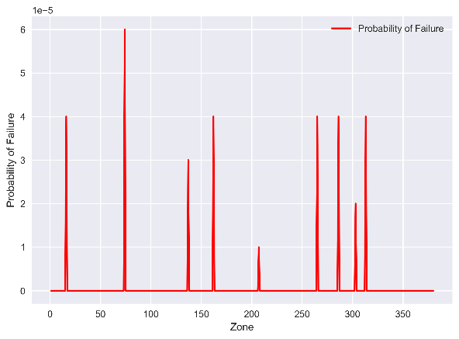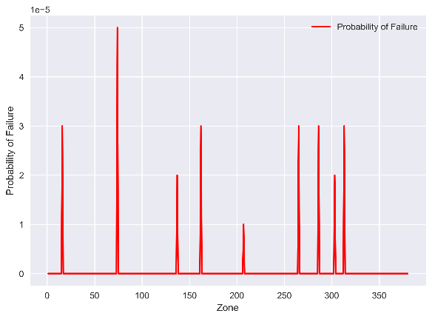
(a) (b)
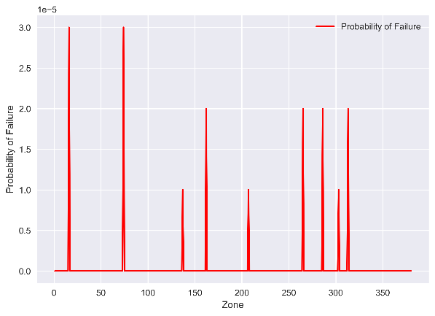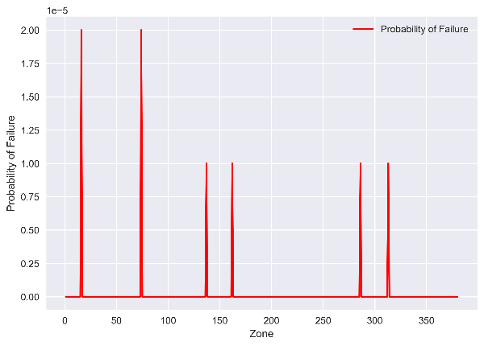
(c) (d)
Fig. 5 Pipeline probability of failure after repair in each zone section with different material modulus (a) 20 GPa, (b) 40 GPa, (c) 60 GPa, (d) 80 GPa.
In Fig. 5, it can be observed that the failure of probability decreased as material modulus increased at the same location. Taking the location of zone 194 as an example, the relationship between modulus and probability of failure is shown in Fig. 6.

Fig. 6 Probability of failure versus material modulus in zone 194.

References
1. Lee, O.S., D.H. Kim, and S.S. Choi, Reliability of buried pipeline using a theory of probability of failure. Solid State Phenomena, 2005. 110: p. 221-230.
2. Zhou, W., System reliability of corroding pipelines. International Journal of Pressure Vessels and Piping, 2010. 87(10): p. 587-595.
3. Miran Seyedeh, A., Q. Huang, and H. Castaneda, Time-Dependent Reliability Analysis of Corroded Buried Pipelines Considering External Defects. Journal of Infrastructure Systems, 2016. 22(3): p. 04016019.
4. Amaya-Gómez, R., et al., Reliability assessments of corroded pipelines based on internal pressure – A review. Engineering Failure Analysis, 2019. 98: p. 190-214.
5. Guillal, A., et al., Probabilistic investigation on the reliability assessment of mid- and high-strength pipelines under corrosion and fracture conditions. Engineering Failure Analysis, 2020. 118: p. 104891.
6. Phan, H.C., A.S. Dhar, and B.C. Mondal, Revisiting burst pressure models for corroded pipelines. Canadian Journal of Civil Engineering, 2017. 44(7): p. 485-494.
7. Kiefner, J.F. and P.H. Vieth, A modified criterion for evaluating the remaining strength of corroded pipe. 1989, Battelle Columbus Div., OH (USA).
8. Zhu, X.-K., A comparative study of burst failure models for assessing remaining strength of corroded pipelines. Journal of Pipeline Science and Engineering, 2021. 1(1): p. 36-50.
9. Jayasuriya, S., et al., Rehabilitation of Corroded Steel Beams Using BFRP Fabric. Structures, 2018. 15: p. 152-161.
10. Mazurkiewicz, Ł., et al., Performance of steel pipe reinforced with composite sleave. Composite Structures, 2018. 183: p. 199-211.
11. Mitra, S., et al., Corroded steel beams with various corrosion aspect ratios – A rehabilitation technique using basalt fibre fabric. Engineering Structures, 2020. 221: p. 111075.
12. Sirimanna, C.S., et al., Analysis of retrofitted corroded steel pipes using internally bonded FRP composite repair systems. Australian Journal of Structural Engineering, 2015. 16(3): p. 187-198.
13. Shamsuddoha, M., et al., Failure analysis and design of grouted fibre-composite repair system for corroded steel pipes. Engineering Failure Analysis, 2021. 119: p. 104979.
14. Watanabe Junior, M.M., J.M.L. Reis, and H.S. da Costa Mattos, Polymer-based composite repair system for severely corroded circumferential welds in steel pipes. Engineering Failure Analysis, 2017. 81: p. 135-144.
15. Mazurkiewicz, Ł., et al., Evaluation of the response of fibre reinforced composite repair of steel pipeline subjected to puncture from excavator tooth. Composite Structures, 2018. 202: p. 1126-1135.
16. Al-Abtah, F.G., E. Mahdi, and S. Gowid, The use of composite to eliminate the effect of welding on the bending behavior of metallic pipes. Composite Structures, 2020. 235: p. 111793.
17. Mahdi, E. and E. Eltai, Development of cost-effective composite repair system for oil/gas pipelines. Composite Structures, 2018. 202: p. 802-806.
18. da Costa Mattos, H.S., et al., Analysis of a glass fibre reinforced polyurethane composite repair system for corroded pipelines at elevated temperatures. Composite Structures, 2014. 114: p. 117-123.
19. Chandra Khan, V., et al., Nanofillers Reinforced Polymer Composites Wrap to Repair Corroded Steel Pipe Lines. Journal of Pressure Vessel Technology, 2017. 139(4).
20. Witek, M., Gas transmission pipeline failure probability estimation and defect repairs activities based on in-line inspection data. Engineering Failure Analysis, 2016. 70: p. 255-272.
21. Leewis, K. and S. Laughlin. Understanding Strain Performance Considerations in Composite Repair of Dents and SCC. Citeseer.
22. Reis, J.M.L., A.R. Costa, and H.S. da Costa Mattos, Repair of damage in pipes using bonded GFRP patches. Composite Structures, 2022. 296: p. 115875.
23. Karbhari, V.M., Rehabilitation of pipelines using fiber-reinforced polymer (FRP) composites. 2015: Elsevier.

Project Activities with Cost Share Partners:
Cost share is provided by Rutgers University and Marquette University during this quarterly period as budgeted in the proposal.

Project Activities with External Partners:
N/A

Potential Project Risks:
Due to additional time and effort spent on Task 2 for data collection and Task 3 for model development and refinement, one-year no-cost extension is planned to extend the project date to 9/30/2025.

Future Project Work:
Work will be continued on Task 4 to quantify probability of failure of steel pipes before and after repair and started on Task 5 on decision making of inspection timing and repair strategy.

Potential Impacts to Pipeline Safety:
The AI-enabled modeling and analysis of pipeline inspection data will be used to develop probabilistic growth models of corrosion defects and make cost-effective repair or replacement decisions to minimize pipeline failure risk.

