Quarterly Report – Public Page

Date of Report: 1st Quarterly Report, December 20, 2023
Contract Number: 693JK32310013POTA
Prepared for: Government Agency: DOT and Co-funders
Project Title: Tank Foundation and Floor Designs and Best Practices for Improved Corrosion Control
Prepared by: Pipeline Research Council International (PRCI), Inc.
Contact Information: Janie Norton, jnorton@prci.org 703-205-1600 ext: 105
For quarterly period ending: December 30, 2023

1: Items Completed During this Quarterly Period:
Item # | Task # | Activity/Deliverable | Title | Federal Cost | Cost Share
2 | 1 | 1st quarterly status report | Submit 1st quarterly report | $14,069 | $3,517

No technical activity was undertaken this quarter. A subcontract with Mears Group, Inc is still being worked out. The subcontract is in the final stages of the signature/approvals. The project technical work will begin as soon as the contract has been established.

2: Items Not-Completed During this Quarterly Period:
Item # | Task # | Activity/Deliverable | Title | Federal Cost | Cost Share
1 | 1 | Kick-off web meeting with all stakeholders | Meeting minutes and a Summary of the Literature Review to be included in the  quarterly report | $34,863 | $8,716

The project is behind schedule due to contracting between PRCI and Mears Group, Inc.

3: Project Financial Tracking During this Quarterly Period:
Note that this chart reflects Federal share only:
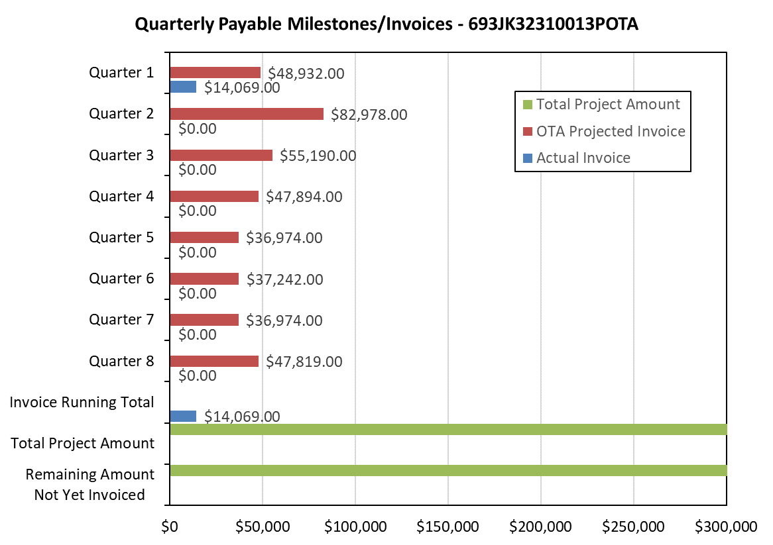

4: Project Technical Status –
No activities were undertaken by Mears Group, Inc. or PRCI.

5: Project Schedule –
The project is behind schedule.

