Quarterly Report – Public Page

Date of Report: 1st Quarterly Report, December 18, 2023
Contract Number: 693JK32310010POTA
Prepared for: Government Agency: DOT and Co-funders
Project Title: Standardize the Application of Vapor Corrosion Inhibitors
Prepared by: Pipeline Research Council International (PRCI), Inc.
Contact Information: Janie Norton, jnorton@prci.org 703-205-1600 ext: 105
For quarterly period ending: December 30, 2023

1: Items Completed During this Quarterly Period:
Item # | Task # | Activity/Deliverable | Title | Federal Cost | Cost Share
3 | 5 | 1st quarterly status report & project management | Submit 1st quarterly report | $7,985 | $1,996

No technical activity was undertaken this quarter. A subcontract with Battelle Savannah River Alliance (BSRA), LLC. is still being worked out. The subcontract is in the final stages of the signature/approvals. The project technical work will begin as soon as the contract has been established between PRCI and BSRA.

2: Items Not-Completed During this Quarterly Period:
Item # | Task # | Activity/Deliverable | Title | Federal Cost | Cost Share
1 | 5 | Kick-off meeting with all stakeholders | Meeting summary and action items to be included in the quarterly report | $7,644 | $1,911
2 | 1 | Conduct literature review of the VCI qualification and related testing methods | Summary of the literature review to be included in the first quarterly report | $10,424 | $2,606

The project is behind schedule due to contracting between PRCI and BSRA.

3: Project Financial Tracking During this Quarterly Period:
Note that this chart reflects Federal share only:
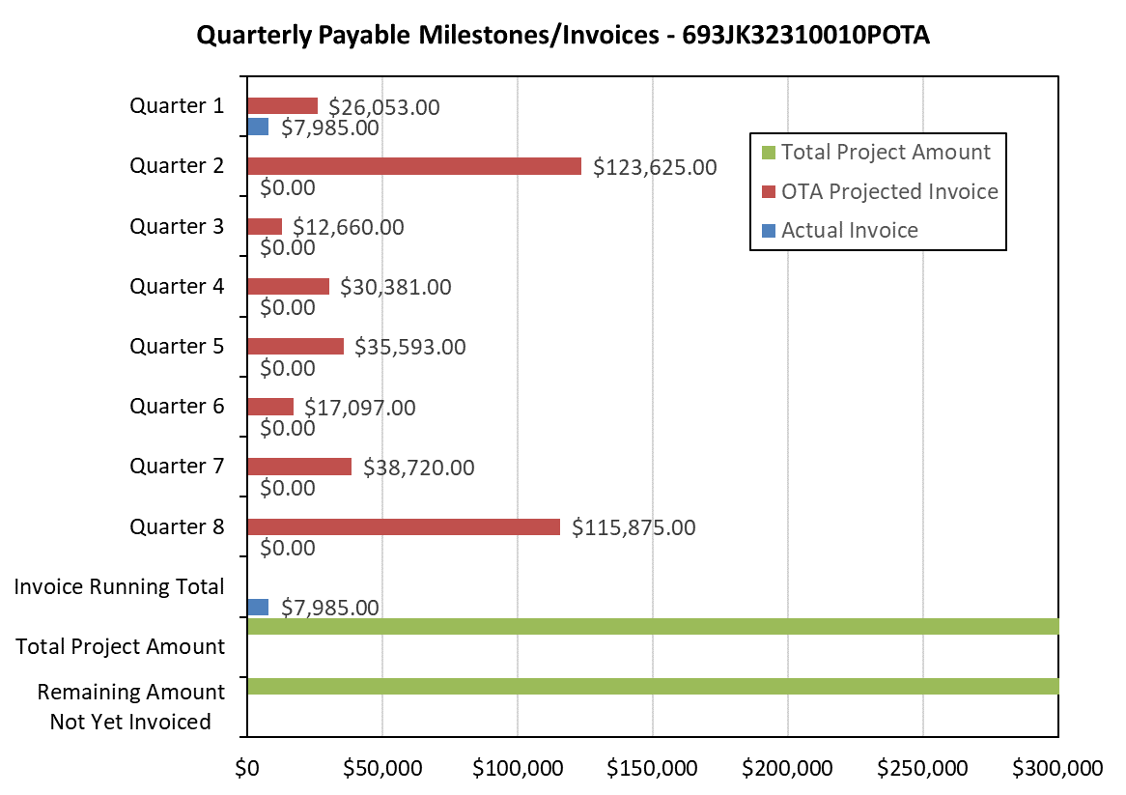

4: Project Technical Status –
No activities were undertaken by BSRA or PRCI.

5: Project Schedule –
The project is behind schedule.

