**FINAL REPORT**

GTI ENERGY PROJECT NUMBER 22689

**Develop and Demonstrate a Remote Multi-Sensor System for Right-of-Way Defense**

Reporting Period:

September 1, 2019, to July 31, 2023

Draft Report Issued:

August 31, 2023

Prepared For:

Mr. Benjamin Kendrick

General Engineer R&D/SBIR Program Manager

US Department of Transportation

Pipeline and Hazardous Materials Safety Administration (PHMSA)

8701 S Gessner

Houston TX, 77074

713-855-1626

benjamin.kendrick@dot.gov

GTI Energy Technical Contact:

Mr. Christopher Ziolkowski

Institute Engineer

847-768-0549

cziolkowski@gti.energy

1700 S. Mount Prospect Rd.  
Des Plaines, Illinois 60018  
[www.gti.energy](https://www.gti.energy/)

# Signature Page

***Print or typed  
First M. Last Signature Date***

***AUTHOR:***

_______________________________ _________________________________________________ _______________

Title: _________________________________

***REVIEWED BY:***

_______________________________ _________________________________________________ _______________

Title: _________________________________

***APPROVED BY:***

_______________________________ _________________________________________________ _______________

Title: _________________________________

# Legal Notice

*This information was prepared by GTI Energy for DOT PHMSA.*

*Neither GTI Energy, the members of GTI Energy, the Sponsor(s), nor any person acting on behalf of any of them:*

*a. Makes any warranty or representation, express or implied with respect to the accuracy, completeness, or usefulness of the information contained in this report, or that the use of any information, apparatus, method, or process disclosed in this report may not infringe privately-owned rights. Inasmuch as this project is experimental in nature, the technical information, results, or conclusions cannot be predicted. Conclusions and analysis of results by GTI Energy represent GTI Energy's opinion based on inferences from measurements and empirical relationships, which inferences and assumptions are not infallible, and with respect to which competent specialists may differ.*

*b. Assumes any liability with respect to the use of, or for any and all damages resulting from the use of, any information, apparatus, method, or process disclosed in this report; any other use of, or reliance on, this report by any third party is at the third party's sole risk.*

*c. The results within this report relate only to the items tested.*

# Table of Contents

Signature Page i

Legal Notice ii

Table of Contents iii

Table of Figures iv

Abstract 1

Executive Summary 2

Introduction 3

Objectives 3

Business Value 3

Gas Industry Need 3

Background 4

Project Activities 5

Technology Review 5

Improvements to the Hardware 7

Data Management and Analytics 11

Improvements to User Interface 13

Deployment and Testing of Improved System 17

Project Results 26

Conclusions 27

List of Acronyms 28

Appendix A. Open Geospatial Consortium (OGC) Standards 29

Appendix B. TinyML Workflow for Sound Recognition 31

Appendix C. Examples of JSON Data Messages 33

Appendix D. Example of Tabulated Sensor Data 41

# Table of Figures

Figure 1. Early Version ROW Defense System 4

Figure 2. Early ROW Monitor Sensor Block Diagram 5

Figure 3. Current ROW Monitor Sensor Block Diagram 6

Figure 4. STM32L496 “Dragonfly” Board 8

Figure 5. STM32L4R5 “Swan” Board 8

Figure 6. Lightning Detection Sensor (AS3935) 9

Figure 7. Nevada Nanotechnology Multi-Species Gas Sensor 9

Figure 8. Pin Brazing Equipment Under Test 10

Figure 9. New and Original Vibration Sensors 10

Figure 10. Strain Sensor Installation 11

Figure 11. Campbell CELL210 Modem 13

Figure 12. Early User Dashboard 13

Figure 13. Workflow Structure in Losant 14

Figure 14. General System Health Dashboard 15

Figure 15. Aboveground Sensors Dashboard 15

Figure 16. Belowground Sensors Dashboard 16

Figure 17. Sample Alarm Message 16

Figure 18. Protective Wrap for Coating Restoration and Sensors 17

Figure 19. Sensor Cables Pulled into Instrument Enclosure Ready for Installation 18

Figure 20. Instrumentation being Installed on Test Site 19

Figure 21. Accelerometer Cable Splice 19

Figure 22. Instrumentation with all Cabling Complete 20

Figure 23. Site Overview 21

Figure 24. Sensor Station at Original Test Site 23

Figure 25. Instrumentation Upgrade in Place 23

Figure 26. RMS Sound Level 24 Hours at Suburban Site 24

Figure 27. RMS Sound Level 24 Hours at Rural Site 24

Figure 28. Vibration Sensors Activity 24 Hours at Suburban Site 25

Figure 29. Vibration Sensors Activity 24 Hours at Rural Site 25

Figure 30. Vibration Sensor Threshold Counts at Suburban Site 25

Figure 31. Vibration Sensor Threshold Counts at Rural Site 26

Figure 32. Examples of Time Series Data 31

Figure 33. Time Series and Spectrogram 32

Figure 34. Training Data as Spectrograms 32

# Abstract

**Objectives:** The objective is to improve and deploy additional instances of a pipeline right-of-way (ROW) Monitoring System based on stationary sensors mounted on and near the pipeline. Sensor data from multiple locations along the pipe is wirelessly forwarded to a central location for processing. Analytics at the central location correlates data from multiple sensors to rapidly alert operators to events occurring in the ROW. One prototype system is currently deployed; the project seeks to deploy two more instances with improved field hardware and with Machine Learning (ML) analytics.

**Methodology:** The approach is to make hardware improvements to an existing prototype system and to apply ML to sensor data from the ROW acquired with this hardware. The ability to simultaneously capture data from multiple locations will allow ML to identify events occurring on the ROW. The sensor types (vibration, strain, current, seismic, and soil) were identified and tested in earlier work. The current work addresses lessons learned regarding how to better package the system for deployment by utilities. It also addresses improvements to the user interface and automatically alerts utility personnel when events occur on the ROW.

**Sponsoring Organizations:** DOT PHMSA provided funding for this work. Operations Technology Development, NFP (OTD) provided matching funds and test sites for this work. OTD is a research and development (R&D) consortium of local gas distribution companies supporting efforts in these areas.

# Executive Summary

The greatest threat to buried pipelines is from digging equipment operated in the right-of-way (ROW). This equipment may be utility or third-party operated. Other threats are natural force impingement, material failure, and corrosion. Damage to the pipeline can have severe consequences, including fire, explosion, and loss of life. Additionally, greenhouse gas emissions and disruption of energy delivery can occur. Current methods to comprehensively monitor the ROW, such as distributed fiber optic sensors, are difficult to retrofit to existing pipelines, especially in populous areas. It is the populous, high consequence areas (HCA) that require a cost-effective, retrofit ROW defense system for real-time monitoring and notification.

A prototype, retrofit ROW defense system based on point (rather than distributed) sensors was deployed for testing in an earlier project. This early prototype was partially successful but exposed several issues in the approach. This report describes the current work that sought to address these. The major issues were the effectiveness of the early version of vibration sensors and the methods for attaching sensors to pipelines in general.

A Technical Advisory Panel (TAP) was formed from gas utilities providing funding through OTD and PHMSA staff. GTI Energy presented the original work results to the TAP along with the proposed changes and improvements. The requirements for test sites needed to verify the improvements were presented and discussed early in the project. The goals were to improve the ROW defense hardware and deploy it for testing. The test site from the earlier project was to be upgraded and new test sites deployed. Identifying test sites that fit all the requirements proved to be an issue that caused schedule delays.

Multiple hardware improvements were made during this work, both in the sensors and in the methods of installation. The firmware algorithms to process the vibration sensor signals were developed and tested to replace third-party equipment used during the earlier work. The original radio system (Ingenu RPMA) was eventually replaced with LTE cellular when it became apparent that the RPMA system is no longer well supported. The change in radio systems also caused schedule delays.

Data management and visualization tools were also upgraded during the current project. The original system used multiple Esri ArcGIS tools for visualization. The data available was limited by the bandwidth of the RPMA radio system. The shift to LTE-M provided much more robust communications with the sensor endpoints. Data is aggregated in an AWS S3 instance as before but is now forwarded to the Losant dashboard system. Losant provides analysis, visualization, and alarm functionality within a single platform.

At the time of this report, one new test site has been commissioned and one station at the original test site has been upgraded. These sites are generating test data that can be viewed with a user dashboard. The original sensor functionality is preserved, the vibration sensing is improved, and additional sensor types are in place.

# Introduction

## Objectives

The objective is to improve and deploy additional instances of a pipeline right-of-way (ROW) Monitoring System based on stationary sensors mounted on and near the pipeline. Sensor data from multiple locations along the pipe is wirelessly forwarded to a central location for processing. Analytics at the central location correlates data from multiple sensors to rapidly alert operators to events occurring in the ROW. One prototype system is currently deployed; the project seeks to deploy two more instances with improved field hardware and with Machine Learning (ML) analytics.

## Business Value

The anticipated benefits of a ROW monitoring system are real-time information on events before they develop into incidents. This will allow pro-active response to developing situations such as construction activity near the ROW that has not yet infringed on the pipeline. Additional benefits would accrue if the ROW monitor sensors were co-located with other utility installations. Combining a pressure monitor station, regulator station, rectifier, or cathodic protection test point with the ROW monitor system will allow the capture of operational data as well. This will provide a cost advantage over a monitor system intended solely for damage prevention by eliminating personnel visits for routine operational data.

The most prevalent method of accomplishing ROW monitoring at present is through utility patrols and inspections. The patrol method obviously does not provide 24/7 coverage and is personnel intensive. The cost of adding more personnel to engage in patrol and inspection activities can be high. A hardware-based ROW monitor will have initial installation costs but a much lower operating cost than three shifts of full-time employees going forward. Continuous ROW monitoring can be a valuable adjunct to inspections by providing guidance as to where personnel effort should be focused.

The result of the proposed research is to move a ROW Monitor System from the prototype status toward a field ready and scalable system. The improved system would be deployed at additional sites to provide diversity (climate, soils, terrain, data sources, etc.) in the testing and a growing body of data to validate the effectiveness of the system over time. The benefit of deploying a ROW Monitor System would be to provide operators with improved situational awareness and leading indicators of conditions on their ROW. This would allow the identification of anomalies or damage before they develop into incidents.

## Gas Industry Need

Activity (such as excavation) in the pipeline ROW can have unplanned consequences, including damage causing gas leakage, greenhouse gas emissions, and disruption of energy delivery. In extreme cases, fire or explosion may result. Methods to monitor the entire ROW, such as distributed fiber optic sensors, are difficult to install on pipelines in populous areas. Real-time monitoring will provide better situational awareness than patrols or other current practices.

Background

Recent advances in sensors, low-power electronics, batteries, and data communication have enabled deployment of data collection platforms into field environments. The optimal platform will provide the opportunity to deploy sensors in the field, feed analytics that can integrate multiple data sets, and provide a user interface (UI) for visualization. This would identify many threats to system integrity. A cost-effective, fixed location sensor platform for monitoring that can be retrofitted in small excavations in the pipeline right-of-way (ROW) was proposed.

An early version of a ROW Monitor System (Figure 1) was developed by Operation Technology Development, NFP (OTD), in collaboration with PHMSA and the California Energy Commission (CEC). Most of the installation and testing of the equipment took place in 2018; some adjustments and additional testing took place in early 2019. While much was accomplished in the first phase of this effort, there was still significant work to be done.

A picture containing sky, outdoor

Description generated with very high confidence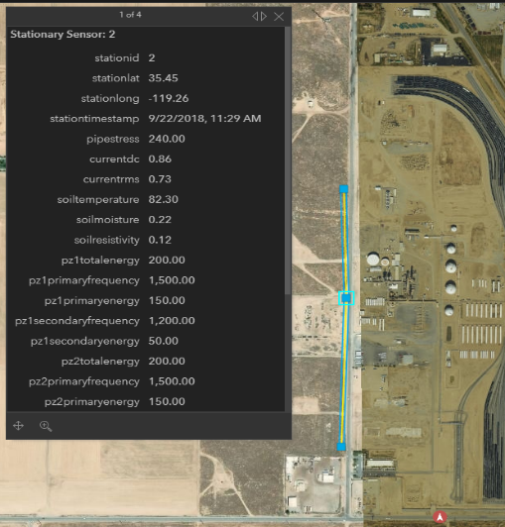

Figure . Early Version ROW Defense System

There were several elements of the earlier system that required improvement. The pipe-mounted vibration sensors were not satisfactory in terms of sensitivity or noise immunity. Machine learning hosted on a cloud platform was not adequately tested, largely due to the lack of reliable vibration sensor data. The general sensor installation procedures need to be simplified to be more field-friendly. Methods for installation on live pipe needed to be developed.

GTI was, for the original site, able to install the sensors after the line was constructed but prior to the line being hydrotested and put in service. Pipelines are at times taken out of service for maintenance or inspection. This cannot be depended on for general retrofit sensor installations. An acceptable method to install sensors on live pipe (pin brazing) was identified and demonstrated. This will be discussed in later sections.

# Project Activities

The following are the major activities carried out over the course of the project.

## Technology Review

A Technical Advisory Panel (TAP) was formed consisting of utility representatives from Operations Technology Development LLC (OTD) and staff from both PHMSA and GTI. OTD is a collaborative group of gas distribution companies that fund R&D in support of utility operations. This group provided 50% co-funding and test sites for this project. The project kick-off meeting of the TAP was held on January 16, 2020.

**Review Existing Technology Status**

The first activity for the TAP was to review the (then current) state of the retrofit technology for ROW Monitoring. A detailed presentation of the earlier work was provided. The list of current features of and proposed improvements to the ROW Defense technology was presented. Figure 2 is a functional block diagram of a remote sensor installation for a ROW monitor system from the earlier system.

Figure . Early ROW Monitor Sensor Block Diagram

The ROW Monitoring System has basic features that are present in both versions. These are as follows:

* Data aggregation and transmission
  + Datalogger; Campbell Scientific was used.
  + Radio system to transmit data.
  + Power supply
* Sensors on the Pipe
  + Vibration sensor
  + Strain sensor
  + Current sensing wire
* Sensors in the Soil
  + Geophone for soil motion
  + Soil moisture/temperature
  + Steel coupon to complete current sensing.

TAP feedback for additional features was requested. Two items of interest were lightning detection capabilities and the ability to detect the presence of gas. This led to the additional category of sensors:

* Above ground sensors
  + Gas detector with built in temperature and humidity sensors.
  + Lightning sensors
  + Microphones

Figure 3 is a functional block diagram of the sensor installation currently being deployed. It maintains compatibility with the below ground suite of sensors tested in the earlier project. In addition to the gas and lightning detection capabilities asked for by the TAP, acoustic microphones were incorporated. The motivation is that sound may be a useful corollary in the identification of machinery operating in the ROW or in detecting thunder. The sub processors that will handle these sensors are discussed in greater detail below.

Figure . Current ROW Monitor Sensor Block Diagram

**Solicit Utility Test Sites**

Another TAP activity was the solicitation and discussion of test sites for additional instances of the ROW Monitoring system. The goal was to identify construction projects that would allow access to pipelines exposed during the project schedule. The requirements that were laid out for the test sites were as follows:

* Access to the pipe surface through an excavation.
* Willingness to remove coating for installation of sensors on metal.
* Restoration of coating to cover sensors and cable.
* Installation of soil sensors within the excavation prior to backfill.
* An above-ground easement to install an instrumentation cabinet.
* Ideally, multiple location on the same pipeline for sensor installation.

With the Ingenu RPMA radio system, there was an additional requirement: a location for the RPMA base station radio with access to continuous power. The individual sensor stations would run from battery-backed solar. The base station was dropped when LTE-M1 cellular modems were used rather than RPMA radios. The reason for the change is that the RPMA radio system is no longer well supported.

Acquiring suitable test sites proved to be difficult and led to several schedule changes. The need for above-ground easement was the primary issue. Several promising test sites were identified but not usable as the right to place the above ground instrumentation was not readily available. The permitting to do such an installation required more time than the schedule of the identified construction projects allowed for.

The COVID-19 pandemic and subsequent supply-chain issues also contributed to schedule delays, but to a lesser degree than test site acquisition issues.

## Improvements to the Hardware

The identified areas of improvement were:

* Vibration sensors and associated signal processing,
* Means of attaching sensors to the pipe under field conditions, and
* Additional sensors identified by the TAP.

**Alternative Signal Processing Hardware**

GTI investigated new hardware and sensor options to optimize existing information collection and add additional sensing capabilities. A Campbell data logger remains central to aggregate various sensor readings and send them over the network using an attached cellular modem. The original stations used the Campbell CR800 datalogger. The new stations use the CR6 model with improved features such as removable storage, USB, WiFi, and Ethernet connectivity.

Independent sub-processors were developed to offload computationally intense sensor data processing from the datalogger, freeing the datalogger for data aggregation and managing data sent over the network. Two types were evaluated during this project. Both devices were from the ST Microelectronics STM32L4 family of processors. This is an ARM Cortex-M4 processor with built-in digital signal processing (DSP) and floating point unit (FPU) hardware. There is an upgrade path to a Cortex-M7 processor if greater capabilities are needed. STM provides the software development environment free to developers using their hardware.

The STM32L496 based Dragonfly (Figure 4) development board was evaluated first. There is a learning curve with any microprocessor; the support software from STM does provide a substantial base of example code and libraries. Several iterations of the code were developed and tested on this device. The Dragonfly was from a small manufacturer and became unavailable during the general chip shortages following the pandemic.

Figure . STM32L496 “Dragonfly” Board

The Swan L4 board (Figure 5), based on the STM32L4R5 processor, was identified as a replacement and an upgrade to the original part. It exceeds specifications of the L496 part in categories such as available memory and clock speed. Given both processors were from the same manufacturer and parts family (STM32L4), only minor modifications to the software were required. The Swan R5 is available from the company Blues Wireless in commercial quantities.

Figure . STM32L4R5 “Swan” Board

Microphones to monitor above-ground activity around the sensor stations were investigated. Audible-range MEMs microphones can allow potential hazards such as construction equipment in the ROW to be monitored. The microphones will be connected to one of the sub-processors where real-time peak and average sound level analysis will occur. Only a compressed summary of the audio activity for a given period will be sent over the wireless network. In instances where a sustained level of abnormally loud sound is observed, an immediate notification can be sent over the network alerting individuals of the situation.

Machine learning (ML) based audio classification techniques were explored to categorize important sounds in the ROW. Using TensorFlow Lite, the classifications can occur locally and in real-time on the sub-processor at the station. This allows a high-bandwidth stream of microphone data to be efficiently represented as a single classifier label, better suited for a low-bandwidth connection such as RPMA.

A second sub-processor will be used to sample and collect geophone and pipe vibration data from the sensors installed in the ground at each station. Attributes such as peak and average vibration signal, and frequency content will be calculated and passed to the data logger.

A lightning detection sensor AS3935 (Figure 6) was investigated to monitor lightning activity near sensor stations. This can aid in root-cause analysis of a failure; lightning damage often goes undetected or misdiagnosed. The sensor was tested with the STML4 boards for reliability and accuracy of the sensor. The results were mixed; it is likely more cost effective to acquire weather data from on-line services than to pursue this hardware further.



Figure . Lightning Detection Sensor (AS3935)

A gas leak sensor from Nevada Nanotechnology (Figure 7) was adapted for use with the STM32L4 board. GTI-developed software libraries from other projects were modified for the STM environment. The NevadaNano sensor can characterize gases, distinguishing methane from hydrogen and other flammables. This sensor also reads ambient temperature and relative humidity as part of its normal operation.

Figure . Nevada Nanotechnology Multi-Species Gas Sensor

**Sensor Packaging and Attachment**

The procedures for attaching sensors to the pipe and the choice of sensors are interrelated. The procedure must be applicable to live pipe under varying field conditions. The packaging of the sensors must lend itself to prefabricating the assemblies as much as possible. All these considerations will lend themselves to end user adoption of the technologies. Pin brazing is an attachment method that is acceptable to the utilities for use on live pipe.

Pin brazing (Figure 8) is a form of resistance “welding” that uses a silver-based solder to attach threaded pins to the pipe surface. The pins bond to the steel at a much lower temperature than conventional welding or brass compound brazing. Bond temperature is critical to not hardening or otherwise compromising the existing pipe material. Some coating must be removed from the steel and a small amount cleaning performed at the attachment point.

Figure . Pin Brazing Equipment Under Test

Another area identified for improvement was vibration sensors and their installation on pipelines. An accelerometer (TE4030) with robust packaging and an integral cable was selected. An issue with the original sensor was that there was substantial in-field work required to install and seal it. A side-by-side test (Figure 9) of the two sensors was performed on a pipe cut-out section. The new sensor was installed on a mounting plate that is secured by brazed pins. The original sensor is adhesive bonded as it is in the field. The new accelerometer with this mounting method provided improved signal strength over the original.

Figure . New and Original Vibration Sensors

Like the vibration sensor, a packaged longitudinal strain sensor with an integral cable was identified and tested. This sensor is compatible with the pin brazing method of installation and requires minimal surface prep in the field. It can be seen on the far right of a photo (Figure 10) taken during the installation of equipment at a field test site. Note that this is a live pipe carrying gas at the time the sensors were installed. The utility hosting this site uses pin brazing as one of their approved procedures; utility personnel performed the sensor installations for GTI.

Figure . Strain Sensor Installation

## Data Management and Analytics

A data management system is required to aggregate data from multiple sensor stations, perform analytics, provide visualizations, and generate alarms when appropriate. Several features are required to implement such a system.

* Connectivity to the hardware sources of sensor data.
* Connectivity to external data sources such as weather and seismic activity.
* Ability to store and time synchronize data from multiple sources.
* Capacity to perform analytical functions on multiple data items.
* Alarm threshold recognition with the ability to generate messages.
* Accessible user dashboard to provide visualization of field conditions.

**Selection of Data Management Platform**

GTI reviewed the OGC (https://www.ogc.org/docs/is) standards for the representation of sensor data. There are many standards maintained by OGC that touch on the device (sensor thing) and data (data stream) that are utilized in this type of project. These standards were reviewed to develop a gap analysis between the OGC standards for sensors and the devices and data being utilized in this project. Due to the generalized nature of the standards and the variations in available sensors, there are significant differences between the standards and the devices used. A discussion of the standards reviewed can be found in Appendix A. Open Geospatial Consortium (OGC) Standards.

Some effort focused on examining Machine Learning (ML) models that run directly on the sub-processor hardware in the field. The target hardware for the vibration ML processing is the STM32L4 processor family described above. The TinyML tools for STM processors allow the construction and training of ML models in a cloud environment that can then be compressed for deployment on small, remote hardware. The TinyML approach was not adopted as the models were not as compact or power-efficient as needed for this application. Appendix B. TinyML Workflow for Sound Recognition provides an overview of the process.

While ML at the field sensor locations can streamline event recognition, an additional layer of ML will need to be hosted in the cloud. This higher ML layer is needed to associate data from field sensor stations that are geographically dispersed. External data such as weather or seismic activity will be applied at this level. The aggregation and characterization of these different data sources are intended to identify localized events versus those that are global to the entire system.

Cloud storage is an integral part of IoT (Internet of Things) for modern in-field data acquisition systems. It allows one to capture, store, and process data and subsequently act upon it to form predictions by creating models from the data. Additionally, the process is simplified by decentralization—the assets or devices—in our case, ROW Monitor Stations—can be monitored from anywhere in the world with internet access and the data is accessible by multiple users for observation and to build the above-mentioned models.

There are several cloud computing service providers that enable cloud connectivity, such as AWS (Amazon Web Services), MS (Microsoft) Azure, Google Cloud Platform, and others.  There are also more specialized platforms that are often marketed to IoT developers or analysts, like Losant, ThingsBoard, Particle (IoT), and others. These provide methods for low-code connectivity and can be integrated with additional services that the major cloud computing companies provide.

The previous phase of the ROW project utilized AWS to fetch, store, and forward the data to Esri GeoEvent Processor for geospatial analytics and real-time alarms and to Esri Operations Dashboard for display. The current phase re-used parts of the AWS architecture, however Losant became the platform of choice for displaying the data and providing alarm notifications. There are two reasons for adopting Losant: first, it’s a low-code platform and thus it is easier to set up and use to provide both internal and external-facing dashboards, and secondly for cost. At approximately $12,000/year, Losant could still be cheaper than the multiple Esri products required now since the Losant enterprise license doesn’t put limits on the number of users or devices. The biggest downside of Losant is that it can’t store and thus display or discover trends in data longer than 180 days (based on license), but it does provide integrations with different computing services providers to store and even perform additional processing on the data in Losant.

Figure . Campbell CELL210 Modem

Campbell Scientific dataloggers provide multiple options for uploading the data to the cloud: FTP (file transfer protocol), HTTP/S posts, via MQTT, and others. The way that the data currently comes into the cloud is through MQTT over a cellular link via the CSI (Campbell Scientific Instruments) Cell210 LTE Modem (Figure 11). The outgoing data is divided into 3 groups, based on functionality: datalogger (or system health), belowground sub-processor, or aboveground sub-processor. That was done due to a limitation of the Campbell firmware: a table combining all 3 groups would have been too large to transmit as a single MQTT packet. Each message is formatted and transmitted as a nested GeoJSON message. It is then “flattened” to a simpler format when received in AWS.  Examples of the GeoJSON message format and flattened representation are provided in Appendix C. Examples of JSON Data Messages.

## Improvements to User Interface

With the ability to transmit, store, and process the data established, the next area to be addressed is data visualization. As noted, the earlier system (Figure 12) required multiple Esri ArcGIS tools to produce a user dashboard and generate alarms. If the system developed a fault, several systems required checking. Losant simplifies this by bundling more functionality into a single platform.

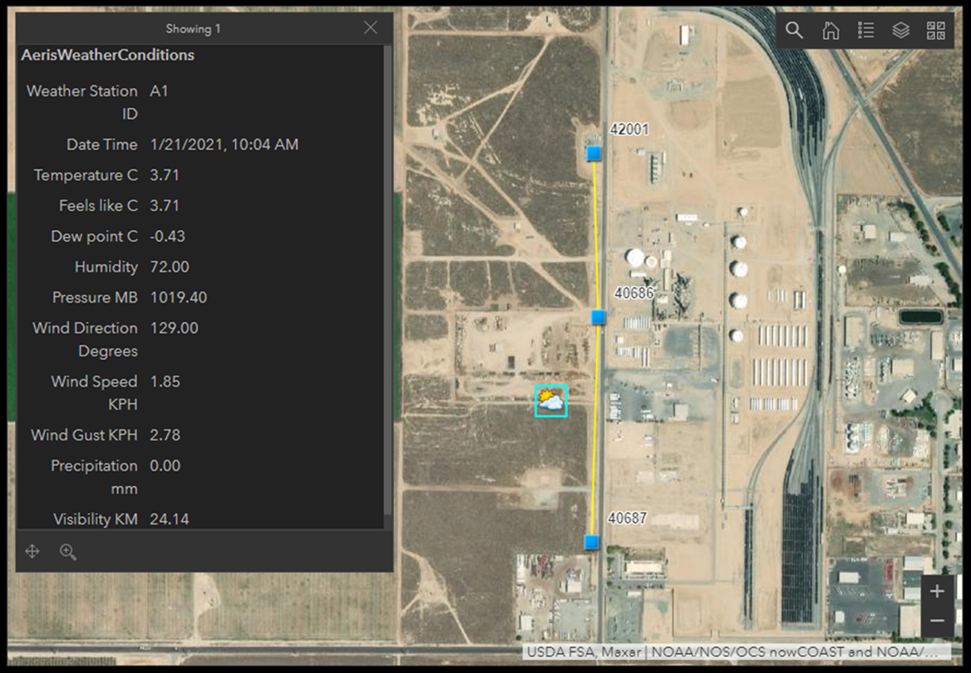

Figure . Early User Dashboard

In the current system, the processed sensor messages are held in AWS-S3 for long-term storage, available for further processing as needed. They also trigger an AWS Lambda function invoking a Webhook to send the messages to Losant servers. Losant sorts the data based on the type (system, belowground sensors, or aboveground sensors). The processing is programmed in a flowgraph (Figure 13) rather than by writing code; this is the “low code” feature of Losant and similar platforms.

Figure . Workflow Structure in Losant

As the incoming data is processed, it populates the dashboards for real-time or near real-time display and visualization. Overall, there are 3 groupings of sensors. The system health, or CR6 datalogger, (Figure 14) dashboard focuses on displaying the system primary voltage (nominally 12 Vdc), the secondary regulator voltage (5 Vdc), and the panel temperature. The rest of the parameters are accumulated representations of different alarms or variables that could point to an alarm. The datalogger provides its GPS coordinates; there is a map on the bottom of the dashboard for user convenience.

Figure . General System Health Dashboard

The next dashboard—the aboveground sensor dashboard—focuses on all of the sensors included in the aboveground sub-processor enclosure which consists of 2 digital MEMS (Microelectromechanical System) microphones, a NevadaNano multi-gas sensor, and a AS3935 lightning detection sensor (Figure 15).

Figure . Aboveground Sensors Dashboard

The last dashboard that is used contains the data for the belowground sub-processor board—that includes the vibration sensor, be it an accelerometer or a piezoelectric disc transducer and a geophone (Figure 16).

Figure . Belowground Sensors Dashboard

Each display can be edited with regards to different parameters such as units, timescale, scaling, and so on and so forth. It is quite easy to do. When alarms get triggered, Losant can send emails and texts to notify the users. A sample email is provided (Figure 17). 

Figure . Sample Alarm Message

While what is pictured above is basic, the alarm messages can be customized with regards to frequency, details, or specificity (which specific sensor triggered the alarm from which group and what or which threshold was crossed), and who and how many are notified.

## Deployment and Testing of Improved System

As noted earlier in the report, obtaining additional test sites with the permits to install the aboveground instrumentation was problematic. Several promising test sites were identified, only to be dropped due to this issue. One of the OTD utilities providing co-funding was, after examining several possibilities, able to provide a test site entirely on their property. This site is large and enclosed by a fence, not in a public space.

The installation at this site took place in two steps. First, utility personnel hosting the test site installed the sensors on their pipeline. Second, the aboveground instrumentation was later installed by GTI. A description of the installation process follows.

Figure 10 shows the attachment of sensors to the pipe using pin brazing. A wire is attached to the pipe (left) to monitor the CP current density relative to 1 cm2 coupon. A three-axis accelerometer (middle) is attached to monitor pipe vibration and inclination. A strain sensor (right) monitors changes in pipe stress. The current coupon, soil moisture/temperature sensor, and a geophone are installed in the soil adjacent to the pipe. The geophone measures soil movement or vibration independent of the pipe.

Figure 18 shows a tape wrap coating being applied to the pipe after the sensors have been installed. The primary purpose of tape wrap is to restore pipeline coating that was stripped for sensor installation. Additional layers are applied over the sensors and cables to protect them from moisture and from the backfill process. Figure 19 shows the enclosure that was shipped with the sensors mounted on a post. The sensor cables have been pulled through a conduit to the enclosure in preparation for installing the instrumentation.

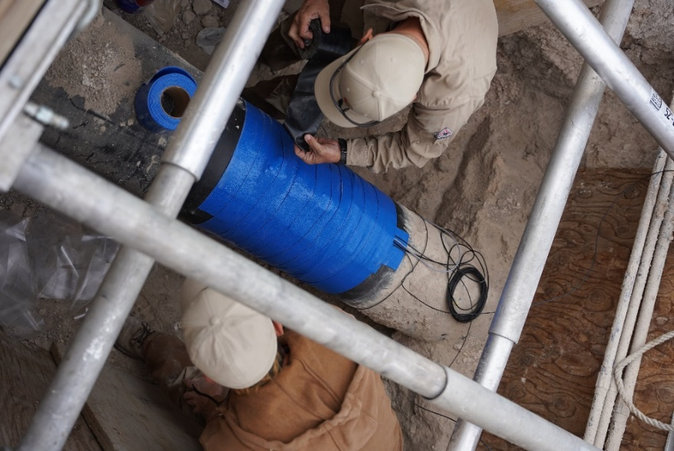

Figure 18. Protective Wrap for Coating Restoration and Sensors

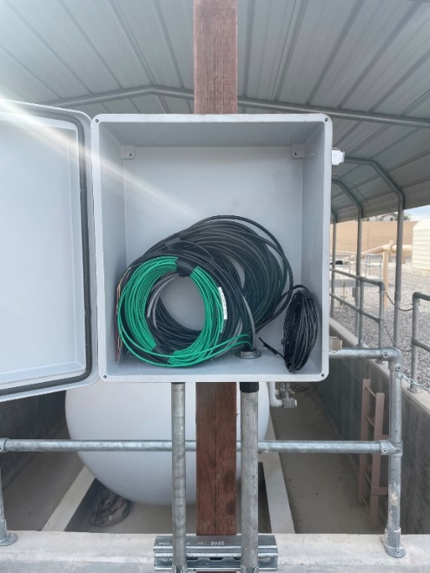

Figure 19. Sensor Cables Pulled into Instrument Enclosure Ready for Installation

In parallel with the sensor installation, GTI assembled and tested two identical sets of instrumentation on panels that are sized for the standard enclosure. One set of instrumentation is being operated at GTI as a reference design for troubleshooting. The second set was tested at GTI and then shipped to the test site for installation.

The installation of the instrumentation required several steps. The prefabricated panel (Figure 20) was placed in the enclosure and connected to the AC mains power line that had been previously pulled in. A module containing a gas sensor, lightning sensor, and microphones was installed on the post above the main enclosure (small grey box). For the accelerometer installed on the pipe belowground, it was necessary to add length to the cable. The utility personnel installing the belowground sensors had installed a valve box (Figure 21) holding the ends of the accelerometer cable and the cable that continued to enclosure. A waterproof field splice was applied to complete the connection and the lid of the valve box replaced.

Figure 20. Instrumentation being Installed on Test Site

Figure 21. Accelerometer Cable Splice

When these initial steps were completed, all the sensor cables were attached to the instrumentation (Figure 22). Two antennae were added to the top of the enclosure: one for the cellular modem (left) and one for the datalogger’s local WiFi (right). The antennae connectors can be seen protruding into the top of the enclosure and the black antennae housing just visible over the enclosure. Once the cellular service became active, it was possible to check basic sensor functionality remotely. Utility personnel were also instructed on how to log into the local WiFi access point to view the raw data.

Figure 22. Instrumentation with all Cabling Complete

Testing the basic sensor functionality consisted of observing that the temperature and humidity readings were reasonable for the conditions that day. The sensors for lightning and the presence of gas gave zero results, as expected. The soil temperature and moisture conditions were reasonable given the weather at the time of installation. The pipe strain gauge and the pipe current density values were reasonable. The accelerometer on the pipe and the geophone in the soil were tested by dropping a weight on the ground near the burial point.

In the case of the accelerometer, an additional test was performed. Utility personnel were able to access the pipeline in a regulator pit upstream and tap on the pipeline with a rubber mallet. The signal generated by this tapping was observed at the instrumentation. The alarm thresholds for this sensor will need some adjustment. The regulator station flow does create some steady state background sound on the pipe that will need to be compensated for.

A description of the equipment deployment and initial testing in early March was provided in prior sections. For the balance of the period the following observations were made. The installation is within the fence of a utility compound (Figure 23). The run of the pipe under observation is designated by the blue line, location of the sensors by the green circle, and the instrument cabinet by the yellow rectangle. The shed structure immediately west of the instrument cabinet houses an odorizer.

The sensors are installed downstream of a regulator station located in a pit. The gas flow is from west to east where it joins a pipe in the shoulder of a road to the east of the enclosure. The vibration caused by the operation of the regulator can be detected by the z-axis accelerometer mounted directly to the pipe; the geophone in the soil immediately next to the pipe does not see this effect. There appears to be a direct correlation between the accelerometer signal and the flow through the station. The geophone in the soil shows varying levels of signal activity during the day. Further work will be needed to distinguish if it is caused by utility traffic entering the compound versus that in the adjoining road. GTI is in discussion with the hosting utility to run a soil compactor above the pipe at varying locations to observe the effects on the accelerometer and the geophone.

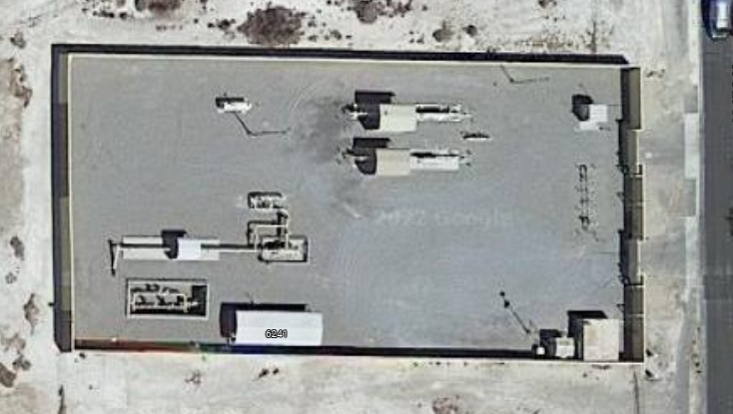

Figure 23. Site Overview

There are microphones included with the installation to monitor the ambient sound level for changes. One faces towards the regulator station and one towards the gates by the street. The microphone facing the regulator shows a consistently higher background level, which is reasonable for this site. As a means of testing this, the microphone facing the regulator has been temporarily disconnected to observe how this effects results. An observation from the test system on the GTI Campus is that periods of rain drive high signal levels in the microphones.

Hardware upgrades were also performed at the original (California) test site. There are now two locations running the improved instrumentation package: one in California and one in Nevada.

Upon arriving at the original test site (Figure 24), the first task was to verify that all the previously installed sensors were working properly. This is particularly critical for the below ground geophone and vibration sensors as there is no means to replace these without excavation. The first test involved continuity checks with an ohmmeter to verify the cables had not been compromised. The second test was to attach a portable oscilloscope to the sensor outputs in the instrument cabinet to monitor them. The ground above the sensor locations was struck with a mallet to provide a signal. This signal was successfully captured. The below ground sensors were verified working.

The next step for the upgrade was to replace the instrumentation panel within the existing enclosure (Figure 25). This was done with the assistance of utility personnel. Most of the new panel was prefabricated at GTI and shipped to the test site to minimize the amount of field wiring required. The changeover was accomplished in under 2 hours. The original panel was shipped back to GTI to be refurbished. There are two more sensor posts on this test site that could be upgraded as part of future work.

A new, small enclosure was added to the system that houses microphones, a gas sensor, and a lightning sensor. This is a change from the original system that was deployed at this location. It adds categories of sensor that were not considered in the earlier work.

With the instrumentation in place, the connectivity of the system was then tested. This site had originally been provisioned with an RPMA radio; this was replaced with a Campbell CELL210 modem in the new setup. Once the new equipment was powered up, the connection was quickly established. The utility personnel on site were shown how to access the raw data through Campbell LoggerNet. Please note that the raw datalogger access is different from the processed displays available through the Losant portal.

Figure . Sensor Station at Original Test Site

Figure . Instrumentation Upgrade in Place

Data feeds are now available from both test sites. The Nevada site installed in March is in a suburban area with some new housing construction in progress. The California site is in a more rural area with some light industry nearby. The following time series graphs show some differences between the two sites over the same 24-hours of live data. Figure 26 and Figure 27 are the sound levels at the site shown as RMS voltage. A casual glance would lead one to believe that the rural site is quieter for much of the time; in fact, the auto-scaling causes some compression of the display. The peak values at the rural site are greater than those at the suburban when the y-axis values are examined. This may be a wind and weather effect as the rural installation is out in the open. The suburban installation is in an area enclosed by a concrete block wall that may provide shelter.

Figure . RMS Sound Level 24 Hours at Suburban Site

Figure . RMS Sound Level 24 Hours at Rural Site

Figure 28 and Figure 29 show the number of times a vibration sensor or geophone is over a threshold during a given period. Both sites are subject to some truck traffic that may excite the in-ground sensors. The suburban site does periodically have utility vehicles within the enclosed area and a gate operating. The rural site is located adjacent to a road that has occasional heavy truck traffic; this probably accounts for the more pronounced peaks.

Figure . Vibration Sensors Activity 24 Hours at Suburban Site

Figure . Vibration Sensors Activity 24 Hours at Rural Site

Events above threshold are registered when a sensor value crosses a low, high, or “impact” threshold that is pre-programmed into the processor module. The threshold values are provisional and may need some modification. At this writing, there is not a method to update the thresholds over-the-air (OTA). This is being worked on. Crossing a threshold also triggers an immediate transmission of data. In the absence of a trigger event, data is sent at 5-minute intervals to allow the establishment of baseline sensor values. The Losant platform does allow email messages to be generated on trigger events.

Figure 30 and Figure 31 show the numeric displays of threshold crossings at the two sites. The rural site does have an older model of vibration sensor that was installed in 2018. This may account for differences in the activity levels observed; this is still being investigated at this time.

Figure . Vibration Sensor Threshold Counts at Suburban Site

Figure . Vibration Sensor Threshold Counts at Rural Site

The utility hosting the suburban (Nevada) site has agreed to perform tests using a soil compactor to generate vibrations in the pipe. This site was visited during the same trip to perform the rural (California) site upgrades. Several points along the pipeline on which the sensors were mounted were designated for this test. The points range 30’ from the sensors to several 100’ in both directions.

The soil compactor test was not completed at the time of this Draft Report. The timing of the tests will be driven by the availability of utility construction personnel. GTI is working with the utility sponsoring that test site to perform the test in time for the data to be in the final report.

# Project Results

There are two test sites currently running versions of the improved ROW Defense hardware and forwarding data to the Losant Dashboard. Because of the difficulty in obtaining test sites with the correct permits these installations took place late in the project schedule, even considering schedule extensions that were granted. The quantity of data captured so far is not large.

The improved sensor station hardware is functioning properly, and the cellular communications system is more reliable than the previous RPMA radio. Data is being collected and archived from these sites. The dashboard view of the tests sites has been reliably available. In addition to the dashboard view, the underlying data is accessible as shown in Appendix D. Example of Tabulated Sensor Data.

Multiple sensor stations on the same pipeline would have been the ideal case. This was not achieved, also due to the siting issues that protracted the schedule. There is one sensor station at each site. The California site has the potential to add two more given that the above ground cabinets with solar power are already in place.

GTI is maintaining regular meetings with the hosting utilities to capture their feedback and impressions of the ROW Defense system. The utilities are engaged and interested. There seems to be an appetite to expand the use of the system if the data meets expectations and if the above ground part of the hardware can be made smaller.

# Conclusions

There is need for a cost-effective means to monitor existing pipelines in the Right-of-Way, driven by the increasing scrutiny brought to bear on an aging gas infrastructure. The threat of third-party damage was already a consideration, now extreme weather driven events such as flooding, and soil movement also are. These are exacerbated by increasing urban development bringing larger population into proximity with the gas infrastructure while simultaneously complicating access to it.

The growth of these high consequence areas (HCA) over existing infrastructure highlights the need for a retrofit monitoring system. The system needs to be installable through a widely-spaced series of excavation on the existing pipeline. Continuous line monitors, such as fiber optic systems, can give excellent results but their installation requirements limit them to new construction. Exposing infrastructure with a continuous open trench is not cost effective, even less so in an HCA.

The improvements deployed do demonstrate the feasibility of operating a Multi-Sensor ROW Defense system. The sensor improvements and the change in mounting methods have streamlined the installation process considerably compared to the earlier system.

There is still the issue of the above ground instrumentation deployment. The ability to permit installation on a site is driven by the size of the instrumentation. A topic for future work could be to reduce the size of this equipment. The form factor of the 3” diameter cathodic protection post would be desirable as these are an accepted part of the utility landscape. It may be possible to achieve this by reducing the total number of sensors below ground. The data from the current phase will provide guidance for this.

# List of Acronyms

|  |  |
| --- | --- |
| Acronym | Description |
| ARM | Advanced RISC Machines |
| AWS | Amazon Web Services |
| CP | Cathodic Protection |
| DSP | Digital Signal Processing |
| FTP | File Transfer Protocol |
| FPU | Floating Point Unit |
| HCA | High Consequence Area |
| IoT | Internet of Things |
| JSON | JavaScript Object Notation |
| LTE-M | Long Term Evolution – Machine to Machine |
| MEMS | Micro Electromechanical System |
| ML | Machine Learning |
| MQTT | Message Queueing Telemetry Transfer |
| OGC | Open Geospatial Consortium |
| OTD | Operations Technology Development |
| OTA | Over the Air |
| RISC | Reduced Instruction Set Computer |
| RMS | Root Mean Square |
| ROW | Right of Way |
| RPMA | Random Phase Multiple Access |
| STM | ST Microelectronics; ST Micro |
| TAP | Technical Advisory Panel |

# Appendix A. Open Geospatial Consortium (OGC) Standards

The following standards from the OGC.org website (OGC Standards n.d.) are related to the sensors and data used in this project and will be evaluated in-depth:

**SWE Common Data Model:** The Sensor Web Enablement (SWE) Common Data Model Encoding Standard defines low-level data models for exchanging sensor-related data between nodes of the OGC® Sensor Web Enablement (SWE) framework. These models allow applications and servers to structure, encode, and transmit sensor datasets in a self-describing and semantically enabled way.

**SWE Service Model:** This standard currently defines eight packages with data types for common use across OGC Sensor Web Enablement (SWE) services. Five of these packages define operation request and response types. The packages are:

1. Contents – Defines data types that can be used in specific services that provide (access to) sensors;
2. Notification – Defines the data types that support the provision of metadata about the notification capabilities of a service as well as the definition and encoding of SWES events;
3. Common – Defines data types common to other packages;
4. Common Codes –Defines commonly used lists of codes with special semantics;
5. DescribeSensor – Defines the request and response types of an operation used to retrieve metadata about a given sensor;
6. UpdateSensorDescription –Defines the request and response types of an operation used to modify the description of a given sensor;
7. InsertSensor – Defines the request and response types of an operation used to insert a new sensor instance at a service;
8. DeleteSensor – Defines the request and response types of an operation used to remove a sensor from a service.

**Sensor Model Language:** The primary focus of the Sensor Model Language (SensorML) is to provide a robust and semantically-tied means of defining processes and processing components associated with the measurement and post-measurement transformation of observations.

**Sensor Observation Service:** The SOS standard is applicable to use cases in which sensor data needs to be managed in an interoperable way. This standard defines a Web service interface that allows querying observations, sensor metadata, as well as representations of observed features.

**Sensor Planning Service:** The OpenGIS® Sensor Planning Service Interface Standard (SPS) defines interfaces for queries that provide information about the capabilities of a sensor and how to task the sensor. The standard is designed to support queries that have the following purposes: to determine the feasibility of a sensor planning request; to submit and reserve/commit such a request; to inquire about the status of such a request; to update or cancel such a request, and to request information about other OGC Web services that provide access to the data collected by the requested task.

**Sensor Things:** The OGC SensorThings API provides an open, geospatial-enabled, and unified way to interconnect the Internet of Things (IoT) devices, data, and applications over the Web. At a high level, the OGC SensorThings API provides two main functionalities, and each function is handled by a part. The two parts are the Sensing part and the Tasking part. The Sensing part provides a standard way to manage and retrieve observations and metadata from heterogeneous IoT sensor systems. The Tasking part is planned as a future work activity and will be defined in a separate document as Part II of the SensorThings API.

**Semantic Sensor Network:** The SSN ontology is an ontology for describing sensors and their observations, the involved procedures, the studied features of interest, the samples used to do so, and the observed properties, as well as actuators.

**Observations and Measurements:** This standard specifies an XML implementation for the OGC and ISO Observations and Measurements (O&M) conceptual model (OGC Observations and Measurements v2.0 also published as ISO/DIS 19156), including a schema for Sampling Features. This encoding is an essential dependency for the OGC Sensor Observation Service (SOS) Interface Standard. More specifically, this standard defines XML schemas for observations, and for features involved in sampling when making observations. These provide document models for the exchange of information describing observation acts and their results, both within and between different scientific and technical communities.

**Pipeline Model Language:** The OGC PipelineML Conceptual and Encoding Model Standard defines concepts supporting the interoperable interchange of data pertaining to oil and gas pipeline systems. PipelineML supports the common exchange of oil and gas pipeline information. This initial release of the PipelineML Core addresses two critical business use cases that are specific to the pipeline industry: new construction surveys and pipeline rehabilitation. This standard defines the individual pipeline components with support for lightweight aggregation. Additional aggregation requirements such as right-of-way and land management will utilize the OGC LandInfra standards with utility extensions in the future. Future extensions to PipelineML Core will include (non-limitative): cathodic protection, facility, and safety.

# Appendix B. TinyML Workflow for Sound Recognition

Tiny Machine Learning (TinyML) is a software tool to develop ML algorithms to run on constrained hardware. This allows recognition of sounds (or other parameters) to be performed on sensor devices at the edge of the network rather than a central cloud server. This allows alarms to be transmitted when specific events occur rather than transmitting a continuous stream of data. This approach can optimize the management of power and traffic in wireless data networks.

The following figures provide an idea of the general workflow. The example training data (Figure 7) show the output of a pipe mounted vibration sensor with and without a soil compactor (or “tamper”) running nearby. This raw time-series data is converted into a spectrogram (Figure 8). The spectrogram captures frequency content along the vertical axis and time at which the frequencies are present along the horizontal axis. This processed training data (Figure 9) represents the sensor data in a manner can be automatically classified with image recognition algorithms. Other algorithms, such as the wavelet transform, were also considered.

Figure . Examples of Time Series Data

Figure . Time Series and Spectrogram

Figure . Training Data as Spectrograms

# Appendix C. Examples of JSON Data Messages

The following are examples of GeoJSON data messages sent from the field sensors to AWS and the processed form of the message that is then forwarded to the Losant dashboard.

**Sample Aboveground Sub-Processor Outgoing Message:**

{

  "type": "Feature",

  "geometry": {

    "type": "Point",

    "coordinates": [

      -115.135376,

      36.273300,

      null

    ]

  },

  "properties": {

    "loggerID": "CR615335",

    "observationNames": [

      "AlarmStateSP2",

      "LightSensEvFlag",

      "LightSensStrkDetCnt",

      "LightSensDistDetCnt",

      "LightSensEnrgMean",

      "LightSensDistMean",

      "GasSensEvFlag",

      "GasSensID",

      "GasSensConcMean",

      "GasSensConcStdDev",

      "GasSensConcMax",

      "GasSensConcMin",

      "GasSensTempMean",

      "GasSensPresMean",

      "GasSensRelHumMean",

      "GasSensAbsHumMean",

      "Mic1EvFlag",

      "Mic1RmsDataMean",

      "Mic1RmsStdDev",

      "Mic1RmsMax",

      "Mic1RmsMin",

      "Mic1CntsAboveLow",

      "Mic1CntsAboveImpact",

      "Mic1CntsAboveHigh",

      "Mic1BaselineCnts",

      "Mic1DrillingCnts",

      "Mic1EngineIdlingCnts",

      "Mic1JackhammerCnts",

      "Mic1SirenCnts",

      "Mic1CntsLowTotal",

      "Mic1CntsHighTotal",

      "Mic2EvFlag",

      "Mic2RmsDataMean",

      "Mic2RmsStdDev",

      "Mic2RmsMax",

      "Mic2RmsMin",

      "Mic2CntsAboveLow",

      "Mic2CntsAboveImpact",

      "Mic2CntsAboveHigh",

      "Mic2BaselineCnts",

      "Mic2DrillingCnts",

      "Mic2EngineIdlingCnts",

      "Mic2JackhammerCnts",

      "Mic2SirenCnts"

    ],

    "observations": {

      "2023-07-26T16:41:00Z": [

        false,

        0,

        0,

        0,

        0,

        0,

        0,

        0,

        0,

        0,

        0,

        0,

        50.775,

        93.831,

        4.147,

        4.826,

        0,

        41.943,

        5.626,

        61.666,

        33.703,

        0,

        0,

        0,

        13,

        0,

        0,

        0,

        0,

        0,

        0,

        0,

        41.943,

        5.626,

        61.666,

        33.698,

        0,

        0,

        0,

        13,

        0,

        0,

        0,

        0

      ]

    }

  }

}

**Sample Aboveground Sub-Processor Processed Message:**{

  "logger_ID": "CR615336",

  "table": "AbovegroundMCUData",

  "timestamp": "2023-07-27T09:56:00Z",

  "longitude": -87.923042,

  "latitude": 42.01807,

  "height": null,

  "AlarmStateSP2": false,

  "LightSensEvFlag": 0,

  "LightSensStrkDetCnt": 0,

  "LightSensDistDetCnt": 0,

  "LightSensEnrgMean": 0,

  "LightSensDistMean": 0,

  "GasSensEvFlag": 0,

  "GasSensID": 0,

  "GasSensConcMean": 0,

  "GasSensConcStdDev": 0,

  "GasSensConcMax": 0,

  "GasSensConcMin": 0,

  "GasSensTempMean": 0,

  "GasSensPresMean": 0,

  "GasSensRelHumMean": 0,

  "GasSensAbsHumMean": 0,

  "Mic1EvFlag": 0,

  "Mic1RmsDataMean": 79.2,

  "Mic1RmsStdDev": 23.912,

  "Mic1RmsMax": 159.459,

  "Mic1RmsMin": 45.546,

  "Mic1CntsAboveLow": 0,

  "Mic1CntsAboveMed": 0,

  "Mic1CntsAboveHigh": 0,

  "Mic1BaselineCnts": 40,

  "Mic1DrillingCnts": 0,

  "Mic1EngineIdlingCnts": 0,

  "Mic1JackhammerCnts": 0,

  "Mic1SirenCnts": 0,

  "Mic2EvFlag": 0,

  "Mic2RmsDataMean": 79.2,

  "Mic2RmsStdDev": 23.913,

  "Mic2RmsMax": 159.464,

  "Mic2RmsMin": 45.549,

  "Mic2CntsAboveLow": 0,

  "Mic2CntsAboveMed": 0,

  "Mic2CntsAboveHigh": 0,

  "Mic2BaselineCnts": 40,

  "Mic2DrillingCnts": 0,

  "Mic2EngineIdlingCnts": 0,

  "Mic2JackhammerCnts": 0,

  "Mic2SirenCnts": 0

}

**Sample Belowground Sub-Processor Outgoing Message:**

{

  "type": "Feature",

  "geometry": {

    "type": "Point",

    "coordinates": [

      -115.135376,

      36.273300,

      null

    ]

  },

  "properties": {

    "loggerID": "CR615335",

    "observationNames": [

      "AlarmStateSP1",

      "AccelEvFlag",

      "AccelCorrDataMean",

      "AccelCorrDataStdDev",

      "AccelCorrDataMax",

      "AccelCorrDataMin",

      "AccelRmsMean",

      "AccelRmsStdDev",

      "AccelRmsMax",

      "AccelRmsMin",

      "AccelCntsAboveLow",

      "AccelCntsImpact",

      "AccelCntsAboveHigh",

      "AccelCntsLowTotal",

      "AccelCntsHighTotal",

      "AccelCntsImpactTotal",

      "GeophEvFlag",

      "GeophCorrDataMean",

      "GeophCorrDataStdDev",

      "GeophCorrDataMax",

      "GeophCorrDataMin",

      "GeophRmsMean",

      "GeophRmsStdDev",

      "GeophRmsMax",

      "GeophRmsMin",

      "GeophCntsAboveLow",

      "GeophCntsImpact",

      "GeophCntsAboveHigh",

      "GeophCntsLowTotal",

      "GeophCntsHighTotal",

      "GeophCntsImpactTotal"

    ],

    "observations": {

      "2023-07-27T14:06:00Z": [

        false,

        0,

        0.14,

        0.049,

        0.085,

        0.279,

        0.007,

        0.001,

        0.009,

        0.007,

        0,

        0,

        0,

        0,

        0,

        0,

        0,

        1.197,

        0.827,

        0.14,

        2.538,

        0.014,

        0.009,

        0.028,

        0.003,

        16,

        0,

        0,

        0,

        0,

        0

      ]

    }

  }

}

**Sample Belowground Sub-Processor Processed Message:**

{

  "logger_ID": "CR615335",

  "table": "BelowgroundMCUData",

  "timestamp": "2023-07-27T13:10:00Z",

  "longitude": -115.135376,

  "latitude": 36.2733,

  "height": null,

  "AlarmStateSP1": true,

  "AccelEvFlag": 0,

  "AccelCorrDataMean": 0.228,

  "AccelCorrDataStdDev": 0.096,

  "AccelCorrDataMax": 0.101,

  "AccelCorrDataMin": 0.501,

  "AccelRmsMean": 0.008,

  "AccelRmsStdDev": 0.002,

  "AccelRmsMax": 0.014,

  "AccelRmsMin": 0.007,

  "AccelCntsAboveLow": 1,

  "AccelCntsImpact": 0,

  "AccelCntsAboveHigh": 0,

  "AccelCntsLowTotal": 0,

  "AccelCntsHighTotal": 0,

  "AccelCntsImpactTotal": 0,

  "GeophEvFlag": 0,

  "GeophCorrDataMean": 2.701,

  "GeophCorrDataStdDev": 1.145,

  "GeophCorrDataMax": 1.268,

  "GeophCorrDataMin": 6.347,

  "GeophRmsMean": 0.035,

  "GeophRmsStdDev": 0.018,

  "GeophRmsMax": 0.089,

  "GeophRmsMin": 0.016,

  "GeophCntsAboveLow": 21,

  "GeophCntsImpact": 0,

  "GeophCntsAboveHigh": 2,

  "GeophCntsLowTotal": 0,

  "GeophCntsHighTotal": 0,

  "GeophCntsImpactTotal": 0

}

**Sample CR6/System Health Outgoing Message:**

{

  "type": "Feature",

  "geometry": {

    "type": "Point",

    "coordinates": [

      -119.077942,

      35.445522,

      null

    ]

  },

  "properties": {

    "loggerID": "CR615333",

    "observationNames": [

      "AlarmStateCR6",

      "DateTime",

      "Battery12V",

      "DCDC5VOut",

      "PanelTemperature",

      "Strain",

      "CurrentCouponMax(1)",

      "CurrentCouponMin(1)",

      "CurrentCouponRMS",

      "CurrentCouponAvg",

      "TempF_Avg",

      "VWC_Avg",

      "EC_Avg",

      "AccelXaxis_Avg",

      "AccelYaxis_Avg"

    ],

    "observations": {

      "2023-07-26T18:03:00Z": [

        false,

        "07/26/2023 18:02:00",

        13.20749,

        5.013226,

        42.07193,

        20.04051,

        0.3213219,

        0.3048742,

        0.3182073,

        0.3181929,

        85.43462,

        0.1008,

        0.3327,

        0,

        0

      ]

    }

  }

}

**Sample CR6/System Health Processed Message:**

{

  "logger_ID": "CR615335",

  "table": "CR6Sensors",

  "timestamp": "2023-07-27T13:11:00Z",

  "longitude": -115.135376,

  "latitude": 36.2733,

  "height": null,

  "AlarmStateCR6": false,

  "DateTime": "07/27/2023 13:10:00",

  "Battery12V": 12.96293,

  "DCDC5VOut": 5.019643,

  "PanelTemperature": 54.47885,

  "Strain": 1.412203,

  "CurrentCouponMax(1)": 2.156126,

  "CurrentCouponMin(1)": 2.125513,

  "CurrentCouponRMS": 2.141249,

  "CurrentCouponAvg": 2.141237,

  "TempF_Avg": 81.13442,

  "VWC_Avg": 0.1764,

  "EC_Avg": 0.3082,

  "AccelXaxis_Avg": 2455.728,

  "AccelYaxis_Avg": 2513.071

}

# Appendix D. Example of Tabulated Sensor Data

In addition to the dashboard visualization of data, the data is accessible as CSV files or other formats that enable further analysis of the data.



**END OF REPORT**