Quarterly Report – Public Page

Date of Report: 4th Quarterly Report – September 30, 2022
Contract Number: #693JK32110008POTA
Prepared for: DOT and Co-funders
Project Title: Advancement of Through-tubing Casing Inspection for Underground Storage Wells
Prepared by: Pipeline Research Council International, Inc.
Contact Information: Zoe Shall (zshall@prci.org, 1-402-680-9186)
For quarterly period ending: September 30, 2022

1: Items Completed During this Quarterly Period:

Item # | Task # | Activity/Deliverable | Title | Federal Cost | Cost Share
10 | 5 | 4th quarterly status report & project management | Submit 4th quarterly report | $6,971.14 | $6,971.14

2: Items Not Completed During this Quarterly Period:

Item # | Task # | Activity/Deliverable | Title | Federal Cost | Cost Share
6 | 2 | Assemble and commission laboratory test apparatus | Summary to be included in the quarterly report | $23,326.68 | $23,326.68
7 | 2 | Conduct logging test round #1 | Results to be included in the quarterly report | $77,755.60 | $77,755.60
9 | 2 | Tool performance evaluation for logging test round #1 | Results to be included in the quarterly report | $31,102.24 | $31,102.24

3: Project Financial Tracking During this Quarterly Period:

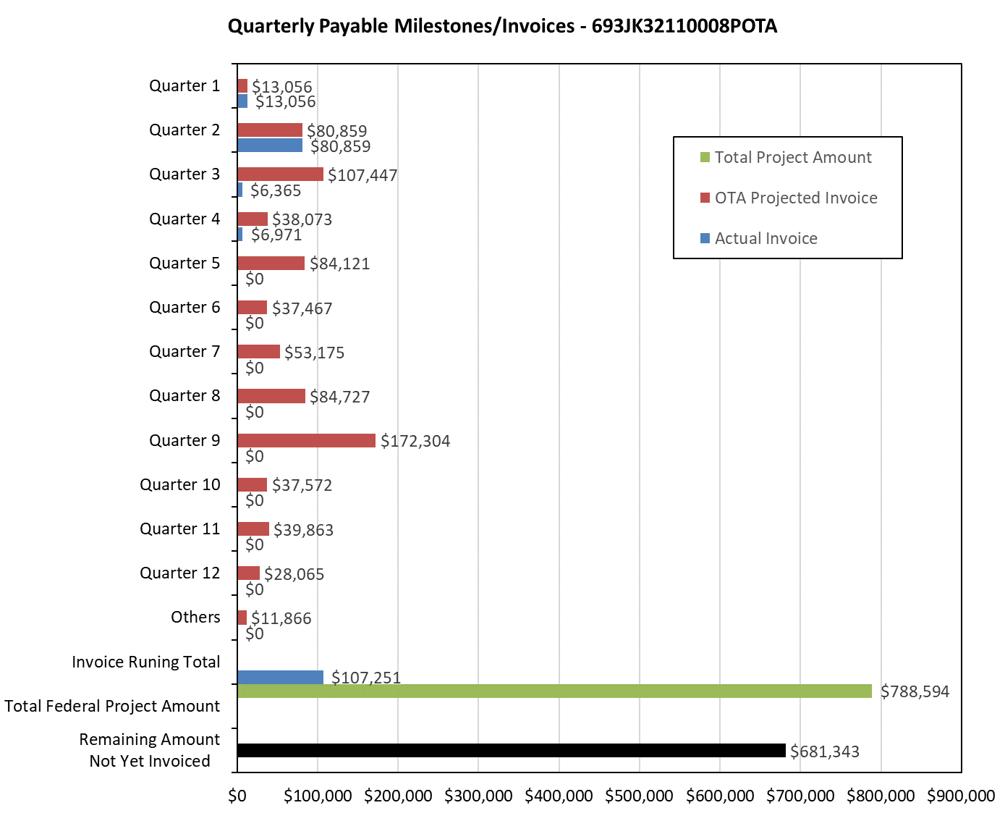

4: Project Technical Status:

[Item #10] [Task #5] [4th quarterly status report & project management] [Submit 4th quarterly report]

A quarterly Technical Advisory Panel (TAP) meeting was held on September 21, 2022. This meeting reviewed the overall project progress and forecasted the work plan for the next quarter.

Significant progress has been made on the test well assembly and preparation for the first round of logging tool tests but are delayed (see detail in the next section). The tool performance task is pending.

5: Project Schedule:

The project is currently delayed approximately 6 months. The project team is optimistic that delays can be minimized over the duration of the project, and therefore, it is uncertain if the current delay will impact the overall project schedule. Monitoring will continue on critical tasks and a discussion on performance period extension will occur, if necessary, within Operating Contract Agreement stipulated timeframes.

Progress on tasks include:

[Item #6] [Task #2] [Assemble and commission laboratory test apparatus] [Summary to be included in the quarterly report]

This task is to complete the test well assembly for vendor tool testing.

All pipe samples have been procured as listed below:

Casing
- 4.5”, 11.6 ppf (0.25” WT), J55, R3, SMLS
- 5.5”, 15.5 ppf (0.275” WT), J55, R3, SMLS
- 7”, 23 ppf (0.317” WT), J55, R3, SMLS
Tubing
- 2-7/8”, 6.5 ppf, L80, R2, SMLS, EUE

Metal loss feature machining is completed for all casing sizes (i.e., 4.5”, 5.5” and 7”). Laser scanning was conducted to accurately characterize the metal loss features for all casing samples. The laser scan results will be used to evaluate the tool measurement accuracy.

The deep well simulator’s use on other projects, as reported in previous monthly reports, has concluded and the apparatus is available for this project. Tools and equipment for manipulation of casing and tubing have been secured and staged. Buckled tubing finite element analyses and sensitivity studies were conducted for the 4.5-inch-diameter tubing to ensure assemblies are realistic representations of field conditions.

Remaining tasks include assembly of the test well and calibration. This task is anticipated to be reported complete in the fifth quarterly report.

[Item #7] [Task #2] [Conduct logging test round #1] [Results to be included in the quarterly report]

This task is contingent upon completion of [Item #6] [Task #2] and although behind, activities to execute the testing are moving ahead. Contracts are executed with Baker Hughes, GoWell, and Schlumberger and schedules are being finalized. Testing protocols have been developed and data reporting templates were created and distributed to vendors to standardize the format for evaluation. Each vendor will conduct the tests over a one-week period, with an anticipated three active days of testing. Testing is expected to start in mid-November, with completion expected by the fifth quarterly report.

[Item #9] [Task #2] [Tool performance evaluation for logging test round #1] [Results to be included in the quarterly report]

This task is contingent upon completion of [Item #7] [Task #2].

