Quarterly Report – Public Page

Date of Report: June 23, 2022
Contract Number: #693JK32110008POTA
Prepared for: DOT and Co-funders
Project Title: Advancement of Through-tubing Casing Inspection for Underground Storage Wells
Prepared by: Pipeline Research Council International, Inc.
Contact Information: Zoe Shall (zshall@prci.org, 1-402-680-9186)
For quarterly period ending: June 30, 2022

1: Items Completed During this Quarterly Period:

Item # | Task # | Activity/Deliverable | Title | Federal Cost | Cost Share
8 | 5 | 3rd quarterly status report & project management | Submit 3rd quarterly report | $6,365.12 | $6,365.12

2: Items Not Completed During this Quarterly Period:

Item # | Task # | Activity/Deliverable | Title | Federal Cost | Cost Share
6 | 2 | Assemble and commission laboratory test apparatus | Summary to be included in the quarterly report | $23,326.68 | $23,326.68
7 | 2 | Conduct logging test round #1 | Results to be included in the quarterly report | $77,755.60 | $77,755.60

3: Project Financial Tracking During this Quarterly Period:

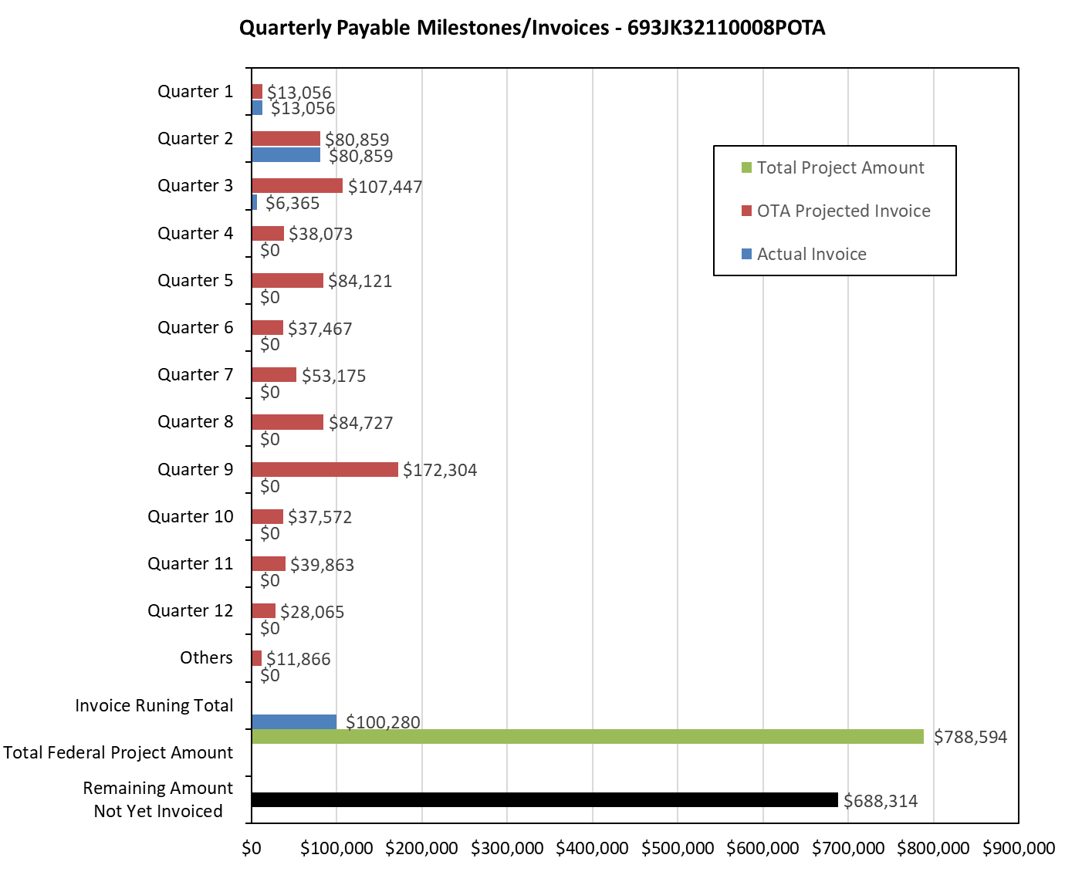

4: Project Technical Status:

[Item #5] [Task #5] [3rd quarterly status report & project management] [Submit 3rd quarterly report]

Project management coordination of material and test procedure was completed; however, the summary of test well assembly and the first round of logging tool tests will be delayed, as detailed in Section 5.

A quarterly Technical Advisory Panel (TAP) meeting was held on June 22, 2022. This meeting reviewed the overall project progress and forecasted the work plan for the next quarter. Minutes and presentation were provided to PHMSA via email.

5: Project Schedule:

The project is currently delayed.

[Item #6] [Task #2] [Assemble and commission laboratory test apparatus] [Summary to be included in the quarterly report]

This task is to complete the test well assembly for vendor tool testing.

The delays of this task were caused by several issues. The desired pipe samples were not readily available, and it took some time to source them, the machining contractor availability was later than anticipated, and the delay of a current ongoing project in C-FER’s Deep Well Simulator is anticipated to continue into September.

Progress has been made on this task, as follows:

- All pipe samples have been procured as listed below:

Casing
- 4.5”, 11.6 ppf (0.25” WT), J55, R3, SMLS
- 5.5”, 15.5 ppf (0.275” WT), J55, R3, SMLS
- 7”, 23 ppf (0.317” WT), J55, R3, SMLS
Tubing
- 2-7/8”, 6.5 ppf, L80, R2, SMLS, EUE

- Metal loss feature machining is in progress. The 4.5-inch- and 7-inch-diameter casing metal loss machining were completed. The 5.5-inch-diameter samples are expected to be complete in July. Upon receiving all metal loss specimens, laser scanning will be conducted to accurately quantify the metal loss features. The laser scan results will be used to evaluate the tool accuracy.

[Item #7] [Task #2] [Conduct logging test round #1] [Results to be included in the quarterly report]

This task is follows [Item #6] [Task #2] and is delayed in tandem.

The current estimated delay is approximately three to four months. As these activities are not on the schedule critical path, it is uncertain if the current delay will impact the total project schedule. PRCI reserves the right to submit a modification request for a time extension at a later date, if required.

