**CAAP Quarterly Report**

**3/31/2022**

*Project Name: Pipeline Risk Management Using Artificial Intelligence-Enabled Modeling and Decision Making*

*Contract Number: 693JK32150001CAAP*

*Prime University: Rutgers University*

*Prepared by: Bingyan Cui (PhD student), Dr. Jingnan Zhao (Postdoc), Dr. Hao Wang (PI)*

*Reporting Period: 1/1/2022 – 3/31/2021*

**Project Activities for Reporting Period:**

*Data Collection from Industry Partner*

The transmission pipeline uses grade X52 steel with total length of 112 km and an outside diameter of 457.2 mm. The wall thickness is 6.4mm. It has been in service since 1969. ILI inspections were conducted using MLF technology in 2005 and using straight beam ultrasound technology in 2010, respectively. In ILI inspection, external corrosion information was collected, including metal loss (in depth, mm), metal loss percentage (% in wall thickness), defect length (mm), and defect orientation. Unfortunately, the pipeline coating condition data were not available.

Figure 1 illustrates metal loss of pipe segments with external corrosion and their corresponding service ages from last installation to the years of inspection. The service age of segments was in a large range (1-43 years) depending on the timing of initial installation and replacement. There were no data points collected between the service age of 11 to 29 years, which may create some challenges to determine when the stable corrosion stage began due to the limited variation of service age.

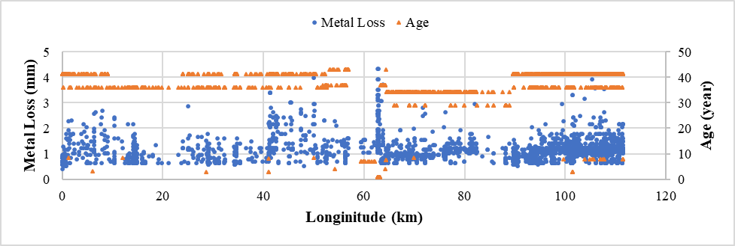

**Figure 1** Metal loss of pipe segments with corresponding ages in the years of inspection

Figure 2 shows the metal loss and defect length from the inspection data collected in 2005 and 2010 plotted along pipeline length. According to inspection data, it is difficult to find the exactly matched defects at the same location and further analysis is needed to develop the propagation trend of defect with time. It is worth noting that some segments were replaced from 2001 to 2005, and initial metal loss might occur during the replacement leading to early development of material loss, which was observed in the inspection conducted in 2005 but not in 2010.

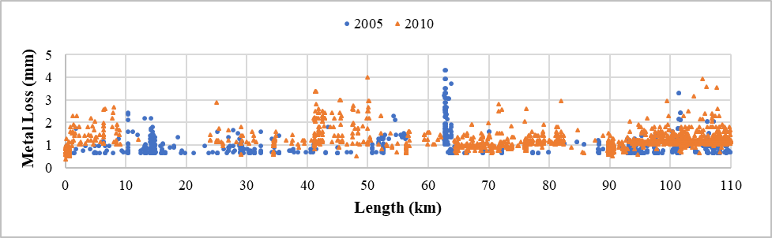

(a)

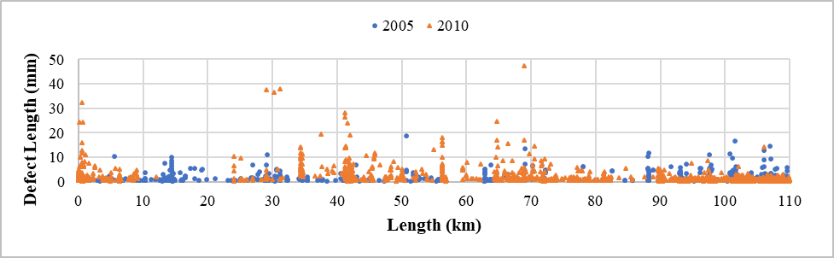

(b)

**Figure 2** Scatter plot of pipe damage along the length of the pipeline (a) metal loss; (b) defect length

The boxplot (in Figure 3) and density plot (in Figure 4) of metal loss and defect length are illustrated to present statistical characteristics of defect data from two inspections. It is evident that the median and mean of metal loss from the second inspection are greater than those from the first ILI run, which reflects corrosion behavior caused by degrading surfaces due to soil environment. Similarly, the boxplot illustrates a more concentrated distribution of metal loss toward the greater values from the second inspection. However, this trend was not obvious for defect length, which indicate different development trends of defect depth and length due to external corrosion.

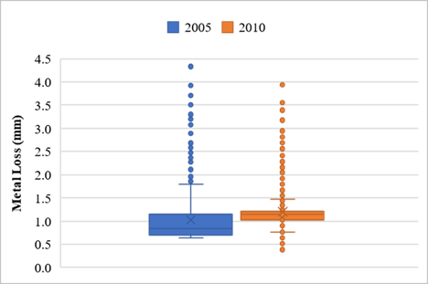 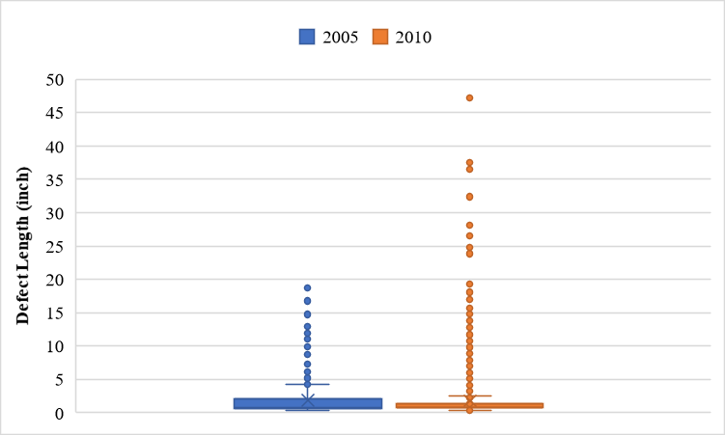

1. (b)

**Figure 3** Boxplot: (a) metal loss; (b) defect length

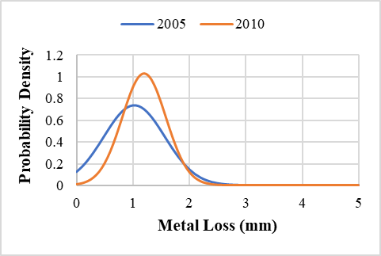 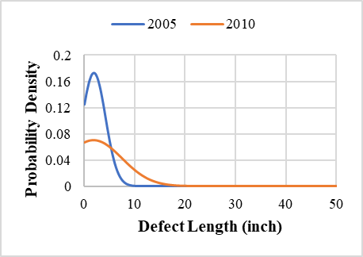

1. (b)

**Figure 4** Density plot: (a) metal loss; (b) defect length

External corrosion was affected by soil physical parameters, such as moisture content, resistivity, pH, soil aeration, and bacteria activities. The soil survey was conducted every 200 m along the pipeline (defined as one zone) in 2012, and a number of soil properties were measured, including Eh (soil redox potential), resistance, resistivity, pH, CO32- concentration, HCO3- concentration, Cl- concentration, SO42- concentration, soil moisture, and soil type. There are totally 433 soil zones with different soil properties, moisture contents, and soil types. Soil redox potential indicates soil’s overall oxidizing or reducing capacity. Soil resistance indicates the capability of providing safe path for fault current, and the soil with high resistance tend to provide unsafe path for fault current and increase the risk of equipment failure. Soil resistivity reflects the soil’s capacity to resist electric current, and the lower resistivity may imply salty groundwater. It is noted that the soil type number (1-10) was used to represent typical soil groups, such as clay, sandy, silty, peaty, chalky, loamy, etc., but the specific soil type for each number was not known. Table 1 presents the statistical summary of soil survey data.

The electrical and chemical properties of soil were found having large variations. The highest content of Cl- was found to be 32 mol/L that happened in the same zone with 15.91 mol/L HCO3-. It is not sure if this indicates contaminated soil or an outlier since all the other zones have the contents of Cl- smaller than 10 mol/L. Checking the inspection data, the corrosion rate (defined by dividing metal loss in depth by age of pipe segment) at this zone was found about 0.2mm/year, which was at the high end among all the corrosion rates at different locations. However, simple correlations between individual soil parameters and corrosion rates were not found. Further analysis will be conducted to investigate the combined effects of soil properties on external corrosion using different data analytics algorithms.

**Table 1** Summary of soil survey data

|  |  |  |  |  |  |  |  |  |
| --- | --- | --- | --- | --- | --- | --- | --- | --- |
| Soil Parameters | Min. | 25% percentile | Median | 75% percentile | Max. |  | Mean | Std. Dev. |
| Potential Redox1 (mV) | -595 | -506 | -461 | -411 | -150 |  | -455 | 64 |
| Calculated electrode potential2 (mV) | -443 | -357 | -314 | -287 | -120 |  | -317 | 56 |
| Eh (mV) | -395 | -306 | -261 | -211 | 50 |  | -255 | 64 |
| Resistance @ 1m (Ω) | 0.89 | 3.2 | 9.2 | 23 | 490 |  | 29.1 | 57 |
| Resistance @ 2m (Ω) | 0.32 | 1.6 | 3.9 | 11 | 180 |  | 12.8 | 25 |
| Resistivity @ 1m (Ωcm) | 559 | 2011 | 5781 | 14451 | 307876 |  | 18310 | 35871 |
| Resistivity @ 2m (Ωcm) | -1530 | 2285 | 5495 | 18490 | 447677 |  | 21310 | 44536 |
| pH | 2.03 | 4.86 | 5.31 | 6.03 | 7.49 |  | 5.35 | 0.95 |
| CO32- (mol/L) | 0.00 | 0.00 | 0.86 | 1.55 | 3.44 |  | 0.87 | 0.80 |
| HCO3- (mol/L) | -1.38 | 1.50 | 2.50 | 3.47 | 15.91 |  | 2.76 | 1.88 |
| Cl- (mol/L) | 0.75 | 2.25 | 3.00 | 3.75 | 32.00 |  | 3.17 | 1.85 |
| SO42- (mol/L) | 0.04 | 0.04 | 0.06 | 0.09 | 2.81 |  | 0.10 | 0.19 |
| Soil Moisture | 0.2366 | 0.2666 | 0.2743 | 0.2803 | 0.2846 |  | 0.2710 | 0.0119 |
| Soil Type3 | 1 | - | 5 | - | 10 |  | - | - |

1. Potential Redox = Eh – 200mv
2. Calculated electrode potential = -59.14 mV/pH * pH

3. Categorical parameter

**Project Activities with Cost Share Partners:**

Cost share is provided by Rutgers University during this quarterly period as budgeted in the proposal.

**Project Activities with External Partners:**

The PI (Dr. Hao Wang) had one meeting with another industry partner on Jan. 27 to discuss the availability of in-line inspection (ILI) data. The ILI data are collected by the pig with MFL (Magnetic Flux Leakage) /Caliper/ Inertial Measurement Unit (IMU). MFL is to provide accurate wall thickness measurements and metal loss depth/length/orientation. Caliper is to measure geometry or condition of pipe, such as dent (deformation), buckles, bend, etc. by making measurements of inside surface pipeline using mechanical arms.

ILI is usually conducted every 7 years since 2000s for transmission lines. After ILI, direct assessment by excavation is conducted at a few selected anomaly locations to verify ILI results. The main defect is external metal loss due to corrosion. Internal metal loss is mainly caused by manufacturing defects and seamless pipe has variations in wall thickness, which should not be considered as internal corrosion. Crack is very rare since the MAOP is maintained smaller than 40% of design pressure.

**Potential Project Risks:**

N/A

**Future Project Work:**

The research team will continue working on Task 2 Data Collection from Existing Literature and Industry Partners. The purpose is to collect field inspection records from direct assessment and ILI and indirect survey/examination data from the industry partner and other available data sources.

**Potential Impacts to Pipeline Safety:**

The in-line inspection data will be used to develop probabilistic growth models of pipeline defects, which can aid pipeline operators better predict failure risk and make repair decisions.