# Table of Contents

Table of Contents 1

Foreword 1

PIPA Recommended Practices and Hazard Mitigation Plans 1

Purpose 2

Background: PIPA Recommended Practices and Hazard Mitigation Plans 4

Hazard Mitigation Planning 4

Inclusion of Manmade and Technological Hazards 7

Threat and Hazard Identification and Risk Assessment (THIRA) 7

Integrating Pipelines into Hazard Mitigation Plans 9

Premises 9

Pipelines represent man-made hazards 9

Hazard Mitigation Planning for Pipelines – Vulnerability Assessment 13

Consequences - Pipeline Safety and Incident Experience 15

National Perspective on Pipeline Risk 15

State or Local Perspective on Pipeline Consequences 15

Hazard Mitigation Planning for Pipelines – Capability Assessments 18

Pipeline Hazard Mitigation Strategies 22

Benefits to pipeline operators of including pipelines in hazard mitigation plans 30

# Foreword

## PIPA Recommended Practices and Hazard Mitigation Plans

Following the [Pipelines and Informed Planning Alliance (PIPA)](http://primis.phmsa.dot.gov/comm/pipa/LandUsePlanning.htm?nocache=4685) publication of *Partnering to Further Enhance Pipeline Safety In Communities Through Risk-Informed Land Use Planning Final Report of Recommended Practices,* in November 2010[1], a team of representative stakeholders began researching how communities plan for other hazards and learned of the hazard mitigation planning process.

The PIPA Communications Team recognized that the PIPA recommended practices are potential hazard mitigation strategies that state and local governments can implement. And, many of these actions can be readily and cost-effectively implemented.

The Stafford Act (Public Law 93-288), as amended by the Disaster Mitigation Act of 2000 (DMA 2000), provides the legal basis for state, Indian Tribal, and local governments to undertake a risk-based approach to reducing risks from natural hazards through mitigation planning. The Federal Emergency Management Agency (FEMA) mitigation grant programs require an approved and adopted mitigation plan for approval of mitigation grant funding.

FEMA offers information and guidance on hazard mitigation planning laws, and regulations, on its website at:

<http://www.fema.gov/plan/mitplanning/guidance.shtm>.

DMA 2000 specifically requires mitigation planning for natural hazards, but not for manmade hazards. However, FEMA supports those jurisdictions that choose to consider technological and manmade hazards as part of a comprehensive hazard mitigation strategy in their respective mitigation plans. FEMA’s How-To Guide # 7, Integrating Manmade Hazards Into Mitigation Planning (FEMA 386-7)[2], assumes that a community is engaged in the mitigation planning process and serves as a resource to help the community expand the scope of its plan to address terrorism and technological hazards.

### Pipelines are Manmade Hazards

Gas and hazardous liquid pipelines are constructed by and for pipeline companies for the transportation and distribution of gas and hazardous liquids. By the nature of the potentially hazardous products they carry, pipelines are a source of potential harm to a community, including the population, environment, private and public property and infrastructure, and businesses. Pipelines should be included in the lists of hazards that communities consider when developing hazard mitigation plans.

Thus, the stage is set and the need is recognized to integrate pipelines into hazard mitigation planning.

## Purpose

This document was created to assist pipeline operators involved with state and local hazard mitigation planning. The goal is to provide pipeline operators with an understanding of the hazard mitigation planning process so they can support state and local governments in their efforts to develop, and implement mitigation strategies from pipeline hazards.

This document also provides information that can be of value in developing risk and capability assessments to support the development of a pipeline hazard mitigation strategy. This includes a table that shows mitigative measures a jurisdictional government might consider including in its hazard mitigation plan to address pipeline hazards. Some actions may be applicable only to state or only to local governments.

Pipeline safety is a common goal and a shared responsibility of all stakeholders. The U.S. Department of Transportation's Pipeline and Hazardous Materials Safety Administration (PHMSA) is the federal safety authority for ensuring the safe, reliable, and environmentally sound operations of our nation's pipeline transportation system. Through certification or agreement with PHMSA, state pipeline safety agencies may assume some of these responsibilities. State and local governments establish emergency management programs, development regulations, zoning and permitting requirements and establish excavation damage laws. (PHMSA) has identified five areas where state and local governments, through their authority, play an important role in developing mitigation strategies to reduce the risks from pipeline hazards. These are:

1. Pipeline awareness - education and outreach,
2. Pipeline mapping,
3. Excavation damage prevention,
4. Land use and development planning near transmission pipelines, and
5. Emergency response to pipeline emergencies,

The PIPA recommended practices and this document were developed for stakeholder information in consideration of the risks associated with existing gas and hazardous liquid pipelines. Neither was intended to address the siting or construction of future new pipelines, although some information related to pipeline construction may be provided.

State and local governments also have varying authority over the siting of new pipelines. The number of agencies and specific permits required for new pipeline construction will vary depending on the route, type of land crossed, or ecological resources impacted. All pipeline projects must follow specific federal, state, and local permitting requirements. PHMSA does not have authority over the siting of pipelines. Some of the PIPA recommended practices, which address land use and development mitigation strategies, may not be appropriate for consideration in the siting of new pipelines.

Our energy pipeline transportation system also includes networks of production, gathering, and distribution pipelines. However, the PIPA initiative focuses exclusively on transmission pipelines and the PIPA recommended practices are not intended to apply to those production, gathering, and distribution pipeline systems.

The PIPA recommended practices also do not specifically address geological exploration and production of oil and gas or environmental resource conservation issues in pipeline rights-of-way.

Pipeline safety is a shared responsibility; thus, others may benefit from this information, including: the general public, pipeline operations personnel, public utilities personnel, and local, state, Indian Tribal, and federal government agency personnel involved with the development and conduct of hazard mitigation plans.

# Background: PIPA Recommended Practices and Hazard Mitigation Plans

Following the [Pipelines and Informed Planning Alliance (PIPA)](http://primis.phmsa.dot.gov/comm/pipa/LandUsePlanning.htm?nocache=4685) development of recommended practices for land use and development near transmission pipelines[3], a team of representative stakeholders began researching how communities plan for other hazards. The PIPA Communications team learned of the hazard mitigation planning process that is encouraged, directed, and supported by grants from the Federal Emergency Management Agency (FEMA). The Team recognized that the PIPA recommended practices are potential hazard mitigation strategies that are within the authority of state and local governments to implement. Equally important, many of the PIPA recommendations actions can be readily and cost-effectively implemented. By incorporating pipelines into hazard mitigation plans state and local government consideration of pipelines and pipeline hazards can be institutionalized, as hazard mitigation plans must be updated every 3 years (states) and 5 years (local) in accordance with FEMA regulations.

This document was created to assist pipeline operators to understand the hazard mitigation planning process and to encourage operators to become involved by working with communities where their pipeline systems are located.

# Hazard Mitigation Planning

Hazard mitigation is any sustained action taken to reduce or eliminate the long-term risk to life and property from hazards. Hazard mitigation planning is the process of systematically determining how policies, actions, and tools can potentially reduce or eliminate the future loss of life and property damage resulting from natural and manmade hazards. Hazard mitigation strategies include both structural measures, such as strengthening or protecting buildings and infrastructure from the destructive forces of potential hazards; and nonstructural measures, such as the adoption of sound land-use policies or the creation of public awareness programs. Some of the most effective mitigation measures are implemented at the local government level where decisions on the regulation and control of development are made. This diagram shows the four basic steps of the hazard mitigation process.

|  |
| --- |
|  |
| **Hazard Mitigation Planning Process**  (Source: http://www.fema.gov/hazard-mitigation-planning-overview) |

For illustration, this diagram portrays a process that appears to proceed sequentially. However, the mitigation planning process is rarely linear. It is not unusual that ideas developed while assessing risks need revision and additional information when developing the mitigation plan or that implementing the plan may result in new goals or additional risk assessment.

**Step 1:** From the start, communities should focus on the resources needed for a successful mitigation planning process. Essential steps include identifying and organizing interested members of the community as well as the technical expertise required during the planning process.

**Step 2:** Next, communities need to identify the characteristics and potential consequences of hazards. It is important to understand how much of the community can be affected by specific hazards and what the impacts would be on important community assets.

**Step 3:** Armed with an understanding of the risks posed by hazards, communities need to determine what their priorities should be and then look at possible ways to avoid or minimize the undesired effects. The result is a hazard mitigation plan and strategy for implementation.

**Step 4:** Communities can bring the plan to life in a variety of ways, ranging from implementing specific mitigation projects to changes in day-to-day organizational operations. To ensure the success of an ongoing program, it is critical that the plan remains relevant. Thus, it is important to conduct periodic evaluations and make revisions as needed.

### Hazard Mitigation Planning Roles and Responsibilities

Hazard mitigation planning is most successful when it garners public and political support, prompts leaders to consider hazards in community decisions, and ties in with other community goals. The hazard mitigation planning process involves the identification and engagement of a variety of partners, including representatives of governmental agencies and private-sector businesses. The primary responsibility of the planning team is to organize material, resources, and technical expertise to produce the plan. The team then synthesizes these inputs into a document and submits it to the state or FEMA for review.

#### Elected Local Officials

Elected officials can play a direct role on the planning team or can offer indirect support by acting as champions of hazard mitigation planning activities. Regardless of their specific duties, elected officials should take an active role in encouraging participation in the planning process and providing overall leadership.

#### Citizens and Tribal members

The relationship between the hazard mitigation planning team and the public is reciprocal. The planning process includes public participation and the implementation of plans and needs the support of community residents. The planning team is trying to adopt measures to prevent loss of life and property and should attempt to gauge:

* Public levels of commitment to mitigation
* Public attitudes toward mitigation strategies
* The need for education regarding the value of hazard mitigation near pipelines.

The planning team should also gather information regarding current building and zoning codes and recent zoning decisions. The team should also determine and understand how to generate support for planning actions.

#### Technical Experts- Pipeline Operators and Pipeline Safety Regulators

The development of hazard mitigation plans can benefit from the availability of detailed technical information, such as statistical analysis, geographic information system (GIS) mapping, and other pipeline information. Pipeline operators can assist in the planning effort by offering technical expertise and informing planning teams that additional technical information can be obtained from other sources, such as pipeline safety regulators, the National Pipeline Mapping System (NPMS), and information and tools on PHMSA’s Stakeholder Communication website.

#### State Hazard Mitigation Officer (SHMO)

The State Hazard Mitigation Officer (SHMO) is responsible for developing a statewide hazard mitigation plan, providing support for community planning efforts, and conducting preliminary reviews of Tribal and local hazard mitigation plans. The SHMO sends the plan to the appropriate FEMA Regional Office for formal review and approval.

***FEMA Regional Administrator***

There are 10 FEMA regional offices covering all the states and territories of the United States, plus the District of Columbia. The regional administrator for each respective office has specific responsibility for approval of state, Tribal, and local hazard mitigation plans and for providing technical assistance. As of January 2012, FEMA had approved over 20,000 state, local and Tribal hazard mitigation plans, covering over 69% of the U.S. population. Many more plans were submitted and deemed approvable pending adoption by the jurisdiction.

## Inclusion of Manmade and Technological Hazards

The Stafford Act (Public Law 93-288), as amended by the Disaster Mitigation Act of 2000 (DMA 2000), provides the legal basis for those governmental entities to undertake a risk-based approach to reducing risks from natural hazards through mitigation planning. DMA 2000 specifically requires mitigation planning for natural hazards, but not for manmade hazards. However, FEMA supports those jurisdictions that choose to consider technological and manmade hazards as part of a comprehensive strategy in their respective hazard mitigation plans.

Hazard mitigation planning traditionally focused on planning for natural hazards. However, events such as the September 11, 2001, terrorist attacks and a hazardous material train derailment in Baltimore, Maryland in July 2001, suggested the need to incorporate terrorism and technological hazards into all aspects of emergency management planning. Consideration of other earlier incidents, such as the 1996 Olympic Park bombing in Atlanta, Georgia, the 1995 terrorist bombing of the Murrah Federal Building in Oklahoma City, and the 1993 World Trade Center bombing, reinforced the need for communities to reduce their vulnerability to future terrorist acts and technological disasters. FEMA’s How-To Guide # 7 (FEMA 386-7)[4] assumes that a community is engaged in the mitigation planning process and serves as a resource to help the community expand the scope of its plan to address terrorism and technological hazards.

## Threat and Hazard Identification and Risk Assessment (THIRA)

THIRA is an all-hazards capability-based assessment tool. Suitable for use by all jurisdictions, the THIRA allows a jurisdiction to understand its threats and hazards and how their impacts may vary according to time of occurrence, seasons, locations, and community factors. This knowledge allows a jurisdiction to establish informed and defensible capability targets and commit appropriate resources drawn from the whole community to closing the gap between a target and a current capability or for sustaining existing capabilities.

Similar to hazard mitigation planning, the THIRA approach involves a step-by-step process:

* *Step One* – assess the various threats and hazards facing a community of any size.
* *Step Two* – assess the vulnerability of the community to those hazards using varying time, season, location, and community factors.
* *Steps Three and Four* – estimate the consequences of those threats and hazards impacting the community and, through the lens of core capabilities, establish capability targets.
* *Step Five* – capture the results of the THIRA process to set an informed foundation for planning and preparedness activities, considering prevention, protection, mitigation, response, and recovery.

The hazard catalogue, hazard profiles, and impact estimates developed in a THIRA will support enhanced hazard mitigation planning.

### THIRA relationship to Hazard Mitigation Planning

THIRA incorporates, expands, and evolves existing local, state, territorial, and tribal risk assessments such as the Hazard Identification and Risk Assessments (HIRAs). The THIRA serves as a consistent foundation for many other follow-on planning initiatives such as estimating capability requirements and hazard mitigation planning.

A THIRA conducted in accordance with CPG 201[5] will provide the jurisdiction with a comprehensive hazard catalogue for the threats and hazards of greatest concern, community defined desired outcomes, a risk overview with hazard profiles and estimated impacts, and capability targets. This initial cataloguing, hazard profiling, and impact estimating are further enhanced to support hazard mitigation planning.

To develop a comprehensive assessment of the threats and hazards facing the community, pipelines and the potential impacts of pipeline failure incidents should be included. Only by considering pipelines in the development of hazard mitigation plans can states and communities identify feasible and effective mitigation actions to address hazardous threats to pipelines and risks to the community resulting from pipeline incidents. The THIRA toolkit[6] lists PHMSA as a data source for information on the Nation’s pipeline transportation system and hazardous materials.

Pipeline operators can also benefit from the inclusion of pipelines in hazard mitigation plans (see “Benefits to Pipeline Operators…” section below).

# Integrating Pipelines into Hazard Mitigation Plans

The PIPA Communications Team is working to pilot the consideration of hazardous pipelines in state and local community hazard mitigation plans.

## Premises

1. Pipelines are man-made hazards.
2. Natural hazards can present risk to pipelines.
3. Pipelines are critical infrastructure.
4. Public awareness information for pipelines needs to be balanced with security sensitivity.
5. Pipelines should be included in the development of hazard mitigation plans to enable state and local governments to identify feasible and effective mitigation actions to address pipeline risks.

## Pipelines represent man-made hazards

Gas and hazardous liquid pipelines are constructed by and for pipeline companies for the transportation and distribution of gases and hazardous liquids. By the nature of the potentially hazardous products they carry, pipelines are a source of potential harm to a community, including the population, environment, private and public property and infrastructure, and businesses. Pipelines should be included in the lists of hazards that communities consider when developing hazard mitigation plans.

Pipeline failures are low frequency, high consequence events. As evidenced by several high-profile pipeline incidents over the last several years, pipeline failures can:

* result in serious injuries, including fatalities;
* result in environmental impacts, such as the pollution of waterways and drinking water sources, and the contamination of environmentally sensitive areas;
* destroy or make uninhabitable residences and other structures; and
* impact traffic flows and disrupt local and regional economies.

Pipeline failures can also impact local community resources. Emergency medical services may be needed, as well as government services including: emergency responders (police, firefighters, and hazardous materials), traffic and crowd control, evacuations, infrastructure expertise, barricading and utility support. Other governmental departments may be required for emergency tasking as well to assist with longer term issues of support and recovery. Ground and water contamination may require clean-up operations lasting from days to years, which could further impact governmental resources.

A pipeline leak or rupture can create the following hazards depending on the product being transported:

1. Fire and explosion – Natural gas, highly-volatile liquids (HVLs), and other refined petroleum products are flammable and combustible. Depending on the environment and characteristics of the release, explosions can occur. Natural gas, if leaked underground can follow paths of minimal resistance, such as other utility line cavities, and migrate inside residences and other structures.
2. Air dispersion of hazardous vapors – Toxicity and asphyxiation effects can impact health and safety. These result primarily from spills of HVLs, but can also be a significant problem for gasoline and other refined products and some crude oil, due to hydrogen-sulfide (H2S) and benzene components.
3. Overland spread of hazardous liquid product – Hazardous liquid products can spread over ground surfaces. This includes paved parking lots with curbs, streets, culverts, and depressions in the earth.
4. Waterway transport – Waterways may create pathways for spilled liquid products and flammable vapors to travel close to populated areas, drinking water sources, and wetlands. Storm drains can be interconnected with streams and can create a path for flammable or combustible liquids and heavier-than-air vapors.

In 2011 there were 284 significant pipeline incidents for all pipeline types combined in the U. S.[7] This includes: 139 hazardous liquids pipeline incidents; 82 gas transmission incidents; 2 gas gathering incidents; and 61 gas distribution incidents. Combined, these incidents resulted in 15 fatalities, 60 non-fatal injuries, and well over $327 million in property damage. These numbers are comparable to recent ten-year averages for the same impacts, although the ten-year average for property damage exceeds $467 million. In 2010, property damage for pipeline incidents combined was over $1.3 billion.

There is no question that these incidents also resulted in unaccounted impacts to local economies, such as loss of supply for customers, the closing of businesses, and the closure of transportation modes for the communities in which they occurred, and beyond.

Pipeline failure incidents also result in risks to the pipeline operators. In addition to personnel fatalities and injuries, there are other risks. The numbers noted above do not reflect the cost of product lost when the pipelines failed. They also do not reflect the costs to the pipeline operators for replacement and repair, corrective actions, fines, civil penalties, and monetary judgments resulting from civil and criminal lawsuits arising from the incidents.

### Natural Hazards Can Present Risk to Pipelines

Natural force damage is cited as the cause of comparatively fewer pipeline incidents than most other pipeline failure causes. However, natural force damage (natural hazards) can and does result in some relatively large-scale pipeline failures due to the potential for extremely large and unpredictable forces to act upon pipelines and their associated facilities.

PHMSA compiles data reported by pipeline operators regarding pipeline accidents and incidents and their causes. Incidents attributed to natural forces include damage reported as the result of earth movement, lightning, heavy rains and flood, temperature, high winds, and other natural force damage. The following tables reflect natural force damage incidents reported for all hazardous liquid and gas transmission pipelines for the ten-year period of 2002-2011.

### Table 1. Hazardous Liquid Pipelines – Natural Force Damage

|  |  |  |  |  |  |  |
| --- | --- | --- | --- | --- | --- | --- |
| **HAZARDOUS LIQUID PIPELINES - NATURAL FORCE DAMAGE – 2002 -2011** | | | | | | |
| **Reported cause of incident** | **Number of incidents** | **% of all incidents** | **Fatalities** | **Injuries** | **Property damage** | **% of property damage from all incidents & causes** |
| EARTH MOVEMENT | 16 | 1.3% | 0 | 0 | $69,702,045 | 3.1% |
| HEAVY RAINS/FLOODS | 17 | 1.3% | 0 | 0 | $207,680,909 | 9.3% |
| LIGHTNING | 22 | 1.8% | 0 | 0 | $28,217,747 | 1.2% |
| TEMPERATURE | 18 | 1.4% | 0 | 0 | $8,645,177 | 0.3% |
| HIGH WINDS | 14 | 1.1% | 0 | 0 | $264,498,153 | 11.9% |
| OTHER NATURAL FORCE DAMAGE | 1 | 0.0% | 0 | 0 | $511,550 | 0.0% |
| Sub Total | 88 | 7.1% | 0 | 0 | $579,255,584 | 26.1% |

### Table 2. Gas Transmission Pipelines – Natural Force Damage

|  |  |  |  |  |  |  |
| --- | --- | --- | --- | --- | --- | --- |
| **GAS TRANSMISSION PIPELINES - NATURAL FORCE DAMAGE – 2002 -2011** | | | | | | |
| **Reported cause of incident** | **Number of incidents** | **% of all incidents** | **Fatalities** | **Injuries** | **Property damage** | **% of property damage from all incidents & causes** |
| EARTH MOVEMENT | 16 | 2.1% | 0 | 0 | $13,357,106 | 0.9% |
| HEAVY RAINS/FLOODS | 70 | 9.2% | 0 | 0 | $309,365,109 | 22.6% |
| LIGHTNING | 7 | 0.9% | 0 | 0 | $1,964,670 | 0.1% |
| TEMPERATURE | 2 | 0.2% | 0 | 0 | $483,571 | 0.0% |
| HIGH WINDS | 10 | 1.3% | 0 | 0 | $114,830,215 | 8.4% |
| OTHER NATURAL FORCE DAMAGE | 3 | 0.4% | 0 | 0 | $2,354,121 | 0.1% |
| Sub Total | 108 | 14.2% | 0 | 0 | $442,354,793 | 32.3% |

During this period no fatalities or injuries were reported as a result of these pipeline incidents. However, the potential for serious injury and fatalities was likely present in every incident. And, the amount of property damage attributed directly to the pipeline failures is significant.

Emergency management organizations and pipeline operators will face some of the same challenges from natural hazard events, including: the inability to use roads to access trouble areas and control points (such as pipeline shutoff valves); the inability of critical personnel to reach needed areas; out-of-service and ineffective communication channels; unresponsive control channels; lost, damaged, and inaccessible response equipment; conflicting and confusing information being received; and the increased need to survey affected areas. These are but a few of the complications that can arise.

Pipeline failures resulting from and in conjunction with natural hazard events can significantly complicate and compound the response to and recovery from such events. Coordination among emergency management organizations and pipeline operators is critical and must be considered both before and during natural hazard events.

### Pipelines are Critical Infrastructure

The energy transportation network of the United States consists of over 2.5 million miles of pipelines that are vital to the transportation of critical energy supplies. These pipelines are operated by approximately 3,000 companies, large and small. In the U. S. there are about 500,000 miles of hazardous liquid and gas transmission pipelines (including federally regulated gas gathering pipelines).

Pipelines connect and supply energy fuels to critical infrastructure such as airports and power plants. U.S. industries rely on raw materials supplied by and derived from large volumes of crude oil, refined petroleum products, and natural gas delivered by transmission pipelines. A significant percentage of the economic benefits from our core national industry sectors, including food products, pharmaceuticals, plastics and resins, industrial organic chemicals, and automotive, would not be possible without oil and natural gas energy and related feed stocks transported by transmission pipelines. Commercial and residential customers use natural gas for space heating, water heating, and cooling.

Pipeline disruptions can have effects that ripple throughout local and regional economies, and, at the most extreme, can impact and the national economy and national security. Minor disruptions may result in localized increases in the prices of gasoline, diesel fuel, home heating oil, or natural gas. Prolonged disruptions could result in widespread energy shortages and the inability of some manufacturers to produce products such as plastics, pharmaceuticals, and many chemicals that rely on oil and natural gas as manufacturing feedstock. In the case of an extreme disruption of pipelines, American transportation and manufacturing could be halted, homes and businesses could go cold for lack of natural gas or heating oil, and energy for vital defense use may begin to limit American defense capabilities.

### Public Awareness of Pipeline Information Must Be Balanced with Security Sensitivity

Although much information about pipelines is publically accessible, certain security-related and/or proprietary information about pipelines, information that cannot be shared with the public, may be needed for emergency managers to make informed decisions during the mitigation planning process. Access to such needed information will require discussions with the pipeline operators.

PHMSA has developed the Pipeline Information Management Mapping Application (PIMMA) for use by pipeline operators and federal, state, and local government officials. The application contains sensitive pipeline critical infrastructure information. Recognizing the public’s need to know the location of transmission pipelines, the NPMS Public Viewer allows users to access pipeline maps without disclosing sensitive pipeline information.

PHMSA’s data access policy for the NPMS restricts state, regional and local government maps as regards release to the public. Maps may show only the pipelines in a single county and must be at a 1:24,000 or coarser scale.  A pipeline map at a coarse enough scale to display the entire contiguous US on an 8.5 x 11 printout may also be released.  Otherwise, the map must be marked “For Official Use Only” (FOUO) and not redistributed outside of working partners.  For internal working purposes, state, regional and local governments may incorporate pipeline data into their GIS or mapping systems in accordance with the level of data they are provided. The data sharing restrictions are signed by the requestor before NPMS data is released.

### Pipelines should be included in the development of hazard mitigation plans

State and local communities today are susceptible to a variety of natural, technological, and societal hazards. It is important that they develop hazard mitigation plans to understand the hazards they face and develop appropriate mitigative actions. They must evaluate the hazards, and take into consideration the at-risk populations, buildings, transportation routes and key facilities.

Communities have an obligation to understand the risks they face. Knowledge of these risks allows them to make informed decisions about how to manage the risks and develop needed capabilities.

## Hazard Mitigation Planning for Pipelines – Vulnerability Assessment

#### Vulnerability

Vulnerability is a measure of the degree to which a jurisdiction, structure, service, or geographical area is susceptible to physical injury, harm, damage, or economic loss by the impact of a particular hazard event or disaster. Vulnerability depends on location, construction, contents, and the economic value of the function(s) of a building or other facility.

Jurisdictional assets that may be vulnerable include residential and public structures and infrastructure. Susceptibility to harm may, for example, relate to the location of a building in relationship to a pipeline or the design of that building (fire endurance).

#### Vulnerability Assessment

The vulnerability assessment leads to an understanding of the types of damages and the costs of damages and injuries that may result from a hazard event of a given intensity in a jurisdiction.

Plan preparers must review not only the degree to which existing development in a jurisdiction is vulnerable to damage, but also how hazards might affect undeveloped areas and future development. To do this, the community should:

* Analyze the effects of hazards on existing development relative to the age and types of structures in hazard-prone locations
* Consider the effects of hazards on undeveloped areas, including environmentally sensitive or culturally significant areas
* Examine development trends, land-use plans, building permit data, and other sources of information about the types and locations of future development

As noted in the Threat and Hazard Identification and Risk Assessment (THIRA) Guide[8]:

*Risk is commonly thought of as a product of a threat or hazard, the vulnerability of a community or facility to a threat or hazard, and the resulting consequences that may impact the community or facility. By considering changes to these elements, a jurisdiction can understand how to best manage its risk exposure.*

The THIRA Guide provides a comprehensive approach for communities to identify and assess risks and associated impacts. It broadens the factors considered in the process, incorporating the whole community throughout the entire process, and accounts for important community-specific factors.

In assessing natural and manmade hazards, emergency management organizations may want to develop:

1. A general description of the hazards
2. Information regarding historical occurrences and impacts (natural hazard events, pipeline failures)
3. Identification of location(s) of the hazards (e.g., floodplains, tornado-prone geography, pipeline locations)
4. Estimates of the probabilities of occurrence (e.g., annually, once in five years, once in one-hundred years)
5. Vulnerabilities of each jurisdiction
6. Vulnerabilities of governmental (state and local) and other critical facilities
7. Estimates of potential losses (dollar-value) for each jurisdiction
8. Estimates of potential losses (dollar-value) for governmental and other critical facilities
9. Determinations of the potential for life hazard and response requirements

To develop a comprehensive assessment of the threats and hazards facing the community, pipelines and the potential impacts of pipeline failure incidents should be included. Only by inclusion of pipelines in the development of hazard mitigation plans can communities identify feasible and effective mitigation actions to address hazardous threats to pipelines and risks to the community resulting from pipeline incidents. The THIRA toolkit[9] lists the U.S. Department of Transportation’s Pipeline and Hazardous Materials Safety Administration (PHMSA) as a data source for information on the Nation’s pipeline transportation system and hazardous materials.

## Consequences - Pipeline Safety and Incident Experience

Annual, state specific and composite statistics on pipeline accidents and causes can be referenced from the PHMSA website at <http://primis.phmsa.dot.gov/comm/reports/safety/PSI.html> Historical pipeline incident information is also located on this site. The major causes of pipeline accidents as reported by PHMSA’s Office of Pipeline Safety include: corrosion, excavation damage, incorrect operation, material/weld/equipment failure, natural force damage, and other outside force damage.

## National Perspective on Pipeline Risk

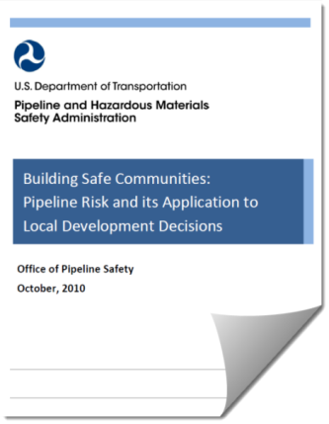PHMSA published a Pipeline Risk Report in 2010[10] in conjunction with the release of the PIPA Report[11]. The purpose of the Pipeline Risk Report is to assist local governments and developers in better understanding pipeline risks and to provide a context for the use of the PIPA recommended practices for development near hazardous liquid and gas transmission pipelines. The Pipeline Risk Report offers comparisons of the frequency of incidents involving death or injury resulting from hazardous materials releases from different transportation modes over 2005-2009.

## State or Local Perspective on Pipeline Consequences

To gain a perspective on pipeline risk, one approach is to identify where in the affected area pipelines are located and overlay other hazards that could affect or could be affected by those pipelines. Additionally, the pipeline mileage within an area can be overlaid with other hazards that could affect or could be affected by pipeline failures.

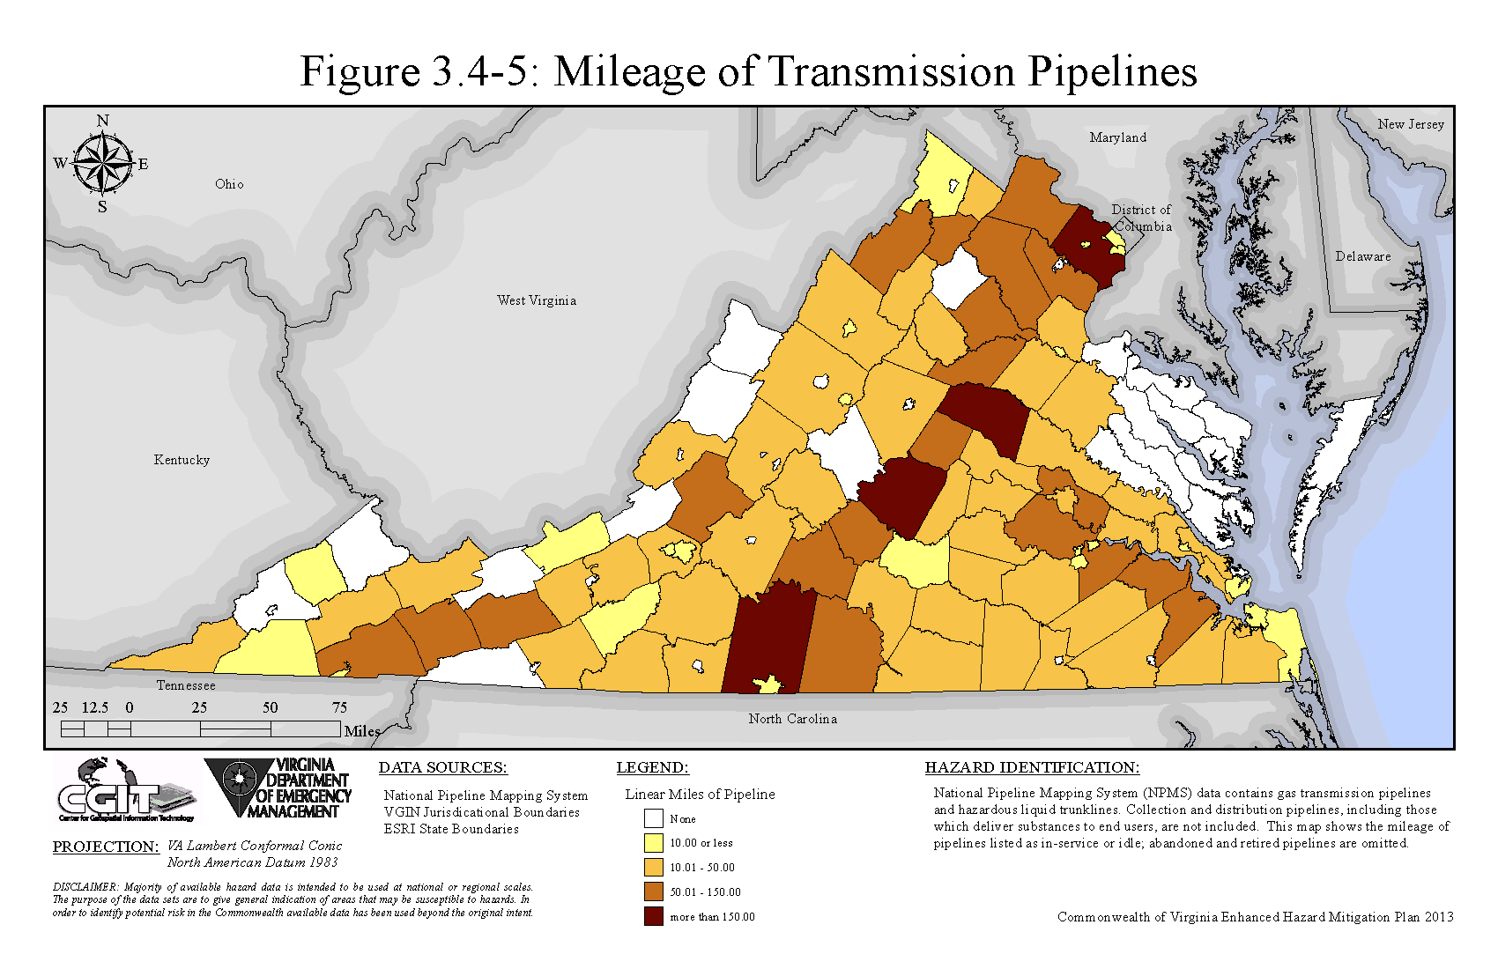

**Example: Mapping the Mileage of Transmission Pipelines.**

**Source: Commonwealth of Virginia Hazard Mitigation Plan 2011.**

Another approach is to leverage historic pipeline incident data for specific state or local jurisdictions. Past performance cannot accurately reflect future incidents since many factors could change over time, but such data can provide trend lines that point to the need for mitigation strategies.

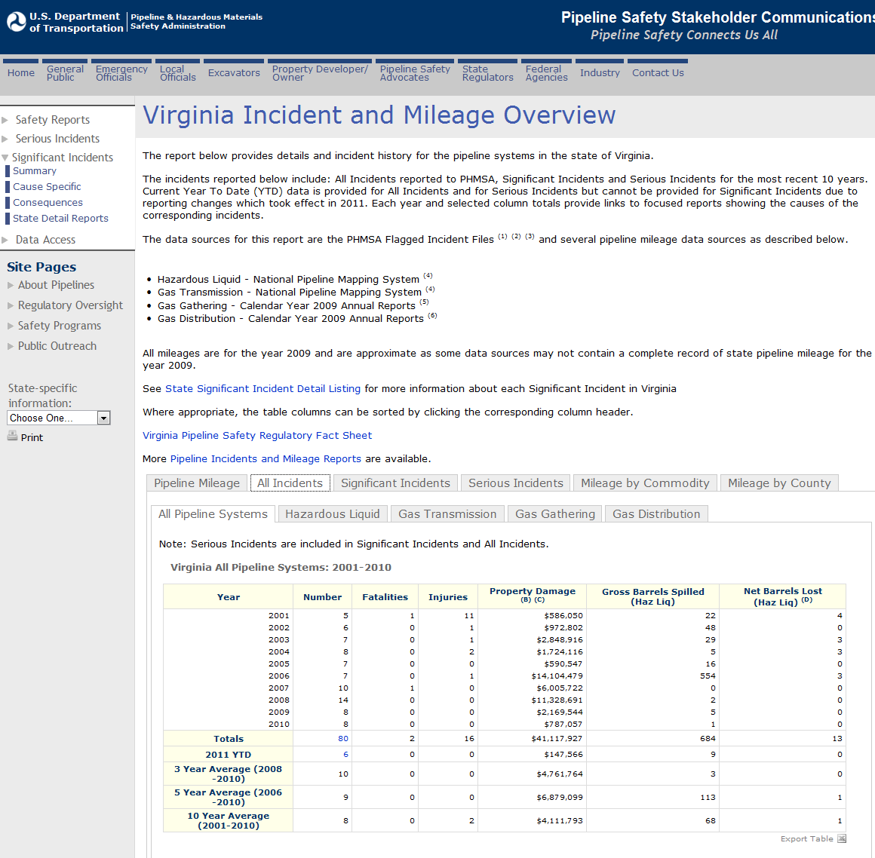

Reference: <http://primis.phmsa.dot.gov/comm/reports/safety/VA_detail1.html>

## Hazard Mitigation Planning for Pipelines – Capability Assessments

As in any planning process, it is important to try to establish which goals, objectives and/or actions are feasible, based on an understanding of the organizational capacity of those agencies or departments tasked with their implementation. A capability assessment helps to determine which mitigation actions are practical and likely to be implemented over time given a local government’s planning and regulatory framework, level of administrative and technical support, amount of fiscal resources and current political climate.

### Funding Capabilities

While funding to assist state and local governments to adequately develop mitigation programs that will completely address properties at risk is generally a challenge, the U.S. Department of Transportation (DOT) Pipeline and Hazardous Materials Safety Administration (PHMSA) (<http://primis.phmsa.dot.gov/comm/DamagePreventionGrantsToStates.htm>) has several grant programs that may provide assistance. It is hoped that as awareness of the need and benefits of hazard mitigation for pipelines increases, due in part to implementation of the hazard mitigation plan, agencies will be able to incorporate mitigation strategies into exiting processes and programs. Pipeline operators may also be a source of pipeline awareness promotional materials, emergency preparedness training, and charitable contributions for emergency response equipment or additional training.

#### PHMSA Federally-Funded Programs

* **Technical Assistance Grants (TAG)** – PHMSA’s TAG program awards enable local governments, communities and groups of individuals to obtain funding for technical assistance in the form of engineering or other scientific analysis of pipeline safety issues and help promote public participation in official proceedings (universities are not eligible). Enhancing hazard mitigation plans for pipelines would be an eligible activity under the TAG program. The amount of any grant may not exceed $50,000 for a single grant recipient. [CFDA Number 20.710](https://www.cfda.gov/index?s=program&mode=form&tab=step1&id=146a1b573b3b1217e6b426b2bb06ed3c). Authorized under 49 USC §60130.
* **State Damage Prevention Grants (SDP)** - The purpose of these grants is to establish comprehensive state programs designed to prevent damage to underground pipelines in states that do not have such programs and to improve damage prevention programs in states that do. The amount of any grant may not exceed $100,000 for a single grant recipient. [CFDA Number 20.720](https://www.cfda.gov/index?s=program&mode=form&tab=step1&id=4e5ff5859623528e5aac47fd3ba6fb44). Authorized under 49 USC §60134.
* **PHMSA Pipeline Safety Program One-Call Grants** - One-call Grants are designed to provide funding to state agencies in promoting damage prevention, including changes with their state underground damage prevention laws, related compliance activities, training and public education. State agencies that participate in the pipeline safety program are eligible to apply for one-call grant funding on an annual basis, with a maximum request amount of $45,000 per state. A State may provide funds received under this section directly to any one-call notification system if the State substantially adopts the Common Ground Best Practices. [CFDA Number 20.721](https://www.cfda.gov/index?s=program&mode=form&tab=step1&id=3bff11c2defa9ead513d45549e1a6a95). Authorized under 49 USC §6106.

#### Pipeline Operator Contributions

Pipeline operators’ public awareness programs are required by federal regulations to comply with the American Petroleum Institute (API) Recommend Practice (RP) 1162, “Public Awareness Programs for Pipeline Operators”. Appendix D of RP 1162, “Detailed Guidelines for Message Delivery Methods”, Media Section D.2.6 “Charitable Contributions by Pipeline Operators” provides:

*While contributions and civic causes are not in themselves a public awareness effort, companies should consider appropriate opportunities where public awareness messages can be conveyed as a part of or in publicity of the contribution. Examples include:*

* *Contributions of gas detection equipment to the local volunteer fire department*
* *Donation of funds to acquire or improve nature preserves or green space*
* *Sponsorship to the community arts and theatre*
* *Support of scholarships (especially when to degree programs relevant to the company or industry)*
* *Sponsorship of emergency responders to fire training school*

### State Programs and Capabilities

The following state agencies, officials, and programs may have either direct or indirect roles in hazard mitigation in a state. These agencies can play a key role in reducing risks from pipeline hazards in a state and in improving the effectiveness of mitigation activities.

#### Emergency Management Department

The primary mission of a state’s emergency management department is to protect the lives and property of the state’s citizens from emergencies and disasters, by coordinating state emergency preparedness, response, recovery, and mitigation programs. The responsibility is to ensure a comprehensive, efficient and effective response to emergencies and disasters throughout the state, including providing assistance in the absence of federal aid. In this role state emergency management departments are usually charged with supporting mitigation planning. State emergency management departments may also work with the U. S. Environmental Protection Agency (EPA) and their state partners on oil spill response drills.

#### State Fire Marshal

The state fire marshal is the most senior fire official in the state. State fire marshals' responsibilities vary from state to state, but they tend to be responsible for fire safety code adoption and enforcement, fire and arson investigation, fire incident data reporting and analysis, public education, and advising state governors and legislatures on fire protection. Some state fire marshals are responsible for fire fighter training, hazardous materials incident responses, wild land fires and the regulation of natural gas and other pipelines. Most state fire marshals are appointed by state governors or other high-ranking state officials.

#### State Department of Transportation (DOT)

State DOTs are responsible for building, maintaining and operating state roads, bridges and tunnels, including repairs and replacements required after natural disasters. In accordance with requirements of the Federal Highway Administration, state DOTs routinely factor flood hazards into the planning and design of transportation infrastructure. In some cases seismic hazards are also considered.

#### State and Territorial Environmental Agency

State and territorial environment agencies have major responsibility for the environmental consequences of accidents and disasters. These agencies play a major role in hazardous materials containment, testing, and abatement, and provide oversight to the joint permitting processes that oversee any activity with potential impacts to rivers, streams or wetlands.[12]. They may also regulate gas fracturing and the associated water needs.

### Local Capabilities

With respect to addressing pipeline hazards, local jurisdictions control land use through codes and ordinances, planning, zoning, and permitting. These local governmental functions are enabled through state and federal laws and regulations, and can contribute significantly to mitigation of pipeline hazards. Local jurisdictional programs are also extremely relevant as state agencies generally manage state facilities in a manner that is consistent and complementary of local comprehensive planning and zoning.

Use of uniform statewide building codes is generally required for all new construction and significant building repairs or additions within most cities, counties and towns. Many local hazard mitigation strategies reflect local land use requirements and building codes and may contribute significantly to mitigating pipeline hazards.

Following are some typical means by which local jurisdictions control land use and development.

* **Comprehensive citywide and countywide plans** are prepared by local planning commissions and address the physical development of land within a jurisdiction’s boundaries. These may be enhanced or supported by sector plans. These may also be supported by, for example, general plans, ten-year plans, growth policy plans, utilities plans, and major road plans,
* **Zoning ordinances** provide for the public health, safety, morals, and general welfare of the citizens of a jurisdiction, and secure for them the social and economic advantages resulting from an orderly planned use of the land resources within the jurisdiction. They are used to regulate and restrict the location and use of buildings, structures, and land for residence, trade, industry, and other purposes. They restrict the height, number of stories, and size of buildings and other structures, and the size of yards, courts, and other open spaces on a lot or tract. They provide definite official land use plans for property publicly and privately owned within the jurisdiction. They help to guide, control, and regulate the future growth and development of the jurisdiction in accordance with development plans, and provide for the administration and otherwise carrying out of such plans.
* **Land subdivision and development ordinances** are prescribed by statute. They generally provide for the harmonious development of the jurisdiction and its environs, including the coordination of roads within the subdivided land, with other existing or planned roads, or with the state or regional plan, or with the plans of municipalities in or near the region. They provide for adequate open spaces for traffic, light, air and recreation; for the conservation or production of adequate transportation, water, drainage and sanitary facilities; for the avoidance of population congestion. They also provide for the avoidance of such scattered or premature subdivision of land as would involve danger or injury to health, safety or prosperity by reason of the lack of water supply, drainage, transportation or other public services, or would necessitate an excessive expenditure of public funds for the supply of such services. They also control the manner in which roads shall be graded and improved, and water, sewer and other utility mains, piping, connections or other facilities shall be installed.
* **Building codes** are sets of rules that specify the minimum acceptable levels of safety for constructed objects such as buildings and other structures. The main purpose of building codes is to protect public health, safety, and general welfare as they relate to the construction and occupancy of buildings and structures. The building code becomes law of a particular jurisdiction when formally enacted by the appropriate authority.

Building codes are usually a combination of prescriptive requirements that spell out exactly how something is to be done, and performance requirements which just outline what the required level of performance is. In recent history, the trend has been for building codes to move to more prescriptive requirements and less performance requirements.

The major model building codes used in the United States are developed by the [International Code Council](http://en.wikipedia.org/wiki/International_Code_Council) (ICC), which has 14 sets of international codes, including, for example, the [International Building Code](http://en.wikipedia.org/wiki/International_Building_Code) (IBC), the International Residential Code, the International Fire Code, the International Energy Conservation Code, the International Plumbing Code, the International Mechanical Code, and others.

* **Floodplain management** provisions for development within a regulated floodplain have typically been addressed by standalone ordinances adopted for voluntary participation in the National Flood Insurance Program (NFIP). The designated NFIP coordinating agency of a local government may find benefit in discussing potential oil spill consequences with pipeline operators. The data from this program may inform pipeline operators of locations where flooding is more likely to impact pipelines.
* **Regional Cooperative Development** occurs when the physical land use of an area extends beyond the boundaries of a single jurisdiction. An example of this would be the development or extension of new interstates, railways, and airports. Pipelines cross jurisdictional boundaries. Arraignments and locations are often negotiated by all stakeholders involved.

## Pipeline Hazard Mitigation Strategies

PHMSA has identified mitigation strategies wherein state and local governments have the authority to reduce the risk of pipeline hazards. They are:

* Pipeline mapping,
* Pipeline awareness - education and outreach,
* Excavation damage prevention,
* Land use and development planning near transmission pipelines, and
* Emergency response planning for pipeline emergencies.

#### Pipeline mapping

The National Pipeline Mapping System (NPMS) ([www.npms.phmsa.dot.gov](http://www.npms.phmsa.dot.gov)) is a geographic information system (GIS).  The NPMS consists of geospatial data, attribute data, public contact information, and metadata pertaining to the interstate and intrastate hazardous liquid trunklines and hazardous liquid low-stress lines as well as gas transmission pipelines, liquefied natural gas (LNG) plants, and hazardous liquid breakout tanks jurisdictional to PHMSA.

PHMSA developed the Pipeline Integrity Management Mapping Application (PIMMA) to enable federal, state, and local government officials to access NPMS data. The PIMMA provides restricted internet access to sensitive, pipeline critical infrastructure information for reference purposes only.

State and local government officials can request access to the PIMMA via an online application ([www.npms.phmsa.dot.gov](http://www.npms.phmsa.dot.gov)). Applicants will be granted access only to the information that is pertinent to the jurisdiction in which they are employed. Government officials can obtain shape files of the pipelines in their jurisdiction to facilitate inclusion of pipeline maps in their various electronic mapping systems.

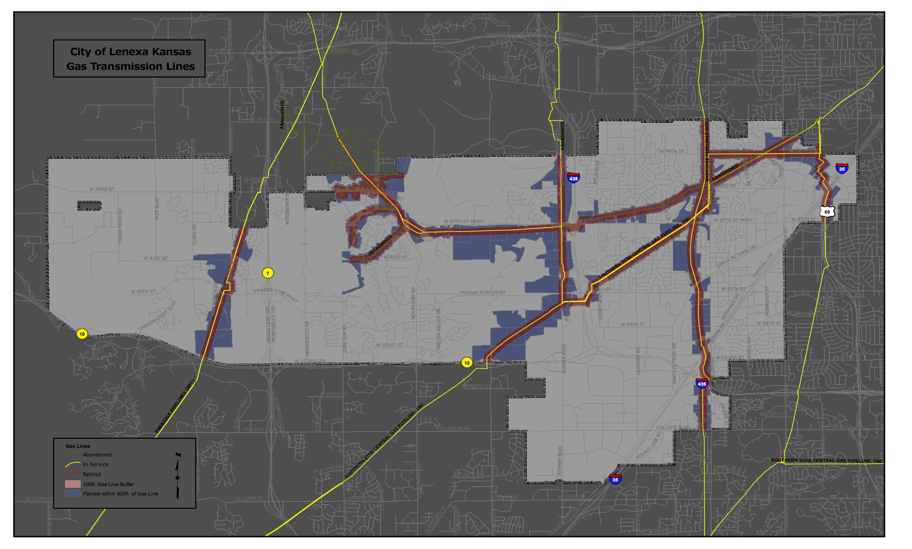

**Gas Transmission Pipelines Incorporated into City of Lenexa, Kansas Map**

#### Pipeline awareness – education and outreach

Being aware that there are pipelines within the borders of a jurisdiction and the hazards associated with those pipelines are key to enabling the jurisdictional government to determine what can be done to mitigate pipeline hazards and to determine what its own capabilities are in that regard. For example, awareness of the existence of pipelines within the jurisdiction can lead to incorporating pipeline locations and information into maps and graphic information systems (GIS).

Promotion of pipeline awareness among constituents is also one method governments can and should adopt as a pipeline hazard mitigation measure. Being aware of pipelines can help affected constituents understand the risks posed by pipelines, become aware of what precautions they should take to prevent pipeline damage, understand acceptable uses of the pipeline rights-of-way (ROW), and learn to prepare for, identify, and respond to pipeline emergencies. Promotion of pipeline awareness can be done through brochures, public service announcements (PSAs), permitting processes, websites and other means used to communicate with the broader constituent audience.

Federal pipeline safety regulations [49 CFR 192.616](http://ecfr.gpoaccess.gov/cgi/t/text/text-idx?c=ecfr&sid=54eb3a5aac253f6a10828979abce1d96&rgn=div8&view=text&node=49:3.1.1.1.8.12.9.11&idno=49) and [49 CFR 195.440](http://ecfr.gpoaccess.gov/cgi/t/text/text-idx?c=ecfr&sid=54eb3a5aac253f6a10828979abce1d96&rgn=div8&view=text&node=49:3.1.1.1.11.6.21.23&idno=49)require pipeline operators to develop and implement public awareness programs that follow the guidance provided by the American Petroleum Institute (API) [Recommended Practice (RP) 1162, "Public Awareness Programs for Pipeline Operators"](http://mycommittees.api.org/standards/pipeline/1162%20Links/1162nonprintable.pdf). Under these regulations:

* Pipeline operators must provide the affected public, fire, police, and other public officials with information about how to recognize, respond to, and report pipeline emergencies.
* The importance of using the one-call notification system prior to excavation is to be emphasized for all stakeholders.
* Emergency officials and local public officials must be provided information about the location of transmission pipelines to enhance emergency response and community growth planning.
* Affected municipalities, school districts, businesses, and residents must be advised of pipeline locations.

Citizens look to their state and local governments as trusted sources of information. A local or state government may supplement and support the public awareness efforts of pipeline operators and other stakeholder organizations by acquiring and/or developing and disseminating additional materials to increase pipeline awareness.

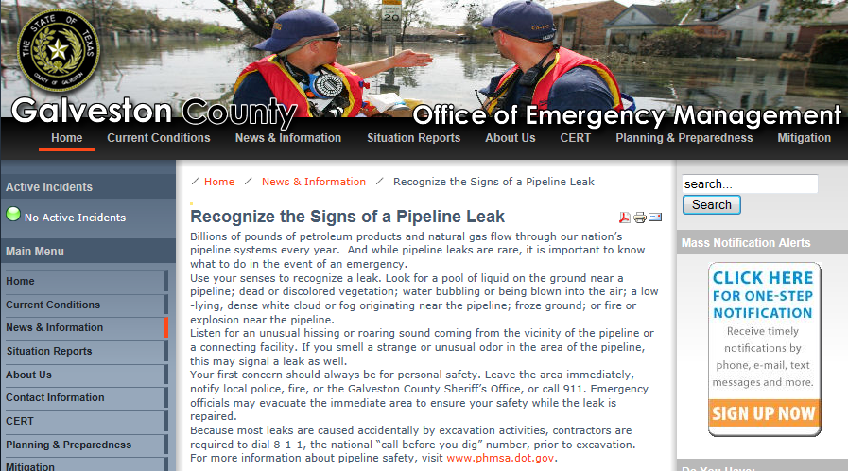

**Galveston County, TX, Office of Emergency Management – Pipeline Awareness[13]**

#### Excavation damage prevention

Preventing excavation damage to pipelines, as well as other underground facilities, is a mitigative measure that goes hand-in-hand with pipeline awareness and land development planning. A significant portion of serious pipeline incidents are caused by excavation damage. Excavation damage most often occurs because of a weakness or breakdown in implementation of the damage prevention process. It occurs because of gaps in damage prevention laws or inadequate and ineffective inspection and enforcement. It occurs as a result of insufficient or ineffective public education and awareness. It occurs because an excavator failed to call before digging or didn’t wait the necessary time for underground facilities to be located and marked. It occurs because a facility locate was not done timely or accurately. It occurs because the facility owner/operator did not maintain adequate mapping in-house or with the one-call center. There are several stakeholders in the damage prevention process and damage prevention is a shared responsibility of all stakeholders.

Each state has a damage prevention law in place that requires an excavator to call a one-call center before digging. One-call centers work with excavators and underground facility operators to ensure underground facilities in the excavation area are located, identified and marked prior to digging. In any area of the country, excavators can simply dial “811” to reach the one-call center. More information is available at [www.call811.com](http://www.call811.com).

It should be noted that a local government can wear the many hats of the various damage prevention stakeholders at different times. Local government may be a facility owner, excavator, project owner, designer, or facility locator. The local government may also be the permitting agency. Local government should assume some role in public education and awareness of damage prevention practices, and could have a role in enforcing state damage prevention laws.

Many state damage prevention laws provide exemptions for some activities, such as an exemption for state, county and municipal transportation departments to call the one-call center before performing road maintenance. Local governments can augment gaps and weaknesses in the state damage prevention law. For example, if the state damage prevention law provides for one-call exemptions, local government can address this weakness by requiring all departments and employees to call before digging.

Local governments can also get involved to promote strengthened damage prevention laws and more effective enforcement of those laws. Local governments can also address excavation damage prevention through their permitting authority. They can include a requirement that the excavator to call 811 in order to have a permit approved and issued to them.

#### Land use and development planning near transmission pipelines

Another area in which state and local governments can implement mitigative relief to pipeline hazards is the adoption of risk-informed planning for land use and development near pipelines. Community growth can have an impact on transmission pipeline safety. Placing people in proximity to existing transmission pipelines can increase their risks resulting from the unintentional release of products transported through the pipelines. Such releases can result from a variety of causes and may result in injuries or fatalities as well as property and environmental damage. Although the risk of any individual being injured by a transmission pipeline incident is very low, land development in proximity to pipelines can increase such risk. The Pipelines and Informed Planning Alliance (PIPA) has developed recommended practices in this regard.

[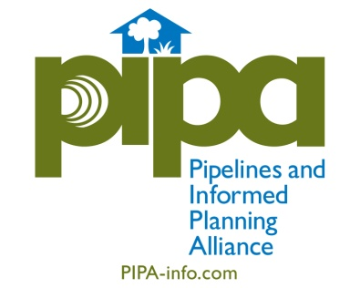](http://www.pipa-info.com)PIPA has developed a tool for use by local governments to evaluate their land use and development practices near transmission pipelines. This evaluation tool also looks at coordination of infrastructure projects, the use of pipeline overlay districts, zoning and planning ordinances, development/building permitting reviews and requirements, and land document recordation practices.

Go to [www.PIPA-Info.com](http://www.PIPA-Info.com) for more information on PIPA and the PIPA recommended practices for land use planning and development near transmission pipelines.

#### Emergency response planning for pipeline emergencies

Fire departments frequently respond to gas distribution pipeline incidents. However, transmission pipeline incidents are very different from distribution pipeline incidents. Incidents involving larger, transmission pipelines are low-frequency but potentially high-consequence hazardous materials events. It is imperative that effective risk assessment, emergency response planning, and training are performed to increase the safety of the public, emergency responders, and property when pipeline incidents occur.

The most important aspects of pipeline emergency preparedness and response are communication, coordination, and cooperation between pipeline operators and emergency responders. There is no substitute for establishing positive working relationships and clear lines of communication before and during response to pipeline emergencies.

Key resources for emergency preparedness are:

* *Pipeline Emergencies Training*

Several pipeline emergency training resources are available at no cost. The most comprehensive of these is the second edition of “Pipeline Emergencies,” available for free at www.pipelineemergencies.com. The “Pipeline Emergencies” training manual was produced through a cooperative agreement between PHMSA and the National Association of State Fire Marshals and was released in May 2011. The second edition includes updated information about commodities transported by pipelines, related videos, an instructor’s guide for trainers, and mobile apps for iPhone and Android devices.

* *Emergency Response Guidebook*

The 2012 edition of PHMSA’s Emergency Response Guidebook (ERG) contains expanded information about pipelines, including:

* A basic overview of pipeline types, associated structures and markers;
* Indications of pipeline leaks and ruptures; and
* The fundamentals of a safe and effective response.

Product information, as well as the physical state and pressure of the product in the pipeline, is critical to responders to initiate public protective actions as soon as possible. Initial isolation zones and downwind protective action distances are listed in the ERG. To learn more about the ERG, visit <http://phmsa.dot.gov/hazmat>.

* *Hazardous Materials Cooperative Research Program Report 5: Guide for Assessing Community Emergency Response Needs and Capabilities for Hazardous Materials Releases*

This guide is designed to assist emergency response planning organizations at all jurisdictional levels in assessing their needs for hazmat emergency response, in assessing their capabilities to respond, and in identifying and addressing any significant shortfalls in coverage, visit <http://www.trb.org/Main/Public/Blurbs/8be31746-4853-4b77-a5b1-e1bf3547453e.aspx>.

* *Pipeline Operators*

Fire, police and other response agencies are encouraged to regularly conduct pipeline emergency drills and practice exercises with pipeline operators to improve their preparedness to respond to emergencies.

#### Mitigative measures to address pipeline hazards

The table below suggests some mitigative measures a jurisdiction might consider including in its hazard mitigation plan to address pipeline hazards, and the typical jurisdictional agency that might be responsible. Some actions may be applicable only to state or only to local governments.

### Table 6: Mitigative Strategies

| Strategy Category | Strategy Description |
| --- | --- |
| Pipeline Mapping | Identify & map gas transmission and hazardous liquid pipelines located within the jurisdiction using information and shape files from the National Pipeline Mapping System (NPMS). |
| Pipeline Awareness – Education and Outreach | Determine who regulates gas and oil pipelines in your jurisdiction. |
| Understand the risk pipelines pose to the community and the risk the community poses to pipelines. |
| Establish a buffer distance from the pipeline where mitigative actions such as a consultation zone or planning area will be considered. |
| Develop, communicate and disseminate pipeline information to appropriate governmental agencies, the affected public, land developers, builders and excavators. Pipeline information may include pipeline basics (e.g. types of pipelines, pipeline facilities, pipeline regulators, , how to recognize and respond to a pipeline emergency, pipeline integrity management & assessment techniques, operations & maintenance, construction, repairs, causes of pipeline failures).   * Promote the use of NPMS. * Promote the Pipelines and Informed Planning Alliance (PIPA) recommended practices for land use and development near transmission pipelines. * Promote 811 Call Before You Dig. * Promote the Common Ground Alliance (CGA) best practices for prevention of excavation damage. * Promote the Pipeline Emergencies training curriculum for emergency response to liquid and natural gas pipelines, that includes a range of emergency scenarios, including leaks, spills, and fires. * Promote the use of PHMSA’s Technical Assistance Grants to strengthen the depth and quality of public participation in pipeline safety matters. * Promote PHMSA’s Stakeholder Communications website as a source to obtain operator information and other pipeline safety information. * Leverage PHMSA resources such as the Community Assistance & Technical Services (CATS) Managers to facilitate communications and provide additional information. |
| Require disclosure of known transmission pipeline easements on the property as part of all real estate sales transactions. Landlord laws also provide a mechanism to promote pipeline awareness and damage prevention. |
| Excavation Damage Prevention | Identify a point-of-contact (POC) for the one-call center which covers the jurisdiction. |
| Review state requirements for excavation notification and facility marking. |
| Participate in local damage prevention councils (or similar groups) to understand and address damage prevention issues in the area. |
| Become familiar with resources available by visiting [www.commongroundalliance.com](http://www.commongroundalliance.com), [www.call811.com](http://www.call811.com), and <http://primis.phmsa.dot.gov/comm/>. |
| Adopt various permitting requirements to encourage excavators to use 811 (Call Before You Dig) and other excavation damage prevention practices. Examples of where damage prevention requirements might be prerequisite to the issuance of permits include: land use changes, demolition, construction of fences & retaining walls, building construction, water development, sewer development, and right-of-way/public space planning. |
| Land Use Planning | Effectuate early communication among key stakeholders when considering changes to existing land use or new land use development adjacent to existing transmission pipeline rights-of-way (ROW). |
| Model the potential impacts of a pipeline incident on proposed developments. |
| Consider enhanced records research and information collection regarding the proposed development and the pipeline attributes when development is proposed in close proximity to transmission pipelines. |
| Review development designs for safe integration with transmission pipeline ROW.   * Consider measures to prevent excavation damage during construction and in the future * Review the potential for pipeline damage resulting from other impacts of development (e.g., water runoff, interference with cathodic protection systems). * Review to ensure adequate access for pipeline operations/maintenance activities. * Review to ensure adequate access for emergency response personnel, vehicles, and equipment in the event of a pipeline incident. * Review buildings and pathways to ensure safe and timely evacuations can be accomplished if necessary. * Review to maximize separation between proposed facilities transmission pipeline ROW.   + Minimum separation within the ROW to other structures?   + Consider measures to minimize the consequences and likelihood of pipeline failure from future excavation damage.   + Cluster buildings away from the pipelines.   + Ensure higher-density or difficult to evacuate developments are located with a maximum separation from the pipeline.   + Locate open spaces closest to the pipeline, thereby creating buffers. * Review building materials for enhanced fire endurance if needed. * Review selection and design of vegetation on and adjacent to pipeline ROW. * Consider the effects of noise and odor from pipeline operations. |
| Consider the escalation of risk due to cascading effects, such as a pipeline failure affecting water supplies needed for firefighting. |
| Consider pipeline ROW for alternative uses such as green spaces, parks, golf courses, hike and bike trails, horse trails, and other recreational spaces. |
| Consider enhanced damage prevention practices for development near transmission pipelines. |
| Review land record requirements for development in close proximity to transmission pipelines. |
| Implement physical protective strategies, for example, adding fencing and barriers to protect critical aboveground junctures or components, or adding berms or collection locations to protect sensitive areas. |
| Emergency Preparedness and Response | Support programs that are designed to improve planning, preparedness, mitigation, response, and recovery capabilities for pipeline emergencies. Confirm emergency response organizations:   * Have emergency responders that are adequately trained, prepared, and staffed to respond to pipeline emergencies. * Have emergency responders that are familiar with PHMSA’s Emergency Response Guidebook (ERG) pipeline section. * Have emergency responders that are familiar with Hazardous Materials Cooperative Research Program Report 5: Guide for Assessing Community Emergency Response Needs and Capabilities for Hazardous Materials Releases. * Train and participate in emergency drills and exercises with pipeline operators when possible. * Have adequate and proper equipment to respond to pipeline emergencies. * Maintain and test response equipment to ensure it is in proper working order and is adequately and sufficiently located. * Have adequate communications equipment and channels. * Ensure cooperative agreements are in place to assure the dispatch of emergency response units and deployment of equipment. |
| Confirm that 911 operators have the necessary information to answer emergency calls pertaining to pipeline emergencies. |
| Ensure ongoing, positive relationships are established between emergency responders and pipeline operators. |
| Develop communication plans to be used in the event of a pipeline emergency. |
| Proactive Monitoring | Develop routine or scheduled checking of local wells in sensitive areas to detect small leaks that may go undetected by other means. This could be similar to how methane checks are conducted for properties built on or near former landfills and dump sites. |

## Benefits to pipeline operators of including pipelines in hazard mitigation plans

Participation in state and community hazard mitigation planning processes can benefit pipeline operators in several ways. These include providing enhanced opportunities to:

* Exchange and communicate information regarding pipeline threats and hazards,
* Convey information regarding pipeline safety and integrity,
* Gain increased stakeholder acceptance regarding the need to protect the pipeline rights-of-way and to perform needed maintenance and repairs,
* Develop relationships to facilitate the coordination of emergency response plans, and
* Build improved relationships with community leaders and emergency management officials.

These opportunities can help operators raise the bar on pipeline safety by developing partnerships with safety regulators and other key state and local government stakeholders. Better-informed state and local governments can help to improve pipeline safety in many ways, including:

* Enhancing pipeline safety through land use and development regulation,
* Establishing enhanced requirements affecting excavation damage prevention,
* Improving the communication of pipeline safety, pipeline awareness, and damage prevention information as a result of their credibility with constituents, and
* Enhancing understanding of their associated roles in emergency preparedness, response, and recovery.

States and communities utilize a variety of resources in the development of their hazard mitigation plans to identify and assess natural hazards that can threaten pipelines and other infrastructure. Natural hazards include floods, hurricanes, tornados, severe winter weather, wildfires, drought, landslides, land subsidence, and earthquakes. Developing cooperative relationships with states and communities relative to hazard mitigation can provide pipeline operators with data and information that can help assess the potential impacts of these threats to their pipelines.

During natural hazard events such as floods and hurricanes, state and local emergency management organizations establish incident command systems (ICS). An ICS[14] is a standardized, on-scene, all-hazards incident management approach that:

* Allows for the integration of facilities, equipment, personnel, procedures, and communications operating within a common organizational structure;
* Enables a coordinated response among various jurisdictions and functional agencies, both public and private; and,
* Establishes common processes for planning and managing resources.

Cooperation and coordination with an ICS during a natural hazard event can facilitate the acquisition and sharing of information needed by and from the pipeline operator and enable timely preventive and mitigative actions to address pipeline threats and ensure the safety of potentially affected pipelines. This may require that one or more pipeline operator personnel who have emergency management responsibilities receive training and certification in the ICS.

Finally, but not least, including pipelines in the development of state and community hazard mitigation plans will further the institutionalization of considering pipeline risks and land planning and development near pipelines.

1. Review and download the PIPA Report at <http://primis.phmsa.dot.gov/comm/pipa/LandUsePlanning.htm>.
2. FEMA’s Multi-Hazard Mitigation Planning Guidance can be helpful in developing and evaluating plans that include these hazards. See How-To Guide # 7 (FEMA 386-7), <http://www.fema.gov/library/viewRecord.do?id=1915> 
3. Review and download the PIPA Report at <http://primis.phmsa.dot.gov/comm/pipa/LandUsePlanning.htm>.
4. FEMA’s Multi-Hazard Mitigation Planning Guidance can be helpful in developing and evaluating plans that include these hazards. See How-To Guide # 7 (FEMA 386-7), <http://www.fema.gov/library/viewRecord.do?id=1915> 
5. Threat and Hazard Identification and Risk Assessment Guide, Comprehensive Preparedness Guide (CPG) 201, First Edition, April 2012, U.S. Department of Homeland Security. <http://www.fema.gov/library/file?type=publishedFile&file=cpg_201_thira_guide_final_040312.pdf&fileid=b8f77f90-7e65-11e1-8178-001cc456982e>
6. Threat and Hazard Identification and Risk Assessment Guide, Comprehensive Preparedness Guide (CPG) 201, Supplement 1: Toolkit, First Edition, April 2012, U.S. Department of Homeland Security. <http://www.vmasc.odu.edu/downloads/CPG_201_SUPP_1_THIRA_Guide_Toolkit_FINAL_040312.pdf>
7. Source: PHMSA Significant Incidents Files April 30, 2012
8. Threat and Hazard Identification and Risk Assessment Guide, Comprehensive Preparedness Guide (CPG) 201, First Edition, April 2012, U.S. Department of Homeland Security. <http://www.fema.gov/library/file?type=publishedFile&file=cpg_201_thira_guide_final_040312.pdf&fileid=b8f77f90-7e65-11e1-8178-001cc456982e>
9. Threat and Hazard Identification and Risk Assessment Guide, Comprehensive Preparedness Guide (CPG) 201, Supplement 1: Toolkit, First Edition, April 2012, U.S. Department of Homeland Security. <http://www.vmasc.odu.edu/downloads/CPG_201_SUPP_1_THIRA_Guide_Toolkit_FINAL_040312.pdf>
10. Building Safe Communities: Pipeline Risk and its Application to Local Development Decisions. October, 2010. <http://primis.phmsa.dot.gov/comm/publications/PIPA/PIPA-PipelineRiskReport-Final-20101021.pdf>
11. Partnering to Further Enhance Pipeline Safety In Communities Through Risk-Informed Land Use Planning: Final Report of Recommended Practices. Pipelines and Informed Planning Alliance. November 17, 2010. <http://primis.phmsa.dot.gov/comm/publications/PIPA/PIPA-Report-Final-20101117.pdf#pagemode=bookmarks>
12. Clean Water Act, Section 401, “Permits and Licenses – Certification” and Section 404, “Regulations”. ([http://water.epa.gov/lawsregs/rulesregs/)](http://water.epa.gov/lawsregs/rulesregs/)%20%20) 
13. <http://www.gcoem.org/index.php?option=com_content&task=view&id=367&Itemid=145>
14. FEMA, Incident Command System (ICS), <http://www.fema.gov/emergency/nims/IncidentCommandSystem.shtm>